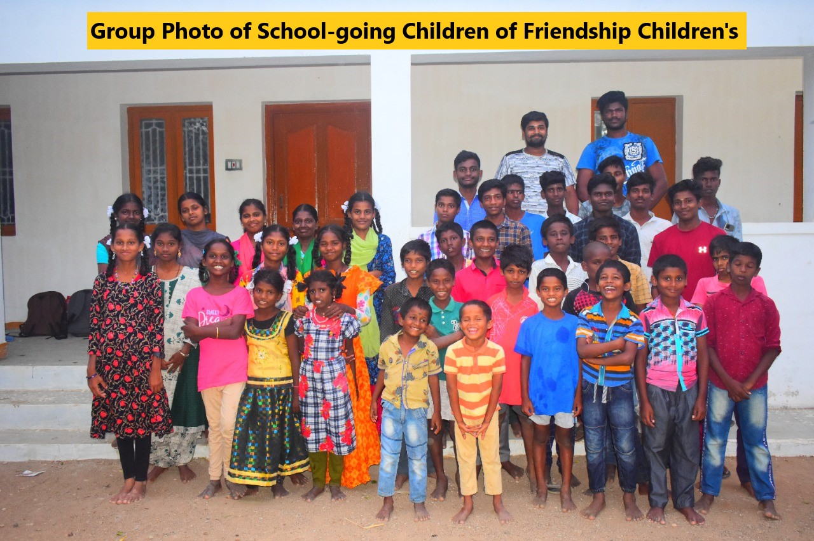

Application from VOICE Trust, a non-profit social service organization from India
for Rest Room Facilities in Friendship Children’s Home at Siruganur, Tamil Nadu, India
for benefit of 48 parentless, at risk and other disadvantaged Children

- NAME OF THE PROJECT:
Rest Room Facilities in Friendship Children’s Home at Siruganur, Tamil Nadu, India
- THE APPLICANT:
Mrs.J.Preethi,
Administrator – VOICE Trust
18 Thathachariyar Residency, Mambalasalai, Tiruvanaikoil Post, Trichy – 620005
Mobile No: 99945 58587 Email ID: janet@voice-trust.org

- THE IMPLEMENTING ORGANIZATION:
VOICE Trust (Voice for the Oppressed through Integrated Community Emancipation )
18 Thathachariyar Residency, Mambalasalai, Tiruvanaikoil Post, Trichy – 620005
Mobile No: 9443143380 Email ID: voicetrust.try@gmail.com Website: https://voice-trust.org/
VOICE Trust was registered in 1985 as a non-profit social service organization under the Indian Trust Act. The Registration Number is 380/85.The recent amendment deed was registered in 2005, signed by the Donor and the first 3 Trustees authorizing running of the Trust by the current 5 Trustees

VOICE Trust is approved from 1986 by Ministry of Home Affairs, Govt. of India under the FCRA (Foreign Contribution Regulation Act). The FCRA Number is 075960042. The audited statements are submitted to the government every year. The FCRA Registration continues to be active with renewal upto 2021.

VOICE Trust is tax exempted from 2002 by the Income Tax Department under 12A and 80G Acts for social works to the economically–socially– educationally disadvantaged Children, Adolescents, Women, Farmers, Landless Laborers, Differently Abled, Ageing, Terminally Ill Patients and other destitute people without any discrimination like creed, caste, gender, language, region etc.. The 80G tax exemption is now permanent by Finance (No.2) Act 2009. The PAN (Permanent Account Number ) is AAATV 3191M.

Approved from 2013 by Organic Certification Department of Government for VOICE Trust at Siruganur.
Registration Number is : TNO(F) 569. Once in 3 months, Organic Inspectors from Government visit the Nature Wonder Organic Farm of VOICE Trust at Siruganur. This Farm is not for commercial purposes but for spreading nature centric agriculture for poison free food, pollution free life and better returns on investment for profitability.

Registered from 2014 under Niti Aayog by Government of India- NGO Darpan. The registration number is TN/2014/0074831. Following are the 3 Trustees who are in the Board of VOICE Trust as of July 2022.

Mrs.A.Jecintha – Managing Trustee
Mrs.Jancy Quintal – Financial Trustee
Mrs.R.Meenakshi – Wholetime Trustee

Following are the Key Responsible Persons in the Office and Field Centers
Mrs.J.Preethi (M.B.A) – Administrator
Mr.J.Godwin (M.B.A) – HR & Admin Manager
Mr.P.Silambarasan (B.E., M.S.W., PGDAM) – Program Manager | Ecology and Empowerment
Ms.J.Nitu (B.E.,M.Tech) - Program Manager | Environment and Empowerment
Mrs.R.Kavitha (CAPART Trainee) – Organic Farming Organizer | Social Forestry
Mrs.R.Victoria (B.A.,) – Coordinator | DPD (Development Programs with Disabled)
Past activities of VOICE Trust are many. Following are important ones:
- Emancipation of Widows exploited by “White Saree” humiliation (from 1985).
- Integrated Rural Development of Murungai Village from 1986-1988
- Employment generation for unemployed Youth from 1989-1991.
- Rights of unorganized Workers and Dalit People during 1992-1993.
- Skills Trainings for self employment to landless people from 1994
- Sponsorship of 850 Dalit and Backward Class Children from 1995.
- Ecological Agriculture for poison free food from 1996.
- All round Inclusion of the Differently Abled (Disabled from 1997
- Students Environment Groups in Schools of Trichy District from 1998.
- TOT Trainings in IFS (Integrated Farming System) for 105 Groups from 1999.
- Bio Control Lab for Production of Trichogramma Egg Parasitoids from 2000
- Integrated Pest Management in cotton with FAO Cotton IPM from 2001-2004
- Organic Cotton Production Centre at Sirganur from 2005
- Rehabilitation of Mentally Ill Persons with Employability Skills from 2005
- Involving 300 Women Farmers in Integrated Farming Systems from 2006 to 2009.

Focus from 2010: ecological, enviro, economic, educational empowerments:
- Friendship Children’s Home for 23 Parentless and at risk Children.
- Technical Education of 75 Rural Adolescents under ”Joy to Children Program”
- Empowerment of 50 Disabled Women for Rights and Self Reliance.
- Guide Scheme for 1823 Differently Abled Persons in Mannachanallur Union
- with help from District Differently Abled Welfare Office of the Government through
- 1 Coordinator and 40 Differently Abled Welfare Workers.
- Biodiversity Agri Trainings to 1500 Youth every year.
- National Green Corps with 2000 Students in 50 Schools,
- 585 People’s Organizations for Rights and Responsibilities SHGs of Women,
- Men, Farmers, Landless laborers, Disabled Persons etc
- Networking is done under IVI(Iyarkai Vellan Inaiyam) in all 38 Districts of Tamil Nadu and in Pondicherry/Karikal.
- Extended to Kerala under Kerala Flood Response in 2015
- BDMRFA(Block Disability Mitigation and Rehabilitation Facilitating Agency) for Manachanallur and Thottiyam Block from 2014 to 2018 with Mahalir Thittam under TNSRLM(Tamil Nadu State Rural Livelihood Mission)
- Training of 134 more CDF in Lalgudi, Pullambadi, Tiruverumbur, Vayampatti, Uppliyapuram.

There are 15 full-time Staff, 75 part-timers, 150 Volunteers and 287 Care Givers

Besides, Manachanallur Block, VOICE Trust is also working in parts of Pullambadi Union, Lalgudi Taluk, Andanallur Union, Thottiyam Block and Thuraiyur Union in Trichy District. Outreach Centers are in 60 Villages in parts of Perambalur, Ariyalur, Thanjavur, Karur and Nagapattinam District including the Tsunami Villages around Madavamedu Coastal Hamlet in Sirkali Taluk of Nagapatinam District. Recently, 2 Children Development Programs have been implemented near Kamuthi in Ramnad.

Present Focus Activities:
Focus Activities are Eco Farming, Environment Protection and Empowerment of Disadvantaged including 9222 Differently Abled Persons in 199 Village Panchayats of 7 Blocks (half of Trichy District), 11940 women and men of 597 People's Organizations and 40 parentless / other disadvantaged children in Friendship Children's Home with help from Foreign Agencies.

Working with many Government Departments: In 1996 – District Rural Development Agency, Trichy District.
From 1998 – Department of Environment, Government of Tamil Nadu (25th year in 2022)
From 1999 – District Differently Abled Welfare Office, Trichy District (24th year in 2022)
From 2000 – Forest Department | M.R.Palayam Forestry Extension Division (22nd year in 2022)
From 2007 – Tamil Nadu Pollution Control Board – Tiruchirappalli District Environment Engineer (15th Year in 2022)
From 2012 – Mahalir Thittam under TNSRLM as BDMRFA and Agri supports (10th year in 2022)
From 2015 – Trichy City Corporation (5 Zonal Officers including Srirangam Zone and Ponmalai Zone) (7th Year in 2022)

From 2022 – Started Working with District Collector and District Social Welfare Department for Agriculture Schemes in Pullambadi Blocks and other social services in parts of Trichy District
- LOCATION:
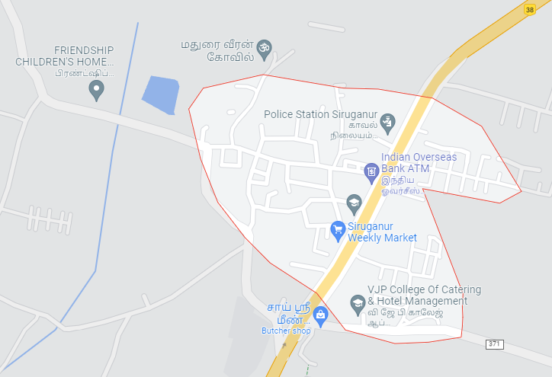
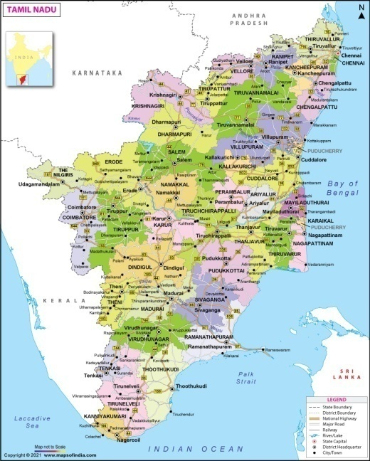
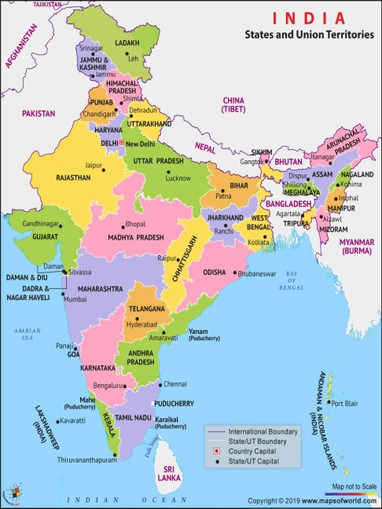
Sirugnaur Village is one of the 35 Village Panchayats of Mannachanallur Block in Trichy District. It is 25 kilometers north of Trichy – the District Head Quarters in the National Highways between Trichy and Chennai – the State Capital which is 323 kilometers distance. Siruganur is 3 kilometers last of Tirupattur, where a Brahma Temple exists and 12 kilometers north of Samayapuram where Mariamman Temple is situated.

- HISTORY OF FRIENDSHIP CHILDREN’S HOME:
AEM (les Amis des Enfants du Monde) – a Children friendly organization from France chose VOICE Trust to start a Children’s Home in the year 2006 at Siruganur Village in Trichy District State of Tamil Nadu, southern region of India for the benefit of 15 orphan Children. AEM gave funds for building 2 rooms (one for Girl Children and one for Boys), Infirmary, 2 Store Rooms.
VOICE Trust had already 3 Class Rooms, 1 Study cum Meeting Hall, 1 Dining Place, 1 Kitchen, 6 Toilets, 6 Bathing Rooms, 1 Open Well and 1 Bore well for water supply with pipe connections and these facilities were offered for Friendship Children’s Home with 15 Orphan Children.
In 2009, District Collector gave approval for 20 Children above 5 years of age. District Social Welfare Office guided Friendship Children’s Home.
In 2011, State Government gave approval under JJ Act (Juvenile Justice Act) after VOICE Trust presented License from Thasildar, Building Stability Certificate, Health Department Certificate and Certificate from Fire Safety Department.
Now, there are 48 parentless, at risk and other disadvantaged Children with 35 Children going to Government schools for Grade 1 to Grade 12 classes, 6 going to Colleges and 7 in Internships. Please find attached Names of Children, Group Photo of School going Children and individual photos of other Children
In 2010, AEM informed about difficulties to continue helps for Friendship Children’s Home and asked us to get local donations. VOICE Trust prepared brochure (copy attached) and is trying to get supports from individuals and groups. But, it is a challenge to get regular helps and assistance for Rest Room Facilities. True, AEM continues to extend specific helps. True, also VOICE Trust is making efforts to get additional supports from local friends and groups.
- NEED FOR THE PROJECT:
As of July 2022, there are 48 Children in Friendship Children’s Home and 35 school going Children saty their always besides weekend stays by 6 college going Children and 7 Children in internships.
The 6 Toilets and 6 Bathing Rooms provided in 2006 for Children of Friendship Children’s Home were meant for the 15 Orphan Children. Now, that there are 2 times more Children in Friendship Children’s Home and hence, they need another 6 Toilets and 6 Bathing Rooms.
VOICE Trust needs your help for the construction of 6 new Toilets and 6 new Bathing Rooms in Friendship Children’s Home for the benefit of totally 48 parentless, at risk and other disadvantaged Children.
- OBJECTIVES FOR THIS PROJECT:
The main goal for this project is maintaining Healthy Environment with Sanitation Safeguards for the Good Life of 48 parentless, at risk and other disadvantaged Children of Friendship Children’s Home at Siruganur Village in Trichy District, State of Tamil Nadu, India
The other objectives is to increase Rest Room Facilities for enabling all 48 Children of Friendship Home to access to healthy sanitation provisions for their good health.
Another objective is to create a Healthy Environment in Friendship Children’s Home for good health of 48 parentless, at risk and other disadvantaged Children and also for the visiting Family Members and friends.
- ACTIVTIES UNDER THIS PROJECT:
With your help for this project, VOICE Trust will construct 6 new Toilets and 6 new Bathing Rooms in Friendship Children’s Home for enabling 35 school going Children and other 13 college students cum interns to have sufficient Rest Rooms Facilities.
VOICE Trust will submit the Completion Report along with the Audited Statement for the grant amount given by you for this project.
VOICE Trust will continue to send you the Annual Reports with names of Children and prove to you that your one time help is assisting around 100 children every year including 48 Children of Friendship Home and the Children who come for exchange programs besides Families and Friends who visit.

- RESULTS FROM THIS PROJECT:
Because of your help for this project, 48 parentless, at risk and other disadvantaged Children of Friendship Children’s Home of VOICE Trust at Siruganur Village in Trichy District, State of Tamil Nadu, India, will get New Toilets and 6 New Building Rooms to avoid congestion as the present numbers of Rest Room Facilities are insufficient to the growing number of Children.
Because of your support number of Children. Campus of Friendship Children’s Home of VOICE Trust at Siruganur Village in Trichy District, State of Tamil Nadu, India will become a Eco-friendly and Environment enhancing Sanitation Center both for the good health of 48 Children and for the visiting Family Members and Friends through New and Sufficient Rest Rooms Facilities.

- COST OF THE PROJECT (Budget in Indian Rupees):

- For Construction of 8 New Toilets = 2,75,000.00
- For Construction of 8 New Bathing Rooms = 2,75,000.00
- For Septic Tank and Water Supply Systems = 2,50,000.00
Total Cost of the Project = 8,00,000.00
(Indian Rupees eight lakhs only)

Approximately Euros 10000 or $ 10000

Requesting your help,
For VOICE Trust

(Mrs.J.Preethi)
Administrator, VOICE Trust

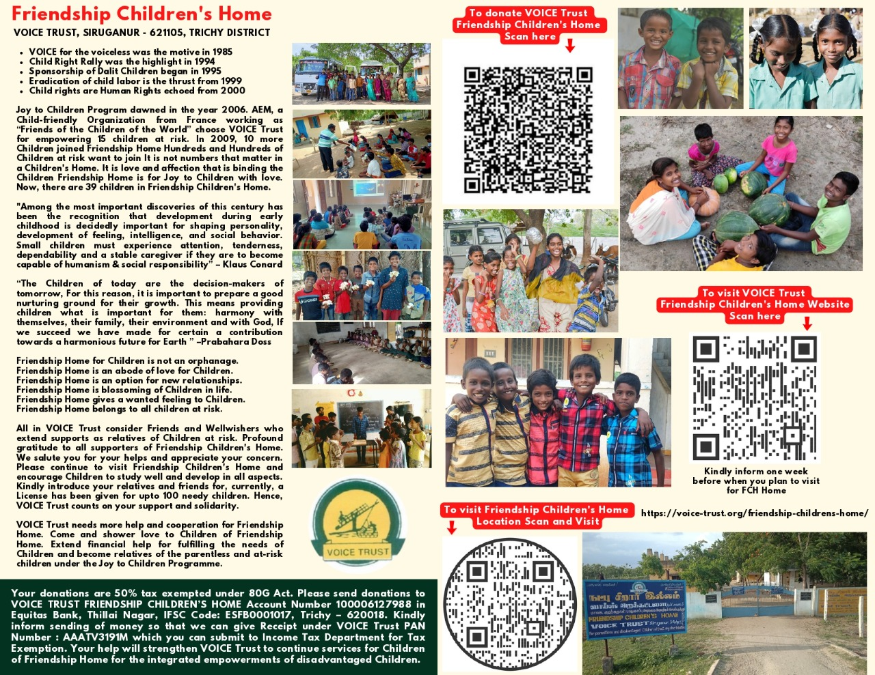
Damaged Rest Room:

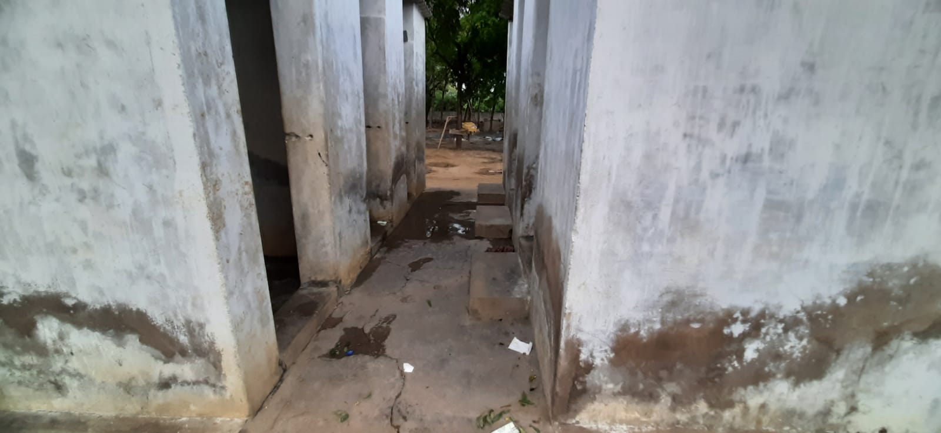
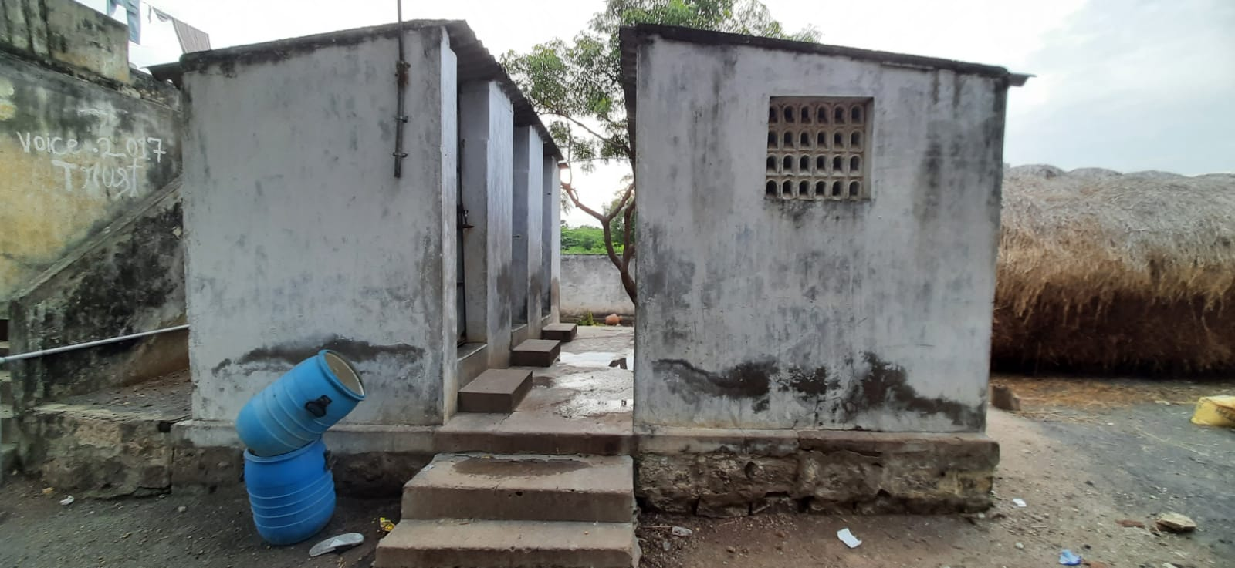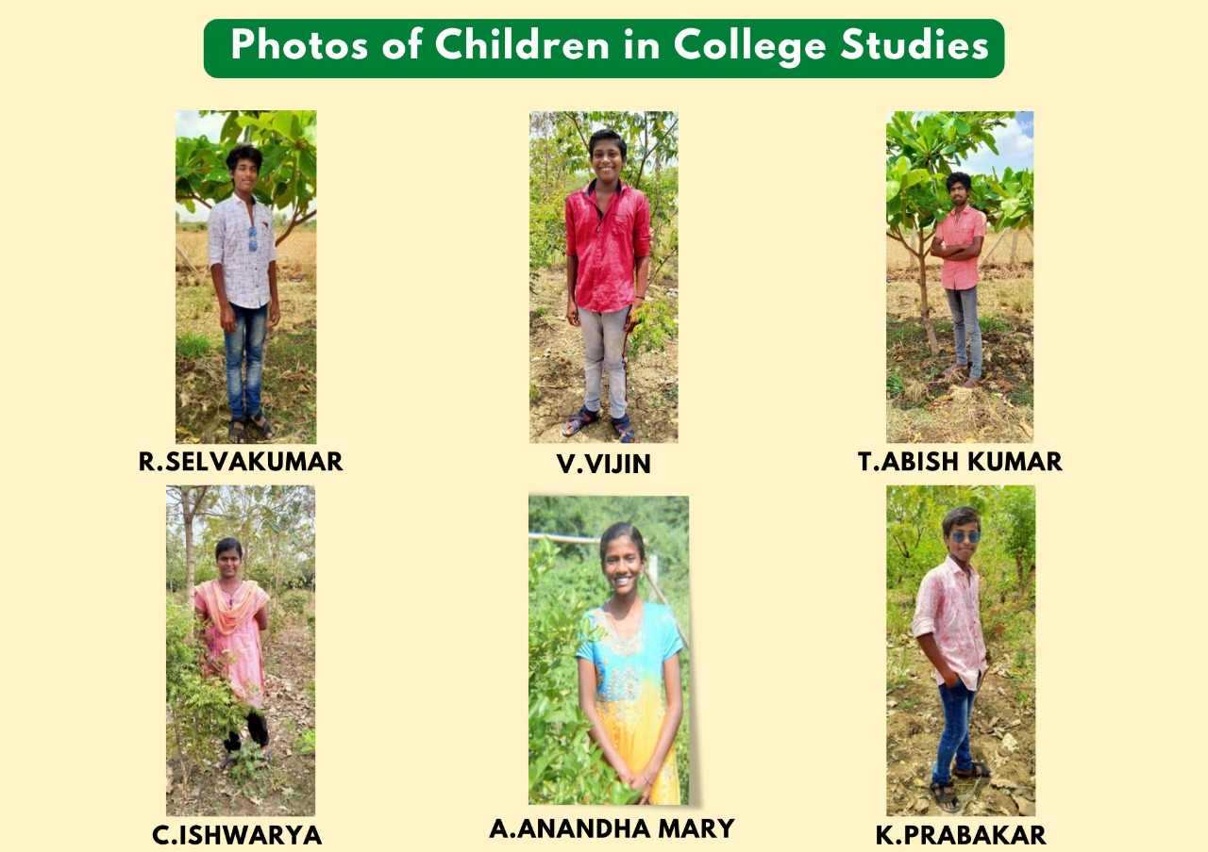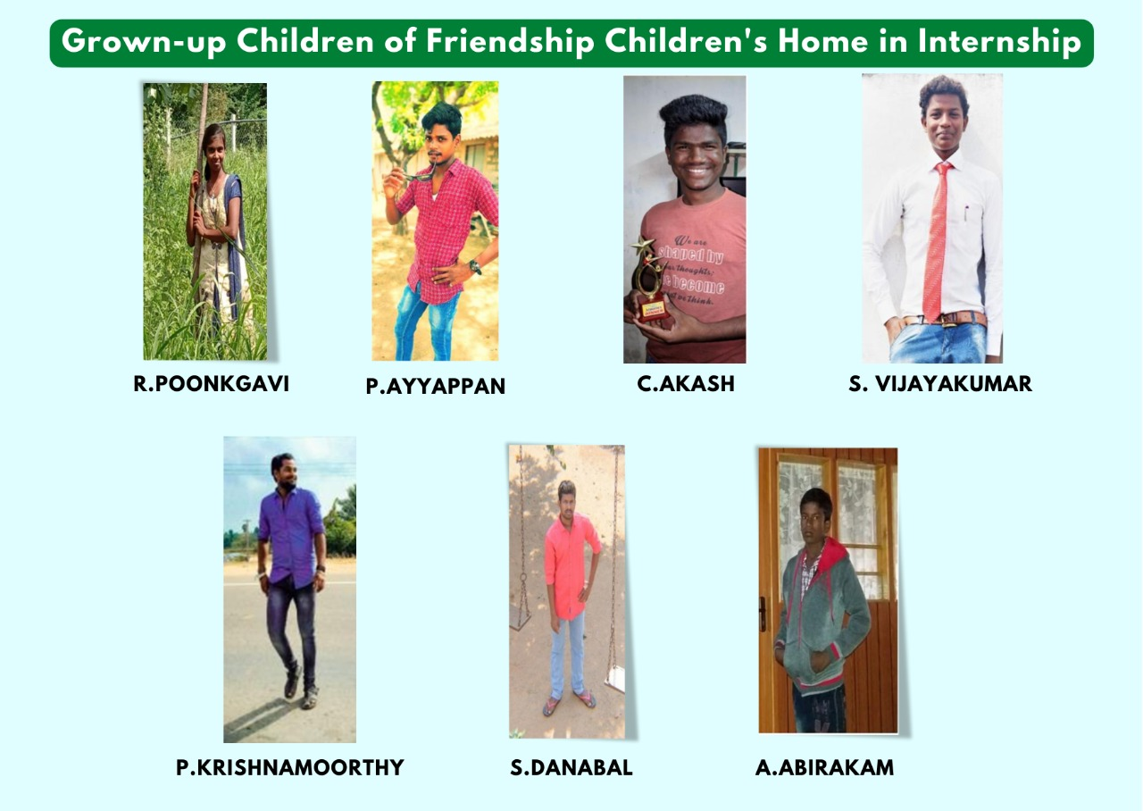

We are the future..!! Please support us

