n

October 2021

Govind Singh Rathore
Founder/Director
Sambhali Trust

Sambhali
Girls Boarding Home

Submitted by:
Sambhali Trust

1B K.N. College Road , Rai Ka Bagh,
Jodhpur, 342001 Rajasthan INDIA
phone: 0091(0)291 25 12 385
mobile: 0091(0)98 28 089 293
email: info@sambhali-trust.org
www.sambhali-trust.org

Table of Contents

Reasons for a Boarding Home 3
Our Mission, Vision and Values 4
The Laadli Boarding Home 5
May we introduce – Case stories 7

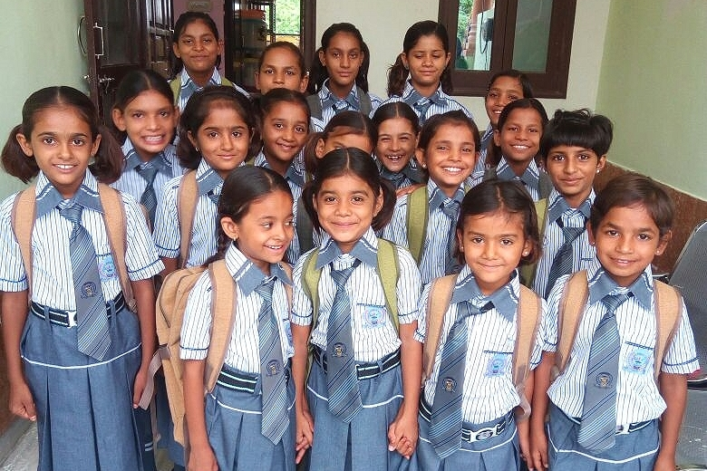

If you educate a man, you educate an individual.
But if you educate a woman, you educate a generation.

Bringham Young

Reasons for a Boarding Home

Mumal (11) used to graze cattle and did household chores day by day instead of going to school.
There are numerous reasons, why girls in rural areas of India are deprived of their right to education:

- Because they are girls
Their chances are even smaller if they come from a poor family, live in a rural area, or have a disability. Girls are four times more likely to dropout of school than boys from the same background. The poorest girls are also the least likely to complete primary school.
- Few female teachers and inadequate school system
Low percentage of female teachers (in Rajasthan only 32,56 %) can make school a daunting experience for girls. The presence of more women would provide a girl-friendly environment that would put young girls at ease. There are Government schools in villages but poor school infrastructure, poor access to toilets, sanitation facilities and teacher absenteeism work as barriers for girls.
- Excessive distance between school and home
The walk to school can be dangerous or intimidating, most parents are unwilling to allow their daughters to walk long distances to reach school or take sketchy routes that could be dangerous.
- Child/domestic labour
Girls often spend every day working to help feed themselves and their families. They stay home to take care of younger siblings and bear the major burden of housework. While educating a boy is considered a sound investment, it is sometimes considered to be a waste of time for girls. Children living in rural areas of Rajasthan bear responsibilities akin to an adult, they cannot live their adolescence.
- Lack of funding
Too many girls are being left behind because funding is targeted to boys' education. Funding is an important issue when looking at reasons why girls aren’t in school. Education for girls is often the among the lowest on the priority list.
- Early marriage
Too often marriage is considered a higher priority than education. The low value attached to girls’ schooling means few other opportunities are available to them. After their wedding girls leave the education system because they have fewer educational skills and more responsibility towards their in-laws. They and their families are more likely to live in poverty.

Many underprivileged girls have the potential to be exceptional students but aren’t given the opportunity or encouragement to explore their capabilities and discover their unique talents.
Their parents bring them to Sambhali for better, healthy and nourished living, a risk free, secure environ-ment and quality education, which their parents are not able to provide in their living circumstances.

Our Mission, Vision and Values

Sambhali Trust is an NGO focused on the development and empowerment of marginalized women and girls in Rajasthan. We work throughout Jodhpur and the surrounding Thar desert with women and children experiencing discrimination and violence daily due to economic, gender, and caste status.
We believe that education is an essential part of a child's future.

Our Vision

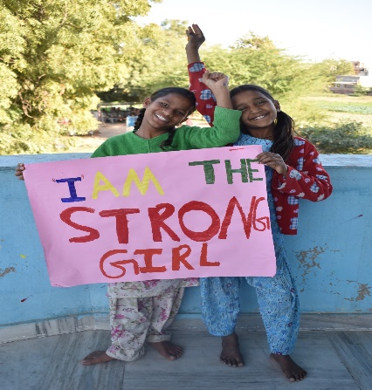
- Every child grows with love
Through love and acceptance, emotional wounds are healed, and confidence is built. Children learn to trust and believe in themselves and others. With this self-assurance each child can recognize and fulfil his or her potential.
- Every child grows with respect
Each child’s voice is heard and taken seriously. Children participate in making decisions that affect their lives and are guided to take a leading role in their own development. The child grows with respect and dignity as a cherished member of his or her family and society.
- Every child grows with security
Children are protected from abuse, neglect and exploitation and are kept safe during natural disaster and war. Children have shelter, food, health care and education. These are the basic requirements for the sound development of all children. We provide them environment where they can speak and share their view.

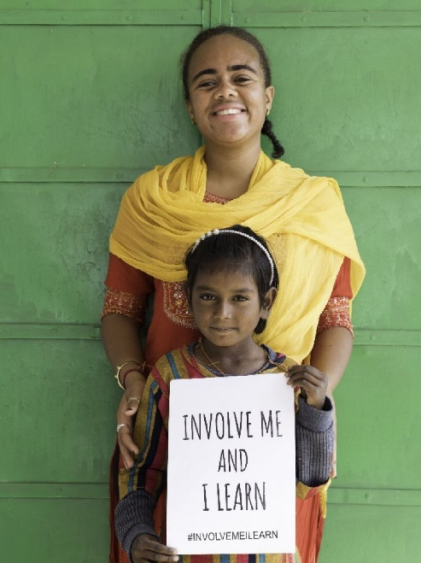
Our Values

- COURAGE: We take action
- COMMITMENT: We keep our promises
- TRUST: We believe in each other

These are the core beliefs and attitudes on which our organization has been built, and they are the cornerstones of our success.
These enduring values guide our actions, decisions, and relationships as we work towards fulfilling our mission.

Sambhali Boarding Home

Our Goals

We are providing 25deprieved girls mostly from the rural Thar desert of Rajasthan safe accommodation where they can feel comfortable and can concentrate on their studies.
They will receive a good academic education, have the ability to develop their personality to reach their full potential and broaden their outlook.

How to reach these goals

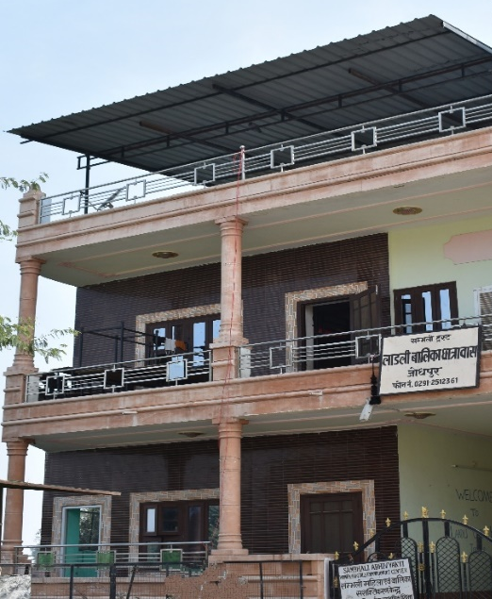
Safe accommodation

Girls are living in house owned by the Trust in Gurukripa 16, Vidya Nagar Jodhpur. There is ample space for bedrooms and bathrooms, a kitchen, dining room and space for learning and playing.
Balconies and rooftop are used for leisure and sports activities.
Girls are provided 3 meals a day and looked after by a housemother, so so the girls (and their parents) will know the girls are safe and secure and able to thrive in this environment.
They also help the cook in making meals regularly, hence have a sound knowledge of how to cook for themselves.

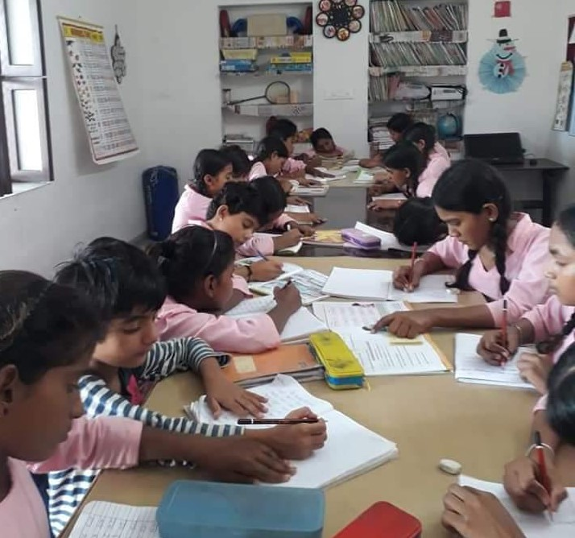
Good academic education

The girls are enrolled in Saint Francis Senior Secondary School, a very good private school.
Safe transportation to and from the school is taken care of by the Trust’s own van and driver.
They are provided daily help with homework to improve success in their academic studies.
Extra computer tuition and weekly sewing classes are given as well.
All girls are expected to successfully pass exams every year. After 5th class the girls will be shifted to Sheerni Boarding Home for Secondary Education.

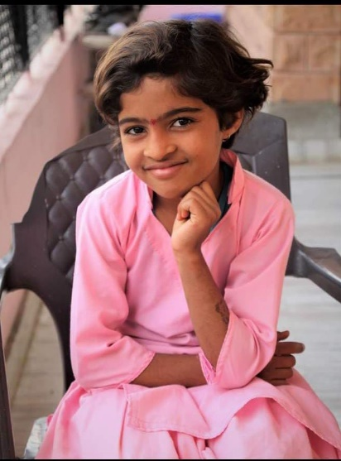
Develop their personality

Counselling, support and advice on a daily level will help to improve the girl’s self-confidence and ability to deal with their emotions, thoughts and concerns as they are growing up.
Extracurricular activities will help the girls to broaden their horizons, develop their interests, gain practical, critical thinking and social skills as well as responsibility.
They have Self Defense Class as well. The three most important factors when it comes to self-defence for women are: competence, confidence, and consciousness.

Daily Time-Table
Timings | Activities at Boarding Home
6:00 - 7:00 a.m. | Waking Up and Getting Ready
7:00 - 7:30 a.m. | Breakfast / prayer
7:45 - 1:15 a.m. | going to School/ College
1:45 - 2:30 p.m. | Having Lunch
2:30 - 5:00 p.m. | Tuitions
5:00 - 5:15 p.m. | Evening Snacks /games
5:15 - 6:30 p.m. | Computer Class
7:00 - 8:00 p.m. | Chanting and Evening Prayer
8:00 - 9:00 p.m. | Dinner
9:00 - 10:00 p.m. | Leisure Activities
10:00 | Going to Bed

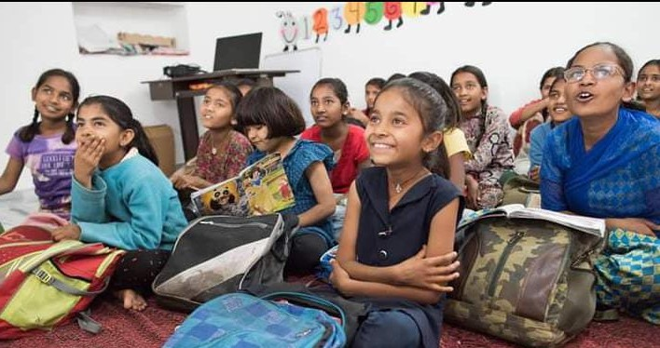

May we introduce – Case stories

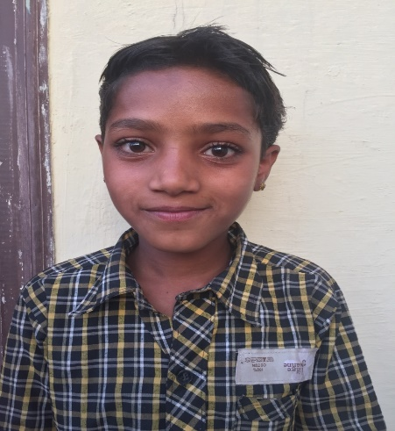
Mumal is 11-year-old girl. She has 5 elder sisters, and her father was chronically sick and for her mother it was very difficult to work and fulfil the needs of the family. So, her mother took decision to marry off her 4 girls early. Her mother wants her 6th girl to study and achieve something in her life so, she can support her mother. Before coming to the boarding home Mumal used to graze cattle’s and now she is very active in learning and an enthusiastic child. In 2018 her father passed away and her mother had to take decision to arrange marriage of her 5th sister as well. Sambhali Trust is supporting Mumal so that she will not be part of all this and can achieve her goal and can support her mother.
Krishna is 10-year-old girl, and she has a younger sister and a brother. Her father was usually sick and for her mother it was very difficult to work and fulfil the needs of the family. After some years her father died, and her mother came to Sambhali to ask for help. When they arrived at the boarding home their mother used to cook at boarding home. Later her younger brother was died of rabies. The girls were very sad of losing their two loved ones and their mother was also depressed. Later she decided to leave girls at the boarding home and now works at people's as maid. By now Krishna is in class 6th and working very hard to achieve her goals and to be a support system for her mother and younger sister. She wants to become a policewoman.
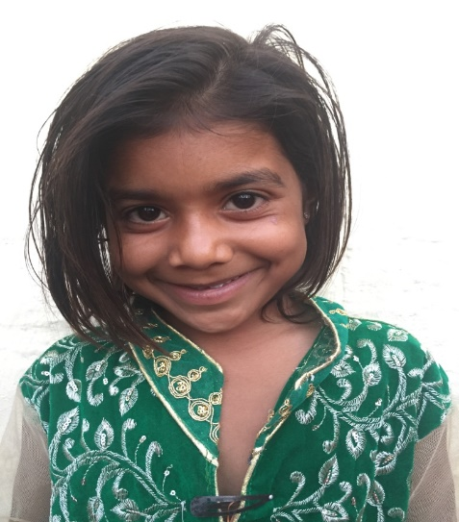
Karishma is 10 years old. She came in 2017 to the boarding home. She has two younger brothers. Her father doesn’t go on job and he used to drink alcohol a lot. Her mother is the only one who earns in the family. So her mother came to Sambhali and asked for help and she wants her daughter to be educated. Ration was given to the family by her neighbours. Also all the necessities like clothes and more were fulfilled by them. Karishma is a cheerful girl and great learner. Currently she is in 5th class.

