KIBERA MPIRA MTAANI

The translation of this name is Kibera Village Football. However, this project is about more than just football. Over the last 10 years, Kibera Mpira Mtaani has co-ordinated football tournaments and community work in the slums of Kibera.

Kibera Mpira Mtaani views football as a tool that can be used to reach out to the youth of Kibera and educate them on a variety of subjects including HIV/AIDS, the importance of education, reproductive health and alternatives to crime. Working alongside organisations including “Alive and Kicking” and “CARE Kenya”, Kibera Mpira Mtaani uses football tournaments as a forum to provide accurate and relevant information to the children of Kibera. For many of these children there are no parents to check up on them or their parents are too busy trying to make ends meet to worry about performance at school etc. Football coaches are able to step into this role and check up on children on a regular basis. There are also rules that every team must sign up to before taking part in a tournament. These encourage children not to smoke or drink alcohol, to attend school and to behave in a respectable manner.

Having used football as a means of building strong relationships with a large number of children in Kibera and a network of volunteers, in 2009 the organisation moved on to the next level with their work in the community. The committee has been structured into three “desks” – sports, education and environment – and their offices have been turned in to a resource centre and library for children in the local community.

Sports

Kibera Mpira Mtaani football tournaments have grown in popularity to the point where in 2009 their “John Packard Family Cup” tournament attracted 136 teams (around 2,500 youths) from Kibera and the surrounding areas. The tournament was categorised in 5 groups (U10s, U12s, U14s, U16s, Ladies).

To promote girls’ football, Kibera Mpira Mtaani introduced a ruling in 2008 that every U10 and U12 team must have a female player on the pitch at all times in their tournaments. After some initial reluctance among coaches, this ruling has now seen a large number of young girls joining football teams in Kibera and it is hoped that this will help grow ladies football in Kenya in the near future.
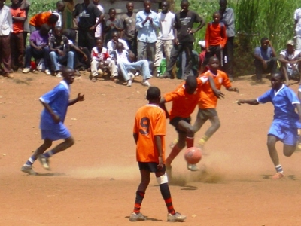
In addition to the high standard of prizes awarded, the growing popularity of Kibera Mpira Mtaani tournaments is mainly due to the reputation they have for being well organised. From the registration process to fixtures and officiating, a large number of volunteers are involved in ensuring that tournaments run smoothly. For the lower age categories, Kibera Mpira Mtaani is training older players in officiating matches so that the community is involved at every level. Older age categories and ladies are officiated by referees who have undergone FIFA-recognised training.

In 2008, a new tournament was introduced for the informal schools of Kibera. This tournament involved 20 teams and was a great success as there are no opportunities for pupils of informal schools to take part in sports activities. In 2009 the informal schools tournament involved 26 schools, each with a boys team and a girls team. This event was hailed a success by the staff and students of the schools and it is hoped that the 2010 tournament can involved a bigger number of teams as there are over 100 informal schools throughout the 13 villages in Kibera and these schools are not allowed to take part in the annual sports, drama and music festivals in which government schools compete.

Education

This is the newest area of Kibera Mpira Mtaani’s work but has proved to be as successful as their football programme despite have zero budget and being dependent on volunteers and donations of books, teaching materials and stationery.

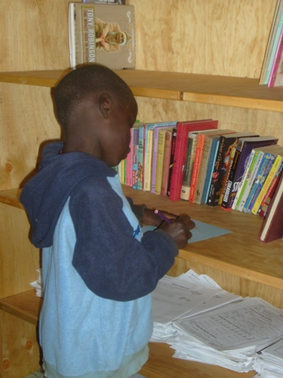
In February 2009, their resource centre and library opened its doors to the children of Kibera. Thecentre offers free after school tuition to children and ensures they have a safe place to do their homework and additional studies. Some of the local football coaches volunteer as teachers providing support and individual tuition which is not possible in schools where the teachers to student ratio can be 1:120. In 2009, KMM’s resource centre registered around 520 children who wished to use the facilities. As well as academic tuition, fun educational activities and games are used to enhance the children’s language skills and on a Saturday morning the centre opens its doors to children as young as four years old who come along to watch age-appropriate dvds or play games or take part in other activities.

By November 2009, there were twenty five candidates registered with Kibera Mtaani. These students used the study facilities and were tutored in all subjects to improve their chances of passing their KCPE exams. The effort of the students and tutors paid off with eighteen students passing and five of these scoring over three hundred marks.

Kibera Mpira Mtaani hopes to grow on the success of 2009 and see a larger percentage of their candidates achieving high grades in 2010.

Environment

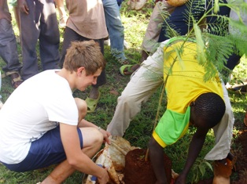
With the Kibera Mpira Mtaani committee and football coaches donating their time to assist the children of Kibera and other individuals and organisations funding tournaments and donating resources, it is felt that the children should also contribute to the program. In order to facilitate this, Kibera Mpira Mtaani organises clean-ups in the local community and involves children from the library and football tournaments in helping to open up trenches, cut grass and do general cleaning.

A youth team who recently visited Kibera for a 5 day tournament facilitated by Kibera Mpira Mtaani, donated a number of trees to the organisation. These were planted at various football pitches which were used during the tournament and teams have been given responsibility for ensuring that they are maintained.

The goal of KMM is to create rounded individuals who can help to shape a better future for the community of Kibera. The environment program is seen to be a key contributor to the development of the youths of Kibera.

Goals for 2010

2009 saw Kibera Mpira Mtaani grow from a football project to a community organisation demonstrating the important role that sports development can play in society.

In 2010, the committee hope to secure funding for their two annual club tournaments in April and August holiday periods. A tournament for informal schools is also scheduled for later in the year along with a music festival for informal schools which will take place in February.

In terms of the education program, the organisation would like to secure funding to enhance this activity and is exploring the possibility of starting its own nursery school for those younger children who are left roaming around while their parents work.

Rather than be one hundred percent reliant on charitable donations, Kibera Mpira Mtaani has started up an income generating activity to be run by the committee. By installing a satellite dish, the organisation is able to attract customers who will pay a small fee to watch football matches. This venture is in its early stages and some items are required to allow it to grow but it is hoped that once established it will give the organisation a certain degree of self sufficiency.

Contacts
For further information about Kibera Mpira Mtaani, please contact:

Kirsty McLullich
Telephone: +254 725052828
Email: kirsty@vision-africa.org

