Elephant calves under nursing and rehabilitation at CWRC: Interim update

Dated 5th May 2026

10 orphan Asian elephant calves are under various stages of rehabilitation at CWRC as on today. The age class of the calves are between 5.6 years to 03 months. Barring the youngest two individuals, Manikuntal and Gotonga, all other elephants spend 7 hours a day foraging inside Panbari RF guided by two keepers. They start forest walk at 8:30 am and return to CWRC campus at 4-4:30 pm (sometimes decide not to) to take the concentrate feed and green forage and spend the night inside the campus within a 3-hectare solar fenced enclosure (elephant enclosure). The two younger calves are taken for short walks inside the forest from 9 am till 12 pm, when they return to CWRC nursery for their milk formula and spend the entire day foraging within the elephant enclosure. At night, they are kept within the elephant nursery to avoid exposure to rain, thunderstorms and chill weathers during winter.

The following are the details of each of them,

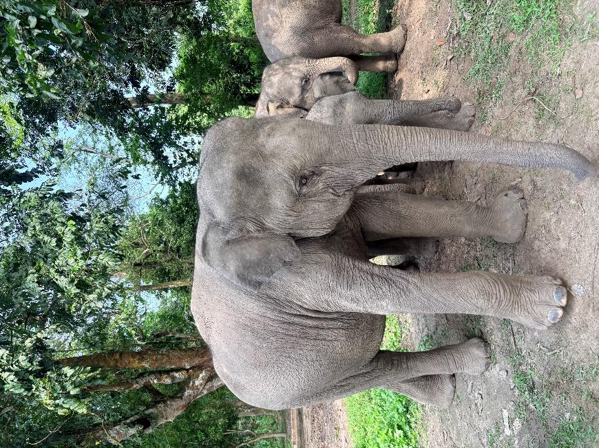
Kunti:

Admitted on 11th Nov 2020 from Lutumari RF area under Nagaon Territorial Division when she sustained injury due to a fall from a hillock, and later the herd left her. She was admitted with bruises all over her body without any fracture or dislocation. She was admitted with a body weight of 113 kgs and approximately 3-4 months of age. Currently, she weighs 1000 kgs, and she has assumed the role of the leader of the family, especially during foraging walks inside the forest. She responds first to any foreign smell, sight or sound and ensures everyone in the family is safe.
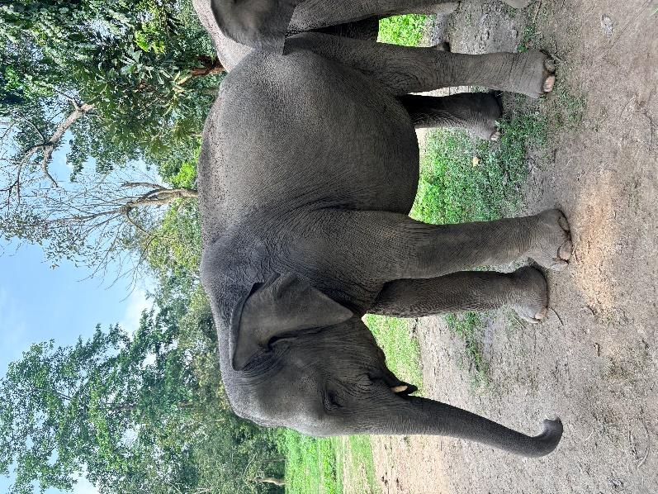
Taiwan:

The eldest male calf was admitted on 28th Oct 2020 from Assam Arunchal Border under Tinsukia District when it was found alone, and the exact cause of displacement could not be ascertained. Weighing 140 kgs on admission, Taiwan was estimated to be around 2-3 months of age on admission. He was nursed successfully and now weighs 857 kgs.

Xadiya:

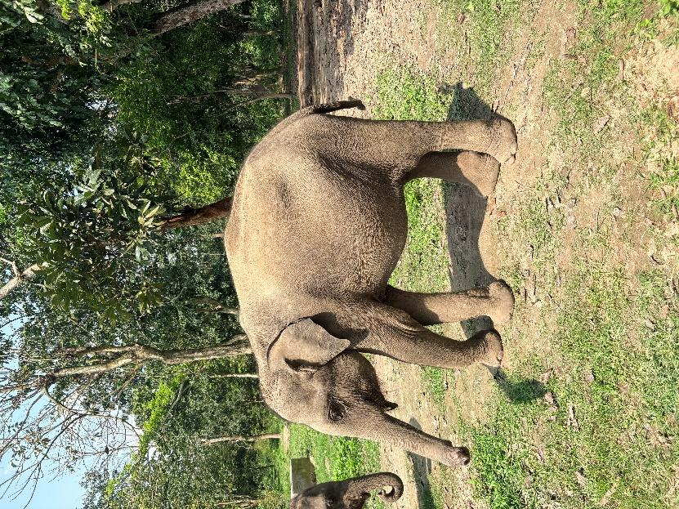

Xadiya (Female) was admitted on 30th Sept 2021 from Naharbari, Xadiya Range in Tinsukia District, when it was found alone and the exact cause of displacement could not be ascertained. She weighed 120 kgs on admission and was estimated to be 2-3 months. She now weighs 561 kgs.

Lanka:

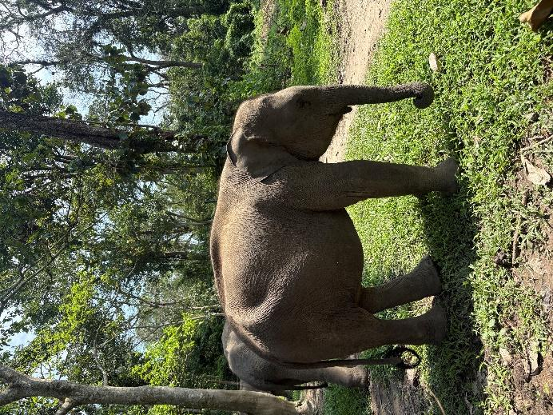

Lanka (female) was admitted on 29th Oct 2023 from Lanka range under Nagaon Territorial Division. She was found alone; the exact cause of displacement or separation from mother/family could not be ascertained. She weighed 110 kgs on admission and was approximately of 2-3 months old. She was nursed with a new milk formula, Nan Lo Lac, with very low lactose, which proved to be successful in raising her. She now weighs 411 kilos.
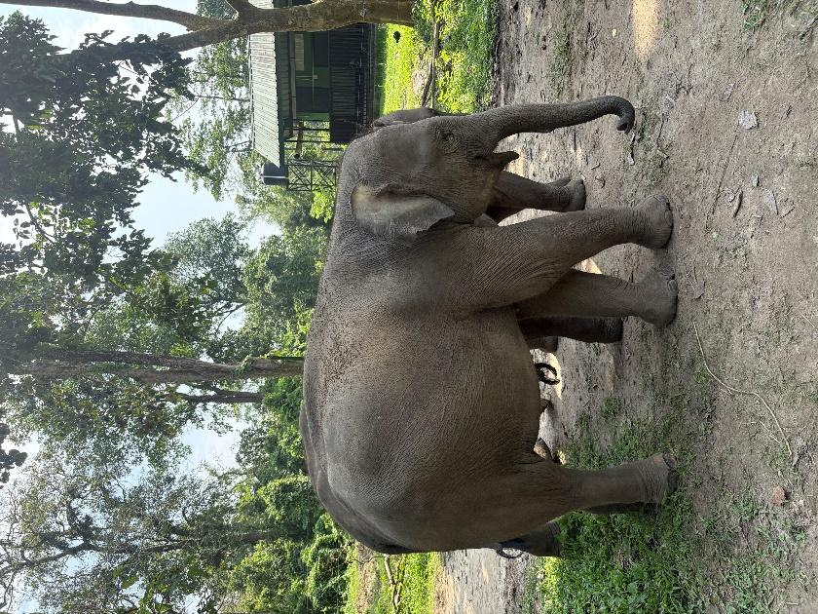
Hojai:

Hojai was admitted on 6th July 2024 when he was swept away by the strong current of the Kopili River near Hawaipur range under Hojai Forest Division. He weighed 312 kgs on admission and approximately 2 years or more. He is a dominant individual and bullies every young elephant, especially during forage walks and feeding concentrate.

Kheroni:

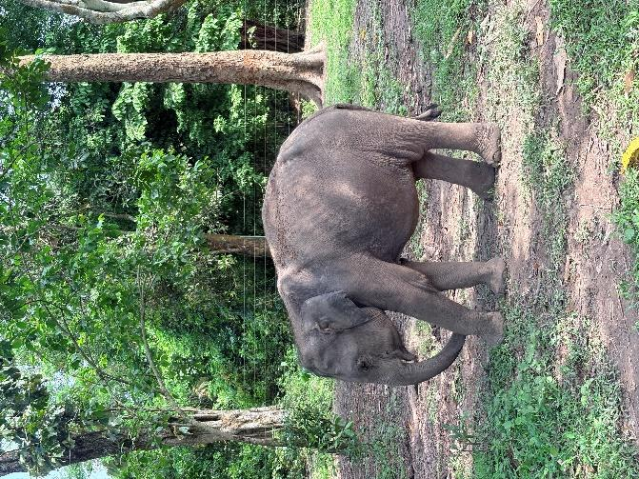

Kheroni was admitted on 1st February 2024 when she was found in a cachectic condition in a sugarcane field. She weighed 311 kgs and was approximately 2-3 years old. The community around the area reported that the elephant had been moving alone for the past six months and thriving only on forage within and around the sugarcane field. As the condition deteriorated and the animal was almost collapsing, Kheroni was admitted at CWRC. With a lot of dedicated effort, the animal survived and is now growing well. She is still keeping an average health, but marked improvement has been seen. Now she weighs 452 kgs.

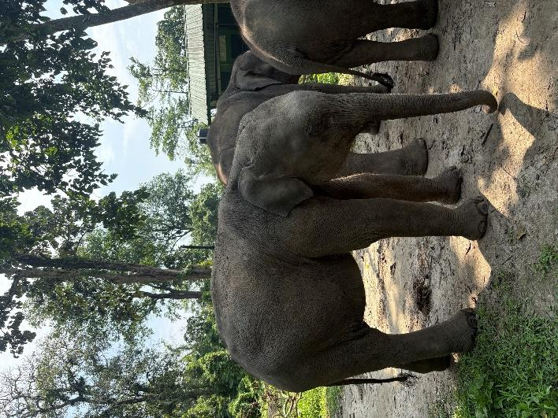
Deopani:
Deopani was admitted on 4th July 2024 after he was swept in flood and landed near Gobinda Rangphar village in Karbi foorhils near Bagser Reserve Forest under Kaziranga T R. The animal was captured chemically and admitted on the same day. He weighed 256.5 kgs on admission and was estimated to be about 2 years or more when admitted. He is now 466 kgs as of today. He is a bit shy and is constantly being bullied by Hojai.

Majuli:

Majuli was admitted on 1st November 2024 from the Majuli islands. He was found alone, hence no cause of displacement could be attributed. He was 111kg on admission, estimated to be about 2-3 months of age. He was actively alert when admitted with a great appetite. He interacted with the older elephants much earlier than other calves, and hence, he started his forest walks much earlier than elephant calves of similar age groups. He weighs 298 kgs as of today and is growing really well.

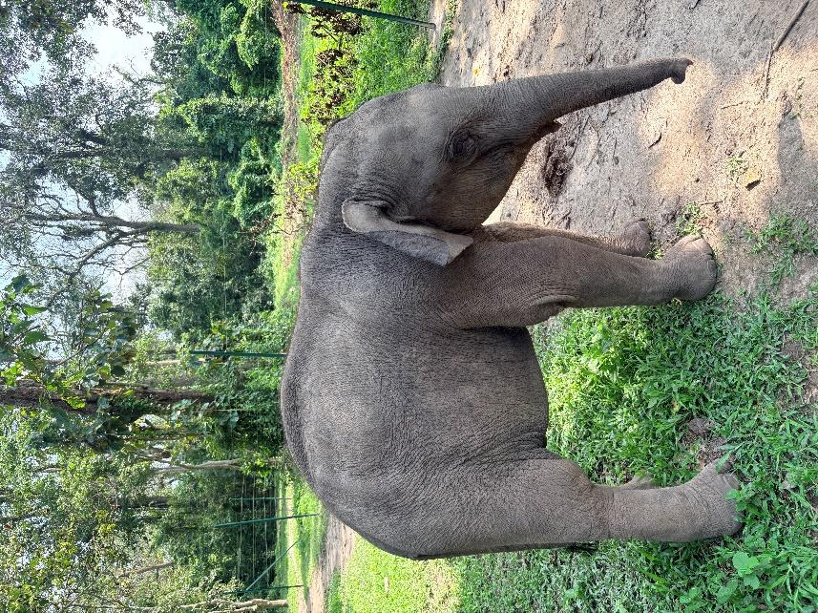

Manikuntal:

Manikuntal was admitted on 26th March 2025 from Bogapani Tea Estate when he fell into a trench, and the family could not retrieve him and left him alone. He was rescued on 16th March and kept in a makeshift facility for the next 9 days at MVS Eastern Assam unit in Guijan, Tinsukia. He weighed 97 kgs at admission and was estimated to be between 2 and 3 months of age. He received utmost care from all the keepers and has been growing well. He started moving with the older calves after two months of admission and started foraging on wild plants. He now weighs 218 kgs, in prime health.

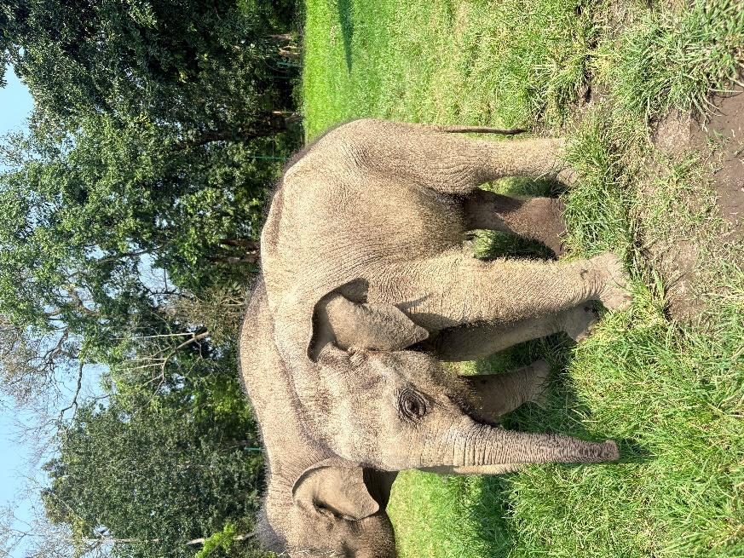
Fig: Manikuntal

Gotonga:

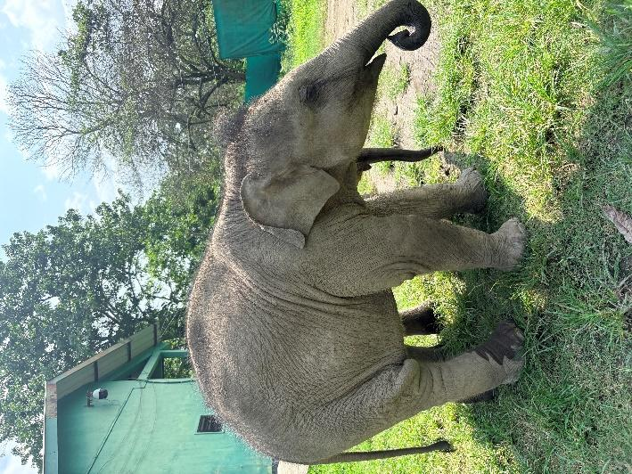
He is the youngest among all, admitted on 11th March 2026 and weighed 119 kgs. He is approximately 2-3 months of age during admission. He was severely dehydrated with an average appetite. For the past two months, he has been gaining weight and drinking 16 litres of prepared milk formula in 24 hours. He has started eating greens and being taken for short walks inside the forest along with Manikuntal. He now weighs 146 kgs as of today. Very active, alert, and possesses a loud voice, he makes his presence felt to everyone around.
Fig: Gotonga

