THE BRIDGE FUND’S COMMITMENT TO TIBETAN WOMEN AND GIRLS

In 2021, The Bridge Fund provided financial and other resources to 33 programs implemented by Tibetans in Tibet. Of these programs, 10 programs, funded in the amount of $255,400, addressed specific concerns of Tibetan women and girls.

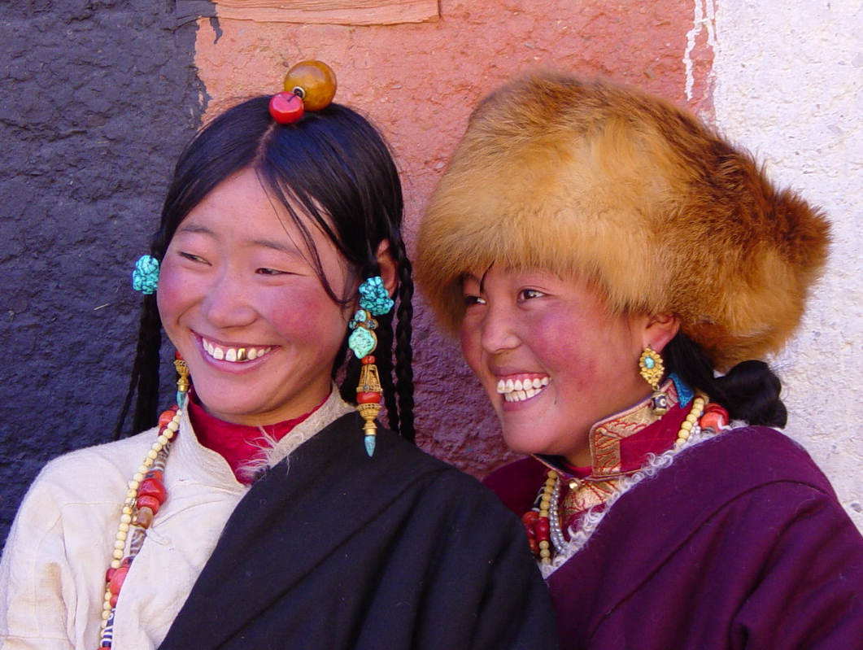

Whether through the dissemination of learning, implementation of programs, or talent placement, the Bridge Fund is firmly committed to adopting strategies that can help overcome gender obstacles holding back Tibetan women and girls in Tibet. Working with Tibetan partners, we direct funding and other resources to programs across the Tibetan Plateau that contribute to better education, health and business outcomes -- and to greater equity for Tibetan women and girls within Tibetan society and in China.

Bridge Fund has long prioritized Tibetan female leadership in the workplace and the integration of Tibetan women and girls in our programs both to deepen and broaden local impact and to reinforce their value in social circumstances that can be challenged by traditional or other biases. Programs designed specifically for women and girls have been so successful that we often find Tibetan men and boys asking to be included!

We celebrate these achievements and their potential to correct gender-based inequities where they exist in Tibetan communities, and we recognize there is much more that is needed. We’ve recently received the following message from a Tibetan program partner: “Our programs help Tibetan girls nourish their wings to fly as high as they can and pursue their dreams in life! Many are becoming teachers, cooks, nurses and business owners. And, after some time, I see them returning back to their own communities and making huge contributions to the lives of others so that changing a girl’s life is truly changing the fate of a community!”

