Project Title: Assist Conflict-Affected Children to Return to school.
Project Area: Kumba.
Since late 2017, the Anglophone Crisis in the North West and South West regions of Cameroon has led to the death of over 3910 individuals and displaced 579,000 (UN OCHA). As a fallout of the Anglophone Crisis in the North West and South West regions, the UN OCHA August 2021 report points out that over 700 000 children of school-going age have been negatively affected. When the crisis started, it halted the education of teenage girls and boys. They lost a structured environment in a critical time and with every year passing, it was more difficult for girls of that age to resume and complete their education, especially in rural areas where there was already a higher culture for parents not to send their girl children to school. The result has been an increase in the rate of school dropout, especially amongst girls, teenage and unwanted pregnancies amongst school children. With parents being internally displaced and losing their source of income, many of them have not been able to afford the education of their children. This project provided books, pens, school bags, and other educational materials as well as tuition fees to 9 Internally Displaced children and orphans affected by the Anglophone crisis in the South West regions of Cameroon. Three families were supported thanks to the help of Reach Out social workers in Kumba who did purchases of school kits and did the payment of school fees for these children. The families are:
The Unisa’s,
The salimatou’s
The Habiba’s.
At the time of identification, these children despite being of school-going age, had dropped out as a result of the crisis.
Table showing the number of children supported

S/n | Name of child | Amount paid as tuition fee | Class | Content of the school kit received
1 | Ashiatou U. | 75$ | Lower sixth art, | School fees, exercise books, pens, and a bag
2 | Ibrahim U. | 90$ | 6 | School and examination fees exercise books, pens, and a bag
3 | Hawa U. | 64$ | 1 | School fees, exercise books, pens and a bag
4 | Rahima G. | 64$ | Form 3 | School fees, exercise books, pens and a bag
5 | Bobo I. | 64$ | Form 4 | School and examination fees, exercise books, pens, and a bag
6 | Maryam U. | 64$ | 5 | School and examination fees exercise books, pens and a bag
7 | Habiba S. | 64$ | 3 | School fees, exercise books, pens and a bag
8 | Bakisu D. | 64$ | Form 5 | School fees exercise books, pens and a bag and public examination fees paid
9 | Hadiza A. | 64$ | 2 | School fees, exercise books, pens and a bag

Feedback from Beneficiary Family
The families taking care of these children were so happy that we came and supported these children at this time in need. Sending the children to school and providing them with school kits was a heavy cost that has been taken off their shoulders
Recommendations
The families taking care of these children should also be given a sort of capital for a startup in any income-generating activities for their sustainability. Reach Out is looking into the future to graduate the parents and guardians of these children so that for the next academic year and beyond they won’t have to rely on donations.
We thank you immensely for your support and continuous selfless donations.

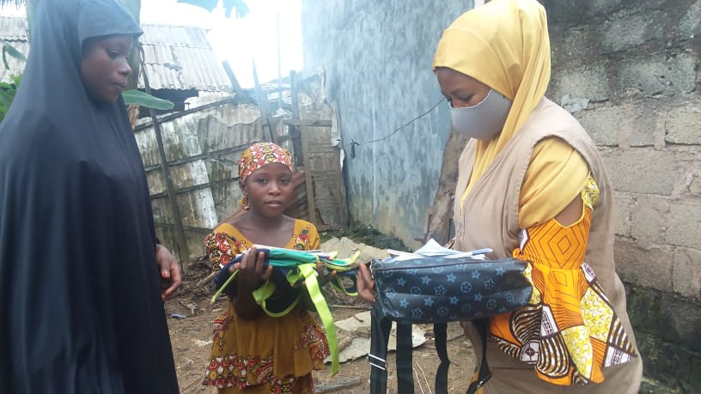
Habiba and sister

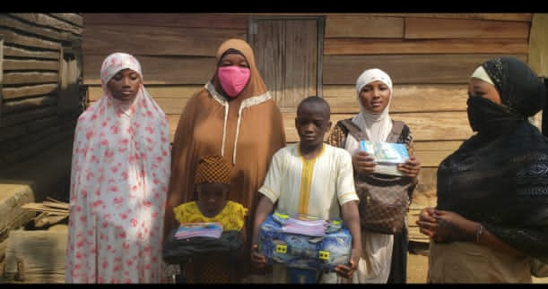
salmimatou and family and Reachout caseworker

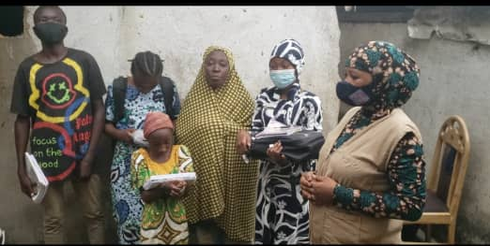
s

Habiba and her grandchildren

