Project Report | Basic Needs Assistance

Organization Name | Alawite Islamic Charity association
Contact person  Name, email, and phone | Hassan Salloum –  Email : howck@aica-lb.org
Reporting period  From – To | From 1 of January 2022 - To 31 March 2022 .

Activities implementation

Brief description of updates and activities during the reporting period as per the implementation plan
Activity 1: Providing hot meals for 150 individuals distributed over 23 HH. The beneficiaries received their meals as per the “Smart Card Program” launched by AICA early July. The family can select from a variety of meals (Meat, Chicken, Fish and Vegetarian) to cater to all tastes. The meal/individual weighs 550 Grams and it is served for 3000 LBP (0.1 USD) in order to emphasize on beneficiaries’ resilience and dignity. AICA distributed 3900 meals per month.
Below is an aggregation for the distributed meals/month:
January | February | March
3900 | 3900 | 3900

Activity 2: Conducting food and water samples tests where samples were regularly sent to Chamber of Commerce and Industry labs in Tripoli, in order to ensure the food safety. Below are the latest results issued by CCIAT labs:

Activity 3: Carrying on with the door to door visits, and assessing additional families in order to include them in the program upon funds availability. Around 800 HH are pending on AICA’s waiting list, in addition to 100 families who were assessed late September, out of whom 45 HH were deemed eligible. AICA is trying to leverage own funds to increase the number of “Smart Card Program” beneficiaries despite the hardships and limited resources.
Activity 4: Improving the quality and taste of provided food through constant monitoring & evaluation. The kitchen staff recorded the beneficiaries’ daily feedback and conducted the needed adjustments when existed. AICA also extended the monitoring activity and collected feedback from staff and regular customers who are purchasing meals from the kitchen, all to guarantee the best outcome in terms of quality and taste.

Challenges
Overview of any challenges encountered during the reporting period and how they were tackled
Challenge(s) | Response(s)
The constant change in raw material prices with the fluctuation and exchange rate. | Framework agreement with suppliers pricing items in USD.
The inability to deliver meals to the card holders houses. | Seeking funding opportunities to procure motorcycles
The inability to procure material for a month due to the limited space of storage room and the need of larger fridges. | Deliver items on a daily basis except for products with long shelf life.
High cost for packaging (Boxes and plastic bags) | Initiated the design of eco-friendly and reusable canvas bags as well as procurement of reusable Tupperware dedicated to each HH

Monitoring
The number achieved during the reporting period is the sum all targeted participants that have been reached.
The progress towards target is a percentage calculated as follow:
Progress = (Number achieved during the reporting period) ÷ (Overall target) × 100
Targeted participants | Number achieved during the reporting period | Overall target | Progress towards target
150 beneficiaries receiving meals 6 days per week for 3 months | 11700 meals | 11700 meals | 100%
Total project target | 11700 meals | 11700 meals | 100%

Coordination and communication
Please list any coordination meetings or communication with national COVID-19 response actors (Government of Lebanon, municipalities, local community, NGOs, INGOs

Date [dd/mm/yyyy] | Response actor | Type of coordination [meeting, email, phone call]

Way forward
Brief description of preparation for upcoming activities and any deviation from the implementation plan
- Activity 1: Carrying on with the vulnerability assessment to register families with limited income and assigning a dedicated hotline in order for cases to be enlisted on waiting list.
- Activity 2: Designing canvas bags in order to reduce plastic waste, preserve the environment and save production costs.
- Activity 3: Procuring Tupperware and dedicate it for each HH to substitute plastic containers, preserve the environment and save production costs.
- Activity 4: Supporting youth initiatives to encourage Eco-delivery means through the use of bicycles.
- Activity 5: Preparing healthy meals for school students, especially children, through coordination with schools and educational institutes
- Activity 7: Build the kitchen staff capacity to diversify the menu & include western items
- Activity 8: Working on ISO certification to increase the kitchen standards and sales
- Activity 9: Expanding the kitchen services to include catering services
- Activity 10: Diversify the kitchen income streams through different modalities in order to expand the Smart Card program services and include beneficiaries from all around Tripoli.

Budget
Narrative update on budget spent
Please insert the original Budget table, adding one column: “expenses to date” for comparison. Please see an example below:
All costs in US$ | FTE or # of units | Unit Cost | Unit of Measure | % | Frequency | Total Amount |  | Expenses to Date
1. Personnel
PM | 1 | 1800 | Person | 100 | 3 | 5400 | 5400
Cook Cheif | 1 | 1200 | Person | 100 | 3 | 3600 | 3600
Assisstaant Cheif | 2 | 1000 | Person | 100 | 3 | 6000 | 6000
Cleaners | 3 | 800 | Person | 100 | 3 | 7200 | 7200
Reception | 1 | 800 | Person | 100 | 3 | 2400 | 2400
TOTAL Personnel |  |  |  |  |  | 24600 |  | 24600
2. Fringe Benefits
TOTAL Fringe Benefits
3. Travel and Transportation
TOTAL Travel and Transportation
4.Equipment
TOTAL Equipment
5. Supplies
Raw Material | 150 | 1 | Meal | 100% | 156 | 23400 |  | 23400
Packing Box | 150 | 0.2 | Box | 100% | 156 | 4680 |  | 4680
Subsidized amount | 150 | 0.18 | person | 100% | 156 | 4212 |  | 4212
Marketing (Social Media Sponsorship) | 1 | 75 | Month | 100% | 3 | 225 |  | 75
TOTAL Supplies |  |  |  |  |  | 32517 |  | 32517
7. Contractual
TOTAL Contractual
8. Other Direct Costs
Sub Total Programming Expenses
Electricity | 1 | 680 | month | 100% | 3 | 2040 |  | 2040
Gas | 1 | 30 | month | 100% | 3 | 90 |  | 90
Detergents | 1 | 15 | month | 100% | 3 | 45 |  | 45
Sub Total Operational Expenses |  |  |  |  |  | 2175 |  | 2175
TOTAL DIRECT COSTS
TOTAL |  |  |  |  |  | 59,292 |  | 59,292

Annexes

Annex I: Pictures
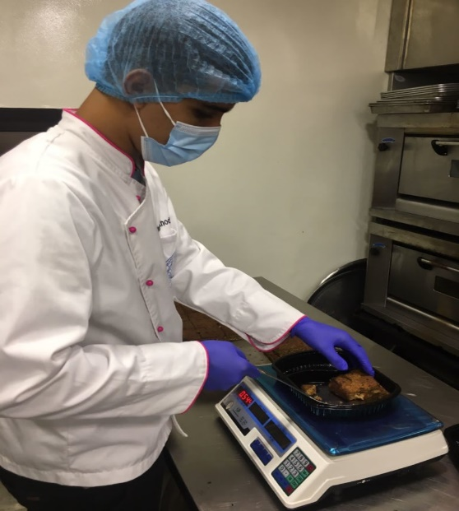
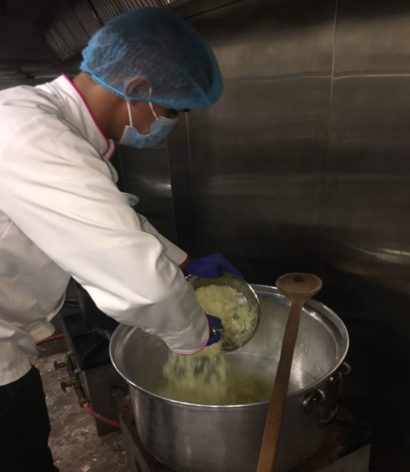
The chef preparing meals according to orders and set Menu | Kitchen staff checking the weight of the meal to ensure it meets the 550 Grams benchmark

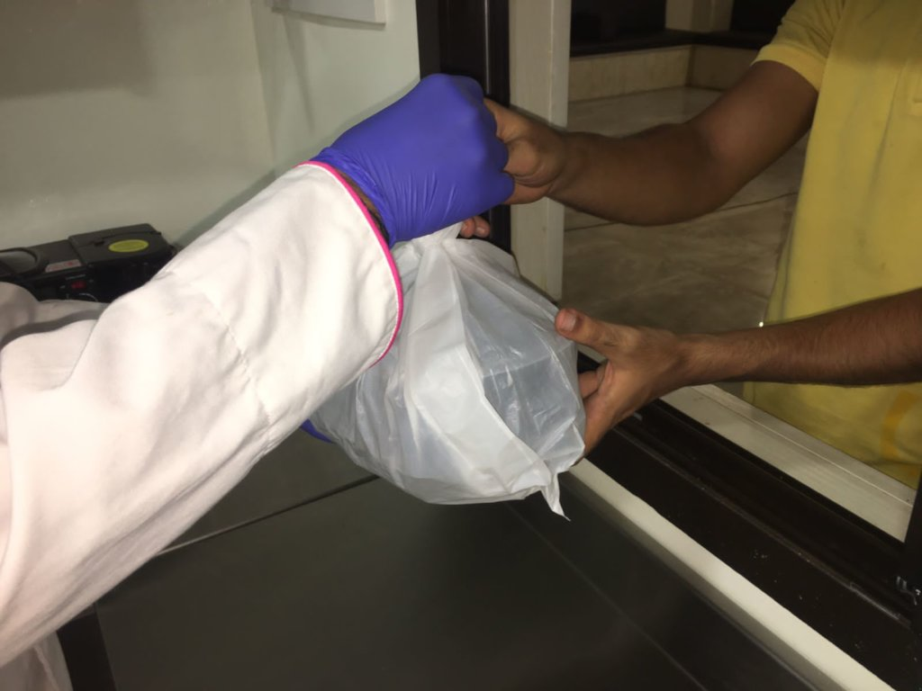
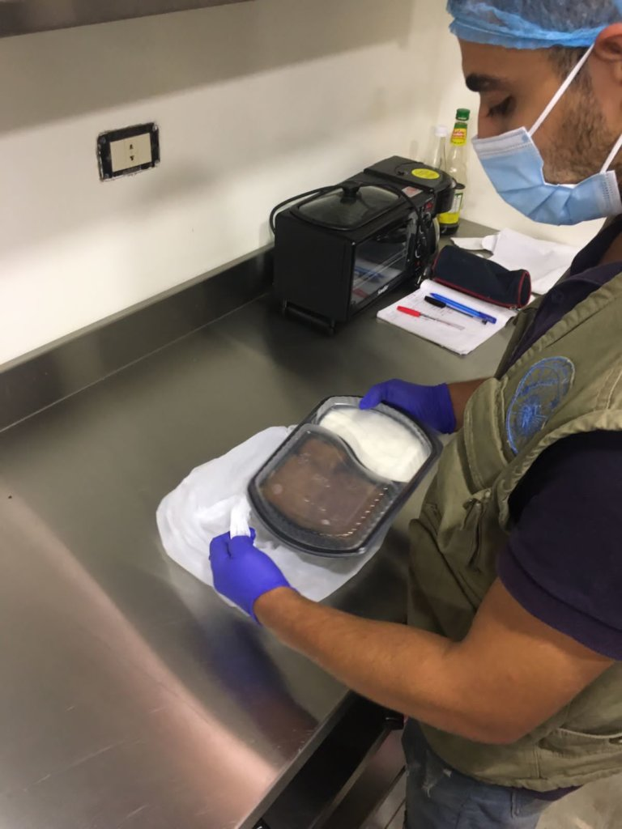
Wrapping meals, served in heat-preserving boxes, in plastic bags to prepare for distribution | Beneficiary receiving his HH meals in person within HOWCK facility

