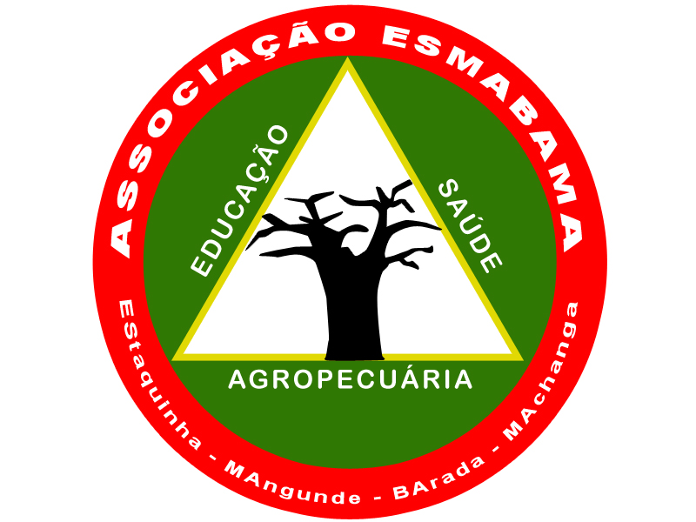
Boarding schools Emergency Needs (54150)
Report (4th quarter of 2021)

Summary
2021, and mainly the last quarter, was especially marked by the COVID context and the decisions taken by the PR on preventive measures. The classes reopened the 22 of March had to respect defined rules as intercalated classes (A class with 40 or more students should be divided into two groups, with the first group having classes on Monday, Wednesday and Friday in the morning and the second group classes on Tuesday, Thursday, Friday (afternoon) and/or Saturday in the mornings). In June/July, many cases have been met on urban areas such as Beira City, Dondo City and Nhamatanda and all the school in the urban areas were closed until September. At the 28/12/21, the situation in Mozambique was the following : 20.642 active cases, 1.976 died, 175.648 case from the beginning of the pandemic and 4,9 millions of people completely vaccinated. In December the PR decided to close restaurants and bar from 9PM, to close the beach from 4PM to 5AM prohibiting the alcohol consumption during the day, allowing the organization of public events up to 30 persons inside and 50 persons outside and private event up to 20 persons inside and 30 outside.
With the support of a partner, ESMABAMA provided basic food (Maize, beans, sugar, oil) and hygiene materials to the students of the boarding schools of Estaquinha, Barada (Buzi District) Mangunde (Chibabava District), Machanga (Machanga District). (Please see pictures below)

Challenges

Guarantee the functioning of 4 general schools with 6.400 students, 3 agricultural Institutes with 262 students and in total of 1.600 boarding students is a big challenge. Currently we are mainly fighting to ensure to the boarding students, food and hygiene material knowing that each student only pay / month 2€, just representing 10% of the monthly basic needs.
During the COVID pandemic, it’s still worth cause we have to maintain the preventive measures, opening new rooms and bedrooms to avoid a too close situation and new contaminations in the schools and boarding schools.
During the last quarter approaching the end of the year, the prices of all the products increase, particularly food due to the next Christmas and new year holidays. The product can increase of 15 to 50% and this situation can happen till the end of January of 22.
Results
During the last quarter of 2021, ESMABAMA ensured the basic food for each student: corn – 0,5Kg/day, bean – 0,065Kg/day, sugar – 0,05Kg/day, salt – 0,01Kg/day, oil – 0,05Kg/day.
In total, ESMABAMA during the last quarter distributed to the 4 boarding schools: 56T of corn, 7,3T of bean, 5,6T of sugar and 5,6T of oil. The food beneficed to 1.600 students of the boarding schools (Female-45%) in October and November, and in December to only 768 students cause the number reduced due to the exams sessions in the general schools (grades 7th, 10th, 12th) and in the agricultural Institute.
ESMABAMA provided also basic hygiene material for the individual and collective hygiene of the boarding students (liquid soap, domestic soap, disinfectant products,...). The schools closed the day 21 of December.

Next step
ESMABAMA has to organize the start of the new academic year (the start of February) for more than 1.600 boarding students. For that, it will be necessary to provide all to the didactic material for teachers, renew few equipment of the boarding schools (bed, mattress, mosquito net,…) and provide food and hygiene material from February.

Pictures

Purchasing and Transporting Food(23/11/21)
