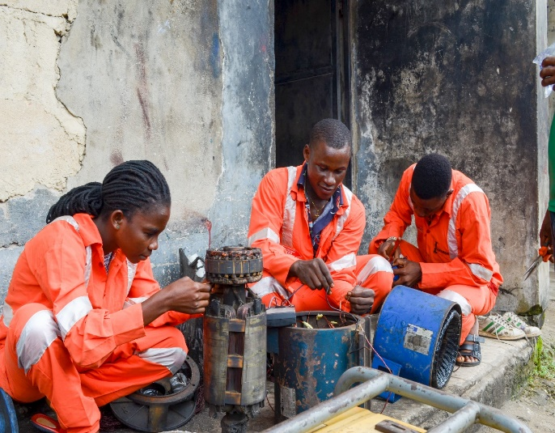
A beneficiary working at her training centre during the skills training period.

