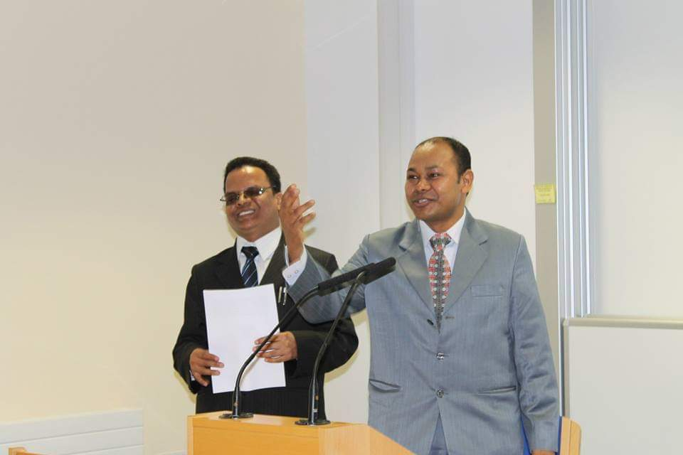

Dev Datta Joshi – Equip for Equality Nepal’s Executive Director, presenting paper on “Where Do We Go from Here? Anywhere We Want Equality for Women with Disabilities.”

