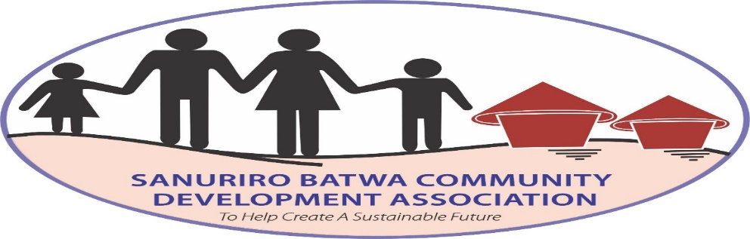
Activities performed effective June 2023 to September 2023 by Sanuriro Batwa Community.
Prepared by: Alex Byomugabe and Winton Kiiza, Project leaders
Submitted to: GlobalGiving
About the project: The Sanuriro Batwa Community aims at empowering, training, educating the voiceless and forgotten forest people in Agriculture, education, community development for better livelihoods. The project mainly focuses in supporting the Batwa who were displaced from Bwindi Impenetrable National park in the name of conservation.
General Objectives of the project
- To transform the lives of Batwa people through training and building different skills for self-reliance
- To train, educate , and sensitize the Batwa about the conservation of Bwindi forest ecosystem
- To train the Batwa/pygmies, women, children in agriculture for food security for a sustainable living
- To train the Batwa in income generating activities for community development
- To empower and promote education among the Batwa so as to eradicate illiteracy

OBJECTIVES | ACTIVITIES | ACTIVITY DONE | OUTCOME | COMMENT
1. To transform the lives of the Batwa through training different skills for self-reliance  2.To train, educate ,and sensitize the Batwa about the conservation of Bwindi forest ecosystem  3.To train the Batwa in Agriculture for food security for a sustainable living  4.To train the Batwa in income generating activities for community development  5.To empower and promote education among the Batwa | (a) To train 70 Batwa in artisanal skills  (a)To educate and train about conservation  (b) To plant 10 indigenous trees  (a To Prepare nursing beds  (b) To transplant seedlings into the main garden  (a)To train and educate agro-tourism activities  (a)To sensitize and train 40 Batwa about the importance of education  Other activities  (a)Attended a Biodiversity workshop  (b)Attended a meeting with Uganda Wildlife Authority on the Batwa welfare | Trained 60 Batwa who appreciated and developed different skills  37 Batwa were able to appreciate the conservation concept  Trained Batwa how to plant trees to conserve the environment  Trained 30 Batwa how to prepare nursery beds and how to apply manure and seeds  Trained 30 Batwa how to transplant seedlings into the main garden  Trained 20 Batwa how to grow coffee, goat rearing, piggery, poultry etc.  Trained and sensitised the Batwa about the merits of education to live with a purpose  Learnt how to manage, control, and implement project activities | Transformed their lives and expect them to make sales and earn a living for their families  The Batwa involved will in turn appreciate the importance of conservation  The Batwa appreciated that planting trees is one way of conserving the forests  Appreciated how to prepare the nursery beds  The Batwa learnt and appreciated how to transplant seedlings into the main garden  Appreciated how to grow multiple agro-tourism activities  Learnt that once they are availed with education facilities, they will be able to read and write  Appreciated different skills in management | Batwa are expected to be improved incomes  The activity was achieved and more will also learn and appreciate the aspects of biodiversity and ecosystem  Activity was accomplished successfully  The activity was achieved  Acquired skills in farming and will produce food for homes  Objective was done  Expected to live a purposeful life and be job creators than seekers  Activity was accomplished

