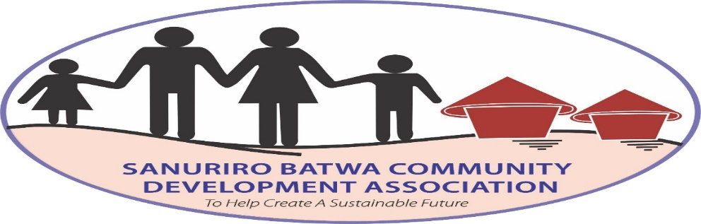
Activities performed effective February 2024 to June 2024 by Sanuriro Batwa Community.
Prepared by: Mr. Byomugabe Alex- Project leader
Submitted to: Global Giving
About the project: The Sanuriro Batwa Community aims at empowering, training, educating the voiceless and forgotten forest dweller in Agriculture, health, education, community development for better livelihoods. The project mainly focuses in supporting the batwa who were displaced from Bwindi Impenetrable National park so as to conserve the Bwindi forest ecosystem. Further still, the other focus is to alleviate poverty
General Objectives of the project
- To transform the lives of Batwa people through training and building different skills for self-reliance
- To train, educate , and sensitize the Batwa about the conservation of Bwindi forest ecosystem
- To train the Batwa/pygmies, women, children in agriculture for food security for a sustainable living
- To train the Batwa in income generating activities for community development
- To empower and promote education among the batwa so as to eradicate illiteracy
- To fight poverty among the batwa
- To train Batwa about sanitation and hygiene so as to have healthier lives

OBJECTIVES | ACTIVITIES | ACTIVITY DONE | OUTCOME | COMMENT
To transform the lives of the Batwa through training different skills for self-reliance  To train, educate ,and sensitize the Batwa about the conservation of Bwindi forest ecosystem  To train the Batwa in Agriculture for food security for a sustainable living  To train the Batwa in income generating activities for community development  To empower and promote education among the Batwa  To fight poverty among the Batwa  To train and sensitize the Batwa about sanitation and hygiene | (a) To train 40 Batwa how to make stoves, pots and artisanal skills  (b)To train and educate Batwa women in different skills  (c)To train Batwa how to bake cakes, bread, doughnuts, cookies etc.  - To educate and train about conservation  (b) To plant indigenous trees  (a To Prepare nursing beds  (b) To transplant seedlings into the main garden  (c)To harvest agricultural produce  (a)To train and educate agro-tourism activities  (a)To sensitize and train 15 Batwa about the importance of education  (b) To learn how to co-exist with the community  (a) To educate the Batwa about poverty and to secure them  (a)To train about health  Other activities  (a)Attended a Zoom meeting with Globalgiving  (b)Attended a meeting with partner projects | -Trained 50 Batwa and they appreciated and developed different skills  -Batwa women appreciated how to weave baskets and shopping bags  -10 Batwa were fully trained  -20 Batwa were able to appreciate the conservation concept  -Trained Batwa how to plant trees to conserve the environment  -Trained 15 Batwa how to prepare nursery beds and how to apply manure and seeds  --Trained 30 Batwa how to transplant seedlins to the main garden  -Harvested cabbages, tomatoes, egg plants, onions  -Trained 20 Batwa how to grow coffee, goat rearing, piggery, poultry etc.  -Trained and sensitised the Batwa about the merits of education to live with a purpose  -Sensitised the Batwa how to live peaceful and in harmony with the community  -Taught the Batwa that they have to fight poverty by participating in different activities.  -Trained 50 Batwa on how to maintain hygiene  -Learnt how to make articulate project management skills | -Transformed their lives and expect them to make sales and earn a living for their families  -Trained them and they appreciated different skills  -Appreciated the art of baking and making bread, cakes etc.  -The Batwa involved will in turn appreciate the importance of conservation  -The Batwa learnt that planting trees is one way of conserving nature  -Appreciated how to prepare the nursery beds  -The Batwa learnt and appreciated how to transplant seedlings into the main garden  -The Batwa got food for livelihood  -Appreciated how to grow multiple agro-tourism activities  -Learnt that once they are availed with education facilities, they will be able to read and write  -Appreciated that living in a peaceful community is paramount  -Learnt that once land, health, education, and community is attained, they will live a fulfilling life.  -They are expected to live healthier lives  -Appreciated the art and ideas | -Batwa incomes are expected to be improved  -The activity was successfully accomplished  -More Batwa were encouraged to engage and learn how to bake  -The activity was achieved and more will also learn and appreciate the aspects of biodiversity and ecosystem  -Activity was successfully done  -The activity was achieved  -Acquired skills of farming and will produce food  -Objective was done  -Expected to live a purposeful life and be job creators than seekers  -“knowledge is power”  Task was done  -Activity was accomplished  -Activity was partially done  -Successful

Work plan for 2023-2025

- To purchase land for the displaced Batwa to fight poverty
- To train more Batwa on the conservation of the forest ecosystem
- To participate in donor meetings
- To implement scheduled and project programs or activities
- To enhance community development among the Batwa
- To construct at least 30 Batwa houses/shelter
- To construct a Batwa Vocational Institute/School
- To construct a Batwa clinic facility
- To update and make a progressive reports on the funds received from grant makers
- To adjourn cases in Court

