Unlocking Opportunities for Persons Living with Disabilities (PLWD):
There is A chance for everyone to make a difference.
The stories of the PLWDs in the Nigeria are testaments to the human spirit’s ability to triumph over obstacles, turning hardships into stepping stones for growth, and on leashing unwavering determination to be part of an inclusive community. In the face of adversity, marginalization, cultural stigma, the PLWD population in Nigerian continues to demonstrate strength, resilience, and a belief in the fact that a show of empathy to the physical peculiarity of the PLWD in our society will not only propel and inspire them to navigate the physical challenges, it can also enable them become productive members of the society instead of being considered by the society as a liability.
This was the human spirit, GIEVA Organization witnessed at the November 28, 2023 Giving Tuesday program as organized in collaboration with the Department of Special Education and Rehabilitation, University of Jos. Nigeria. The resilience being demonstrated by the PLWDs in Nigeria defies societal expectations and it is reshaping perceptions about ability and potentials among PLWD community. Their journeys not only serve as a reminder that the strength in human spirit knows no physical bounds but also, that every individual, regardless of physical conditions, and ability, if properly understood, harnessed, and empathized can triumph over any level of adversity to become a part of a game changing platform for society and for the common good.

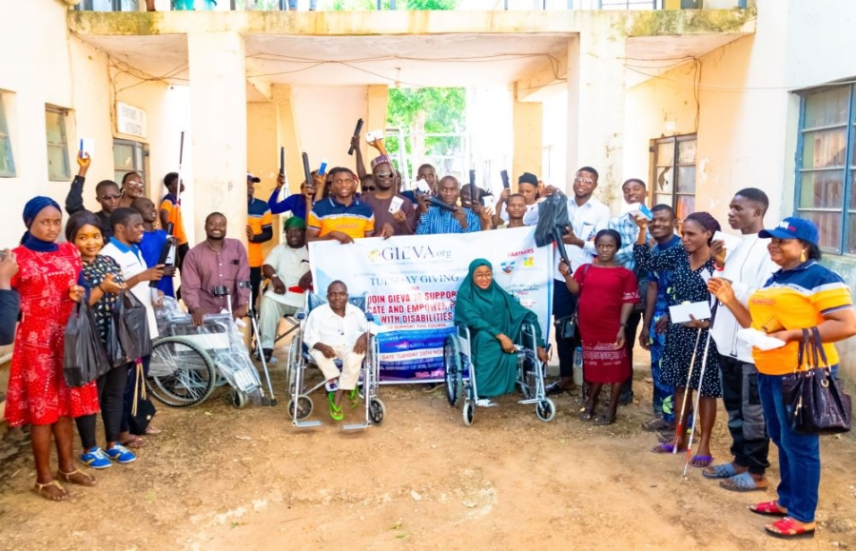

Inclusive Initiatives
“Empower 400 people with Disabilities”
Empowering people with disabilities involves fostering inclusion, accessibility, and equal opportunities. By removing cultural barriers, discrimination, educational exclusion and inequity, the 31 million PLWD’s in Nigeria can be fully integrated to become productive citizens of our Nation.
HOW!? By an intentional provision of access to quality education, promotion of inclusive & equal treatment. Building of platforms that embrace diversity, creating of inclusive environment is crucial for building a more equitable and compassionate community.
The GIEVA’s long term project: educate and empower 400 PLWD leaders in Nigeria embarks on a campaign to intentionally mobilize the larger society to support the rights of People Living with Disabilities.
The annual Giving Tuesday has now become an enabling megaphone to reach the public for the support. The maiden edition of the event, which held in Abuja FCT, in 2021, witnessed the distribution of some educational assistive items to our first batch of PLWD beneficiaries. This first batch beneficiaries are developing into a network of advocates and mobilizers and thus becoming the voice of the PLWD in their corners.
The second edition of the Giving Tuesday, which held in Lagos, in November 2022, also distributed assistive items to the selected PWLD. This third edition of the Giving Tuesday took place in Jos, in November 2023 by collaborating with the Department of Special Education and Rehabilitation Science to embark on a journey with potential to integrate the marginalized population of our society.
Take STEPS today to start in educating and empowering People living with Disabilities by joining the GIEVA Organization to support the Long term project: Educate and Empower 400 PLWD Leaders for self dependence and actualization.
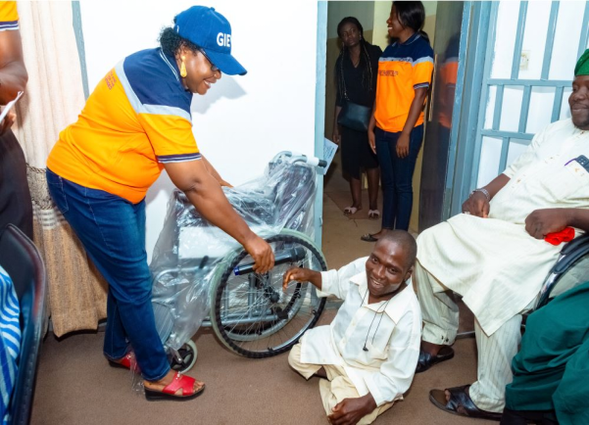
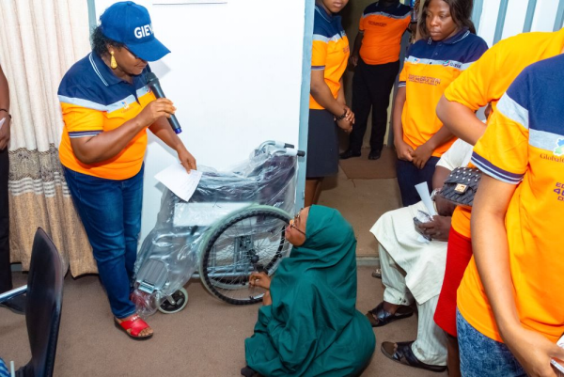

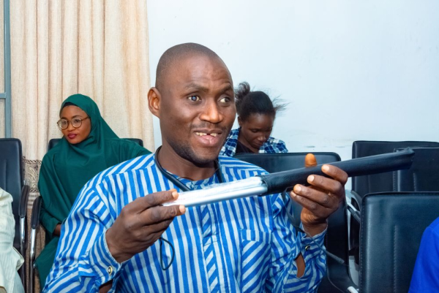

Community Corner: Your Voice Matters
Advocacy for people with disabilities through GIEVA’s Giving Tuesday Walk - Out Campaign emphasizes creating inclusive environments and ensuring accessibility in various aspects of life, such as quality education, workplaces accessibility, and public space integration.
For these reasons, GIEVA, on the November 28^{th,} 2023 took to the street on walk -out campaign with some persons living with disabilities to sensitize the public about the plight of the people with disability and the need to support, empower them to have a fulfilled life. The walk-out -campaign electrified the some members of the public to join in the march through crowded public spaces as we are being escorted by the road safety and policing apparatus of the government. This outing connected GIEVA Organization to attend the Joint Association of Persons with Disabilities, Plateau Chapter to celebrate the International Day for PWD in the State December 8, 2023 where GIEVA was able to donate 3 white walking canes for the blind.
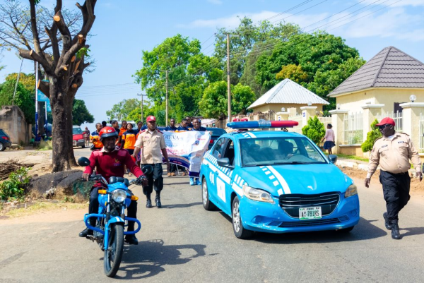

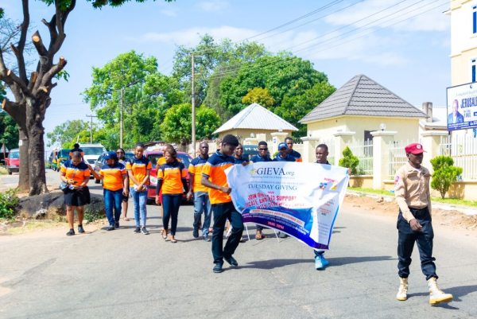
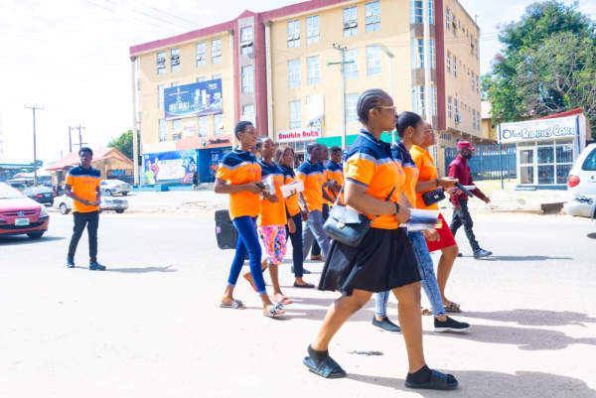
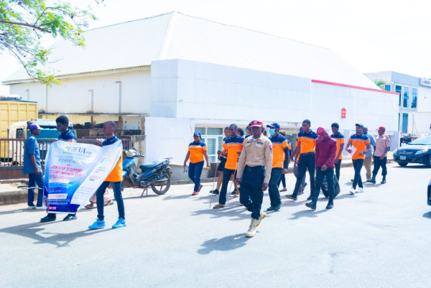

Interview: Advocates for Change
Meet individuals and organizations dedicated to advocating for accessibility and inclusivity. Learn about their journeys, challenges, and victories in making a positive impact on the lives of people with disabilities.
Together We Thrive, as we celebrate diversity and break down barriers, remembering that every person adds unique and valuable perspective to our community.

