In conjunction with CAPWD and KFBI

**History of GIEVA Organization**

The Global Integrated Education Volunteers Association (GIEVA) is an incorporated Non-Governmental Organization established in August 2006. The journey to chart a path began from one unfinished room on the top corner of a balcony in Merit House, Aguiyi Ironsi Road, Abuja, Nigeria, November 30, 2006. With the spirit of volunteerism, the principal co-founder with his adopted son – a new graduate of the National Youth Service Corps Program (NYSCP) came together to begin the journey. This day, November 30, 2006, was very unusual during the year because of bad weather. They stayed and brainstormed in a leaky one-room office. The rain affected the donated used computers, printers and ruined one of the desktop computer systems.

**The Birth of GIEVA Dreams and Imaginations**

In brainstorming, they dared to dream and imagine. They saw endless opportunities for the generations of the youth in the twenty-first century. Late into the evenings, they crafted the guarding Vision and Mission of the organization, thus:

**Vision:** Building **a** transformative system that provides global platforms for young leaders through educational services, entrepreneurial programs, and volunteerism.

**Mission:** Create an atmosphere of tolerance, a sense of belonging to foster cooperation and mutual understanding; build platforms for shared values, creativity, and innovation; facilitate inclusive entrepreneurial initiatives; and appreciation of the environment.

**In crafting the above vision and mission they dared to IMAGINE:**

*An organization with a giving heart willing to provide funds, resources, time and skills in the next five years to identify/ mobilize Nigerian youth, equipped with the necessary tools, inspiration, and training to conduct the trade of entrepreneurial innovations!

*An initiative to mobilize the university/ polytechnic graduate youth in Africa: synthesizing those with entrepreneurial potentials/ mindset; training them into an army of volunteers, making pathways to job creation, and establishing a sustainable platform for workforce development. And take on a “Cause” to educate and empower persons living with disabilities as leaders in Nigeria to chart a path for inclusivity, equity, and diversity.

*The use of information technology to establish “Volunteer Entrepreneurship Training Nodes” with the capacity to mobilize the entrepreneurial youth including PLWDs for sustainable development.

*That, in 5 years, five thousand unemployed university and polytechnic graduates who are inspired, supported, and provided with volunteer entrepreneurial training opportunities to translate the inherent natural talents and creative ability for sustainable economic development and engage them in the transformative agro-allied sector of the economy.

*That in 5 years, these trained graduates are mobilized in the act of volunteerism and connected to public, private, and nonprofit organizations where they engage in volunteer services with a stipend of only N1,500 ($3.00) per day to defray transport and feeding costs.

*Having a pool of volunteers with anagro-allied entrepreneurship mindset and linked to venture capital funds for a “Start-up Nigeria and Africa.”

*A new beginning where young Africans develop a culture of shared ideas, partnership, and entrepreneurial mindset for the public good.

**An Umbrella: -The Sustainable Transformative Education Programs (STEP)**

The above Vision and Mission anchored on the GIEVA’s imagined dreams motivated the establishment of ‘The Sustainable Transformative Empowerment Programs’ (STEP). The dreams and imaginations not only triggered a sustainable transformation of our young generation from system-dependent mentality but also empowered them to have self-dependent mindsets. Thus, the following programs were put in place for operation:

**1. GIEVA Management/Consultancy Services**.

a. Administration of SAT and TOEFL in Nigeria

b. Registration of International tests for college placements

c. SEVIS/ Visa Management

d. Consultations- Establishment of online/offline Test Centers

**2.** **Creative Hands in Organizational Innovations and Constructive Education for Sustainability (CHOICES)**

a. Formation of CHOICES -STEM Clubs in secondary schools.

b. Identification of outstanding female students to encourage and inspire.

c. Selection and training of teachers as CHOICES-STEM Club patrons-nesses.

d. Organizations of annual competitions and talents from among young adults

**3. GIEVA Holistic Education Advising and Learning Services (HEALS).**

a. Platform for holistic advising for academically qualified youth

b. Identification and mentoring of academically qualified students,

c. Training and learning centers

d. Placement of students in high institutions globally

e. Identification and support of STEM students

f. Provision of scholarships to economically disadvantage**d** students.

**4.GIEVA Volunteer - Ambassador Program (GIEVA VAP)**

a. Building platforms for empowering young entrepreneurs for innovation

b. Training young adults on Give-Back Mechanism through volunteering

c. Training and preparing young adults to learn self-dependent mindset

d. Providing employability platform for unemployed graduates

e. Creating collaborative partnerships for internship/volunteering programs

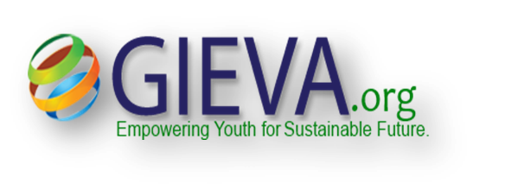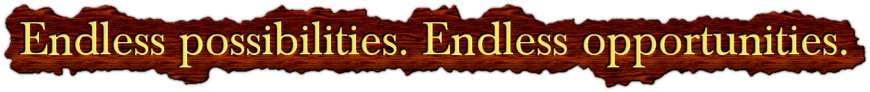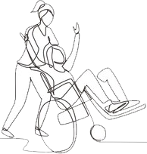

Stand

**for the**

**V O I C E L E S S**

**We dare to**

**Let’s Educate and Empower 400**

**People With Disabilities**

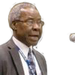

**GIEVA**

**Daniel Newton Obaka (PHD)**

Daniel is a non-profit organization leader and a strategist, the principal founder of Global Integrated Education Volunteers Association, executive director, initiator of Holistic Education Advising and Learning Services, a mentor and advisor with over two decades of outstanding experience in preparing and inspiring youth through education, cultural exchange, and partnership; impacting thousands of lives across Nigeria, West Africa, and Africa.

**10-Year Project Plan for Educating and Empowering Young Adults PLWD as Leaders**

Subsumed within the STEP is GIEVA’s 10-Year project plan – **Educate and Empower 400 young adult-Persons with Disabilities as future leaders in Nigeria.** GIEVA, under its STEP, wants you to share in these questions emanating from persons with disabilities all over the world:

**Worldwide, PWD cry:**

**We do not need sympathy!!!**

**We only need empathy!**

All we require is an opportunity to live a life of dignity.

We require an opportunity like other members of the society to co-create, co-innovate, and share societal responsibilities.

We need your continued support for the GIEVA STEP’s project: - Educate and empower the young adults of Persons with Disabilities in Nigeria.

**The GIEVA Global Giving Project**

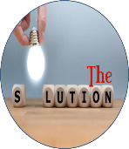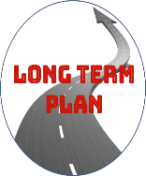

The **GIEVA Global Giving**step-project is a sustainable platform to train Persons with Disabilities (PWD) as leaders in Nigeria. Leaders of PWD, with adequate empowerment, will further liberate other PWD from system-dependent mindset, cultural stigmatization, exclusion, relegation to street begging, and inequality to create a path to their human dignity, social integration, inclusion, equality, diversity, and racial healing.

The project is a **long-term investment strategy,**as it enhances and supports quality educational opportunities for adolescent/ young PWD. This helps them rise above poverty, become independent, form a generation of better communities, the nation, and the world. Education reduces poverty. It brings lasting empowerment in a world hungry for equal rights, diversity, inclusion, and transformative change for the common good of all people.

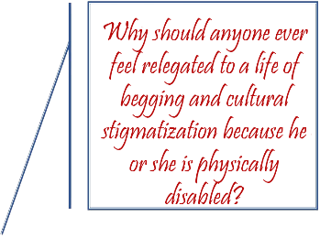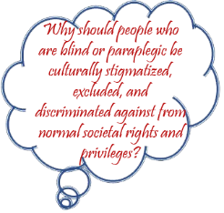

His experiences in educational advising and mentoring are being leveraged by educational institutions, colleges, universities, foreign embassies, parents, testing organizations, and career guidance for advisory services. He is also a committed philanthropist and a passionate care-giver.

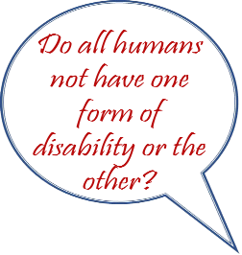

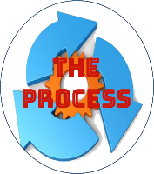

**With your help**, GEVA plans to use the generous donations from 48 pioneer donors on the Global Giving organizational platforms to enable her to support this cause. GIEVA is leveraging its partnership with the Global Giving to foresee a roadmap with a 10-year project plan designed to build a threshold of 400 PWD as leaders. Working with the Center for Advocacy for Persons with Disabilities (CAPWD) and Knowledge for the Blind Initiative (KFBI) Nigeria, we evolve a system of sustainable mobilization, selection training, and engagement of young PWD as beneficiaries.

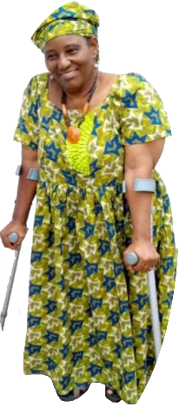

**CAPWD**

**Ellen Omotunde**

The CAPWD is a non-profit organization that caters for persons with disabilities

(PWD). The organization focuses on the development and empowerment of PWD through advocacy, education, and public support for “empathy and not sympathy” with a mission to create platforms for equitable treatment for and inclusion of PWD in Nigeria.

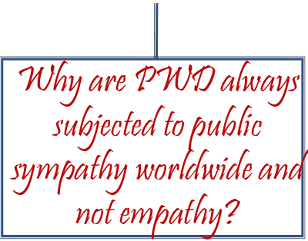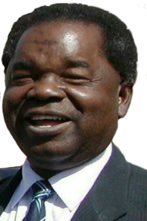

Through education, training, empowerment, and advocacy,**GIEVA STEP**addresses the worsening intergenerational transmission of education inequality among the PWD. Every year, 40 PWD from low-income families in Nigeria will be identified and assisted. These include those who cannot gain admission into higher institutions because of a lack of assistive educational resources and mobility tools, low-income family background, systemic failures, inequality, and lack of inclusiveness.

**KFBI**

**Bitrus Gani Ikilama**

**Bitrus Gani-Ikilama** was the first blind student to complete

the three tiers of education in Nigeria. Born in Donga,

then in Takum Local Government Area of Taraba State,

to a blacksmith and farmer in 1944, Gani-Ikilama against

all odds and challenges attended primary and secondary

school in Gindiri, Plateau State, performing excellently well in his Cambridge exams - especially History where he had an 'A'. In fact, as at then, he was the only blind student in a secondary school in the whole of Nigeria.