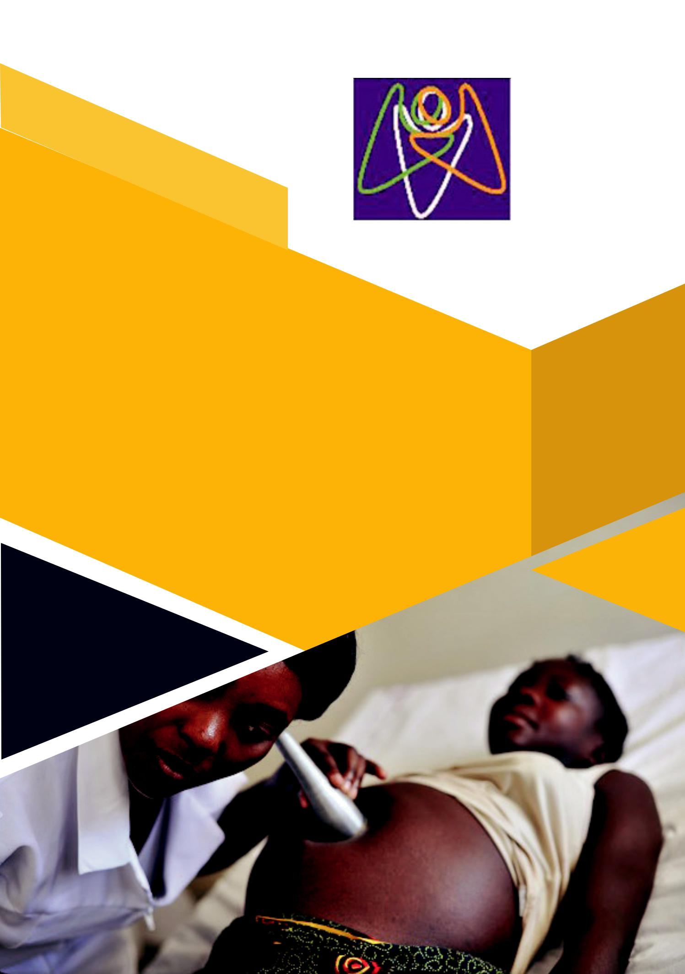

CHILD AND FAMILY

FOUNDATION UGANDA

AMBULANCE FUND RAISING FOR SAVING

LIVES AT BIRTH PROJECT

AMBULANCE FUNDRAISING 1

- AMBULANCE FUNDRAISING
1. About CFU

Child and Family Foundation Uganda (CFU) is a faith-based non-profit non-governmental organization (NGO) dedicated to improving lives of the poor; vulnerable; and disabled with focus on children, youth, women and persons with disabilities (PWDs) in Uganda and beyond. Incorporated as an NGO in February 2012 Registration No. 9049, CFU works with individuals, families and communities; government; local and international partners to promote service and human development in order to reduce disease, disability, illiteracy, poverty, and social injustice. CFU is a result-oriented organization that works to maintain stewardship, transparency, accountability, partnership, innovation, and efficiency (STAPIE) as its core values.

2. Introduction

The Sustainable Development Goals (SDGs) aim to reduce the global maternal mortality ratio to less than 70 per 100,000 live births and ensure universal access to sexual and reproductive health-care services, including family planning, information and education, and the integration of reproductive health into national strategies and programmes by 2030.Uganda has made great strides in maternal health, according to the ministry of health report.

Maternal mortality has reduced from 438 deaths per 100,000 live births registered in the 2011 UDHS report to the current 336 deaths per 100,000 live births. There is also marked improvement in pregnant women attending four or more antenatal care visits from 48% in 2011 to 60% in 2016 while the number of births in health facilities increased from 57% in 2011 to 73% in 2016. While there is some reason to celebrate, Uganda is still quite behind in achieving the SDGS on maternal health.

The project takes forward the overarching vision of CFU by progressing strategies and actions that improve maternal health outcomes in Uganda and focuses on CFU’s role in ensuring that maternal health system is flexible to respond to identified health needs.

3. Purpose

The purpose of this document is to provide a brief overview of the fundraising activity for the procurement of an ambulance for the saving lives at birth project at Child and Family Foundation Uganda (CFU). CFU seeks assistance for the project which will be causative to the sustainability of our organizational goal to improving lives of the Poor, vulnerable and disabled groups in rural and urban informal settlements with focus on women and children.We do this through well-planned and comprehensive programmes

AMBULANCE FUNDRAISING 3

in maternal health and child health. We also empower and catalyze families and communities in disease, disability, illiteracy, and poverty reduction through service delivery, community interventions, capacity and policy development, research and advocacy to enable children, youth, women and PWDs attain life potential. CFU seeks additional support on improving referral and transportation of mothers with complications and sick newborns, including linkage to health facilities in Kampala district.

4. Project summary


Title | SAVING LIVES AT BIRTH
Partners | KCCA, MULAGO REFFERAL HOSPITAL
Target Area | KAWEMPE DIVISION
Beneficiaries | MOTHERS, NEW BORNS & PWD
Cost | 41,000USD
Goal | Promote and improve Maternal and child health in rural
Goal | and urban poor populations (To contribute to 2040
 | Development Goal)

5. Project Description

High maternal mortality rates persist in Uganda due to an overall limited capacity of health facilities to manage complications and prevalence of HIV/ AIDS among pregnant women. Despite malaria being one of the leading causes of morbidity in pregnant women, prevention and prophylaxis services are not well established. Maternal mortality rates are still high in Kawempe division, due to Poor transportation means of mothers and sick newborns. Mothers and adolescent girls die due to long distances to health facilities, and poor transportation systems to the health facilities and to the district referral hospital, Limited means of transport both at the national and health centers has been a major challenge.

The ambulance which were was donated to Kawempe Health Center IV by (Hon. Mubarak Munyagwa ), has continuously broken down, due to the much workload. Patients from local communities in Kawempe division now rely on local transport means like public transportation services & boda boda (motorcycles & bicycles) for transportation to reach referral hospitals, which are not best recommended for patients.

- AMBULANCE FUNDRAISING

6. Aims and objectives of the project

- To reduce on the maternal mortality rate from 43 deaths per 1000, as estimates of 2016 to 39 per 1000 in the country.

- To improve and manage free transportation services for mothers and sick new born babies to linkage health facilities

- To increase maternal and child linkage to care and improved treatment outcome through improved transportation systems

7. Discussion (Objectives)

In order to reach the above mentioned objectives, we have planned a fundraising activity. We believe that with our stakeholders, our community, particularly, the most vulnerable will be able to benefit immensely through continuum of services and social cohesion so that all will appreciate and take responsibility of the ills of societal elements that the organization had in all the years it’s been advocating for.

8. Project activities

Managing the transportation (Ambulance) and links to facilities. Working with both local health centers and the main hospital in utilizing the ambulance rotating in different communities in Kawempe to save the lives of pregnant and expectant mothers (to reduce on the rate of maternal mortality in Kampala district).

The project team seeks to receive a well-equipped ambulance, and also manage the transportation of mothers and sick babies to the main hospitals from health centers, or elsewhere. The Ambulance will work in a team as they will rotate around the health centers in the district depending on emergences available, or any need for referral to the main hospital.

And, that is Komamboga Health center III, Mulago Hospital Kawempe among others. The project will organize awareness, radio and Television programs, to make people aware of these facilities for mothers and sick newborn babies, and also encourage them to utilize these free services, in order to save their lives. However, the project will commit itself to run and manage these services which include hiring skilled drivers, midwives and emergence medical technicians to work in the project Ambulance.

The project will meet all the fuel costs, the servicing and repairs of these ambulances. The Ambulance will have stand by staffs made of two drivers, two midwives and two emergency medical technicians (EMTs) who are well equipped with skills to save the lives of both mothers and babies just in

AMBULANCE FUNDRAISING 5

case the mother delivers on the way before she reaches the hospital. The ambulance driver, the EMTS and mid wives will work in shifts. That is to say, day shift and night shift.

Each shift will have one driver and a midwife and an emergency medical technician (EMTs). In order to manage life-threatening conditions and minimize maternal mortality rate, there is a mandated list of equipment requested to be on board of every single ambulance. However, there are two types of ambulances; the basic Life Support (BLS), and Advanced Life Support (ALS).

Both have a standard set of medical equipment, but the difference between the two is that the Basic Life Support Units are designed for inter-facility transportation and pre-hospital response to ill or injured patients, whereby each unit is staffed with 2 licensed emergency medical technicians, and the EMT’s generally have over 30 days of training, yet, ALS units have a minimum of one paramedic and one EMT, who can administer certain medications, and have advanced airway equipment, cardiac monitors, advanced cardiac life support equipment and blood glucose testing equipment. Paramedics usually have over 60 days of education and training. They can start IVs, push medications, and perform more advanced procedures. Of the two options, we prefer to comply with the ALS type, for the better service in order to save more lives of mothers and newborn babies.

ALS ambulance must have a more robust set of equipment for pre-hospital care. The ambulance must be equipped with the tools necessary for multiple types of emergencies, from respiratory assistance machines and defibrillators to items as simple as bandages and disinfectant solution in order to save more lives of babies.

- AMBULANCE FUNDRAISING

The following list indicates the equipment to be used in our ALS ambulance.

- Portable and fixed suction apparatus with a regulator: An important life saving device is the suction apparatus that is used to remove mucus and similar fluids from the airways. It is not a pretty process, but if something other than oxygen is entering your airways, a device such as the Schuco 130 Aspirator will save your life.

- Portable and fixed oxygen supply equipment capable of metered flow with adequate tubing. Breathing is obviously one of the vital aspects of life support and having metered oxygen equipment on board can save many lives. An oxygen supply device is required for.

- Pulse oximeter with pediatric and adult probes: A pulse oximeter is a useful medical device for measuring the oxygen saturation of a patient’s blood and changes in blood volume in the skin. A pulse oximeter such as the Nonin Avant 4000 wireless oximeter is important for pulse signal quality assessment, high and low SpO₂ and heart rate alarms.

- Automated external defibrillator (AED) with pediatric and adult sized pads: This can save lives by giving your heart a jump start. Defibrillation is the application of electrical therapy which should put a patient’s heart back into a healthy rhythm. AEDs are common in public places and are easy for laymen to use.

- Portable, battery operated defibrillator: Portable defibrillators are very important in assisting emergency personnel during pre-hospital care. When a defibrillator is needed, it is often a matter of minutes before the patient’s heart will not bounce back. A portable unit allows the medical team to bring help directly to the patient.

- Sphygmomanometer: Also known simply as a “blood pressure meter,” this is a smaller piece of equipment needed on ambulances but still very important. Quickly being able to measure blood pressure will tell the medical personnel how well one’s heart is pumping blood the rest of your body.

- Transcutaneous cardiac pacemaker: Yet another tool to measure the effectiveness of your heart, a transcutaneous cardiac pacing device is a temporary means of pacing a patient’s heart during a medical emergency. Pulses of an electric current are delivered through the patient’s chest, which will help stimulate their heart.

AMBULANCE FUNDRAISING 7

- Nebulizer: When it is important to administer medication as quickly as possible to a patient, a nebulizer is used to administer it in the form of a mist inhaled into the lungs. It is similar to how inhalers work for asthma patients and is very effective for immediate relief.

The project will sign a contract with a fuel company to fuel and service the ambulances, and the contract will be renewed depending on the quality of the services by the contracted fuel company. The project will ensure that all accountabilities for the fuel supply are kept with three different recordings that is; the fuel company, the drivers, and our monitoring team to avoid poor filing.

Sustainability

CFU will support with the parking space and security for the ambulance at all time.

Under emergencies requiring more staffs, CFU shall delegate its Medical teams to ensure support of the community. Continuous training of staffs on project ambulance

Kind regards

Social Marketing and Fundraising Team

Contact Persons in Fundraising Department:

Administration | Email: talktous@cfufoundation.org
Harriet Babikako | Email:babikako@yahoo.com

Thank you for your interest in fundraising for the saving lives at birth project (Purchase of ambulance).

- AMBULANCE FUNDRAISING

FUNDRAISING APPLICATION FORM

Name of sponsoring organization: | By signing this
 | form you agree to
 | following terms and
Address: | following terms and
Address: | conditions
Phone:
Contact person:
Email address:
Web site:
Fax:

In order to reconcile funding in a timely manner, Sponsoring Organization agrees that Child and Family Foundation will receive its portion of the net proceeds no later than 30 days after the event or pledge.

Initial here: _____________________
Authorized Representative of |  |  | Authorized Representative
Sponsoring Organization |  |  | of Project Hope
___________________________ |  |  | ___________________________
Printed name, date |  |  |  | Printed name, date
Income Source |  | Amount |  | Expenses | Amount
Sponsorship |  |  |  | Venue Hire
Registration Fees |  |  |  | Food & Beverage
Ticket Sales |  |  |  | Promotional Material
Donations |  |  |  | Printing
Other |  |  |  | Prizes

Child And Family Foundation Uganda Plot 816/817 Block 206 Mpererwe – Ttula Rd. P. O. Box 73243, Kampala, Uganda Tel: 256-414-693073 Mobile: 256-776-693078

AMBULANCE FUNDRAISING 9

10 AMBULANCE FUNDRAISING

Project name: Savings Lives at Birth

Main Project Goal: Promote and improve Maternal and child health in rural and urban poor populations (To contribute to 2040

Development Goal)

Budget estimate breakdown |  |  |  |  |  | 3750
NAME | Months | Level of effort | Salary | Salary | Fringe | Budget ($) | Budget UGX | Budget notes
NAME | (Month) | on the project | Salary | requested | benefit | Budget ($) | Budget UGX | Budget notes
Personnel
Driver To be Hiredd (Day | 12 | 100% | 2,340 | 195 | 20 | 215 | 9,652,500 | For driving an ambulance
Duty)
Driver To be Hiredd (Night | 12 | 100% | 2,340 | 195 | 20 | 215 | 9,652,500 | For driving an ambulance
Duty)
Nurse To Be Named (Day | 12 | 100% | 2,640 | 220 | 22 | 242 | 10,890,000 | For nursing patients in the
Duty) |  |  |  |  |  |  |  | ambulance
Nurse To Be Named (Night | 12 | 100% | 2,640 | 220 | 22 | 242 | 10,890,000 | For nursing patients in the
Duty) |  |  |  |  |  |  |  | ambulance
Emergency Medical | 12 | 100% | 2,610 | 275 | 28 | 303 | 13,612,500 | For emergence treatment of
Technicians (EMTs) |  |  |  |  |  |  |  | patients on an ambulance
Emergency Medical | 12 | 100% | 2,610 | 275 | 28 | 303 | 13,612,500 | For emergence treatment of
Technicians (EMTs) |  |  |  |  |  |  |  | patients on an ambulance
Sub - Total-ROM |  |  | 15,180 | 1,380 | 138 | 1,518 | 68,310,000
Equipment |  |  | Qty | Unit cost | Frequency | Budget ($) | Budget UGX
Ambulance Van |  |  | 1 | 20,000.00 | 1 | 20,000 | 75,000,000
Nabulizer |  |  | 1 | 150.00 | 1 | 150 | 562,500
Accessories to the |  |  | 1 | 300.00 | 1 | 300 | 1,125,000
Nebulizer
Portable and fixed suction |  |  | 1 | 150.00 | 1 | 150 | 562,500
apparatus with a regulator:

 | Transcutaneous cardiac |  |  | 2 | 45.00 |  | 90 | 337,500 | Cadiac Pacing device (for
 | pacemaker |  |  | 2 | 45.00 | 1 | 90 | 337,500 | effective heart functioning)
 | Sphygmomanometer |  |  | 2 | 15.00 |  | 60 | 225,000 | For blood pressure check
 | Sphygmomanometer |  |  | 2 | 15.00 | 2 | 60 | 225,000 | up
 | Portable, battery operated |  |  | 1 | 150.00 |  | 150 | 562,500
 | defibrillator |  |  | 1 | 150.00 | 1 | 150 | 562,500
 | Automated external
 | defibrillator (AED) with |  |  |  | 1,550.00 |  | 1,550 | 5,812,500
 | pediatric and adult sized |  |  | 1 | 1,550.00 | 1 | 1,550 | 5,812,500
 | pads
 | Portable and fixed oxygen
 | supply equipment capable |  |  | 1 | 155.00 |  | 155 | 581,250
 | of metered flow with |  |  | 1 | 155.00 | 1 | 155 | 581,250
 | adequate tubing.
 | Pulse oximeter with |  |  | 1 | 140.00 |  | 140 | 525,000
 | pediatric and adult probes |  |  | 1 | 140.00 | 1 | 140 | 525,000
 | Insurance for the Motor |  |  |  | 139.00 |  | 139 | 521,250
 | Cycle |  |  | 1 | 139.00 | 1 | 139 | 521,250
 | Sub - Total |  |  |  |  |  | 2,745 | 85,815,000
FUNDRAISINGAMBULANCE
FUNDRAISINGAMBULANCE | Grand Total |  |  |  | 41,100 |  |  | 154,125,000

11

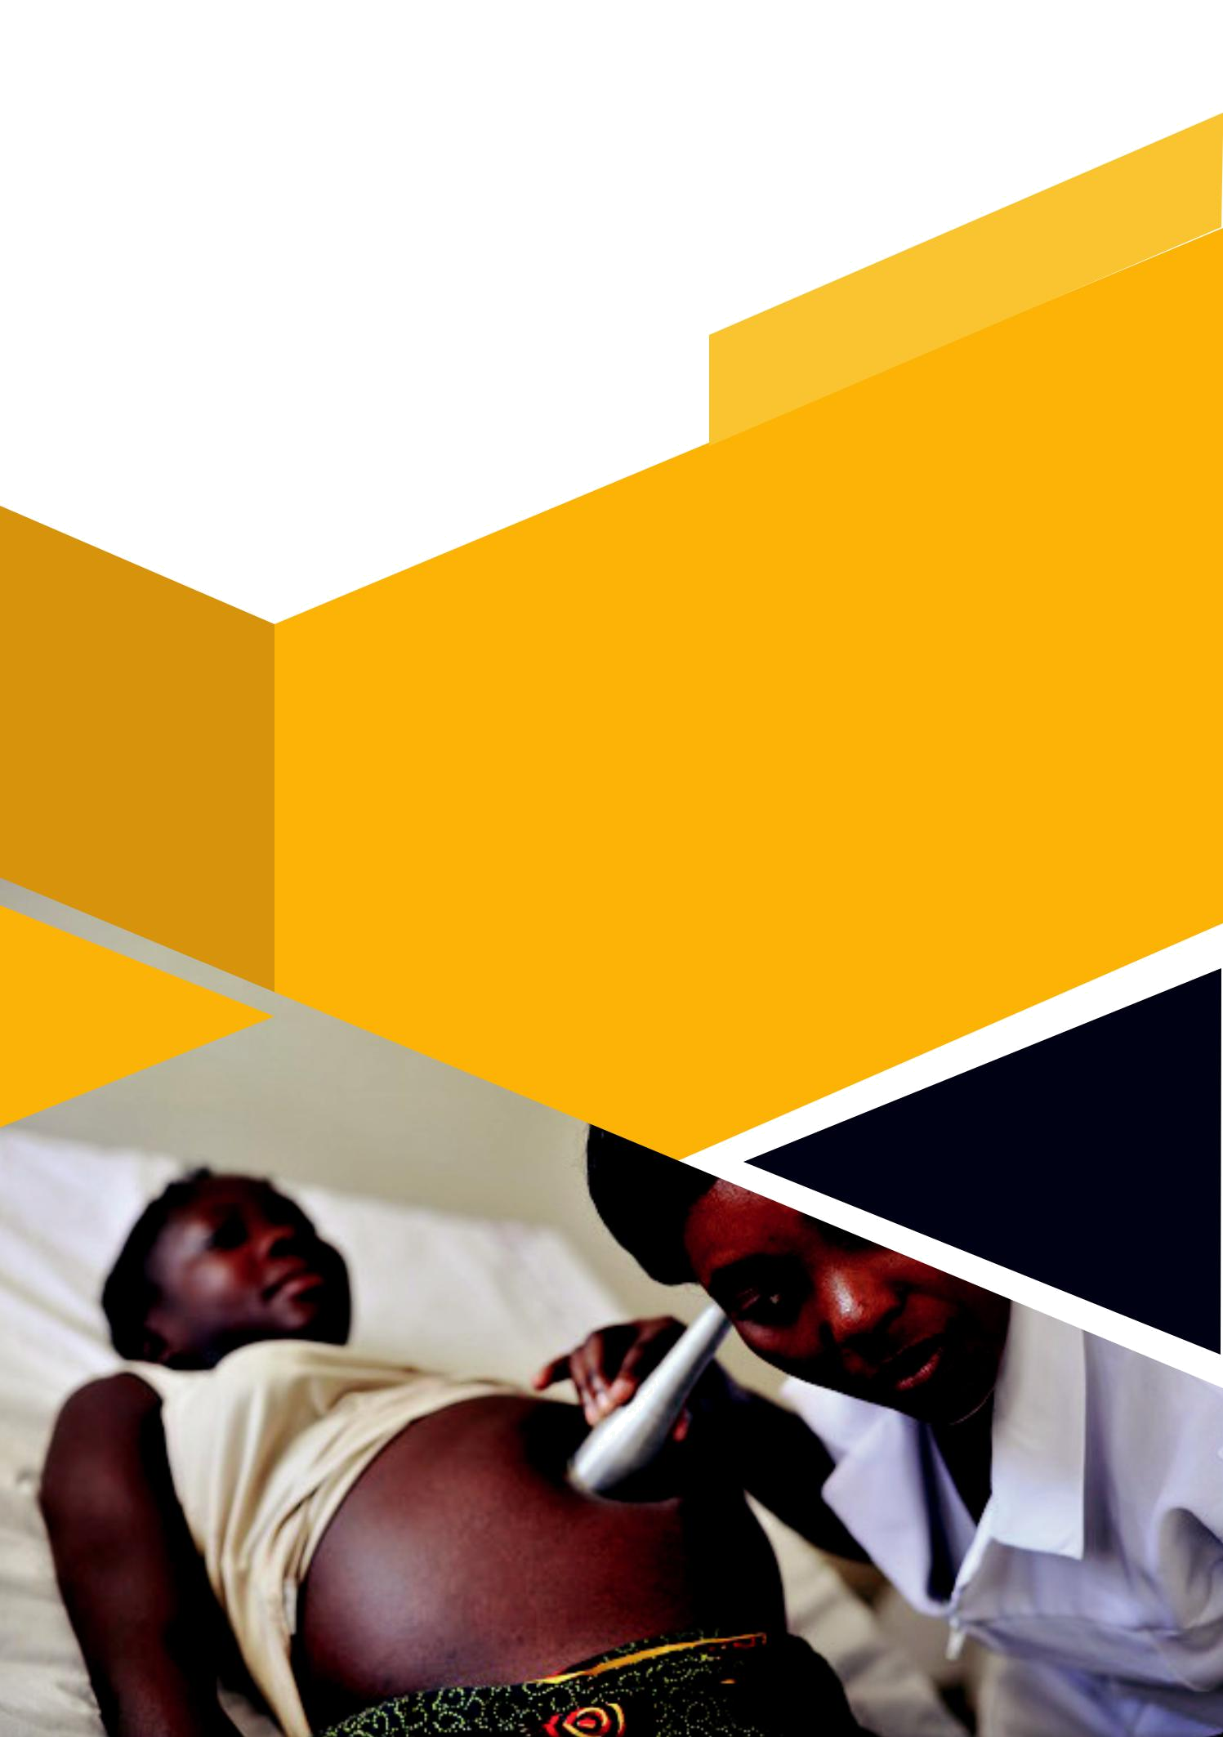
CFU HEAD OFFICE

Plot 816/817 Block 206 Mpererwe – Ttula Rd.

P. O. Box 73243, Kampala, Uganda
Tel: 256-414-693073

Mobile: 256-776-693078 or 256-704-693073

Email: talktous@cfufoundation.org

- AMBULANCE FUNDRAISING

