ANNUAL REPORT 2019.
DIRECTOR’S MESSAGE:
Looking back in the year 2019, I am proud of our combined works and efforts which have yielded positive developments irrespective of some challenges. We have, however, completed remarkable work with hope in the future of our beneficiaries. We are already looking ahead to the change we will make in 2020 as we plan to concentrate more on all our programs.
Thanks to you all for your great unconditional support, partnership, and the different engagements. I would like to sincerely thank and acknowledge the incredibly hard work of all who have contributed to Humanitarian Relief Initiative and Development success in 2019. Whenever am in the field and see beneficiaries smiling with hope in their faces, my heart is humbled then joy and appreciation goes to our partners and the board of directors, without whom no positive achievements would come to our beneficiaries.
I would like also to congratulate our staff as well for their prayers, support, progressive thinking, dedicated work, volunteering, passion, and care. I anticipate the year 2020 to be full of hard work, increased cooperation, and successes in all our programs.
Thank you all so much.

EXECUTIVE MESSAGE:
Humanitarian Relief Initiative and Development Annual Report highlights major activities and transformational initiatives of the Organization for the year 2019. HRID desire that every beneficiary has an opportunity to live a happy life by contributing towards and improving the wellbeing of the vulnerable children, their families, and communities where they live. The year 2019 was another exciting and fulfilling year for HRID. In particular, the year was characterized by growth and expansion with the support from our generous partners and donors.
We thank you all our partners and Communities who have made 2019 possible. Our programs and activities Expedition and Water and Sanitation have been as indicated below.
Humanitarian Relief Initiative and Development has been working in Western Bar El Ghazal and Warrap States since 2019 where it has a program of Wash and Shelter NFI. Here are numbers of Shelter NFI activities that were carried out including and installing of hand washing tank to improve on hygiene and sanitation.
Water and Sanitation, Shelter NFI & FSL Program
Humanitarian Relief Initiative and Development embarked on Water and Sanitation project with the aim of having a health and high performing population through accessing safe drinking water improving on hygiene and providing effective sanitation. Under this program, the organization looks at projects such as construction of drainable pit latrine, installing of water tank, conducting of hygiene lessons and protection of spring wells.
Improved water and sanitation services are a key priority in the national development plan 2018-2025. The united nation as has also identifies water and sanitation as a priority through designation it as one of the millennium development goal number .Since 2001 responsibilities for hygiene and sanitation have been devolved between health water and education departments this has resulted in the fragmentation of budgets. Inadequate funding due to competing demands within the education department has farther aggravated the situation.
Due to the precarious water and sanitation situation children face several preventable diseases like diarrhea, skin infections, malaria, and worms. High morbidity leads to poor school subsequently if not checked to school dropout.
The communities of Western Bar El Ghazal and Warrap States are facing water problem, the communities are collecting water from an open spring and Rivers which was being shared by both the people and the animals, we managed to protect one spring in this communities. Below are some of the photos before the spring well was unprotected and after it is protected.

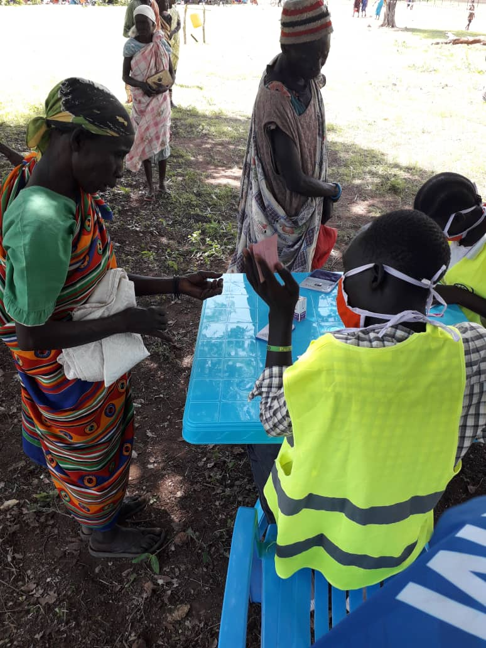
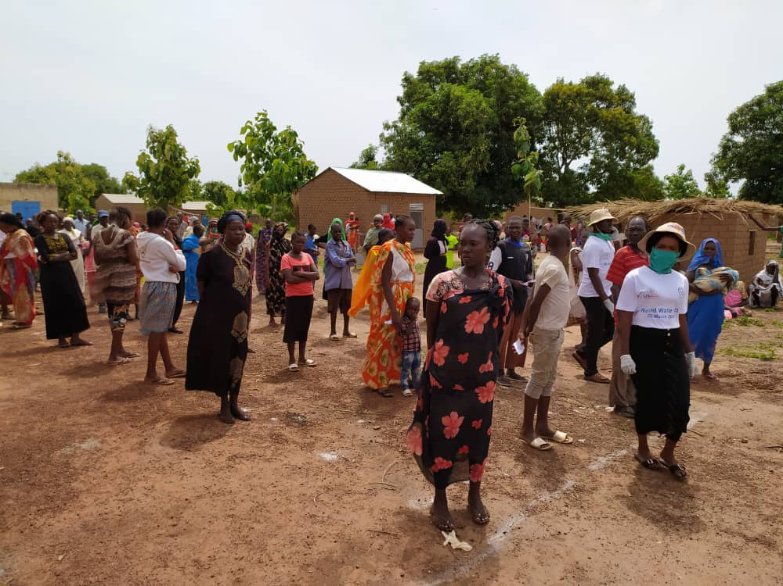
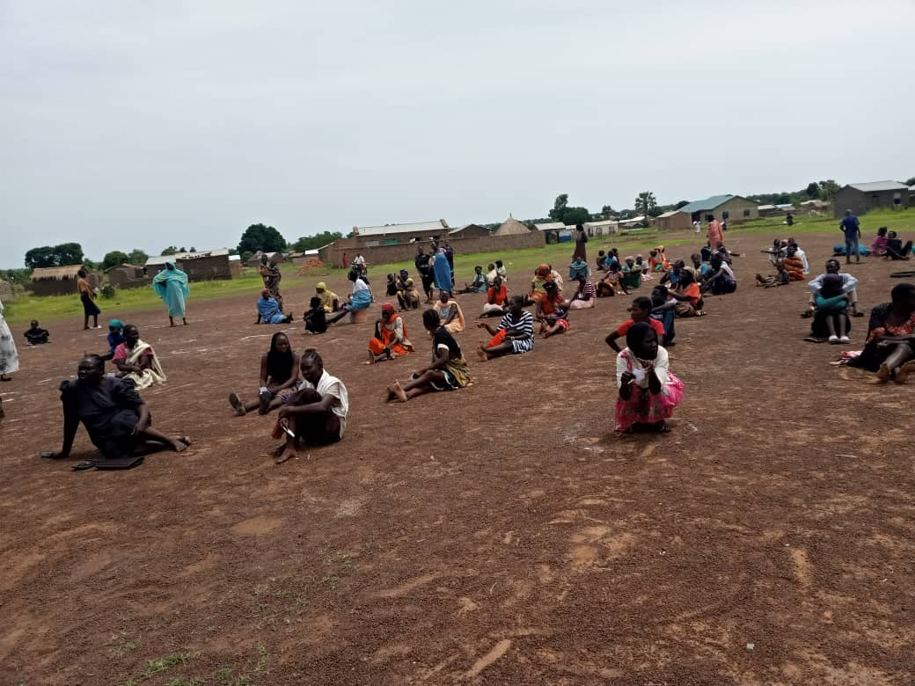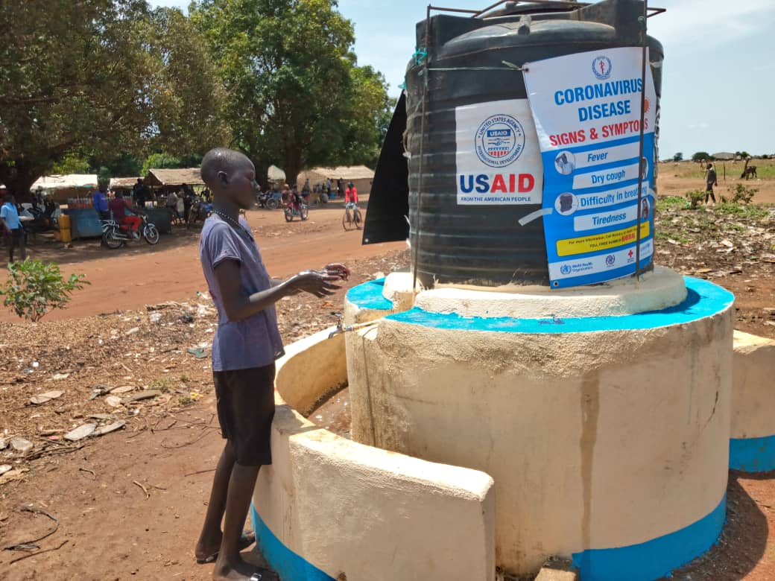
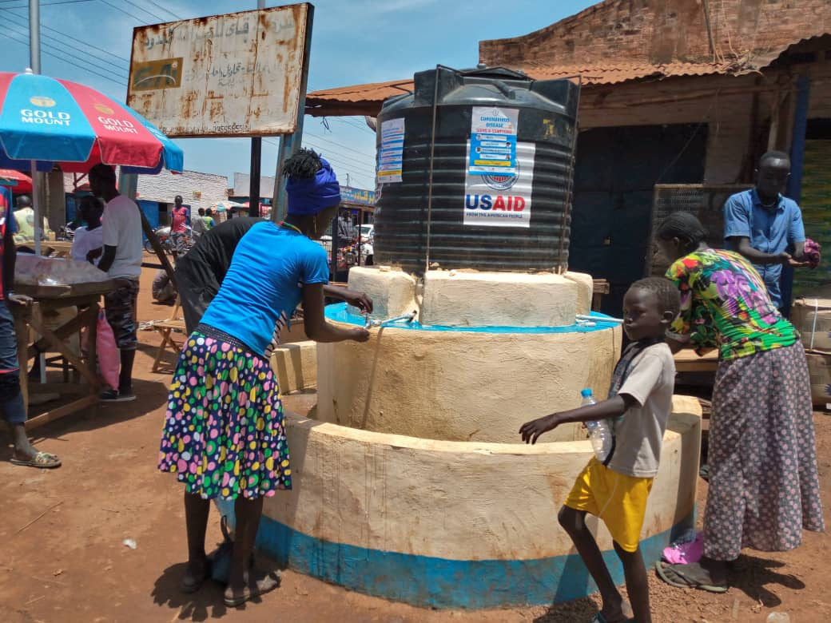
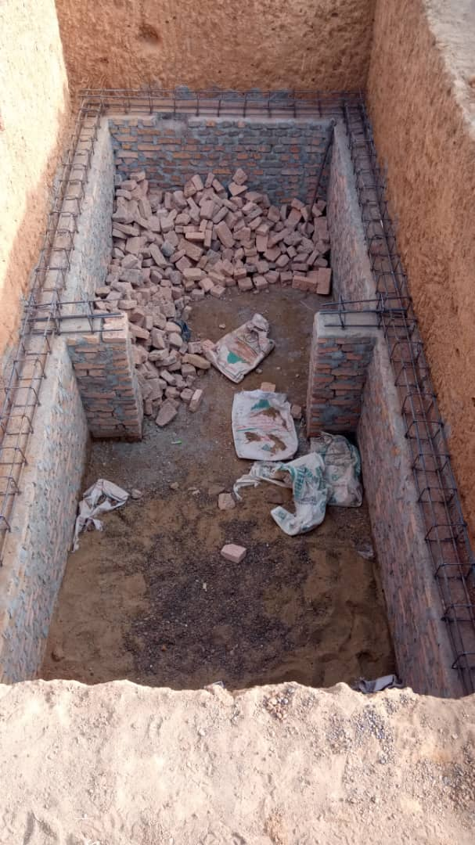

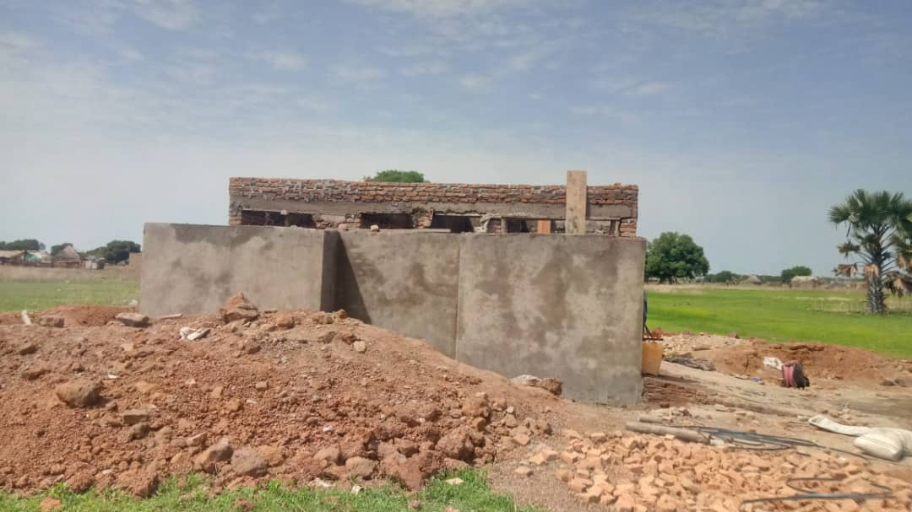

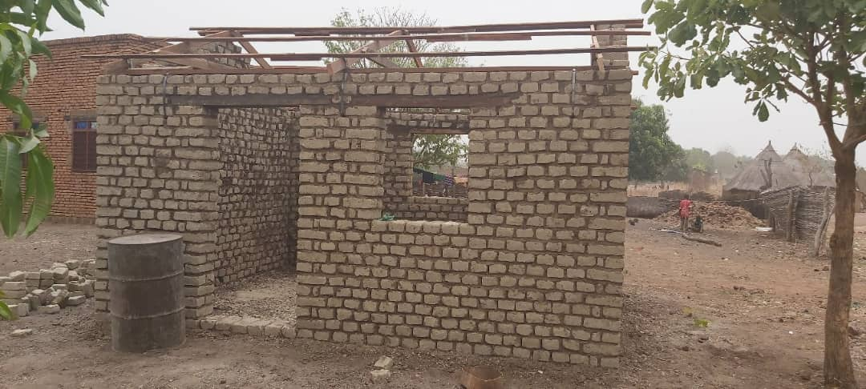
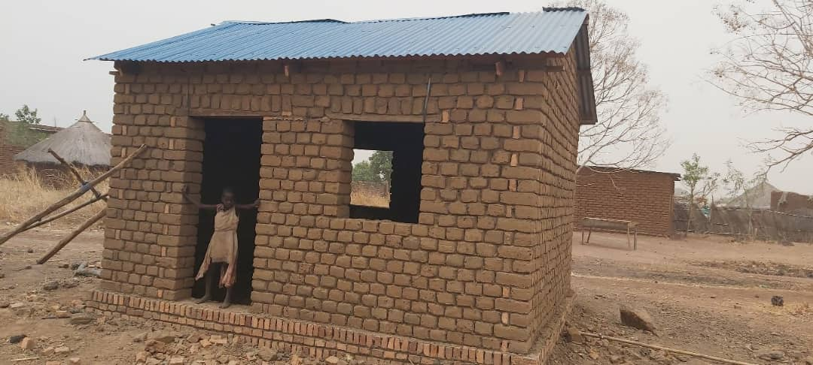
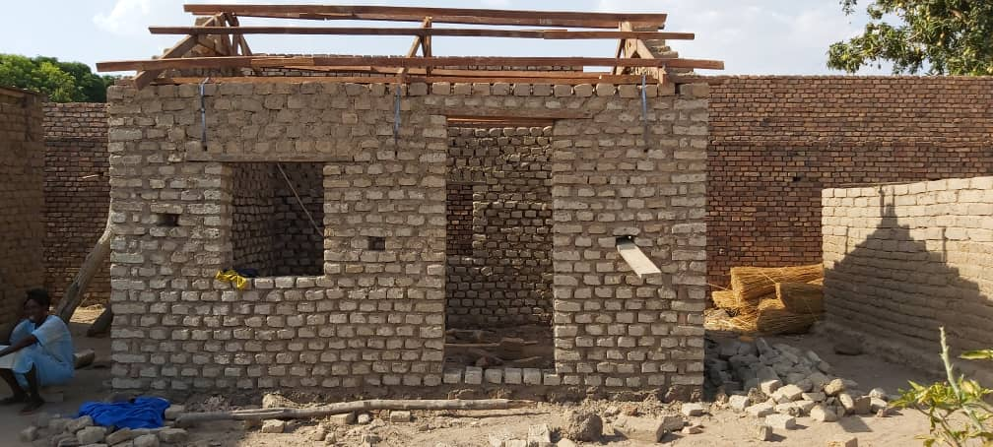
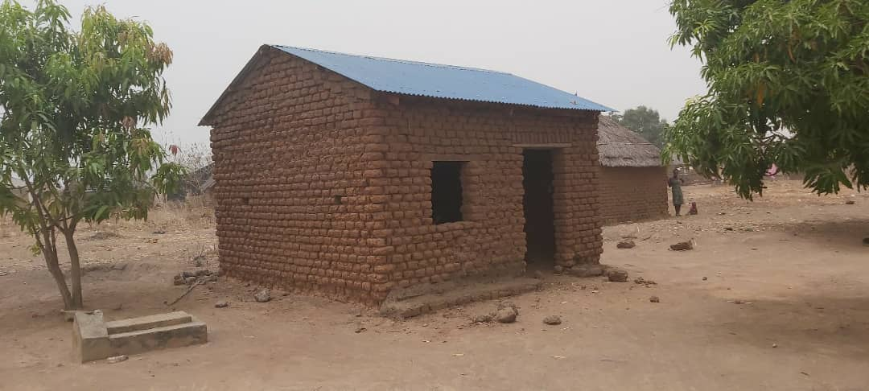
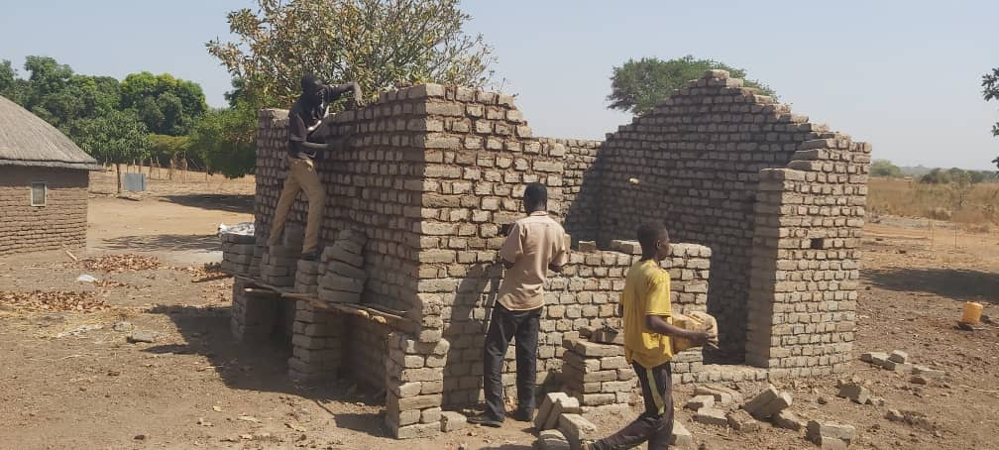
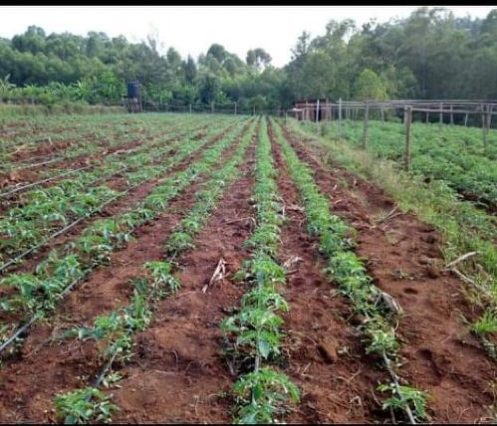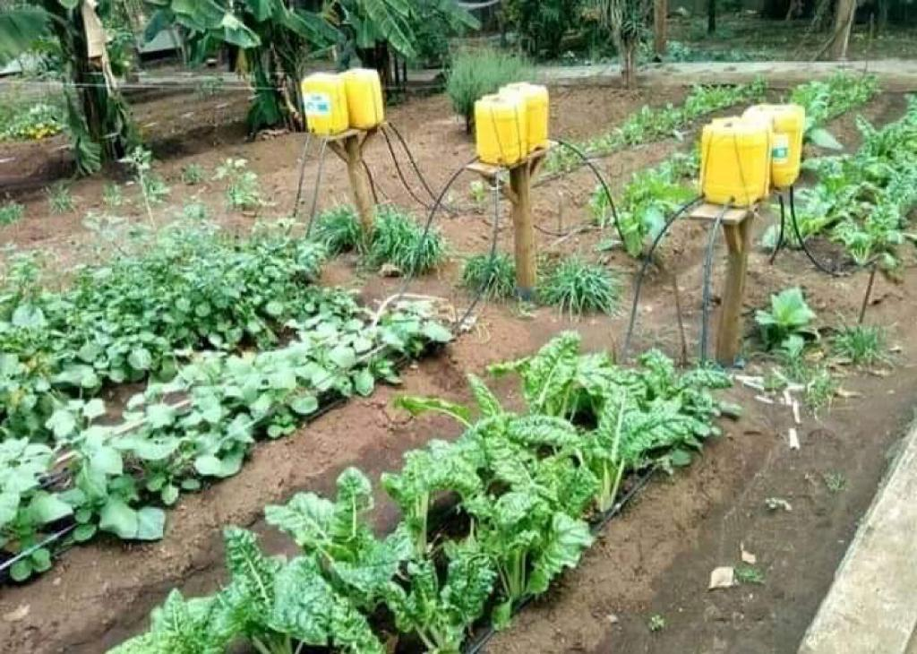

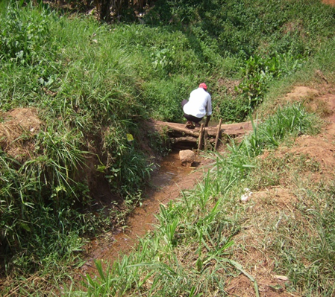
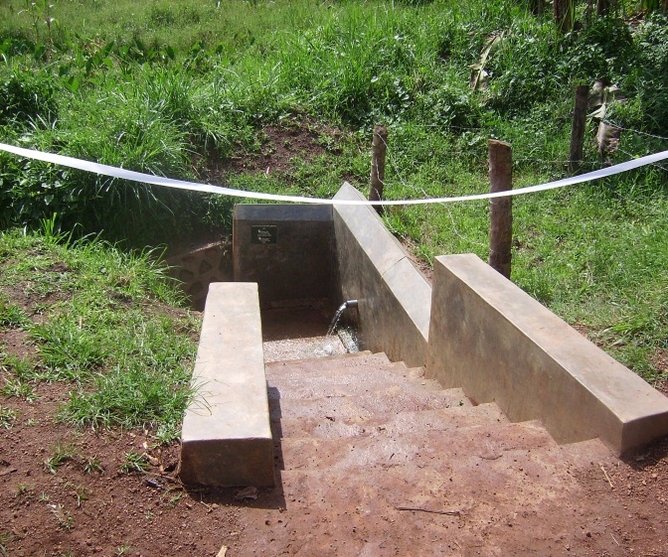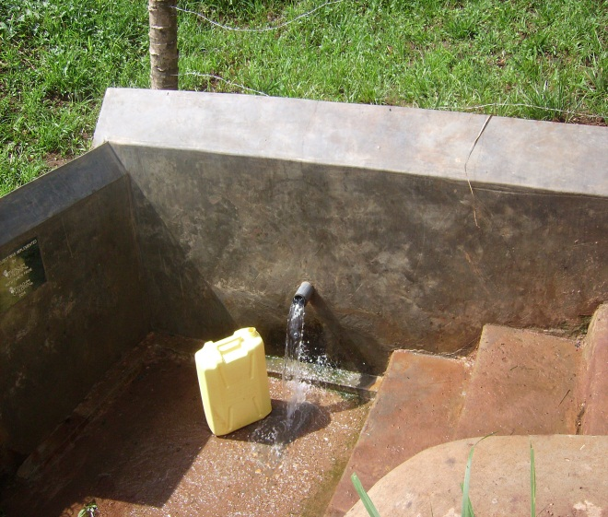
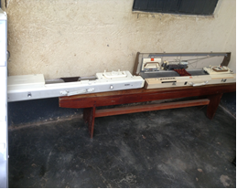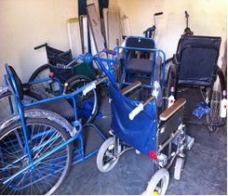
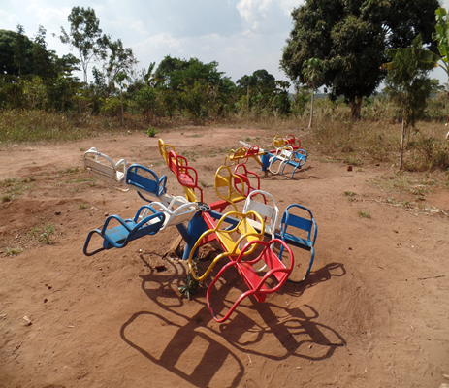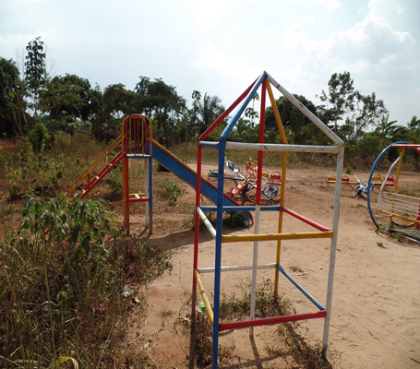
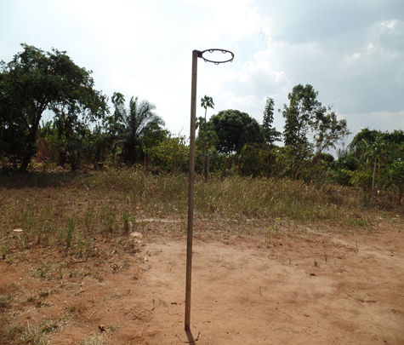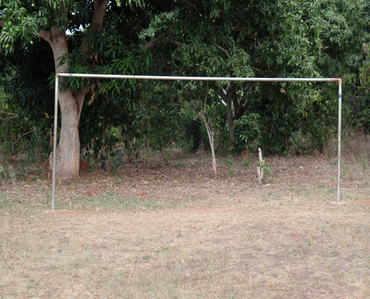

ACHIEVEMENTS
- Successful Expedition of HRID programs
- Constructed one spring well at Warrap State
- Constructed one drainable pit latrine at Baggari Primary school
- Installed 10,000 litter water tank at Wau Municipality
- Conducted Hygiene and Sanitation center
- Kitchen garden demonstration
- Community Participation
- Strengthened the relationship with local leaders
APPRECIATION AND THANKS
To all our stake holders working hard with our team to enable the fulfillment of Humanitarian Relief Initiative and Development objectives and goals.

Prepared by
Richard Lubangakene

Humanitarian Relief Initiative and Development

