Swaddling

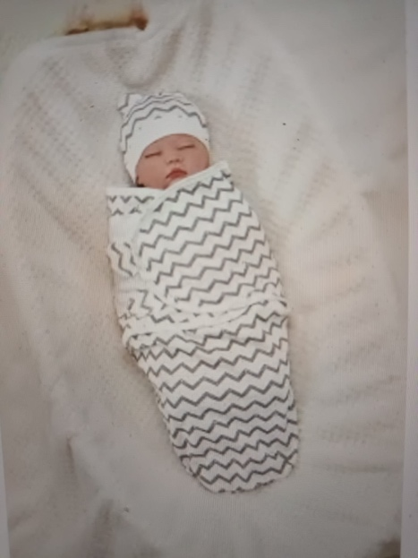

Ever imagined going from a nice warm dark snug womb where food was supplied without your effort, to suddenly being in open air, your arms and legs flailing around without boundaries nor you knowing how to control them, your eyes opening for the first time to lights and lots of unmuffled noise?

Welcome to the world everyone cried with joy! And you? You breathed in for the first time and cried out with surprise and fear at the newness of it all!

Enter the swaddling cloth. A nice soft warm blanket, usually of cotton, that some kind soul wrapped around you so you felt snug, warm and contained again! Yeah, you felt safer now! And slowly in your own pace, you can learn how to move your arms and legs.

The swaddling cloth is an ancient worldwide practice for newborns. It helps the newly born baby feel safe and cuddled. When babies are fussing, and you know they are not hungry or cold or have a soiled nappy, giving them a nice swaddle, and holding them lovingly is all they need to feel comfortable and happy again.

You might remember seeing old drawings or photos of Native Americans with a papoose for their new babies. Mothers could prop their swaddled babies against a log or rock and get on with their duties like grinding corn or scraping hides.

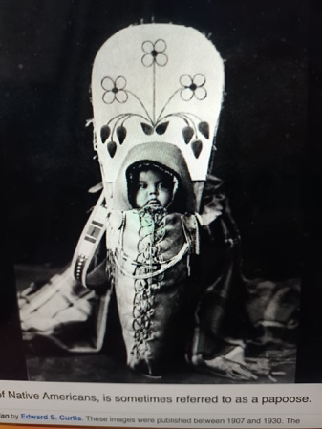

Likewise, in India swaddling cloths are still used to settle fussing babies, like this young chap. He looks content, wouldn’t you say?



In fact, swaddling a fussing baby is found in cultures and countries all over the world, from ancient to modern times. I remember my daughter, who was born with her arms over her head, crossed under the back of her head. She never wanted her arms swaddled (you can swaddle without the arms), but she loved the gentle comfort of the rest of her body and legs being contained in the swaddling cloth. If she had been fussing, after I swaddled her, she would peacefully go to sleep. There is something so soothing about feeling the cloth pressed up against you all over your body. You settle down. You feel loved and cared for.

Then, in time, you outgrow it. But that is after you have learned muscle control! It is disconcerting not knowing how to move your limbs, trying but not getting the desired result. That is why part of post-partum care in ancient cultures the world over is a daily baby massage and baby yoga / neuromuscular exercises. Soothing nourishing touch and someone helping you move your limbs and body so you learn how to move them yourself. AMI has so many good tricks up our sleeve to help the new baby adjust to its new life! Let’s get this beautiful knowledge out to everyone who needs it!

