IAHV – AMI

Why is skin to skin contact with Mum and/or Dad important for a newborn?
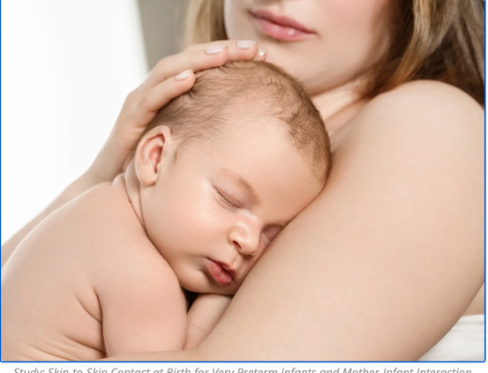
When a baby is born it is now standard good practice to put the naked newborn on the bare chest/belly of the newly delivered Mum. Why?

- Mum’s heartbeat regulates baby’s heartbeat. The baby has been protected in the womb for 9 months with dim lights and dim sound from outside and a steady heartbeat from his Mum. Being born is a big shock of sudden full light and loud sound for the newborn, and his heartbeat becomes erratic from cortisol flooding his system from the process of being born. But putting him on the mother’s bare skin next to her heartbeat is comforting and familiar. Hearing that regular beat calms him down and starts to regulate his heartbeat.

- Mum’s body heat stabilizes baby’s body heat. Baby has been kept warm inside the womb for 9 months. Now suddenly he is exposed to air on his skin, and has to regulate his own body temperature as a warm blooded mammal for the first time. Mum’s chest is 37° C. Putting the baby on her chest immediately warms him up. It is better than a warming lamp, and there is the added benefit of her heartbeat pounding through his skin to his ear! Remember newborns cannot hold their head up, so his ear is right there on her chest, soaking in the sound and warmth. And not only that, Mum’s skin adjusts its temperature to the baby’s: Mum’s chest temperature can increase by 2° if the baby is cold and can decrease by 1° if the baby is hot! This phenomenon has been studied repeatedly and found all over the world by different Mums in different cultures and countries of different temperatures. The mechanism of Mum’s womb to adjust temperature for the baby has been transferred to her exterior skin, automatically! Baby’s temperature is regulated faster than putting him under a warming lamp; put him on Mom’s chest!

- Mom’s rise and fall of the chest by her lungs stabilizes baby’s breathing. The baby has just taken his first breath of air when he is born. His breathing is irregular and shallow, fast and full of pauses. By putting him on Mum’s chest, the regular movement of her chest going up and down with her breath helps synchronize the baby’s diaphragm to follow a regular respiratory rhythm! It is an automatic kinesthetic reaction of the newborn to follow the cue of the mother’s chest movement. His breathing irregularities decrease because he is following his Mum’s breathing in his own shorter rhythm.

- Mom’s skin microbiome is transferred to the baby, strengthening his immune system. The newly born baby is exposed to the germs in the air and surfaces of his environment for the first time. He has not built his resistance to these microbes yet. During skin to skin contact, the mother’s microbiome begins to be transferred to the baby to help him fight the onslaught of the microbial world! Each human being’s immune system has been shaped by the environment we have been raised in. The ‘good’ bacteria help us survive and fight the world of germs we come in contact with. When these good bacteria and other organisms begin to colonize the baby’s body and begin to develop his defense system, they bring an immune blueprint for dealing with the specific environment the mother has been exposed to. This prepares the baby for the same environment he will be living in with his mother. It helps him survive!

- Oxytocin is released by both mother and baby upon skin to skin contact. Oxytocin is the hormone for bonding, decreasing anxiety, decreasing pain, building trust. If the baby is having skin to skin contact with the mother in the first hour after birth, the oxytocin output of both the mother and the baby will be the one of the highest in their lives. Oxytocin creates the feeling of being in love. This chemical helps override the pain, fear, exhaustion and trauma of childbirth and bonds the mother and baby permanently. Cortisol reduces in both people by virtue of oxytocin.

- For the mother, oxytocin also causes the let down response of milk, and the baby’s suckling initiates the contraction of the uterus to push out the placenta in one complete piece, decreasing the danger of her hemorrhaging from partial elimination of the placenta. All of this oxytocin cascade of actions is simply started by skin to skin contact.

Although the above is talking about the immediate hours after a baby is born, these effects also continue each time there is skin to skin contact of the baby with his Mom or Dad because the mechanism is the same, initiated by holding the baby to the skin – heartbeat regulation, body heat stabilization, breathing regulation, microbiome transfer, oxytocin release (also for the Dad), and cortisol reduction. The baby who gets regular skin on skin contact sleeps better, cries less, gets sick less, gains weight faster, and has better stress regulation! Remember: skin contact activates biological processes that support every system In the baby’s body for maximum growth, survival and development.

