QUATERLY REPORT TO GLOBAL GIVING, February 2024 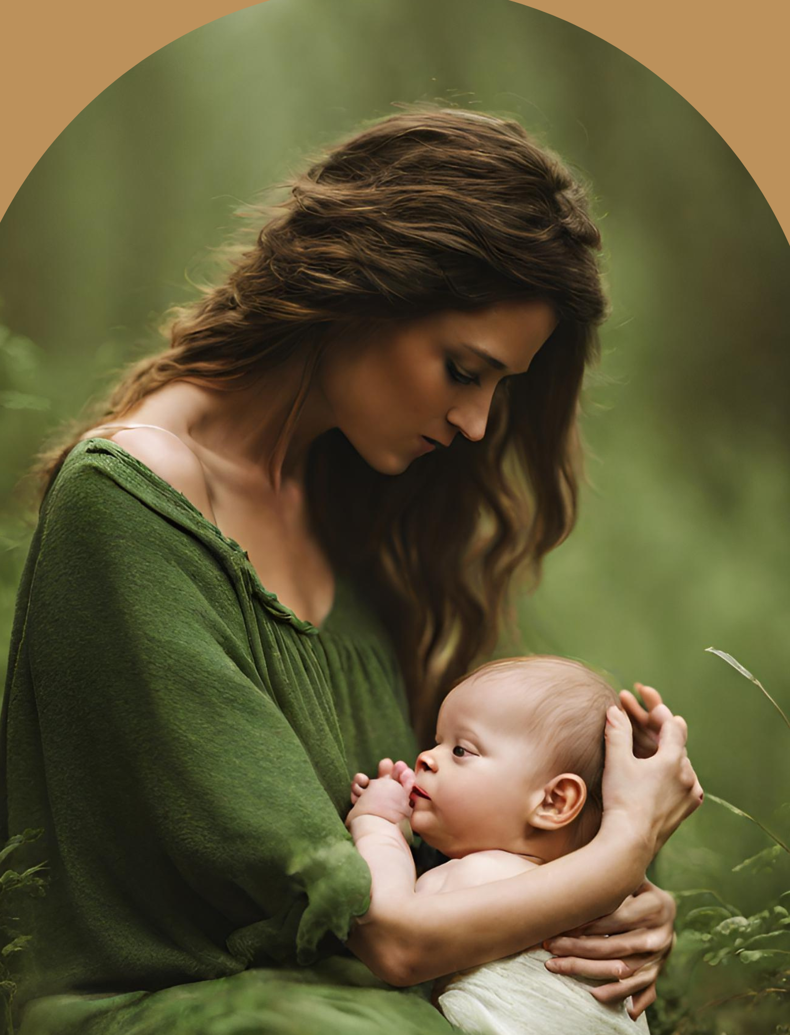

From the springboard of the positive response at the World Culture Festival in Washington DC, our team decided that it is time to take AMI to a greater level of awareness on social media.
These past 4 months have seen intense activity, first searching for the right professional promotion team and then inducting them into our philosophy and programmes.

We were so blessed to find two wonderful Argentinian promotion professional ladies living in Barcelona and already working with our sister organization, the Art of Living, in Europe.

We are also receiving very much appreciated service support from one of our members in the US. We are always happy to welcome supporters on to the team, whether just for an hour here and there or for a longer commitment.

Now, we are excited to share this news! Our first big promotion event for the online course for Infant Massage Practitioner Certification (IMPC) is making its debut on social media this week!

Through this growth in public awareness in the coming months and through consolidating our basic financial requirements, our attention will turn to the many mothers and families under great pressure in many parts of the world, whether it be in war zones, disaster areas, even in our own pretty stable countries where postpartum support is sadly neglected. This often leads to family depression, for both mothers and fathers.

We wish to explore how we can support women who suffer tragedy either as miscarriage or still birth. On top of their grief, women are neglected in these areas of postpartum care and need just the same ayurvedic support as new mothers and their infants. This work will need donations and grant support for sure.

In the coming months, do keep a lookout for us on Instagram and Facebook and, when you see us, please support us with your thumbs up!

With love,
From all the AMI team Su, Preeti, Wanda, Elisabeth, Marina, Lucila and Kathy and Ann

