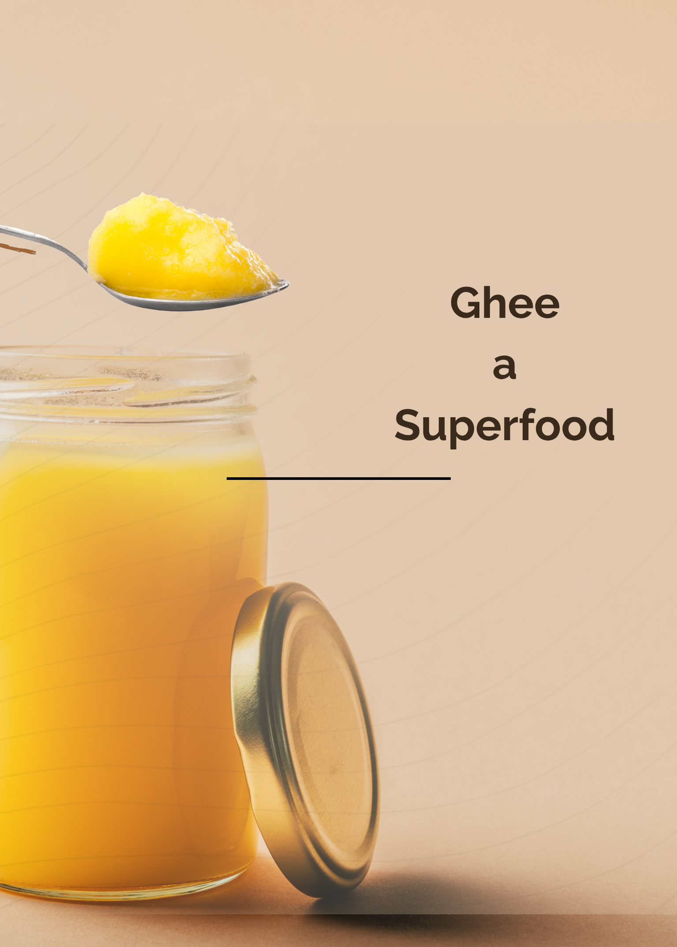

Ghee (Clarified Butter) — A True Superfood
Ghee is one of Ayurveda’s most prized foods. Known as a rasayana, it nourishes the body, promotes vitality, and supports longevity.
For many years, fats—especially saturated fats—have been unfairly blamed for poor health. In reality, it’s the wrong kinds of fats and excessive intake that cause problems. Trans fats, hydrogenated oils, and oxidized fats are the true health hazards.
It’s also important not to confuse pure ghee from butter with vegetable ghee.
Vegetable ghee was introduced in the 1960s to imitate traditional milk ghee. However, it’s made from partially hydrogenated vegetable oils and can contain up to 40% trans fats. Though praised for its long shelf life, high smoke point, and neutral taste, its hydrogenation process creates harmful fats that damage health.
According to Ayurveda, healthy fat intake depends on both quality and quantity.
The amount each person needs varies by constitution and balance. As a general guideline:
- Thin, wiry, or anxious individuals, or those who tend to overheat easily: 1–2 teaspoons per day
- Heavier body types: about 1 teaspoon per day
The best option is to make your own ghee from high-quality, organic, unsalted butter. A batch made from 3 kg of butter can last for many months. Ghee keeps well in a cool, dark place and does not require refrigeration.
When buying ghee, choose organic varieties—and, when possible, Desi ghee made from A2 milk for its superior quality.
Health Benefits of Ghee
Ghee made from milk offers many wonderful benefits:
- Naturally lactose-free, suitable for those sensitive to casein
- Detoxifies the body by penetrating cells and removing impurities
- Acts as an excellent lubricant for the body
- Has a high smoke point, making it one of the safest fats for cooking
- Supports hormonal balance and overall vitality
This last point is an essential ingredient of Ayurveda’s diet plan for postpartum mothers as it supports the rebuilding of a new mother’s hormonal system, the strength of her digestive system, and the reduction of the air and space(Vata dosha) produced in the early stages of postpartum, helping to prevent fatigue which, if not corrected, can lead to lethargy and potentially post-partum depression. ✨
“When we cook with ghee, we cook with love.”
A big ,big thank you to all of you who donated to the funding for Anna in Ukraine, we raised nearly £1000 for her, which is helping to provide a much more extensive support programme for pregnant and postpartum mothers in her area near Kiev.
With all love, the AMI team

Feel free to contact us at Ami if you wish to obtain more pearls of wisdom from Ayurveda.

