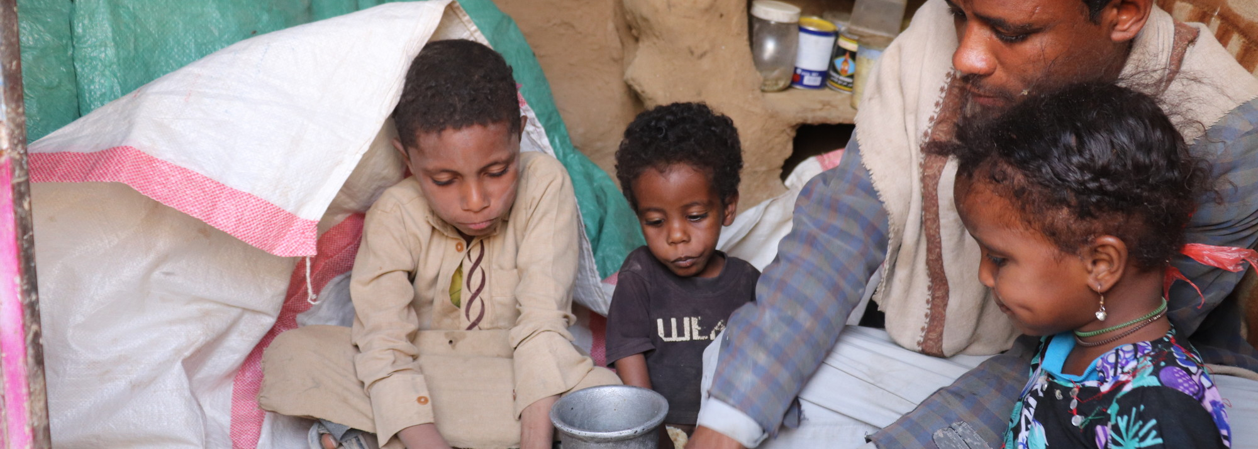
Empowering Women and Their Families in Emergency Response and Long-term Development
In Yemen – one of the countries most threatened by soaring food prices – many families eat only one meal a day.

Meeting Complex Needs
Conflict in Ukraine. Climate change. COVID-19. Today, the world finds itself facing previously unimaginable threats to our planet and its people. When disasters strike, the poorest, most vulnerable people suffer the most. CARE is meeting this moment by doubling down on our efforts to tackle the world’s most urgent challenges – responding to crises as they emerge while leveraging new partnerships, cutting-edge technologies and more impactful ways of working to fight long-term poverty and social injustice.

In response to immense needs caused by the war in Ukraine, we have extended our presence and partnerships into Ukraine, Poland and Romania. While reaching approximately 245,000 people with assistance during the first two months of conflict, we also are marshaling resources to address emerging secondary effects, including a rising wave of worldwide food insecurity linked to shortages and skyrocketing prices of inputs, grain and fertilizer. The situation is fraying the world’s safety net as rising costs have forced the U.N. World Food Programme to cut rations in countries like Yemen – where a long-running conflict has left 80% of the population in need of humanitarian aid. In many places, refugees and displaced people – like those forced from their homes in Syria – are especially vulnerable. Overall, the broader effects of the war in Ukraine on food supplies and prices threaten the world’s most vulnerable people – especially women and girls – with hunger and deeper poverty. Over the past year, CARE and our partners provided immediate aid to more than 24 million people in crisis. CARE’s goal by 2030 is to reach 10% of the population affected by major crises worldwide – at least 50 million people.

As our climate warms, we are experiencing stronger winds, higher storm surges and record rainfalls. Climate change is driving bigger floods during hurricanes, tropical cyclones and typhoons. More storms are reaching Category 4 or 5 – the most intensive – a trend that is expected to continue as the average global temperature increases. Storms also are moving more slowly across land, resulting in an even larger destructive path and severe flooding potential per storm. For example, Hurricanes Eta and Iota were two of the most powerful storms to hit Central America in decades. Occurring two weeks apart in November 2020, the hurricanes destroyed corn and bean production as well as other small-scale enterprises like pig farms, livestock and tilapia fish farms in many coastal and inland parts of Honduras, Guatemala and Nicaragua. The destruction resulted in a reduction or total loss of food reserves by the poorest and most vulnerable smallholder farming households as well as lost income due to damages to their farms, equipment and roads because of landslides and flash floods. CARE provided an immediate response to families most affected by Hurricanes Eta and Iota so they could restart their income-generating enterprises, meet their essential needs and stabilize their food security.

A record 279.3 million people are in need of humanitarian assistance, according to the U.N.’s 2022 Global Humanitarian Overview, marking a 19% increase from 2021. Of that total, nearly 236 million are in CARE’s programming countries.

CARE serves as a vital link between American generosity and families experiencing the effects of crisis, climate change and extreme poverty around the world. CARE operates efficiently to ensure that 90% of expenses go to program activities. This program/overhead ratio is exemplary among international nonprofits. CARE is ranked at the top of our peer group, with “A” and “4-Star” ratings, according to Charity Watch and Charity Navigator. Importantly, CARE is well placed to continue rising to challenges like COVID-19 surges and escalating hunger crises, with 95% of our staff being from the communities where they work.

Across the globe, COVID-19 has affected everyone. The economic aftermath likely will push 426 million more people into poverty – more than the population of the U.S. and Canada combined – and potentially reverse development progress by up to 10 years. In the first year of the pandemic, CARE reached more than 34 million people by establishing COVID treatment and isolation centers, supporting vaccination campaigns, and delivering lifesaving medical equipment, nutritious food and hygiene supplies to health facilities and remote communities. These efforts continue today as part of the largest emergency response in our history. Most recently, in the past three months, we directly reached more than 20 million people through COVID-19 specific responses in 49 countries, and 146.4 million people (including 122.8 million in India) have been vaccinated in areas where CARE is promoting vaccination rollout and addressing vaccine hesitancy through multimedia campaigns. Vaccine delivery is expensive – as much as seven times more than initial projections, according to CARE’s recent studies in Nepal and Zambia – and flexible funding is essential to closing these gaps.

Flexible funding is needed now more than ever
Donors have generously supported CARE’s response to the war in Ukraine, allowing us to continuously scale up our response to reach more people in dire situations. However, those funds do not apply to other communities that receive little attention in the international media but where our help also is desperately needed. Russia exports 21.8% of the world’s wheat, while Ukraine is responsible for 10.6% of global wheat exports. The U.N.’s Food and Agriculture Organization estimates that ongoing hostilities could trigger an increase in international food and feed prices between 8% and 22% on top of already high costs. Some of the world’s hunger hotspots – from Afghanistan to Ethiopia to Honduras – could be disproportionately affected by the unfolding crisis due to their dependence on imported wheat and other farm inputs. Flexible funds are needed to respond to the broader impact of the Ukraine crisis on global food security. Moreover, global challenges require more flexible funding sources to help families restart livelihoods that have been stalled during the pandemic, adapt to the effects of climate change, and be better prepared for the inevitable next emergency.

Providing flexible funding to CARE’s Impact Fund is an expression of solidarity with people in some of the poorest communities around the world. In contrast to restricted funding that supports one project or initiative over a year or two, flexible funding helps CARE increase our total global impact and make targeted investments for the long term to help build a better world. Flexible funding gives CARE the freedom to allocate resources where they will make the most difference. This type of funding unlocks CARE’s ability to respond nimbly and quickly to crises/shocks, fill funding gaps in existing projects, create or expand our most effective and innovative programs, and transform successful field experiences into policy influence to multiply impact.

Philanthropic Support In Action
To meet today’s complex needs, CARE continues to deliver lifesaving humanitarian assistance while also adapting and scaling up our sustainable development programs across 102 countries. We know this approach works because we see the impact every day. Last year, CARE worked in 102 countries with 1,495 projects that directly reached more than 100 million people (71% women and girls), and indirectly improved the lives of nearly 160 million more people through policy changes and replication of successful programs by partners and governments. Our focus on promoting gender equality – and developing the skills of women smallholder farmers, unbanked women and frontline healthcare workers – has helped elevate the status of marginalized women, empowering them to become more valued partners and contributors to family and community success. By 2030, we aim to help 50 million people experience greater gender equality. To maximize the impact of our programs, we work with and though partners to scale up effective solutions and reduce poverty through policy change. Below are examples of how our work is making an impact.

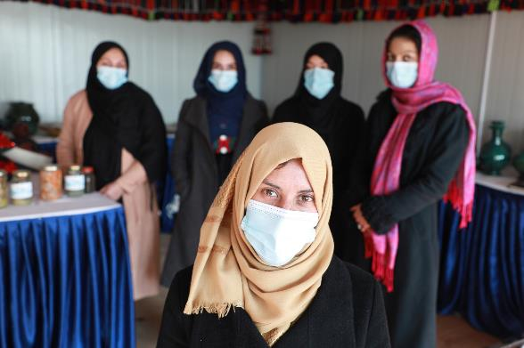
Addressing urgent needs in ultra-challenging situations. The humanitarian situation in Afghanistan continues to deteriorate, with the ongoing crisis made far worse by insufficient rain and crop failures. About 24 million people there need humanitarian assistance, and 3.4 million people are displaced. Of the 700,000 people forced from their homes since August 2021, 80% are women and children. CARE is scaling up a comprehensive response to help displaced families and other vulnerable Afghans. We are providing emergency multi-purpose cash assistance, cash for work, medical supplies, mobile health teams, food and agriculture support, household and hygiene essentials, and supplies to help cope with winter weather.

Improving vaccination rates – from second-worst to second-best vaccination rate in the country. In June 2021, the government of Bangladesh requested CARE’s support to step up COVID-19 vaccination efforts in southwestern Khulna district, which had the second-lowest immunization rate in the country – only 7%. Just three months later, the vaccination rate in Khulna had increased to 36%, with more than 1 million vaccine doses administered to marginalized people, elevating the district to the second-highest vaccination rate in the country, after Dhaka, the capital. The entire vaccine registration system is online in Bangladesh, so CARE’s response team focused on reaching people who were illiterate or lacked access to smartphones to register. We hosted community education sessions so people got the information they needed to trust vaccines, and organized door-to-door visits to further reduce vaccine hesitancy and increase registration. CARE trained 650 government health workers and inspectors to strengthen vaccine deployment and to make sure the system works, and oriented 900 volunteers to support vaccine registration and community awareness. Vaccine support is an important part of CARE’s overall efforts to help 50 million people fulfill their right to health by 2030.

- Meeting the needs of refugees and migrants. An estimated 7.7 million people need humanitarian assistance in Colombia, a country reeling from the economic impact of COVID-19, an increase in armed conflict, natural disasters and the effects of climate change – all while struggling to absorb a large influx of refugees. About 554,000 Venezuelans have received temporary protected status in Colombia (allowing them to remain up to 10 years, with permission to work and access social services), while another 2 million are in the process of regularization. The situation places extreme stress on women, girls and other vulnerable populations. In addition to assisting with food and other basic needs – including through cash and vouchers – CARE has focused our response on sexual and reproductive health, protection for vulnerable individuals, and prevention of gender-based violence. To foster social cohesion, we aim to include 30% host community members in every intervention targeted at refugees.
- Enabling poor families to have (and grow) more food. In Syria, CARE worked with 1,438 farmers to grow 1,800 metric tons more wheat – enough to feed nearly 26,500 people for an entire year. In Malawi, through the Titukulane activity (meaning “let’s develop together”), we invested early to build micro-dams in coastal communities that saved 1,199 hectares (nearly 3,000 acres) of crops for 2,174 families when Cyclone Ana flooded all the nearby farmland in January 2022. By 2030, we aim to enable 75 million people, the majority of them women and girls, to fulfill their right to adequate food, water and nutrition.

- Innovating for the future. CARE has the world’s largest pipeline of promising social enterprises that can yield broader and more sustainable results than humanitarian aid alone. We see the potential to impact up to 235 million lives by 2030 through the expansion of several viable social businesses emerging from our current programs that provide jobs, income and vital services, and help communities overcome COVID-19 and other challenges. These include enterprises like Live Well in Zambia, an impact-driven social business that promotes healthy behaviors, provides access to health products such as anti-diarrhea kits and mosquito nets to rural families, and supports livelihoods in underserved communities, through a network of 2,285 trained community health entrepreneurs. Live Well aims to triple the number of sales agents by 2024, providing the opportunity for year-round, community-driven employment, as opposed to struggling to find seasonal farm work. Within the first six months of COVID-19, Live Well distributed more than 90,000 items that helped protect against the virus, including soap, chlorine, masks, gloves and hand sanitizer.

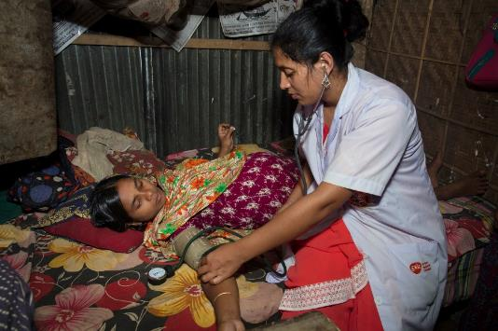
In two rural districts in Bangladesh, where families have little access to quality healthcare services, CARE developed a public-private partnership to identify, train and support a network of 410 skilled health entrepreneurs. These entrepreneurs fill a critical need by providing frontline maternal, newborn and child health services, family planning options and essential health goods in remote communities. They are accredited as skilled birth attendants by the Bangladesh Nursing Council after six months of training and go through further instruction on nutrition, family planning, non-communicable diseases and social entrepreneurship. Each woman health entrepreneur covers about 7,500 people and is supported by 10 community health volunteers who help generate local awareness for services. On average, health entrepreneurs earn $20 per delivery, paid by the families. This compares with the $50-$100 cost an expectant mother would pay to travel and receive services at the nearest hospital, a minimum of 10-15 miles away. As a result, delivery by a skilled attendant increased from 13% to 37% in target communities; newborn deaths dropped by 21%; and deaths of children under 5 were cut nearly in half (46%). Moreover, in the first three months of the pandemic, health entrepreneurs identified and referred 406 COVID-19 cases and conducted counseling sessions for nearly 60,000 people on handwashing, using facemasks and social distancing.
Nurun Nahar was forced to marry at 14 and soon got pregnant. Her husband left her to support their daughter on her own. After observing the need for skilled health workers in her remote area, Nurun trained to become a health entrepreneur and has since delivered 30% of the babies in her area.

- Helping people persevere through the pandemic. CARE’s innovative Village Savings and Loan Association (VSLA) approach empowers groups of 20-30 people (80% women) with training and tools to save money, take out loans, start small businesses and form networks. As we entered 2020, CARE was on track toward our goal of reaching 50 million more women and girls with VSLAs by 2030. However, the onset of COVID-19 and its catastrophic impact became the impetus for a major change in direction. VSLAs have taken on a central role in CARE’s COVID-19 response, supporting communities, sharing important health messages and refocusing finances to adapt to the crisis. CARE takes our lead from women across the globe as they define their own needs, priorities and ideas for navigating the pandemic. Despite unprecedented challenges:
  - We doubled the pace of creating new VSLA groups, adding 1 million new members in 2020 alone.
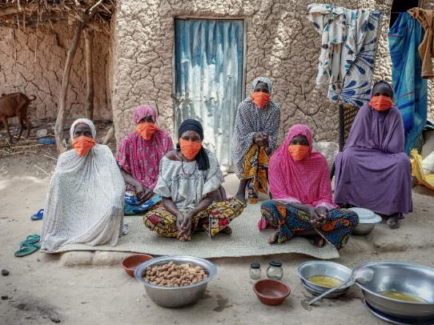
  - 67% of VSLAs are using social funds to help vulnerable members response to COVID, mostly by buying food and hygiene products.
  - 56% of VSLA groups have continued to save during the pandemic, and 54% of groups are still providing loans to members.
  - In Rwanda, we engaged VSLA members in couples dialogues and community activism, resulting in a 55% decline in domestic violence and a 20% increase in incomes.
  - In Ethiopia, VSLA members achieved an 80% increase in food security and 84% increase in incomes.

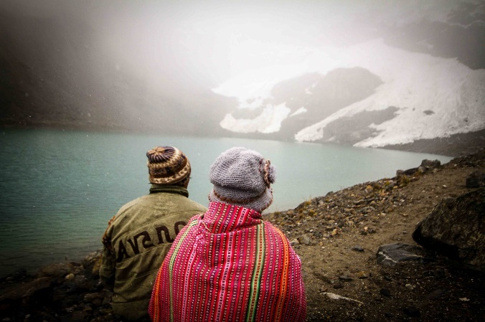
- Adapting to the impact of rapid glacier melt. Peru is home to 71% of the world’s tropical glaciers, which are critical to providing freshwater and sustaining millions of people. With climate change, approximately 43% of Peru’s glaciers have melted since 1970, and the highly unstable glacial lakes they leave behind constitute a growing threat to families in the valleys below when an earthquake triggers a flash flood. Over the past decade, CARE, the Peruvian government and the University of Zurich have worked together on the Glaciares+ project to monitor glaciers and manage 200 associated new lakes used for drinking water and agriculture, and created evacuation maps and the first-ever real-time flood early warning system in South America for vulnerable communities located downstream. The project also worked with Peruvian research institutions to locate possible future glacial lakes as well as estimate the potential socio-economic loss associated with glacial retreat and water loss due to climate change – another first for Peru. We piloted adaptation projects to demonstrate the costs and benefits that can be used to design projects for public investment in other vulnerable communities faced with similar challenges. The model includes water management to ensure sustained access to potable water, water capture and irrigation systems, agricultural and food production systems, and livestock management. The first national adaptation models benefited nearly 70,000 people with reduced risk of water insecurity and climate shocks. The results provided a solid foundation to facilitate community-based adaptation approaches that can be scaled up in different ecosystems and contribute to the development of climate change public policies. This is just one example of how CARE aims to help 25 million poor and marginalized people strengthen their resilience and adapt to the effects of climate change by 2030.

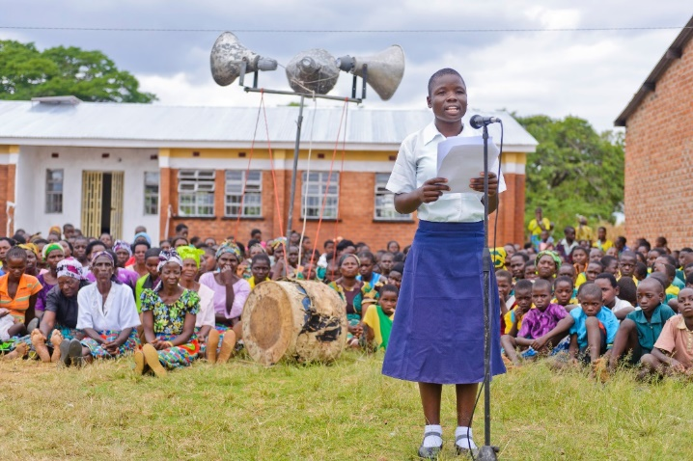
- Restoring education. Flexible funding allows CARE to share knowledge and innovation across countries. CARE originated the SOAR program in India in 1999 to help out-of-school adolescent girls get a fifth-grade education in just 11 months while also developing leadership and life skills designed to help them integrate into formal government schools or to pursue a vocation. Over the years, 95% of out-of-school girls who completed CARE’s accelerated learning program transitioned to formal schools. Refining the program for different contexts, we have expanded SOAR coverage in India, Malawi, Nepal, Somalia, Zambia and Zimbabwe, working with communities to mitigate COVID-19 learning losses that threaten students’ ability to safely return to and stay in school. To date, CARE’s education and empowerment work, including the SOAR program, has reached 4.1 million adolescents. In Zambia, for example, we achieved significant positive impact for 34,844 young children and adolescents across 20 communities during the first three years of implementation. With a focus on achieving scale and sustainability, CARE partnered with Zambia’s Ministry of Education to create the first-of-its-kind curriculum Raising Stars to support parents in enriching their children’s learning and development at home as well as worked to develop another first-of-its-kind curriculum in the country for out-of-school adolescents. Phase II of SOAR in Zambia recently commenced and expands our direct reach in two new districts. Building on this momentum, the Zambian government announced plans to recruit 30,000 teachers, build 120 schools, increase grants to schools and remove exam fees, which will provide relief to poor households that cannot afford the cost. The proposed government education expenditure in 2022 represents a 31% increase over the 2021 allocation. Overall, SOAR has helped change mindsets around education, increasing the value that parents place on learning and enrollment of children and adolescents in school.

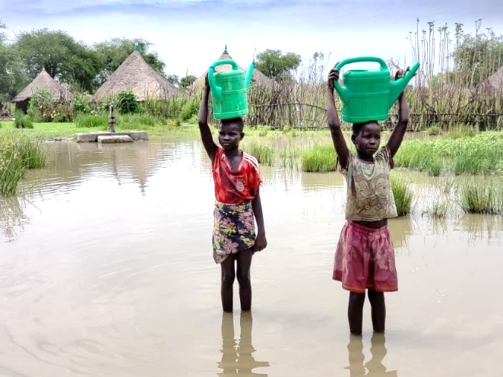
- Responding to the climate crisis, which transforms annual floods and drought into catastrophe. Amid all the innovation and impact, we also need flexible funding to go toward long-term crises that don’t get lots of attention. The climate crisis is exacerbating already dire weather patterns across East Africa. South Sudan, for example, is struggling with the most intense flooding in decades. More than 800,000 people across eight of the country’s 10 states have been affected, with 426,000 people displaced from their submerged communities. Families already weakened by conflict and chronic hunger are now at the brink. Already one of the world’s most logistically challenging countries, many people in remote areas are cut off from humanitarian aid. Canoes and specialized equipment are being used to reach communities. CARE has adapted our nutrition activities, targeting displaced pregnant and breastfeeding women and children under age 5 with critical lifesaving assistance including medicine, temporary shelter, mosquito nets, drinking water, hygiene supplies and emergency food. We continue to scale up outreach sites to meet the needs. Our ability to implement longer-term assistance and climate mitigation measures will be crucial. Meanwhile, in Somalia, a long-running drought emergency continues to intensify, affecting 4.5 million people as of February 2022, up from 3.2 million in December 2021. People are on the move in search of water, food and pasture for their herds, and acute malnutrition levels of children continue to rise. CARE’s multifaceted response to the crisis in Somalia includes supporting communities with primary healthcare services, cash transfers, nutrition outreach, water and sanitation, education, and protection services.

THANK YOU FOR YOUR PARTNERSHIP
In such unprecedented times, flexible funds are more important than ever. On behalf of the millions of people CARE serves around the world, thank you for considering a gift to the Impact Fund that will support high-quality, gender-equal humanitarian and development assistance that is locally led and with global reach.

