**CARE** Emergency Update

**AFGHANISTAN**

*Photo Credit: OCHA/Charlotte Cans*

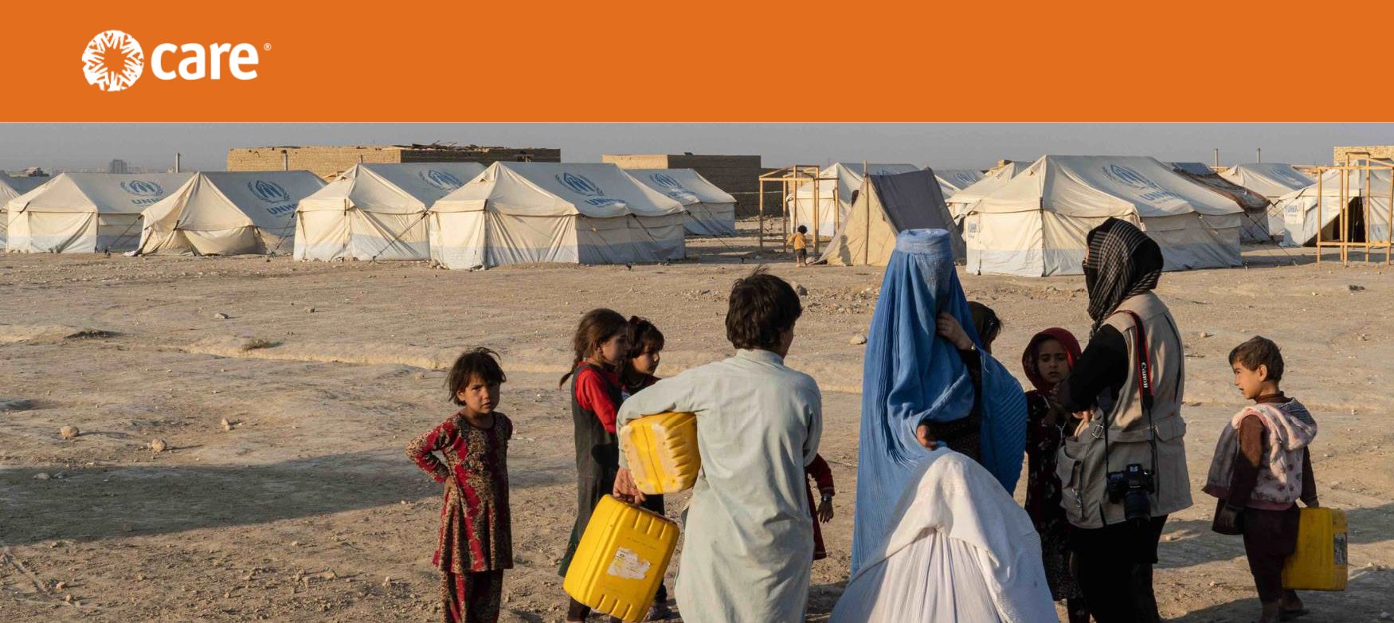

**Freezing temperatures will threaten millions of displaced Afghans this winter**

**Background**

The harsh winter months have always been a difficult time for vulnerable people in Afghanistan, but this year will be particularly bleak. As temperatures drop and snow begins to fall, the humanitarian situation – already one of the world’s worst – will further deteriorate, particularly for families displaced by drought, poverty and protracted conflict. According to the humanitarian community’s [Joint Winterization Plan,](https://www.sheltercluster.org/sites/default/files/docs/winterization_plan_2021_v3_23_august.pdf) 12.1 million people will need help this winter to cope with the cold weather, with needs including shelter, blankets, heaters, fuel, winter clothing and shoes, food and healthcare, among others. Particularly in mountainous areas of the country, freezing temperatures will pose a serious threat to those without the means to protect themselves.

The winter weather will impact vulnerable Afghan families at all levels:

• **Food security:** Winter is traditionally the lean season – the time between harvests when food stocks are low – and this year is no exception. The recent drought has negatively impacted food and livestock production and depleted people’s reserves. Some 18.8 million people – nearly half the population – are now facing [high levels of acute food insecurity.](http://www.ipcinfo.org/ipcinfo-website/alerts-archive/issue-49/en/) Climate change, along with the effects of La Niña, is one of the factors driving hunger. Afghanistan is one of the most vulnerable countries in the world to

climate change and one of the least equipped to manage the impact. Food insecurity uniquely impacts women and girls, especially where cultural norms prioritize feeding male family members first. As food availability decreases and stress increases, women and girls are at greater risk of gender-based violence (GBV) and are more likely to resort to high-risk coping strategies, including transactional sex, or may be forced to marry. The food crisis also leads to additional displacement, which in turn further increases women’s and girls’ vulnerabilities.

• **Health:** Winter brings a rise in respiratory infections, as well as an increase in hospitalizations, morbidity and mortality. An estimated 25%-30% of deaths in children under age 5 are due to such infections, with 90% of deaths due to pneumonia.1 COVID-19 also continues to pose health risks for poor and displaced Afghan families, and winter weather often closes roads and prevents access to the nearest hospitals and clinics.

1 Afghanistan Joint Winterization Plan, Nov. 2021-Feb. 2022.

• **Education:** Winter also presents a challenge for children who struggle to access a quality education. As the Joint Winterization Plan notes, children need to make up for lost learning time – largely due to displacement and the COVID-19 pandemic – during the upcoming months, but most schools lack adequate heating and close for

the winter break. Moreover, remote learning opportunities – such as online classes – aren’t an option for most students.

Within this context, CARE is building on our existing presence in Afghanistan – dating back

**Voices of Afghan women:**

**Aziza, age 35:** *“Winter is my biggest concern. There is no work, prices have gone up. On one hand, there is no food and on the other, the weather is cold and we don’t have money to buy wood. I do not know what to do.”*

**Minhaja, age 35**: *“I think the situation will get worse because winter is coming and we don’t have warm clothing, firewood or food. This is not only a big concern for my family, but for the majority of people.”*

**Soma, age 50**: *“Our condition is bad enough now, we can’t even think about winter. It is clear if this situation continues, a lot of people will die from cold weather.”*

to 1961 – to launch a comprehensive humanitarian response with an immediate focus on meeting people’s

urgent needs for the winter. Says CARE Country Director Victor Moses, “The looming, brutal Afghan winter is of great concern. Without the needed donor funding and sufficient time for supplies to reach remote areas before the heavy snowfall blocks access, communities will be facing catastrophic food shortages and insufficient protection from the elements. We are deeply fearful for what lies ahead for vulnerable Afghans.”

**CARE’s Response**

The overall goal of CARE’s humanitarian response in Afghanistan is to provide life-saving assistance and livelihood recovery support. CARE’s response strategy has three phases and will allow us to reach **1.8 million people** (257,000 households) over three years, representing about 10% of people in need in Afghanistan. We will focus on nine provinces (Kandahar, Herat, Balkh, Ghazni, Kabul, Kapisa, Khost, Paktia and Parwan) where we

have an existing presence and offices that are open and functioning. Women and girls will remain at the center of CARE’s response. They will be consulted directly and engaged fully in the design, implementation and monitoring of program activities.

1. **Phase I: Relief (Months 1-3):** Targeting internally displaced people (IDPs), returnees and host communities and reaching an estimated 247,100 people in 35,300 households. **This phase will help people during the onset of winter**, with a focus on immediate life-saving assistance and the urgent resumption of key health, protection, education and livelihood activities.

2. **Phase II: Early Recovery (Months 4-12):** Targeting all vulnerable groups with livelihood support, cash for work and primary health care, reaching 465,360 people in 66,480 households.

3. **Phase III: Longer-term Recovery (Years 2-3):** Scaling up education and economic recovery programs, reaching 1,086,540 people in 155,220 households.

**Winterization Activities:2** Winterization activities are a critical part of CARE’s immediate relief work (Phase I). To meet the most urgent needs for 5,600 households (27,200 people), CARE will implement a 3-month program with two components:

• **Distribution of winterization kits**, including warm clothes, shoes, hats, gloves, caps and socks, to IDPs and the most vulnerable host community members.

• **Distribution of cash** to cover the cost of rent for three months during the winter. The cash assistance will get people out of tents and temporary shelters and into houses for the coldest months of the year.

2 CARE also plans to provide winterization support in neighboring Pakistan during the cold winter months, with a focus on disaster- affected districts of Khyber Pakhtunkhwa and Baluchistan. CARE further aims to support 5,000 households (35,000 people) with winterization kits, including warm bedding, mattresses, shawls, sweaters, socks, caps and gloves, over a 4-month period.

Targeted provinces for the winterization activities include Balkh, Kapisa, Parwan, Kabul, Paktia and Ghazni. In addition, we are prioritizing four other focus areas for Phase I:

|  |  |
| --- | --- |
| **Focus Area/Target** | **Phase I Emergency Relief Activities** |
| **Health:** 179,713  people (60%  female) | • Establish and deploy mobile teams to provide primary and reproductive healthcare  • Support immunization of children under 5 and pregnant and breastfeeding women  • Support nutrition screening and infant and young child feeding  • Provide counseling services and referral of malnutrition cases for children under 5 and pregnant and breastfeeding women |
| **Food Security and**  **Livelihoods:** 23,500 households | • Distribute food and multi-purpose cash assistance to the most vulnerable  • Distribute vouchers for agriculture inputs, such as seeds, equipment, materials and fertilizers, to IDPs and other eligible individuals  • Provide wheat seeds and wheat flour (vouchers)  • Deliver training on crop production using the distributed seeds |
| **Education:** 12,000  people (50%  female) | • Provide students with material support required to access formal education  • Train teachers to deliver lessons  • Support non-formal education opportunities for out-of-school children, including catch-up and remedial education, as well as literacy and numeracy skills  • Provide psychosocial support and life skills training to school counselors |
| **Protection:** 41,130  people | • Provide GBV-focused and life-saving services at health facilities and community centers, with a focus on case management and referrals  • Establish safe spaces for women and girls that cater to those with disabilities  • Boost GBV awareness with both men and women, including community leaders |

**Activities to Date**

In recent weeks, CARE has provided the following life-saving support:

• Financial assistance that allows families to decide for themselves what they most need, including supplies to prepare for winter, while also supporting the local economy;

• Work opportunities and livelihood recovery assistance to those most affected by the severe drought and most in jeopardy as winter approaches;

• Health programming and nutritional work;

• Non-food emergency items to help meet basic needs as cold weather approaches; and

• Resumption of support to farmers in several provinces, including the provision of fertilizer, tools, seeds and training to encourage women to develop home gardens and other livelihood opportunities.

Building on decades of experience in Afghanistan, CARE **remains committed to helping vulnerable people, particularly as the deadly winter approaches.** CARE’s response targets people affected by conflict, drought and COVID-19, with a focus on women and girls.

*October 27, 2021*