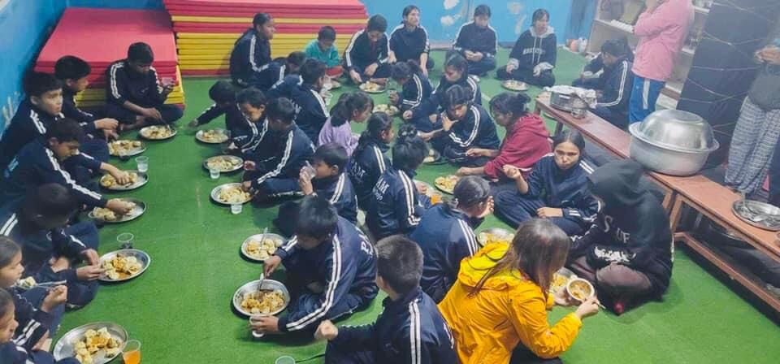
PAM Children enjoying dinner hosted by the community neighbour

