Project Title
Restoration and Management of Riparian Ecosystems and Adjoining Landscape in Ghana’s Ashanti Region.

Project Summary
This project will contribute to the implementation of the 2013 Riparian Buffer Zone Policy for Managing Freshwater Bodies in Ghana as well as restore the livelihood of 1500 poor rural women whose lands have been destroyed through indiscriminate and uncontrolled sand winning in the Ashanti Region of Ghana. Specifically, it will:
- Sensitise communities on conservation of buffer zones.
- Restore green spaces with native grass, shrubs and trees.
- Support 1,500 poor rural women to plant yams for income.

The Problem
The sources of livelihoods of 1500 poor rural women have been destroyed through indiscriminate and uncontrolled sand winning in Ejisu and Kwabre East Municipalities in the Ashanti Region of Ghana. These women can no longer grow staple foods such as cassava, yam, maize and vegetables such as pepper, okra, garden eggs on low level lands. In the process, small perennial streams ecosystems have not been spared despite the existence of the 2013 Riparian Buffer Zone Policy for Managing Freshwater Bodies in Ghana which puts riparian buffer zone limit between 10 to 20 metres for small perennial streams. Continuation and exacerbation of sand winning has added to the sad plight of poor families who depend on these perennial streams for their entire water needs.
The riparian vegetation extends along the catchment landscapes of the water bodies and provides a wide range of socio‐economic, biophysical and ecological functions. These poor and unsustained management practices are jeopardizing the physical quality of the environment, the hydrological and ecological support systems and the livelihoods of local inhabitants around these water bodies. These activities have further exposed most of Ghana’s rivers and water bodies to the vagaries of the weather, and may as a result, account for the many streams and rivers, which used to be perennial, but are now experiencing periodic drying up according to the policy document mentioned supra. Reduced vegetative cover along water bodies, coupled with increasing pollution from domestic and in some cases industrial waste, has resulted in increased sediment and nutrient loading of streams, leading to the deterioration in water quality of the natural water bodies.

The process continues unabated because the bodies charged with implementation of the riparian policy such as Local Authorities, Ministry Of Water Resources, Works and Housing, Environmental Protection Agency and others lack the requisite resources and the political will to act. If nothing is done to reverse the situation, many households, especially women and children, will go hungry and dead making it difficult to meet the Sustainable Development Goals (SDGs); Goal 1: End poverty in all its forms everywhere, Goal 2: End hunger, achieve food security and improved nutrition and promote sustainable agriculture, Goal 5: Achieve gender equality and empower all women and girls, Goal 6: Ensure availability and sustainable management of water and sanitation for all among others.
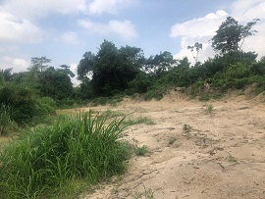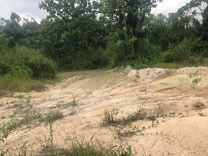
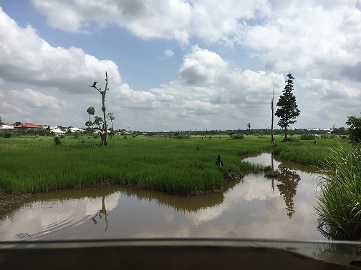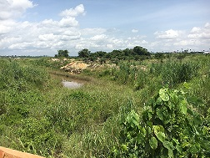
Pictures of the nature of the problem in some of the target communities

Therefore, we humbly request for the support of donors, philanthropist and other individuals passionate about the plight of these poor women and their communities to:
- Restore the vegetation of trees, shrubs, herbaceous plants and grasses for the preservation of the stream channels integrity and bank stability and protect them from future encroachment and environmental damage.
- Empower the target communities on conservation of buffer zones through research, education and training.
- Promote networking and exchange of good practices and experiences with other restoration and protected areas.
- Train 1,500 women in the target municipalities on yam and honey production, provide start up and market linkage support to them.

Objectives
The aim of the project is to contribute to the implementation of the Riparian Buffer Zone Policy for Managing Freshwater Bodies in Ghana, 2013 by restoring the vegetation of trees, shrubs, herbaceous plants and grasses for the preservation of stream channel integrity and bank stability. It specifically addresses four complementary and interlinked processes:
- Empowerment of communities on conservation of buffer zones through research, education and training.
- Development/establishment of green spaces with native grass, shrubs, and trees along waterways and protecting them from future encroachment and environmental damage by restricting the zone from the removal of soil, trees and other natural features
- Development of community-based initiatives of natural resources valorisation (i.e. activities that generate revenues), with particular attention to gender equity;
- Promotion of networking and exchange of good practices and experiences with other restoration and protected areas.

Who will be involved?
Three (3) key partners are involved in the implementation of the project;
- Freeworld International (FI); A local NGO based in Ejisu Municipal with experience in community mobilisation and capacity building of stakeholder groups. FI is the lead applicant for this project.
- Zenith Support Foundation (ZSF); A local NGO based in Kwabre East Municipal in the Ashanti Region. ZSF is a led by an experienced conservation specialist with over 15 years of experience in conserving animal species and forest.
- National Disaster Management Organisation (NADMO); A department of the Ejisu Municipal Assembly that is responsible for preventing disasters, creating awareness in disaster prone communities and institutions on all hazard/disaster types, training and motivating communities especially volunteers to initiate actions to prevent and respond to disasters, bringing relief to disaster victims and assisting to reduce poverty in vulnerable and poor communities through social mobilisation for employment creation and income generation.

The partners will work with 10 NADMO Volunteer Groups based in the target communities, 1500 vulnerable Women, 10 Assembly Members, 10 Traditional Authorities and other community members who are passionate about the deteriorating situation of the river bodies and landscape to bring about the needed change in 10 target communities in Ejisu Municipal and Kwabre East Municipal.

The project seeks to achieve the following benefits:
- Improved water quality resulting in less run off and erosion. This will allow more recharging of the ground water supply. It will also help prevent the transport of sediment and chemicals into streams. Very poor people who depend on these streams for their water needs will now have year round access to water.
- Carbon sequestration: According to US Department of Agriculture one acre of forest absorbs six tons of carbon dioxide and puts out four tons of oxygen annually. The project will plant a total of 10,000 trees covering an estimated area of 20 acres involving 1500 women and 30 members of NADMO Volunteer groups.
- 1500 women and 30 Volunteer Group Members have improved skills in compost preparation as a climate mitigation measure and enhanced income from planting yams in sacks using the compost as well as long term income from harvest and sale of tetrapleura teraplera fruits on denuded soils and sale of the honey.
The key activities will include;
- Purchasing of seedlings.
- Inception Meetings with stakeholders to introduce the project and solicit their support.
- Needs assessment and selection of 300 beneficiary women.
- Community outreaches on the effects of deforestation on the livelihood and health of the communities.
- Training of women and NADMO Volunteers groups in tree planting and compost preparation
- Nursery and watering of seedlings.
- Transplanting of trees along river bodies and other degraded landscapes
- Planting of yam and tetrapleura teraplera on degraded landscapes by women and NADMO Volunteer Groups.
- Monitoring and Evaluation activities
- End of Project Assessment
- Close out meeting.

Community Support
The Assembly Members have accepted the project and have provided areas (destroyed lands and water bodies) where the Tree Planting Project can be done in their communities. NADMO Volunteer groups have agreed to support in the nursing, planting and watering of trees, monitor and protect the river bodies and the restored landscape beyond the project. Through inception meetings, the project will solicit the support of Traditional Authorities, other community members and the Local Authorities.
In addition to the above, the 1500 selected beneficiaries will provide sacks and sand for planting the yam. They will also fetch water for watering the trees, yam and tetrapleura teraplera. They will also play active roles in the planting activities.
Monitoring, Evaluation, Learning and Accountability (MELA)
A MELA team comprising staff from the three partner institutions and the target communities will embark quarterly monitoring to collect data on the implementation of the activities. The MELA Team will be responsible for developing a log frame and the data collection tools for the monitoring activities. Quarterly monitoring activities will be climaxed with Learning Festival where the MELA Team meet with project stakeholders to discuss the findings of the monitoring and the way forward. Lessons learned will be also be solicited, documented and included in the Project Reports. Quarterly Progress Reports will also be shared with stakeholders.
Annual Review meetings will be held at the end of the year to review the project.
A sample of the yam production methods and trees are shown below:

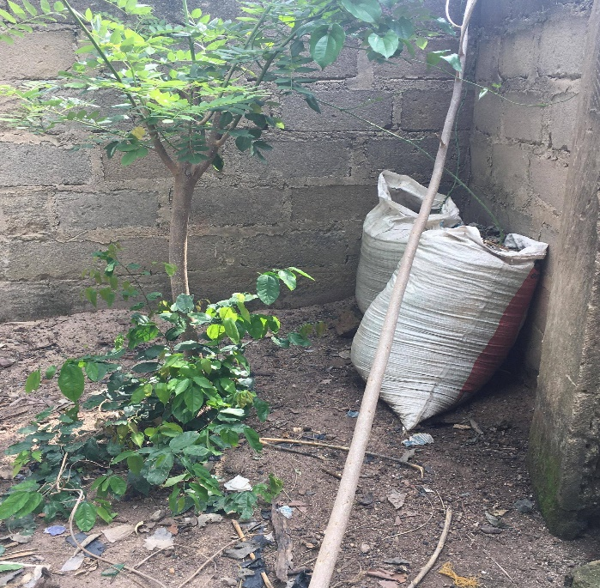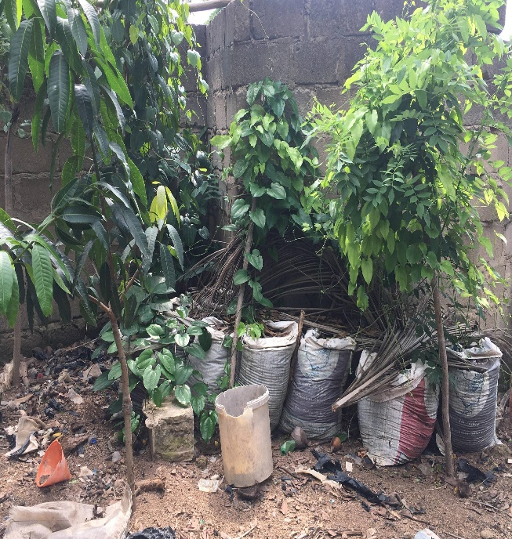
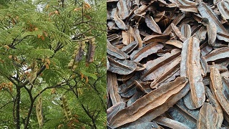

Project Management
Freeworld International (FI) will be responsible for the overall management and supervision of the Project, including Financial Management. FI will also be responsible for the Business Management Training, Needs Assessment and Project Close out meetings.
Zenith Support Foundation (ZSF) will be responsible will responsible for supervising the nursery, planting, transplanting of trees and yam. They will also be responsible for training the target group on compost preparation and planting.
National Disaster Management Organisation (NADMO) will also be responsible for mobilizing the communities and the target groups as well as community sensitizations on the Buffer Zone Policy and Encroachment prevention activities.

Budget
A budget of the project is shown below:

Description | Unit | Cost per Unit ($) | Number | Frequency | Total  ($)
Seedlings | Per seed | 1 | 10,000 | 1 | 10,000
Transportation and Logistics for Inception Meeting | Per meeting | 100 | 10 | 1 | 1000
Training of Women and Volunteers in Compost Prep and Tree Planting | Per day | 1000 | 3 | 1 | 3,000
Sensitisation in Communities | Per Community | 400 | 10 | 1 | 4,000
Needs Assessment | Per day | 500 | 10 | 1 | 5,000
Monitoring and Evaluation | Per Quarter | 500 | 1 | 4 | 2,000
Yam Suckers | Per Sucker | 0.2 | 75,000 | 1 | 15,000
Total |  |  |  |  | 40,000

