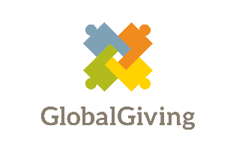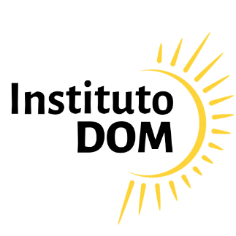

**Instituto Dom’s Project on GlobalGiving**

**Description:**

Our project on GlobalGiving is the *bread-and-butter* of what Instituto Dom does on a daily basis:

* we support underprivileged micro entrepreneurs (many of them women) and we help them grow their business, increase their income and their overall well being.

We accomplish this with our 3 step process:

1. training and entrepreneurial education
2. grant / donation (seed money)
3. mentoring

These 3 steps are done by our volunteers, without costs.

**Project Scope:**

Support 30 single parent mothers from the Rocinha favela in Rio de Janeiro with the 3 steps described above, over a 9 month period. Offer food supplies to these 30 women and their families.

**Project Costs**



**Projects Steps**

We have already listed and screened dozens of single parent mothers and this screening can be seen in the attachments. That is the 1st step we have already taken. Many of these mothers will be supported with other donations and grants that we have or will hopefully receive.

The following steps will be taken once we receive your donation and once we receive the funds from GlobalGiving:

1. select the 30 single mothers
2. register them on our system
3. perform in-depth conversations with each mother to better understand their problems and what they will do with the seed investment.
4. begin the first step of our 3 step process

**Results**

Our results will be posted on our website. The final social change that we seek is to increase the income of underprivileged entrepreneurs. We also seek to increase their businesses, remove barriers that they may have and increase their overall well being.

**Transparency**

|  |  |  |  |  |  |  |  |  |  |  |  |  |  |  |  |  |  |  |  |  |  |  |  |  |  |
| --- | --- | --- | --- | --- | --- | --- | --- | --- | --- | --- | --- | --- | --- | --- | --- | --- | --- | --- | --- | --- | --- | --- | --- | --- | --- |
| *All of our expenses are publicly available and any report can and will be offered by our Accountant. At the end of each year an audit will be performed by an independent auditor who specializes in non profit organizations.*  ***Screening of single parent mothers from Rocinha***   |  |  |  |  |  |  |  |  |  |  |  |  |  | | --- | --- | --- | --- | --- | --- | --- | --- | --- | --- | --- | --- | --- | | *Please click on the attachment below to see a list of single parent mothers from Rocinha. We will select 30 best qualified entrepreurs from this list.*    ***Please Donate now and support Instituto Dom on GlobalGiving.***  ***Thank you!*** |  |  |  |  |  |  |  |  |  |  |  |  | |  |  |  |  |  |  |  |  |  |  |  |  |