Urban Poor Women Development (UPWD)
Report for Staff monthly meeting,
5June 2023
Place: UPWD office
Agenda
- Discussion on Child International Day
- Community follow up
- Other business

Result :
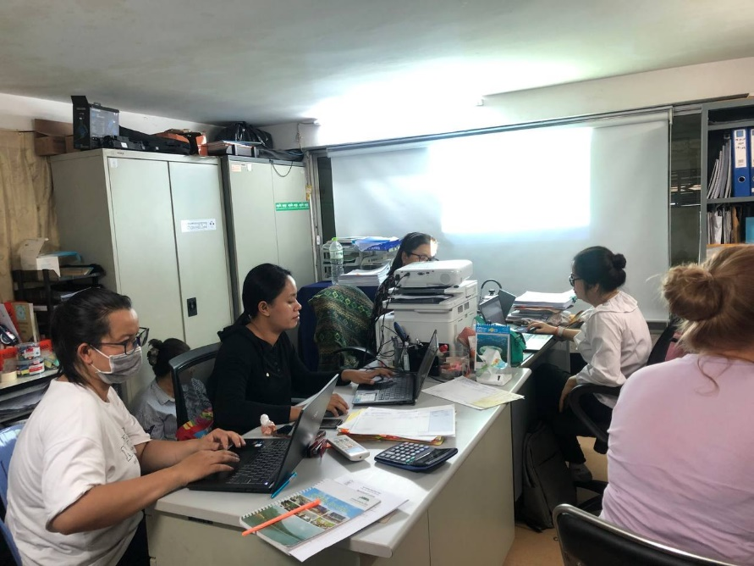
- Child international Day will be conducted on June8,2023 at Tunle Basak restaurant. The topic on Together for child Protection and Development in Digital Age was selected to be in the event. 239 members from Local authority (13 commune) department of education, health center, community leader and children (from 35 communities) will be invited to attend the event.
The process of the event will raise about child education concern, good lesion learn and case study of child related to education, show video clip on children who living in slum community then request to stake holders intervention on education and child protection issue. The picture drawing by children in community also put on the wall for participant to put score, the winner of the picture will be explain of the meeting of picture and then they would be get gift,
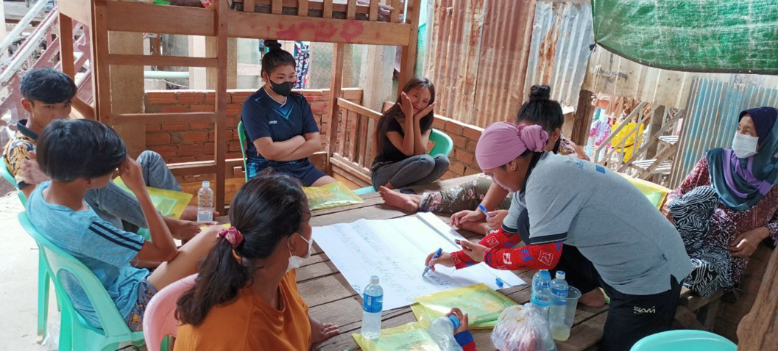
- Team have develop schedule for follow up community target areas on community meeting, interview girl for writing case study and coaching 70 women leader on how to use tool for counselling domestic violence and intervention case by case. Through this work, staff found that 45% of women are actively to work on domestic violence and counselling for women who suffer by domestic violence, a round 15 serous case danger had intervention by community leaders and local authority. In addition, the works as mental health counselling were also do regularly with women who face with mental issue. Total women got counselling on metal issue is 98 member in the semester ( Jan-May2023).
The meeting end with other business talking about next plan and responsible for conduct the child internal day.

Approve by Report by


Soum Samoun Kou Sina


Executive Director Program Manager
Date June5,2023 Date June5,2023

