Photo Gallery of World of Work (WOW) project run
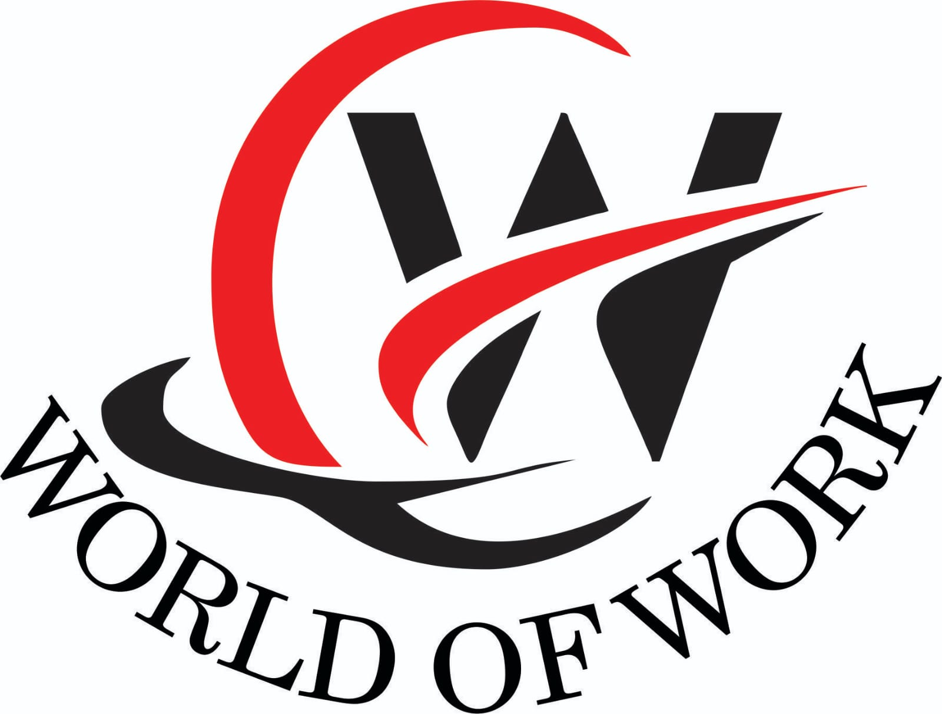
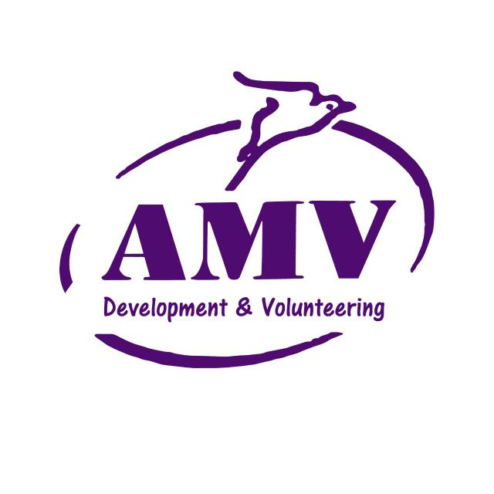
by VMM Africa
(trading as Association of Mission Volunteers – AMV)
July 2021
The World of Work (WOW) project results from work carried out by the Volunteer Missionary Movement (VMM) during 2019 and 2020 when there was various engagements with street connected youth and various stakeholders in Kitale. This work is now continued by VMM trading as Association of Mission Volunteers (AMV) During this period of engagement, as well as the gaps in service provision identified and the ‘why’ regarding the need for change in this vulnerable group’s predicament, the ‘how’ in terms of realising change was also recognised.

To this end the WOW project will support street connected homeless youth by;

* encouraging their economic sustainability through access to vocational and livelihood skills training that will provide them with employment opportunities

* promoting their personal wellbeing through supported access to services and meeting their need for shelter through access to affordable accommodation

* facilitating their learning and development of life management skills within their community and society

* encouraging their active citizenship

In this way, it is envisioned the young people will become ‘included’ as opposed to ‘excluded’ and better positioned to lead self-determined lives.

The WOW pilot has been based in Kitale, at St Martin’s House – AMV’s Headquarters but the next phase will be based at our rented facility, Edwina Gateley House (named after Edwina Gateley the founder of VMM who has agreed to be patron of AMV) in Section 6 in Kitale.
Below find a photo gallery of activities which are carried out in WOW.

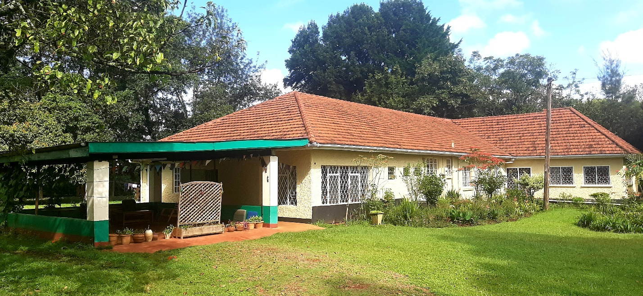
ABOVE - ST. MARTINS HOUSE- MILIMANI, KITALE
BELOW – EDWINA GATELEY HOUSE, SECTION 6, KITALE

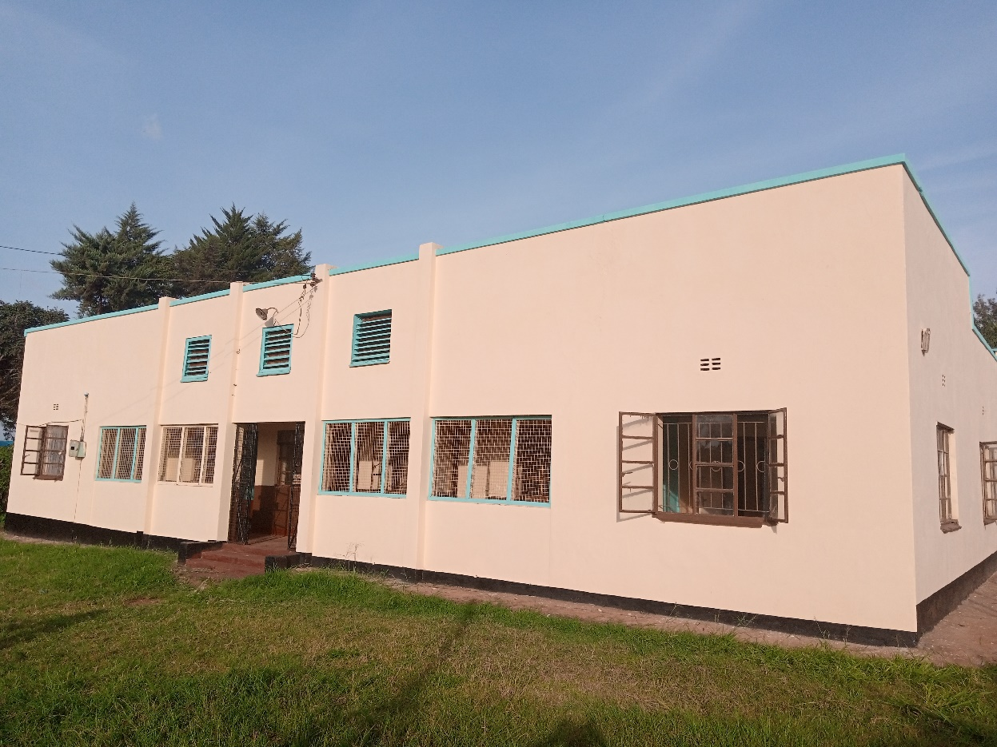
- ARTS AND CRAFTS
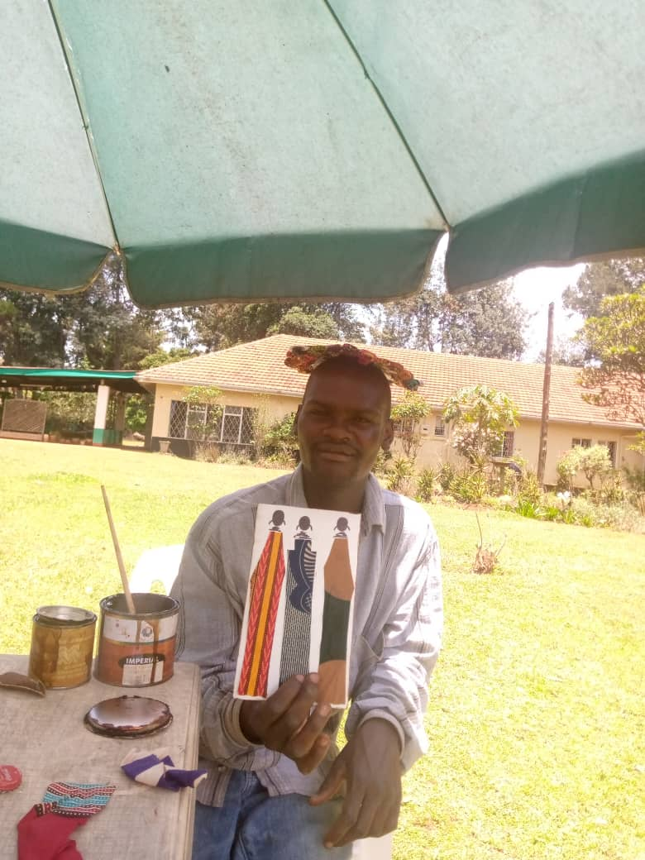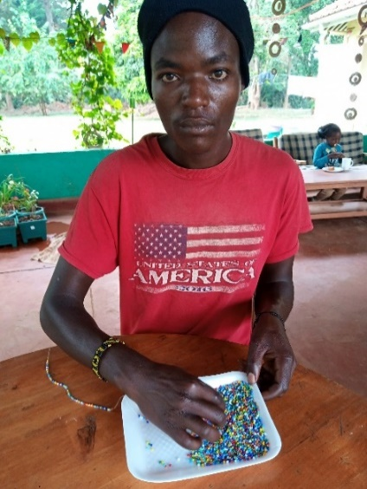
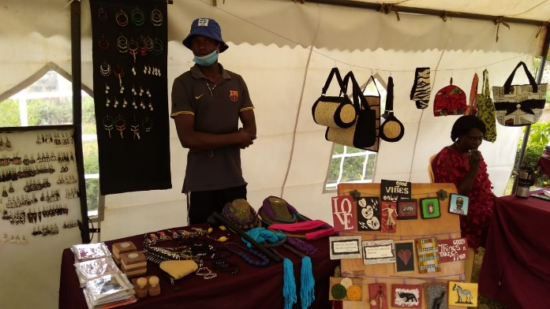
Participants were involved in Craft making. These included wall plaques as shown by Jackson (top left). Above Lope was involved in making of Beaded items like bangles and necklaces. Left shows Tonny assisting in selling at a local craft fair with the various items such as wall hanging decors (plaques), hand-made papers, greetings Cards and other craft items. Bottom left shows John recycling old bottle tops and below the group making homemade paper.

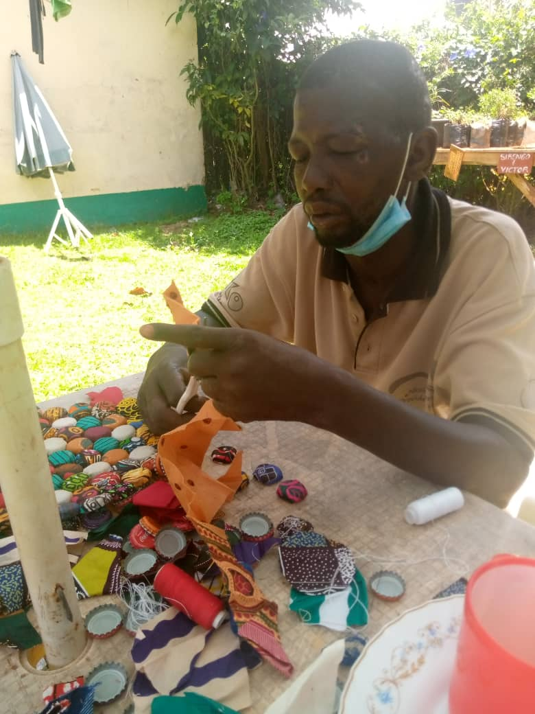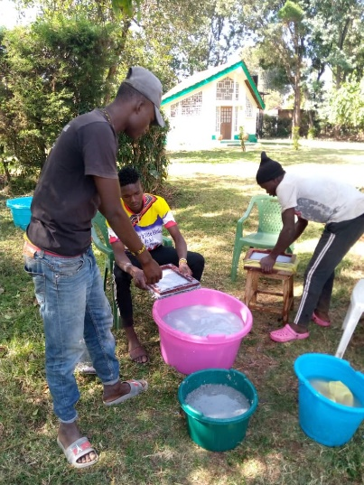
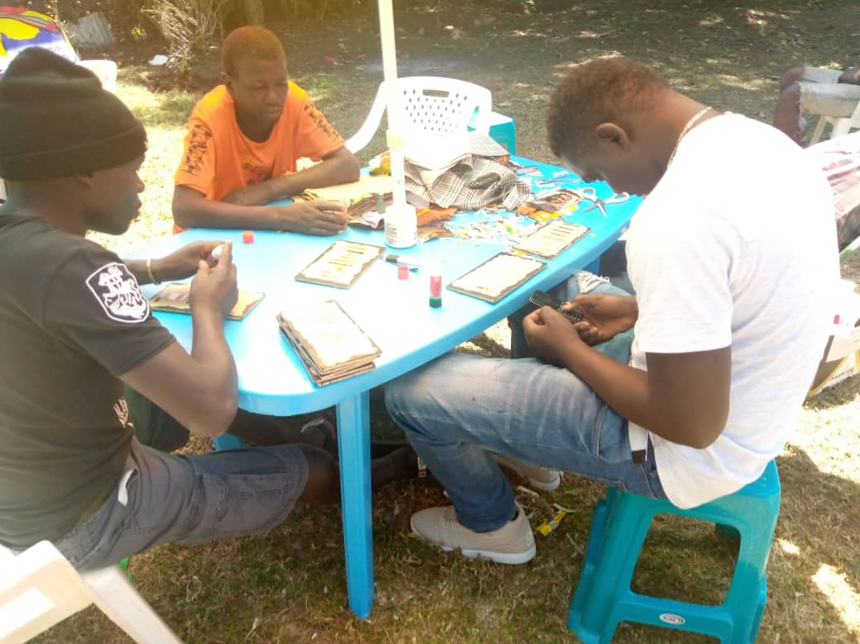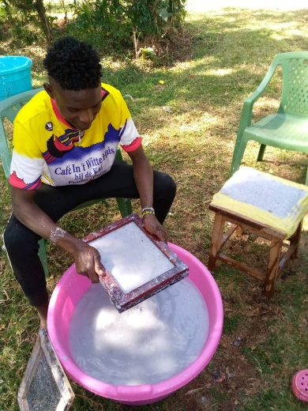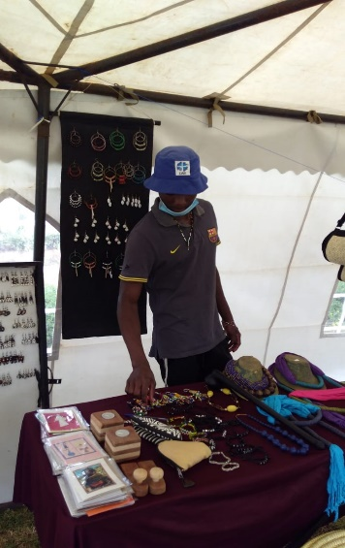

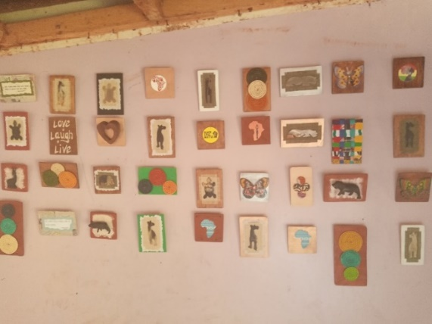
Plaques made by the youth on display on the wall at the craft room.

- CATERING TRAINING – Samosa, Bhajias & Mandazi
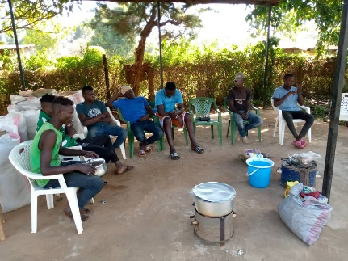

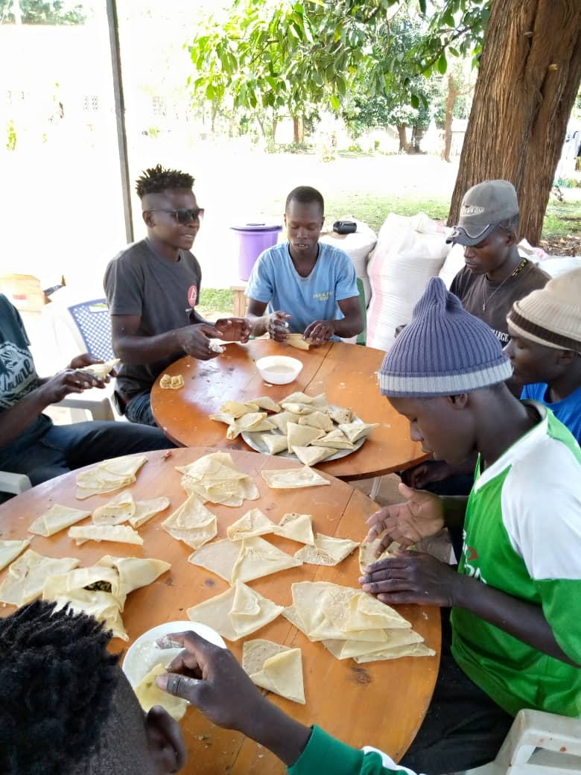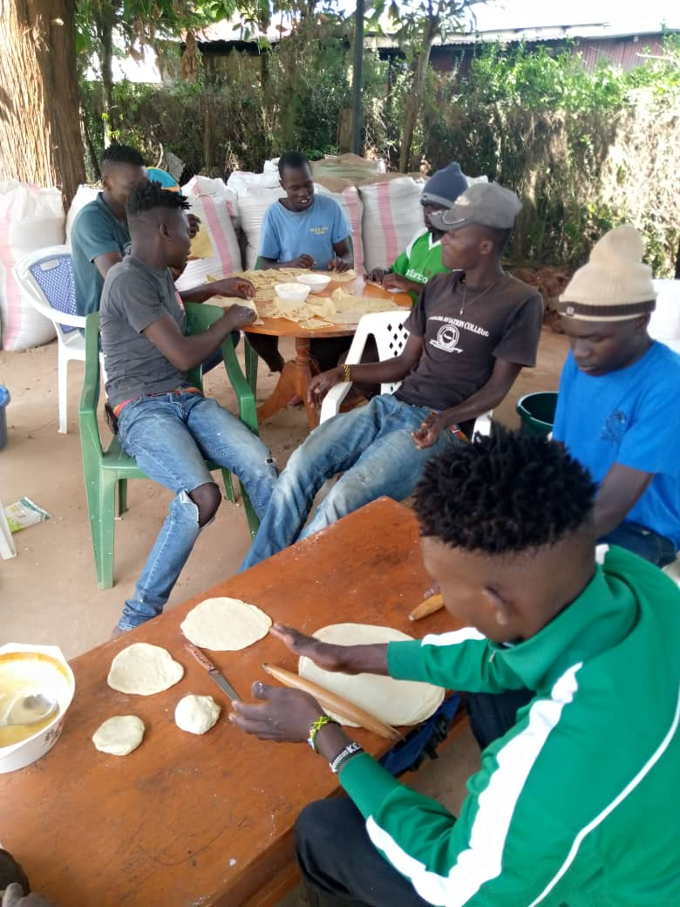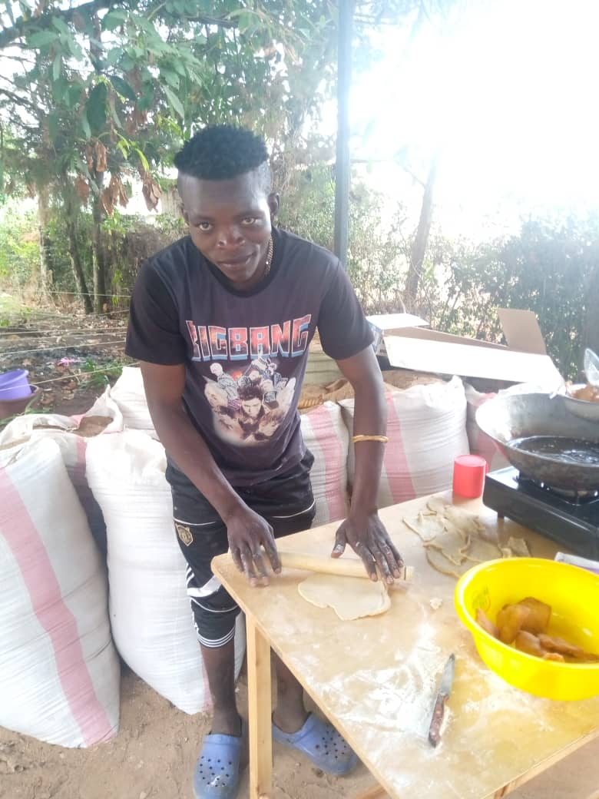

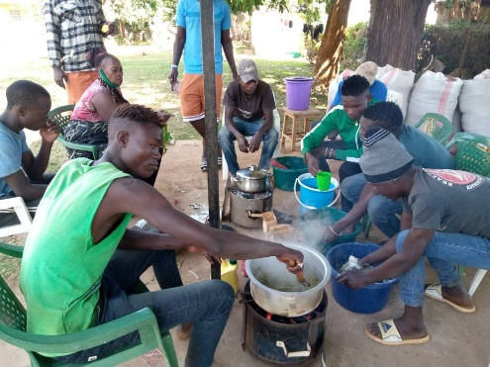

Above: Participants learning how to make Samosa and Bhajias for sales.
Far Right Picture is Sirengo making Mandazi they would use at tea break

CATERING TRAINING – Sesame Seed Snacks
8 boys Sirengo, Lokope, Bush, Tony, Carlos, Victor, Brian and Bravin attended the SIMSIM making. They were trained by Silas Ekidor who have been making and selling SIMSIM in Lodwar

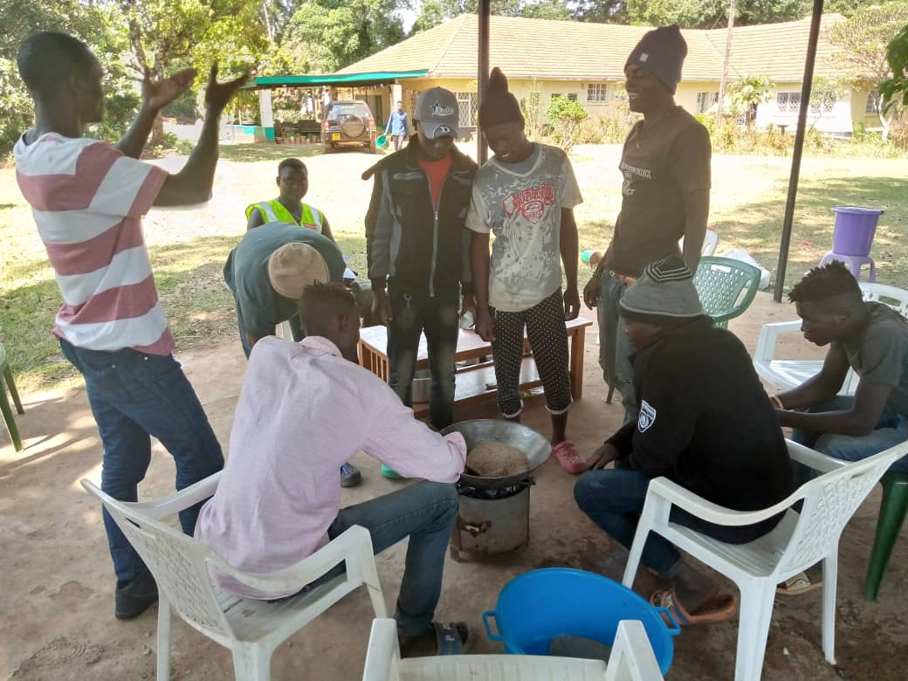

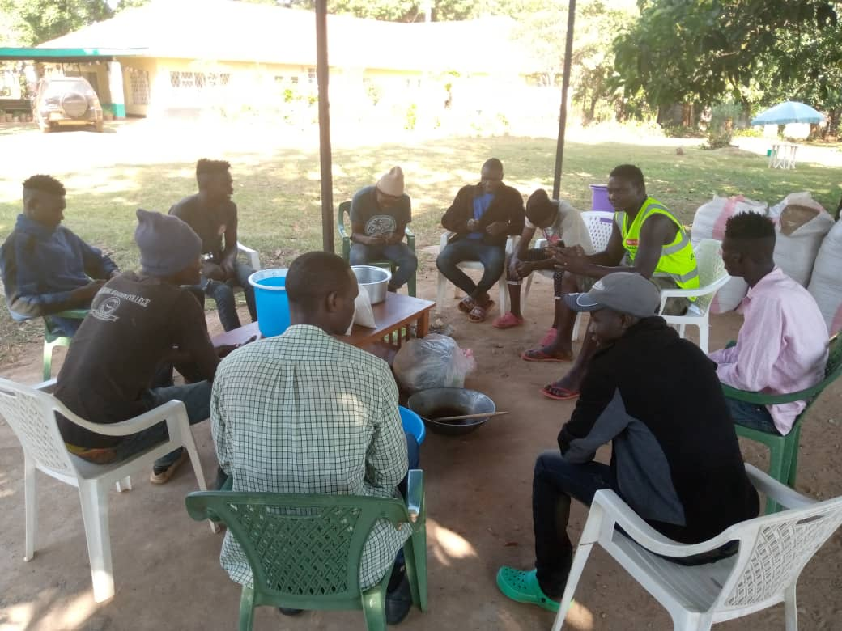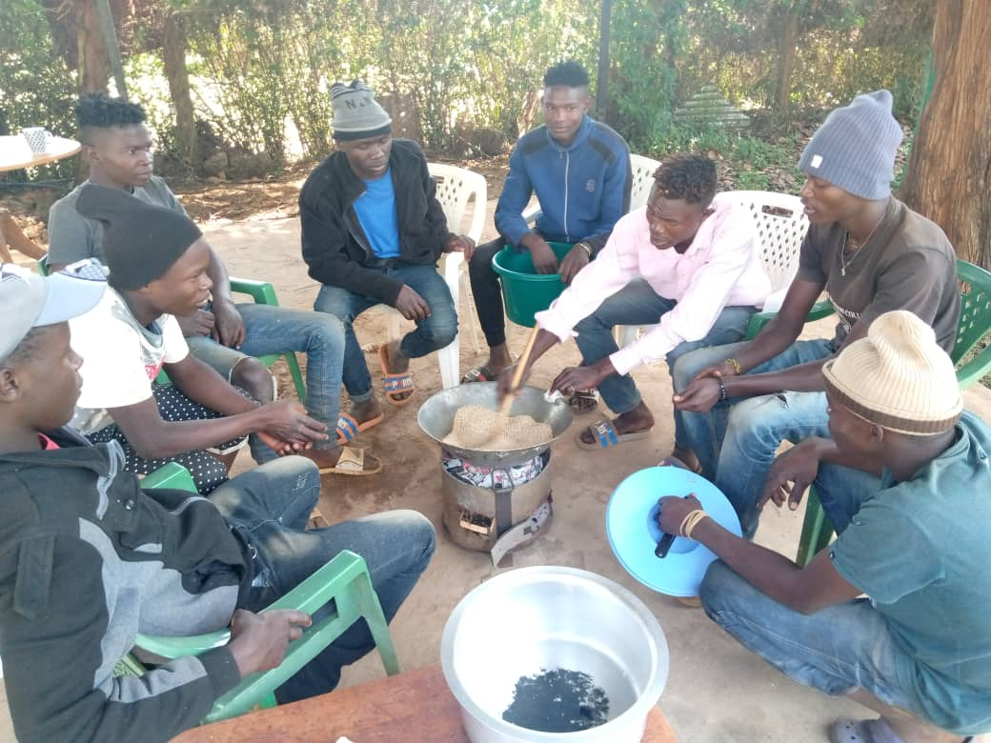

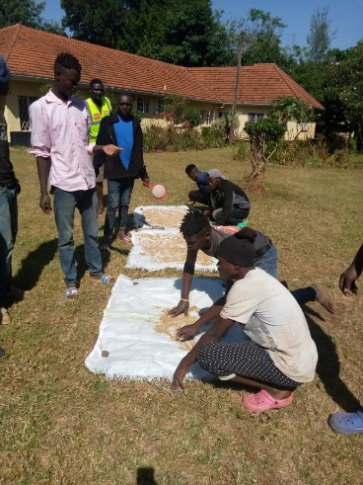

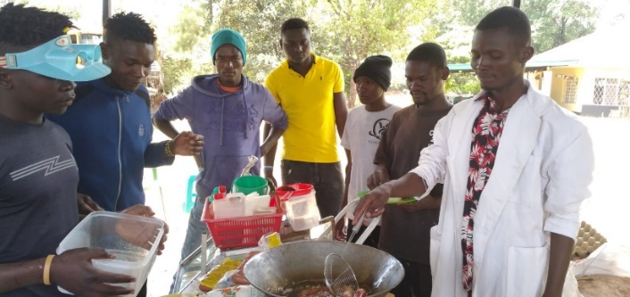
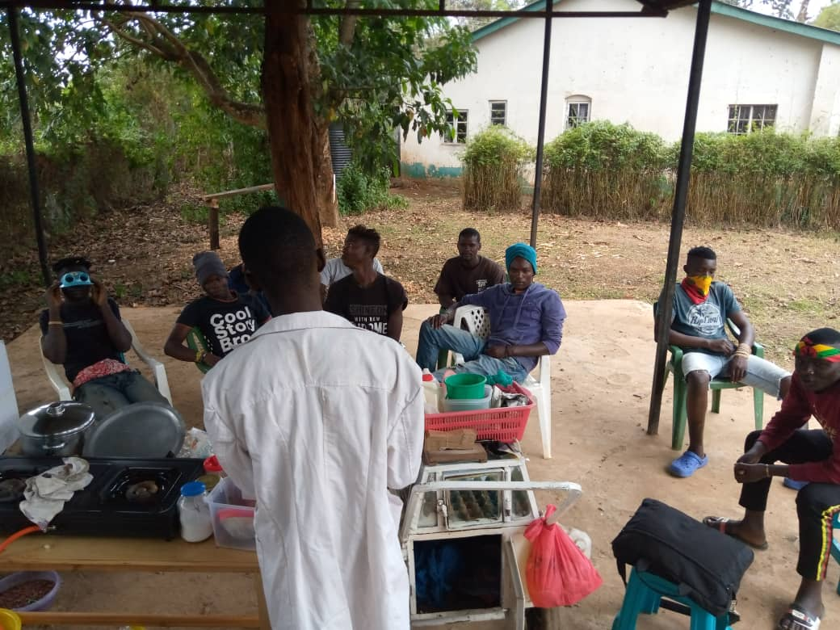

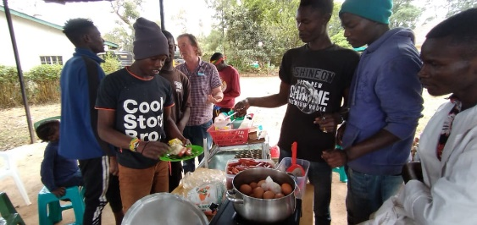

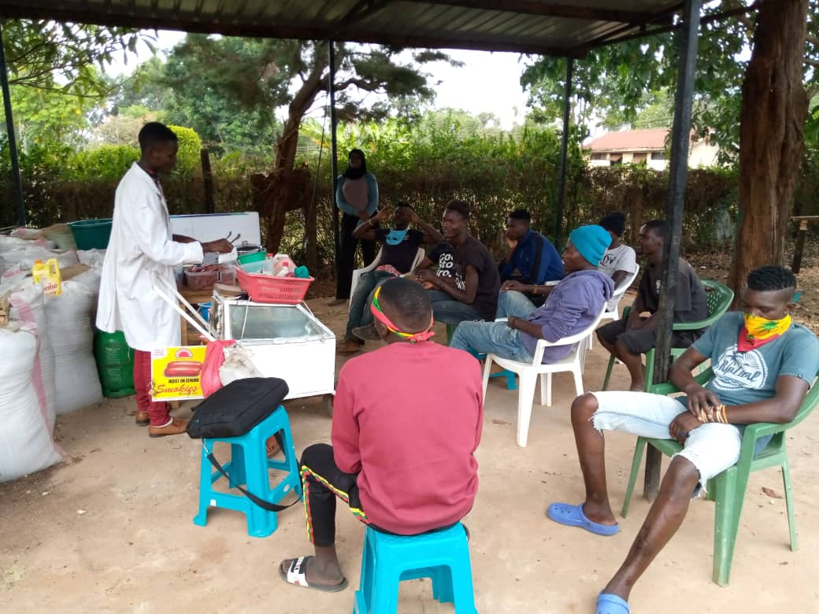

BOILED EGGS AND SMOK
Eggs and Smokie sausage training given by Kevin

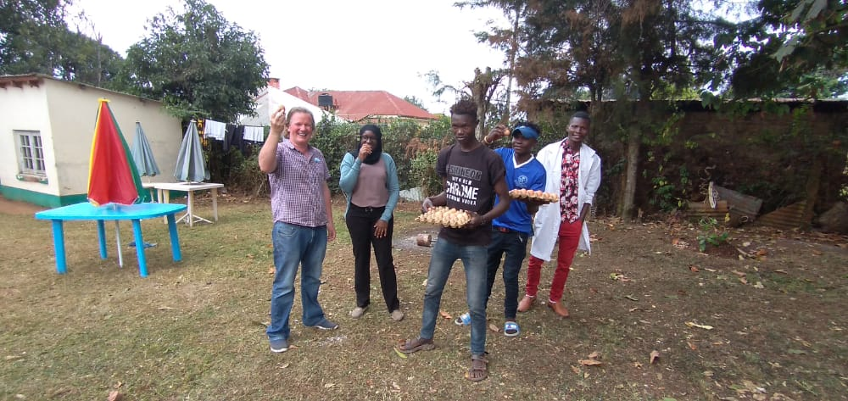

Bush and Victor (participants), Kevin the Trainer and WOW officials Tony and Rehema showing the boiled eggs ready for sale.

- BUSINESS TRAINING/ GRADUATION/ ATTACHMENTS/ OPERATING BUSINESS

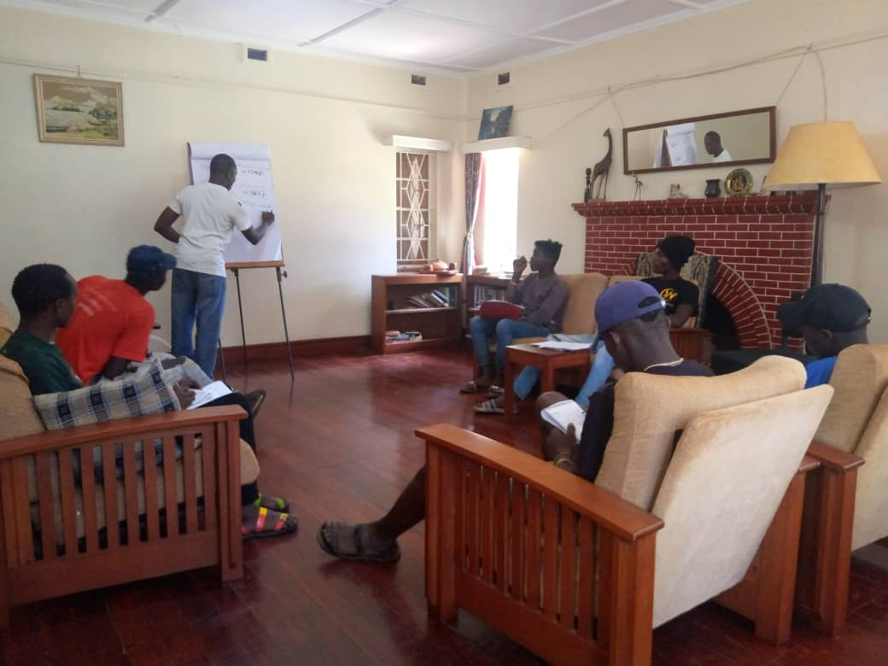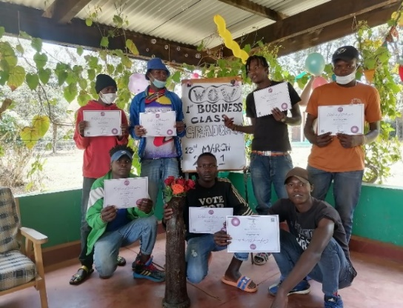
Top Left: Oscar Otieno teaching Business Class. Participants in Business class learning about how to identify, start and run small business as a self reliance for themselves.
Top Right: Participants Graduation after successfully completed the Business Training in March 2021 – Samuel, Tonny, Lope, Sirengo, Victor, Carlos and Haron.
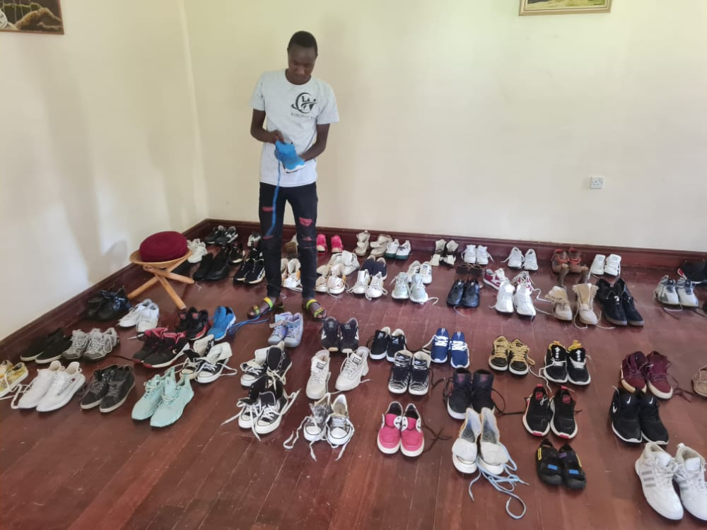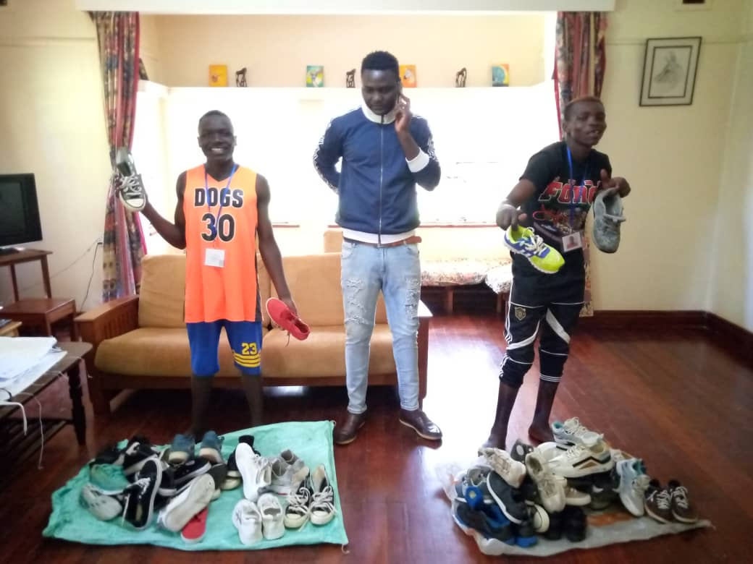
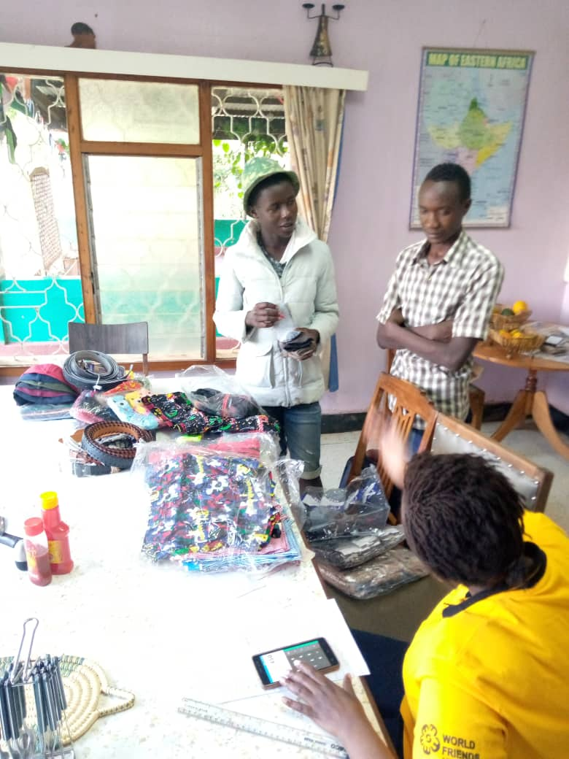
Second hand (MITUMBA) Shoes and other items for sale being selected by Samuel, Carlos, Sirengo and Bravin. Guided and Supervised by Dalmas and Jane and other AMVofficials. WOW gave them the opportunity to get them started in business by giving a grant of stock for sale.
SHOP OPERATION (SALES)
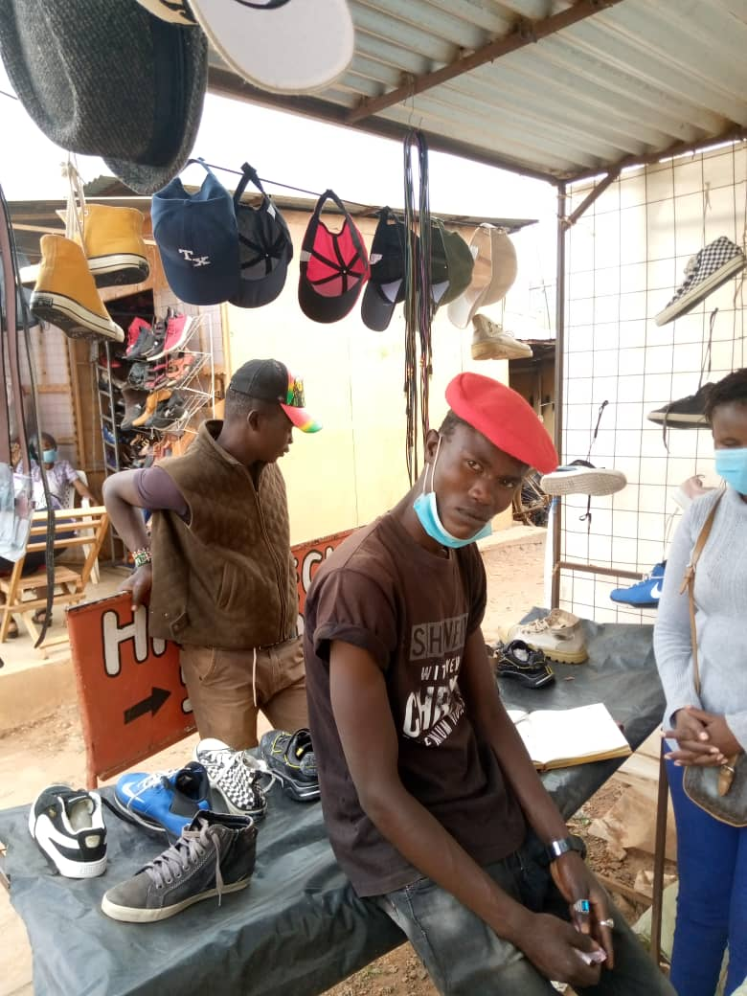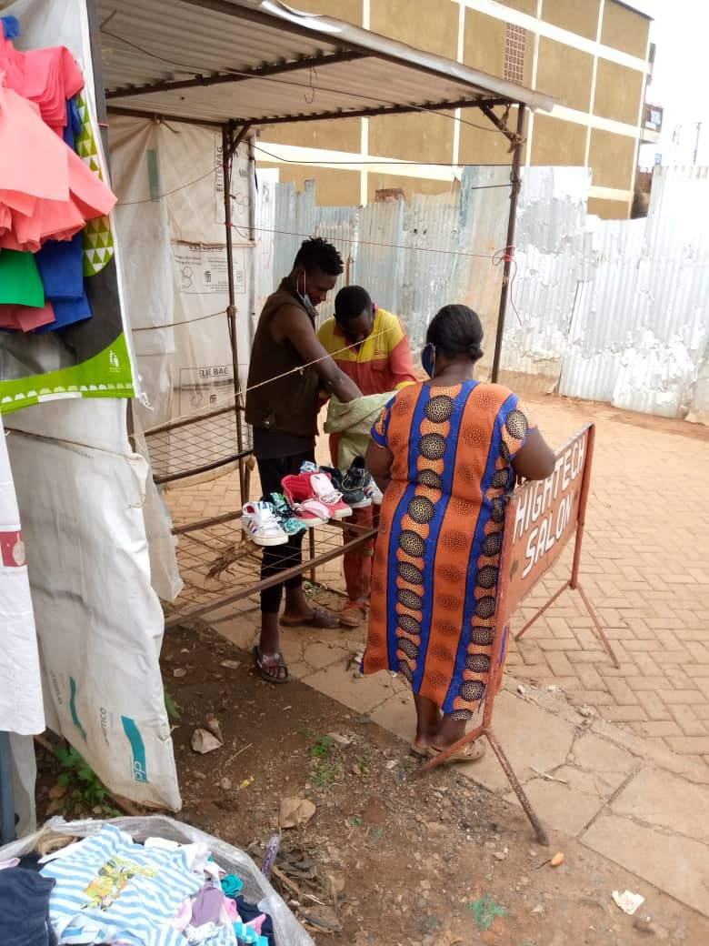
Left: Bush and Victor at their small shop in town.
Right: Tony setting up his second hand shoe kiosk
The WOW Programme offers FIELD ATTACHMENTS (WORK EXPERIENCE) after completion of BUSINESS TRAINING. The youth gained practical experience of the world of work during the 3-4 weeks attachment period they spent at a local business.
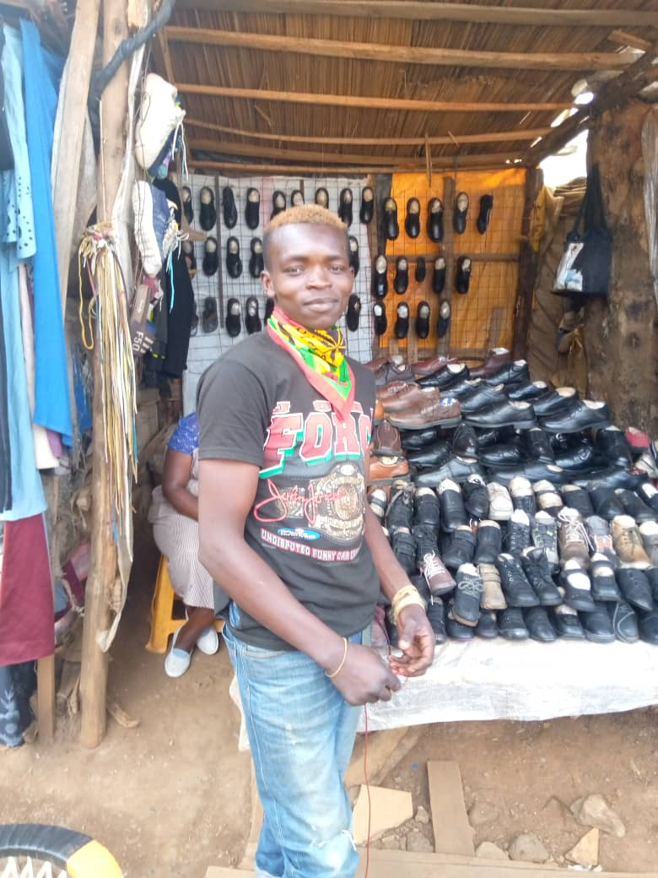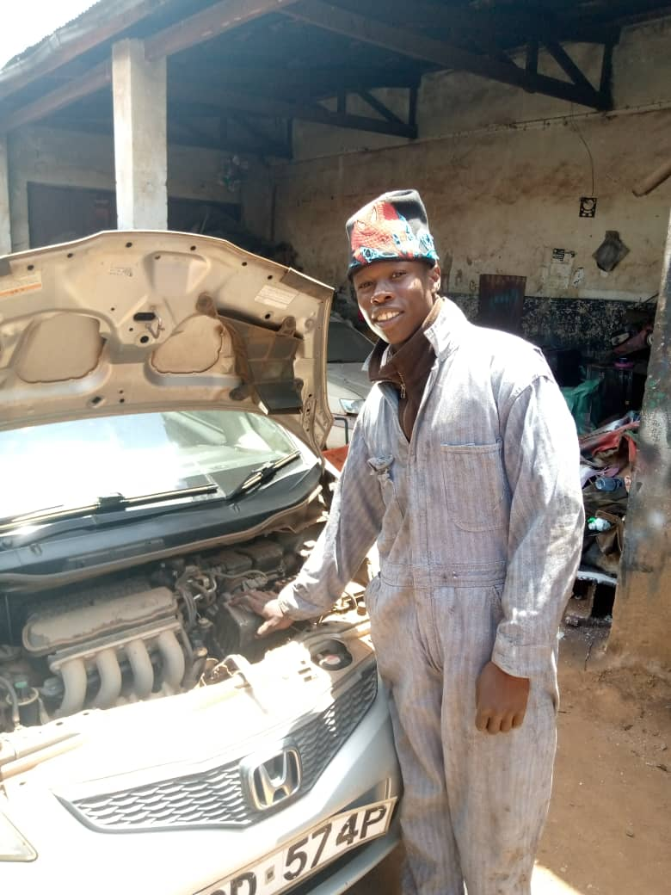
Top left: Sirengo attached at a second hand shop selling shoes and learning business operations.
Top right: Brian at a local garage learning basic mechanics

- AGRICULTURE/ FLOWERS/ GARDENING
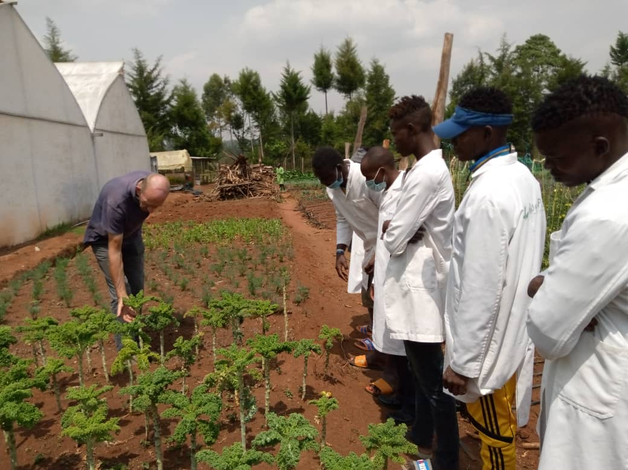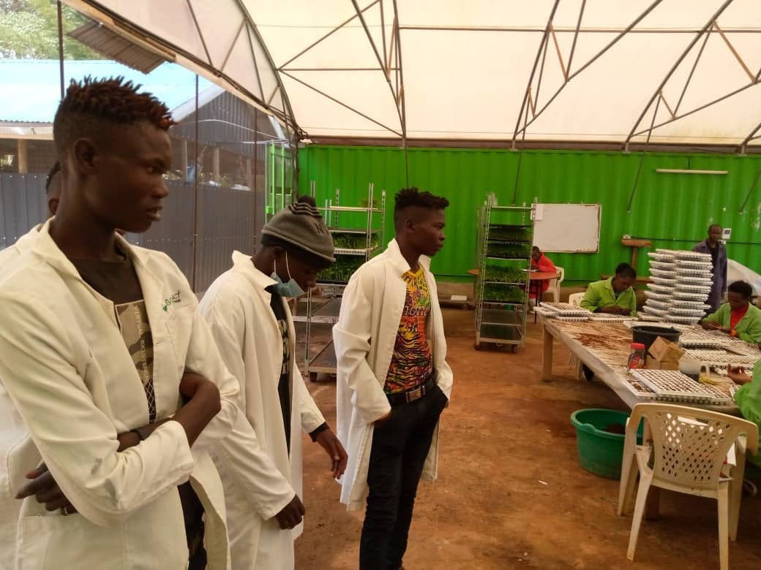
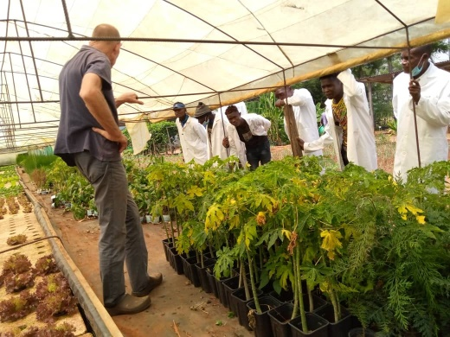
VISIT AT GROWPACT ORGANIZATION:
The WOW participants visited a number of local agricultural centres. Here they learned about growing vegetables and plants using both organice and chemical processes. Above and left was the visit to Growpact. Left and below showed the boys setting up their own garden at St Martins House.

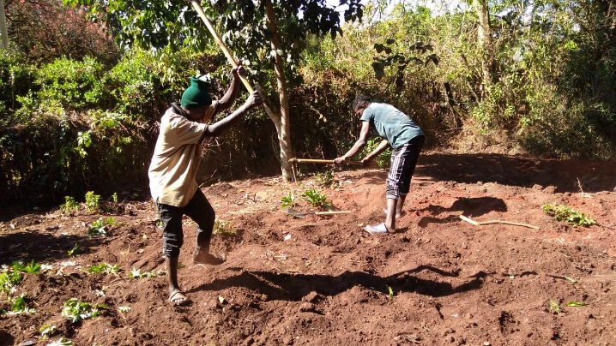
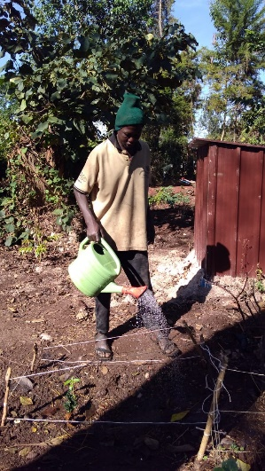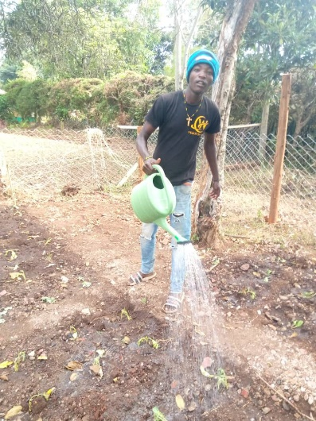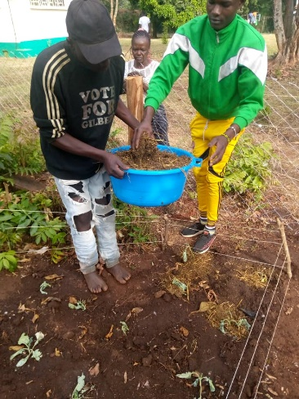
VEGETABLES AND FLOWERS GARDENING AT ST. MARTINS:
On the small garden available the Boys grew kales, spinach, cow peas, tomatoes and other vegetables. They then used these vegetables to cook and use for Lunch
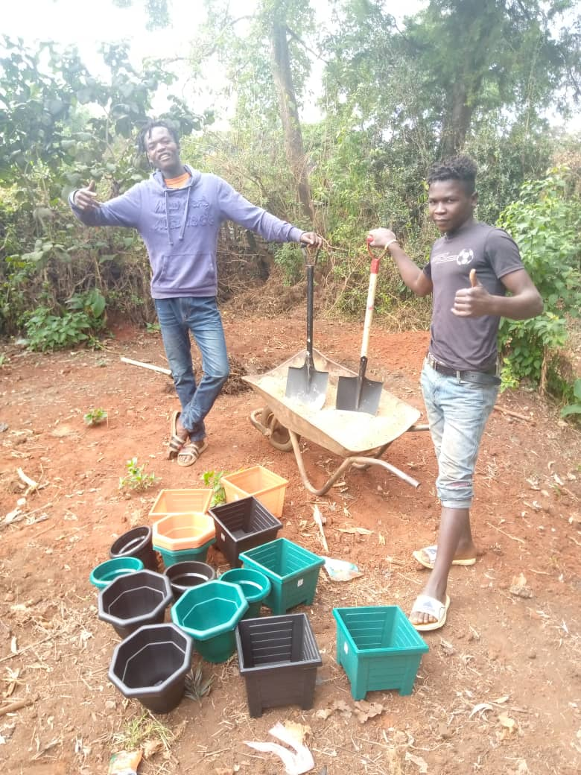

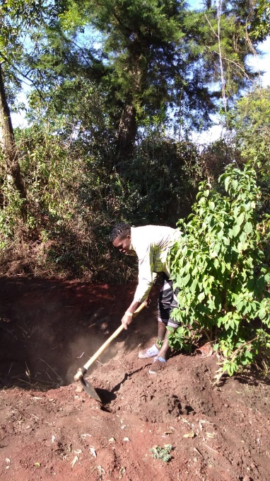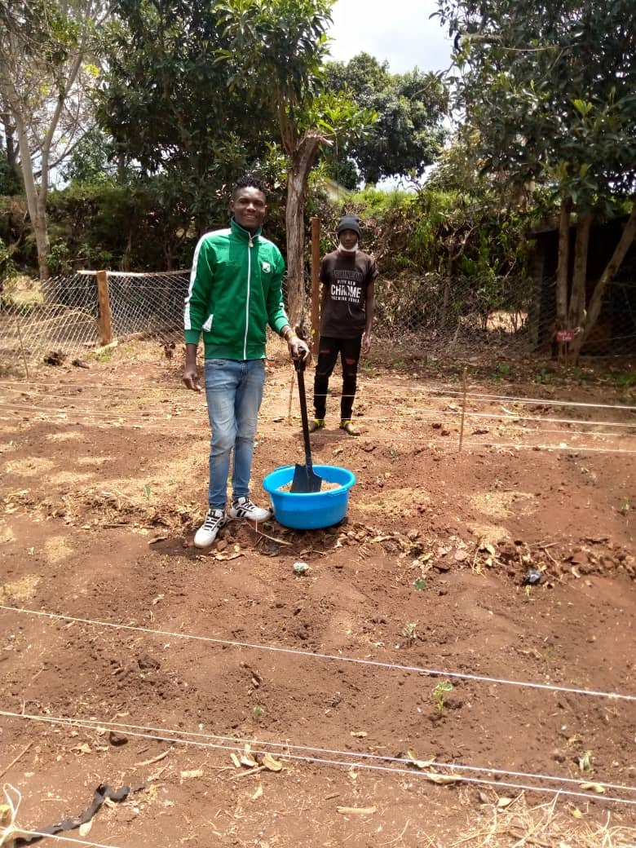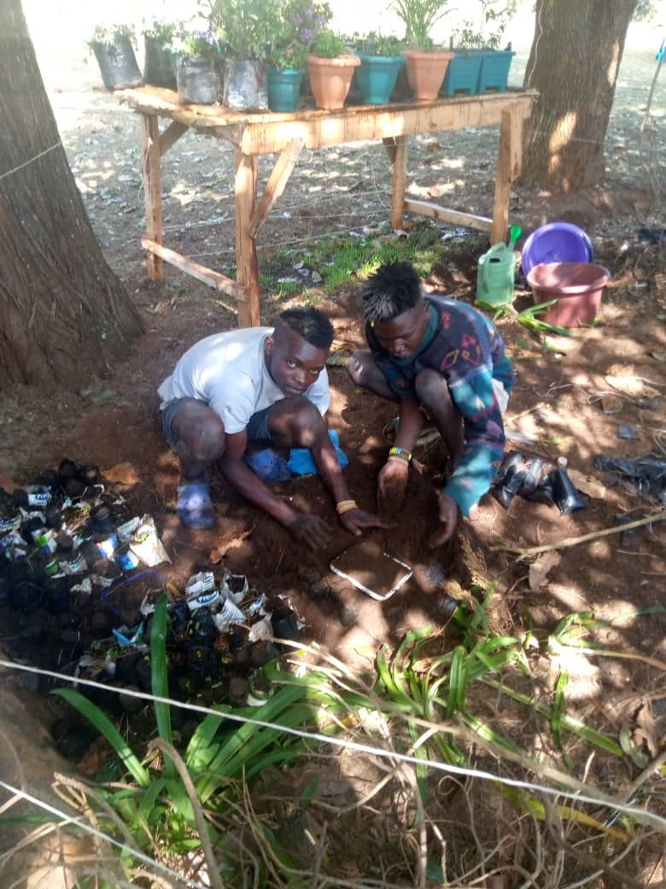

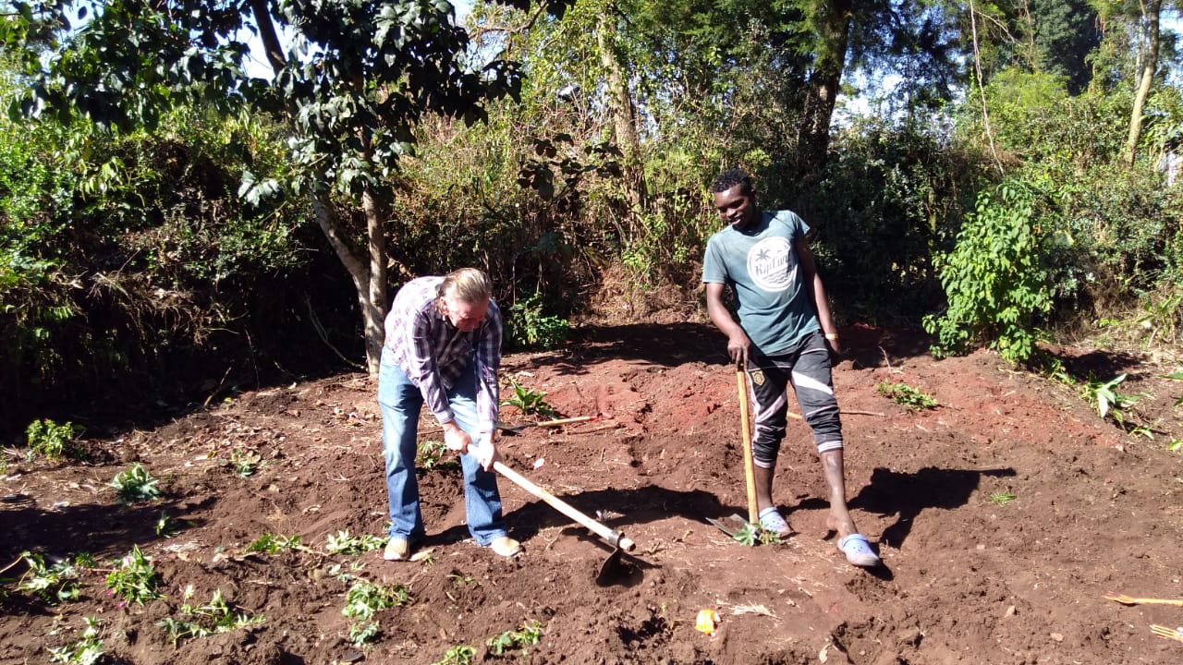

Preparation of the land would take place in the mornings. Watering is in the morning and just before they leave the compound. During the rainy season no watering takes place. As seen on the above pictures Lokope and Victor are ready to fill the pots with soil for flowers. Tony McKay AMV Official helping Tonny, Sirengo and the rest in preparing the land.
- 3 DAY WORKSHOP ON LIQUID SOAP TRAINING

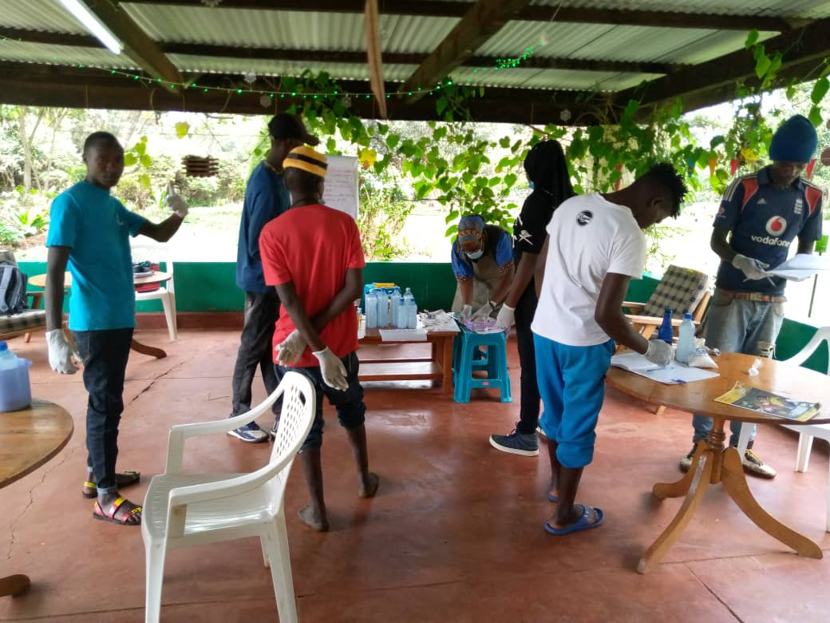

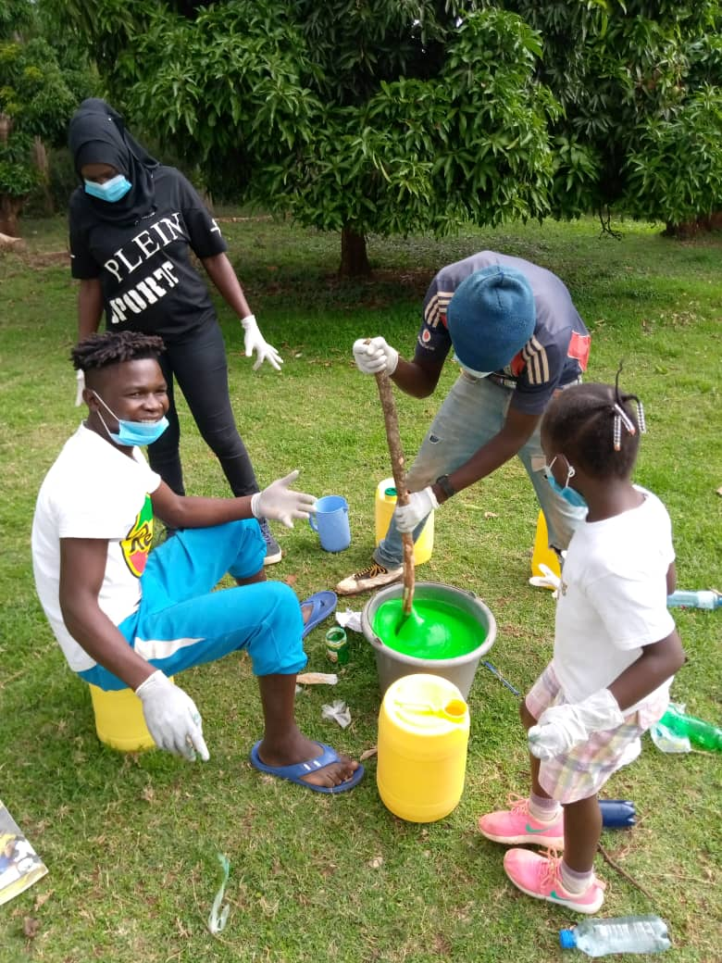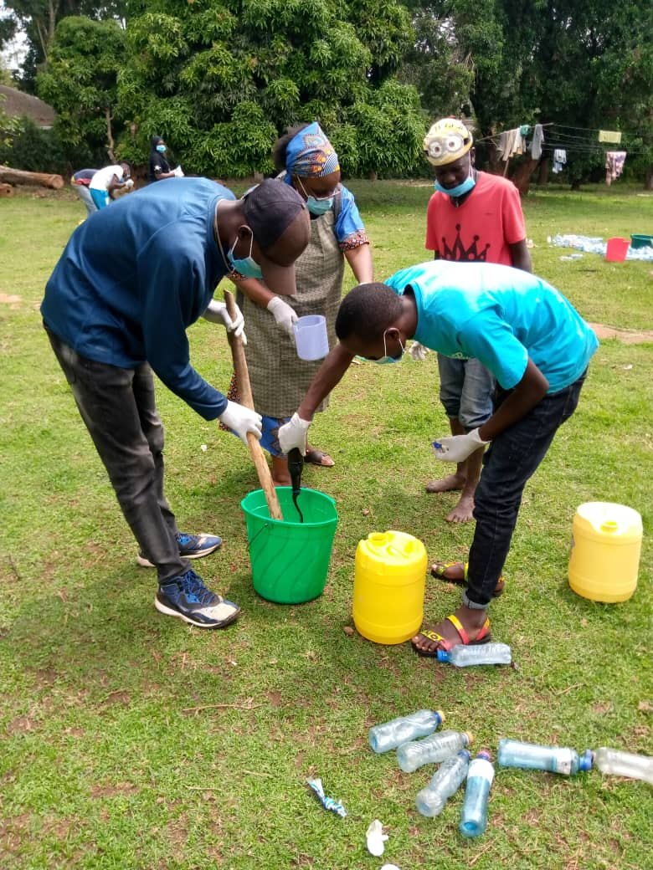
Boys learning how to make liquid soap. The training was carried out by Victorina. The boys learned to make three types of soap – for dishwashing, disinfectant soap and body soap. The pictures above showing the participants mixing the soap. On the left green liquid soap mixing by Lokope. When ready they are bottled in the recycled/reuse plastic bottles on the Right Picture

- OTHER ACTIVITIES
Below: Rehema teaches Introduction to computers to Samuel.

- LEISURE & OTHER EVENTS / BIRTHDAY

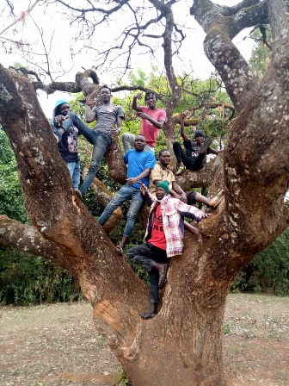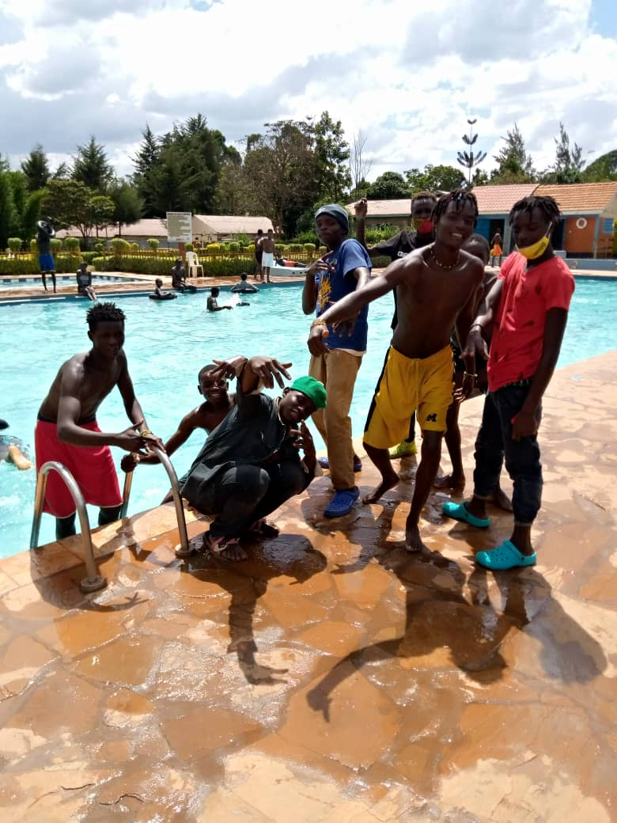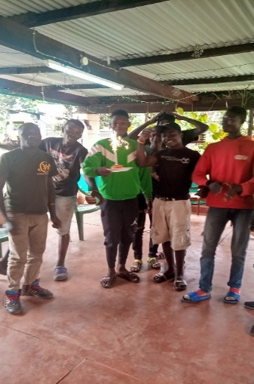
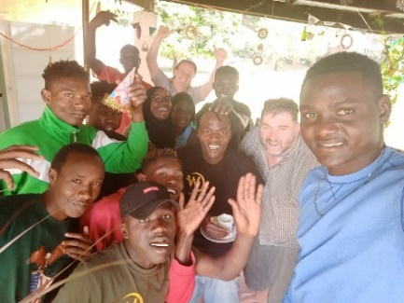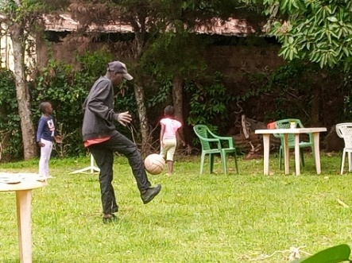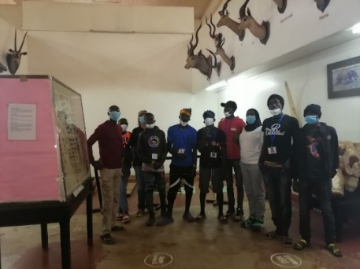
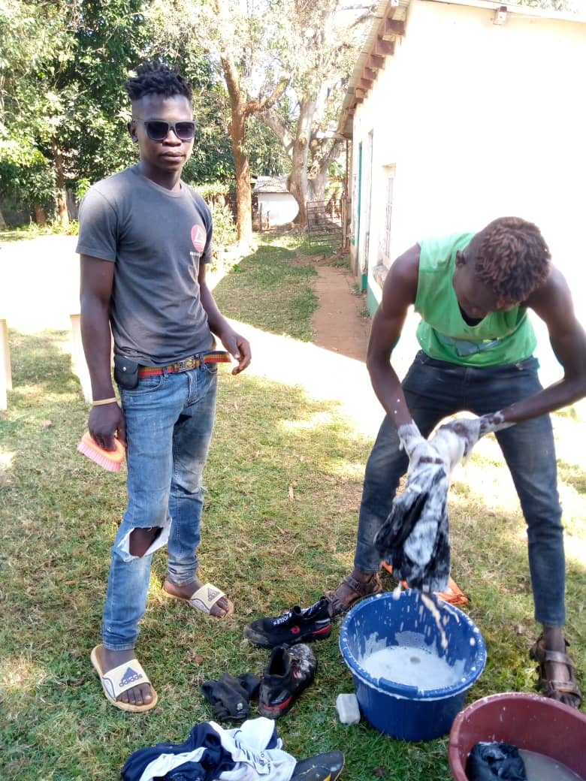

- HOME VISITS:
Home visitation involves reconnecting the boys with their family, parents or guardians. The visit also served as an opportunity to get the copies of their parents or guardians National ID cards in order to help in processing the participants National Identity Card.
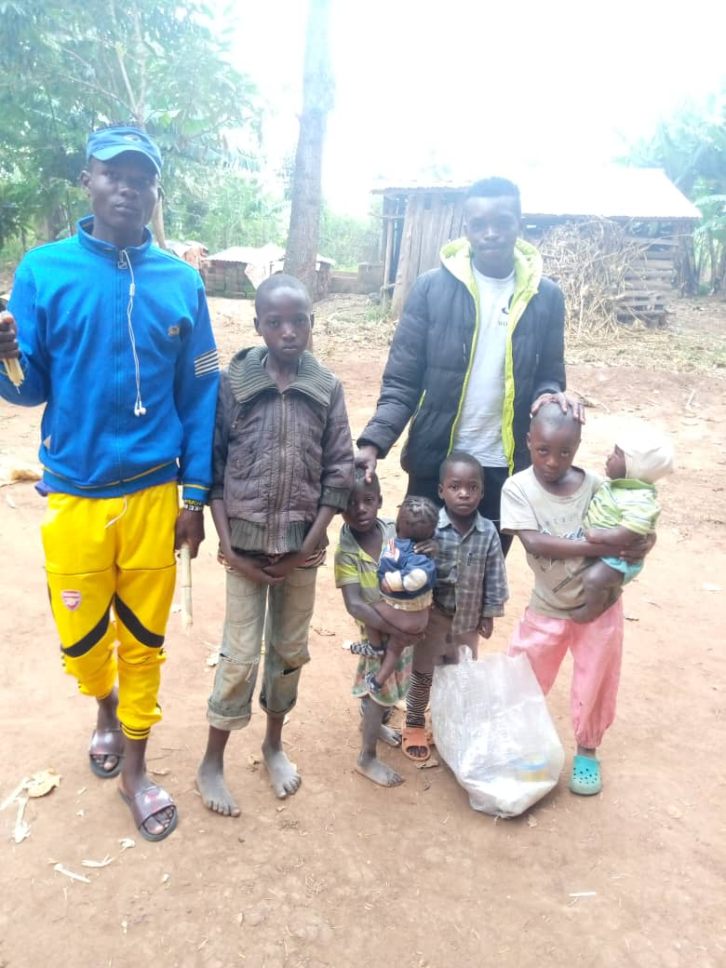
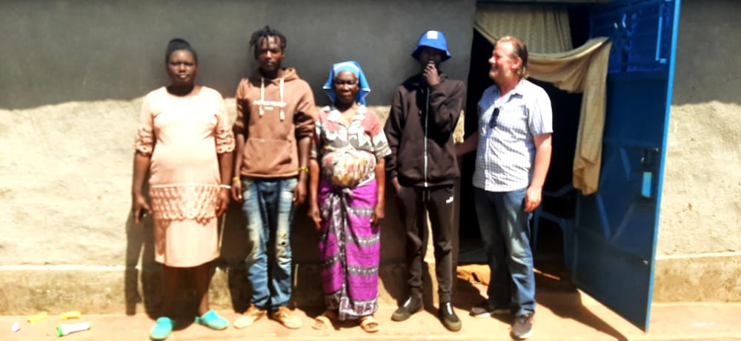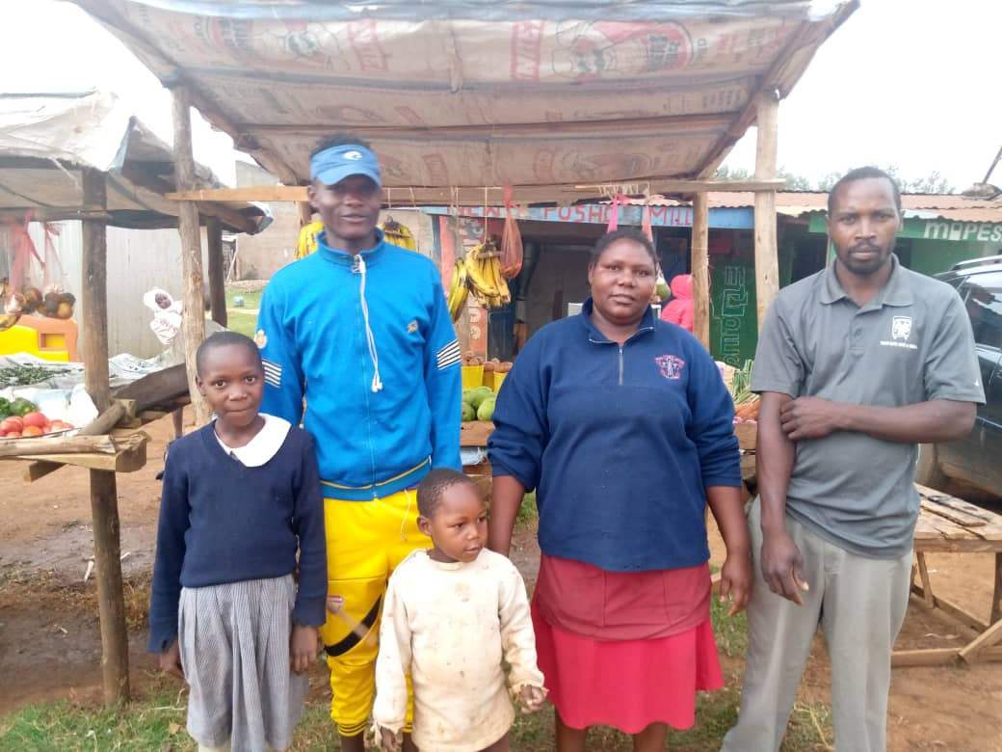
Lokope visits home/Family Tony his Mother, Father and his Siblings

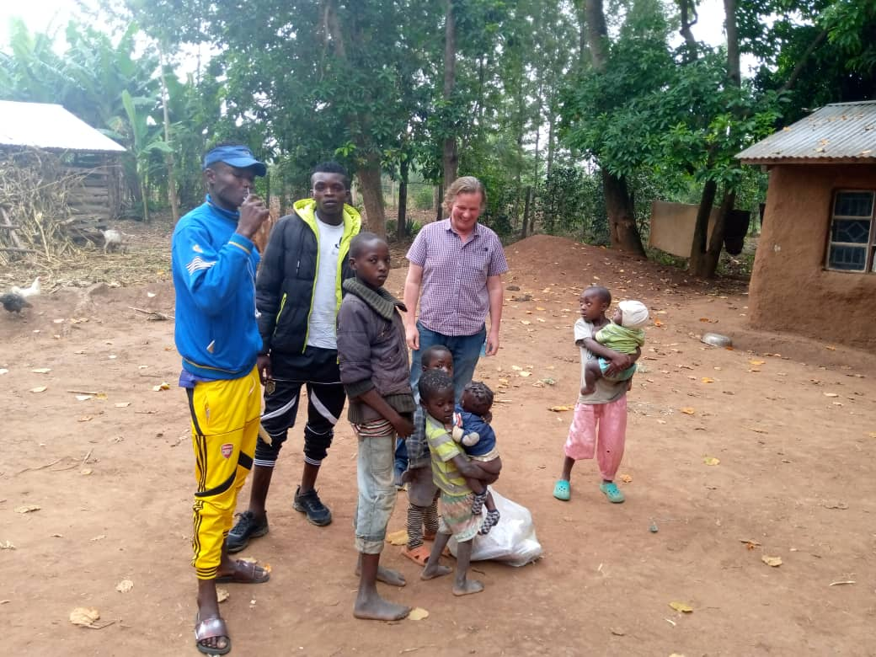
Sirengo at his home with his siblings.
He was accompanied by Wow participant Tony Juma and Tony McKay
- HOUSING
One of the major goals of the programme is to reduce the street life by helping and supporting the participants to get their own houses that they can rent. By doing this they will be off the streets. The pictures below shows Bush and Victor in their rentals houses in Kipsongo Village

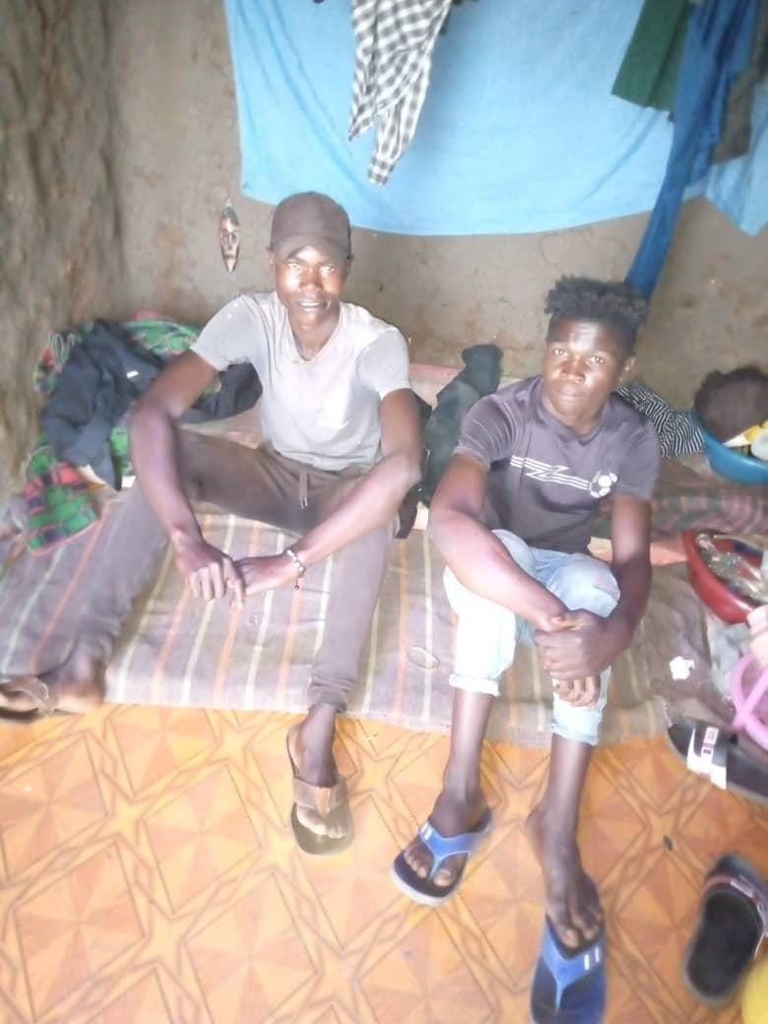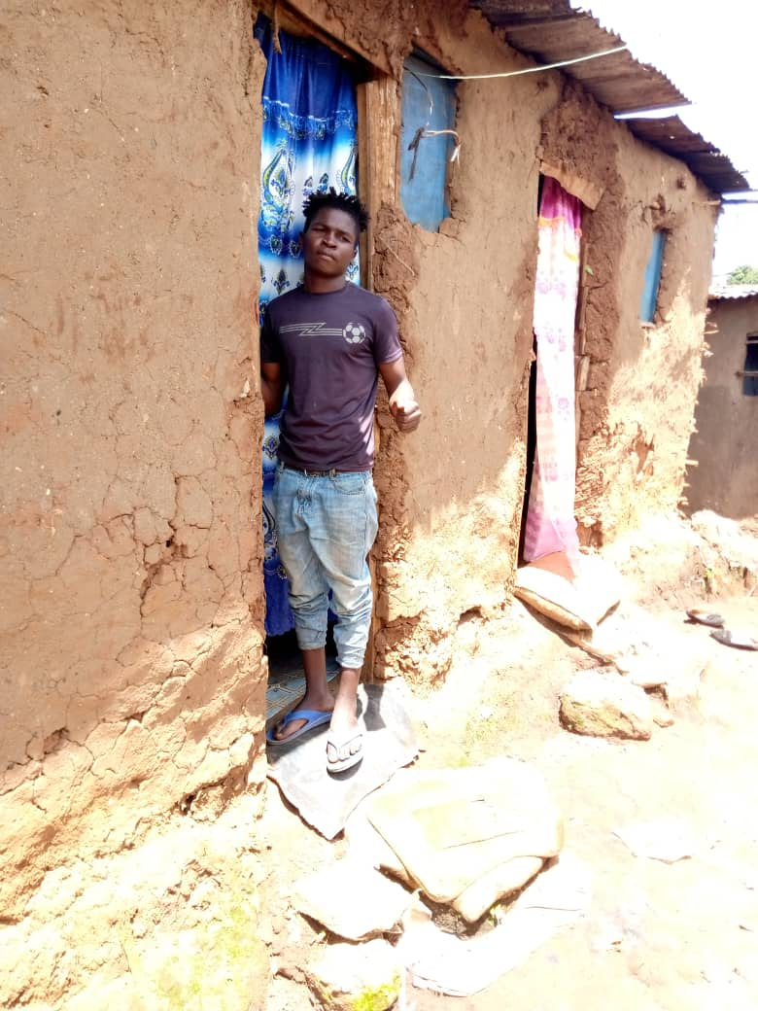
- FOOD & NUTRITION
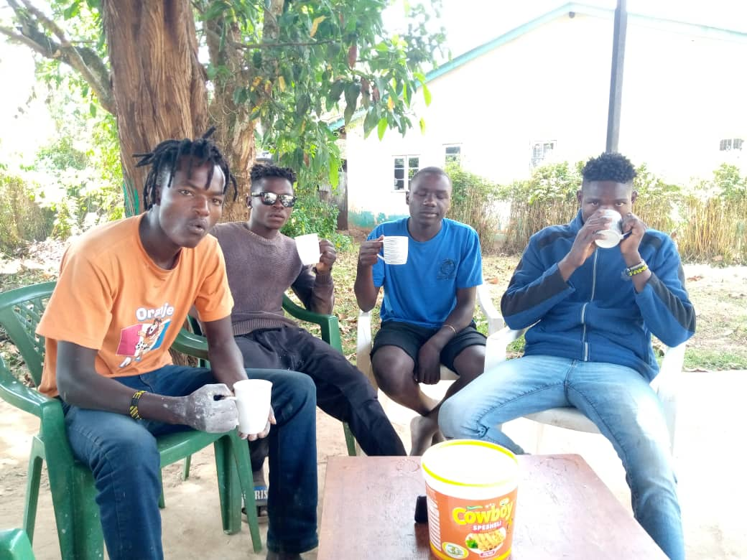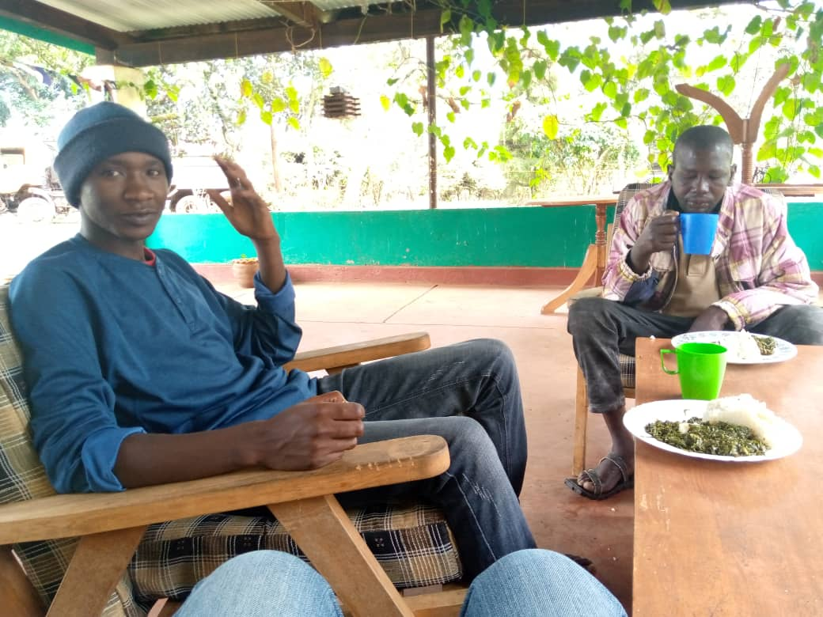
Above: Lokope, Victor, Carlos, Tony, Samuel and John having breakfast and lunch

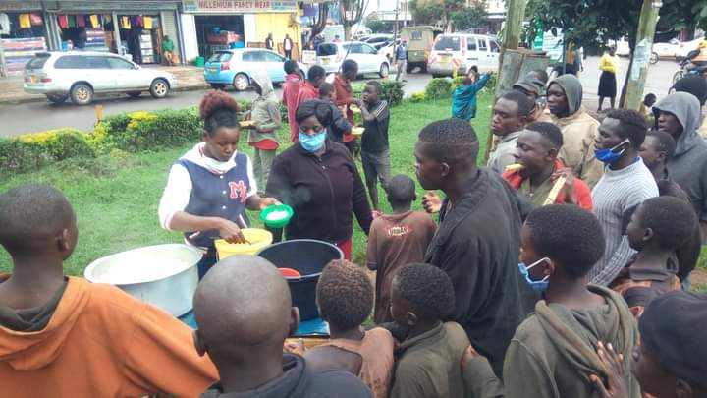

The WOW programme offers two meals a day - Breakfast and Lunch. The youth cook for themselves as well as using vegetables which they have grown in the garden,
Before the WOW programme began there was feeding of youth in Kitale town during the primary Covid period. This happened 3 times a week with Porridge given on Sundays, Rice and Beans on a Wednesday and Fruits on a Friday.

