7Report of the Trustees for the year ending 31st March 2025

Contents

Aims and Objectives
Report from the Chairperson
Achievements
Balance Sheet

To promote the Christian faith by showing and demonstrating God’s love through practical action to: ~
Relieve poverty,
Advance education,
Improve and promote the health of the Kenyan people.

Annual Report of the Trustees 2024-2025

Report of Achievements 2024 -2025

Mothers’ Vision (MV)

All of the children at Mothers’ Vision are now sponsored. Money was sent out for the whole year for food, basic essentials and education. Damaris the manager has now left and a social worker Hellen has taken her place. We thank Damaris for all her faithfulness and hard work over many years.

The children are all well and improving at school. The Christmas party was a great success at the local hotel, swimming, games and of course food followed by ice-cream. Yummy!!!

BBK has provided enough money to feed the widows and poorest people three times during this year. Hannah ( team leader at MV) and her team buys and distributes food and essentials to two villages, Barani and Pentagon. Each food parcel worth £17 was sponsored by Acorn Project. Amini has also given out food to approximately 100 families. BBK also gave money to Lucy to feed the street children four time in 2025.

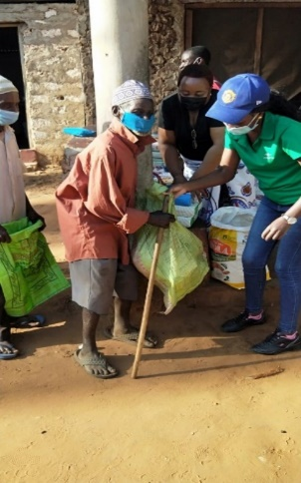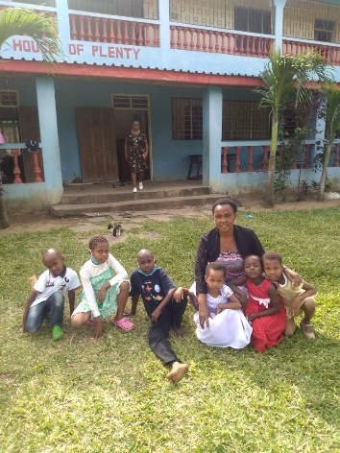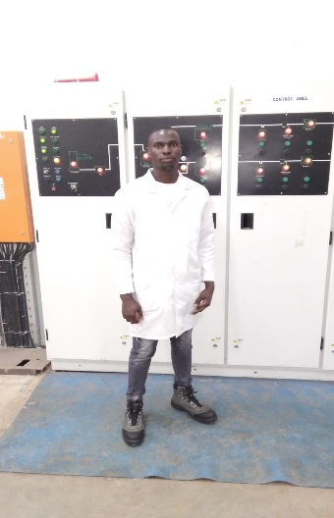
Feeding the villagers Children at MV on a relaxing Sunday Jumaa at University

Jumaa from MV has one year left to complete his university course. A total of £939, per year depending on exchange rate. He is studying hard to make sure his grades are good,

Jesus Healing Ministry (JHM)

The new JHM home is perfect for the 26 children living there. This modern accommodation within its half-acre of land brings security and comfort to children who have no parents or have one parent who is very poor or sick. I am delighted to say all the children are well. Ten children have now completed their last year of secondary school and will be thinking of their futures in 2025.
Sadly, their results were disappointing Thomas passed for university, 2 children will resit the final exam again in July and the other children may go on to do college courses.
The land is producing crops and fruit trees which provide produce for themselves and for sale.
JHM is situated in a very poor area and three families desperately needed help. BBK is providing school fees, food and school uniforms for six extra children and a wheelchair for a father who has lost his legs due to diabetes .

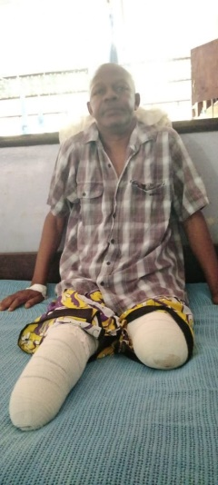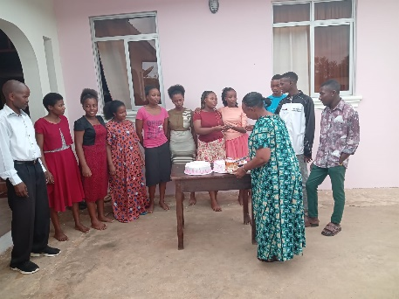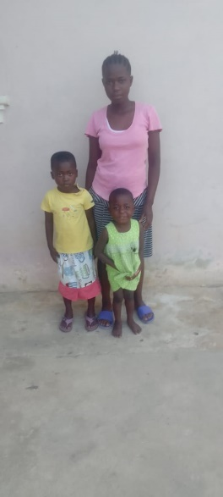
Meshack’s dad A celebration cake for Form 4 students A new family helped in the community

Barani Primary School (BPS)
Betty has been an enormous help to the children at her school in Barani Village. BBK has sent her sufficient money to buy school uniforms for over 200 poor children. The children receive instant dignity for looking very smart. Food, clothes, underwear, shoes, toothpaste and brushes, soap, school equipment and fees have been paid for the poorest children. Caroline orders reuseable Sanitary wear from a company in Kenya who delivers them to Betty’s home. Parcels are then given to the children with underwear and soap Using a video link Betty teaches the children how to use the reuseable towels. BBK hopes to provide more sanitary parcels for the school and encourage the production of sanitary wear in the future.

Rent is paid for two extremly poor faimilies and many individual children are provided with food and clothes when needed.

Betty has also organised medical care for those who cannot afford to pay for their treatment in her village.

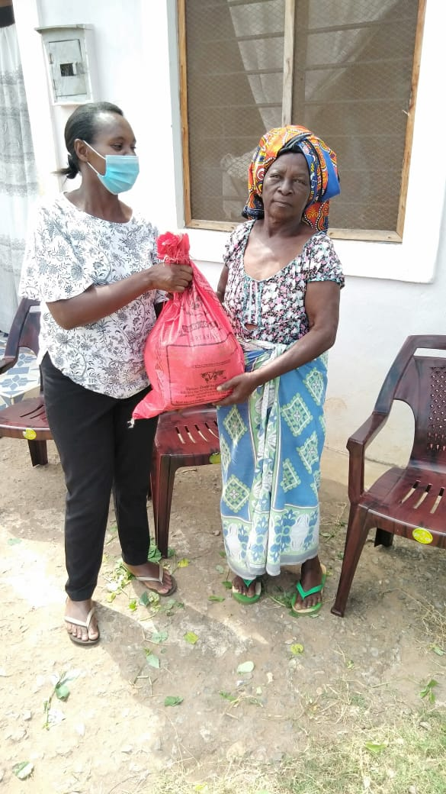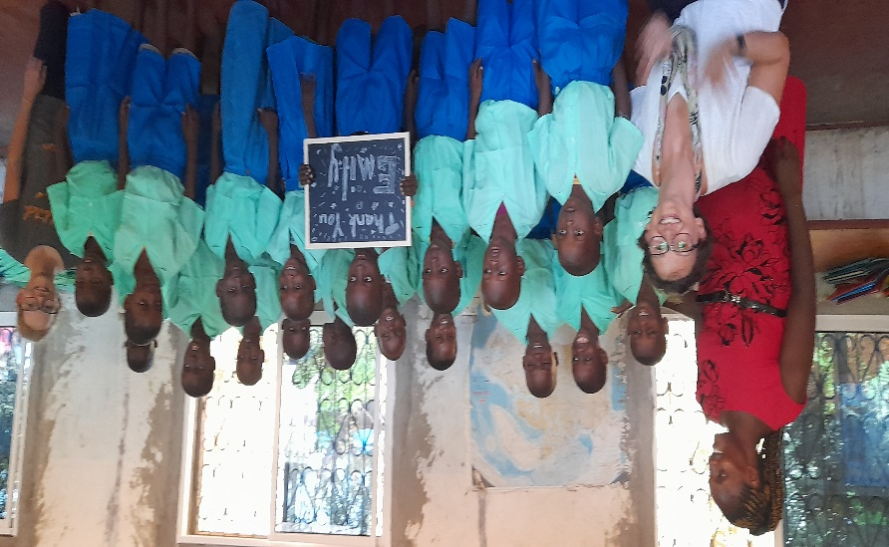
Food for Mama Margaret’s family twice a month Caroline, Alice, Betty and new school uniforms
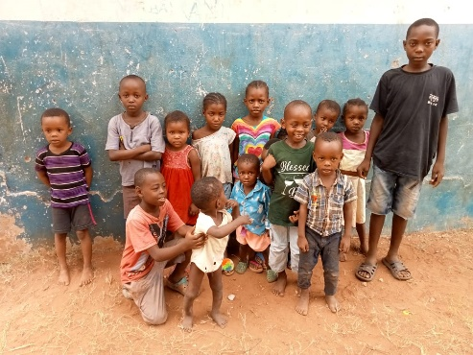

Children waiting for new uniforms.

Gladys completed her last year at school and will continue to receive new special shoes .

This year BBK has repaired 14 toilets at BPS .

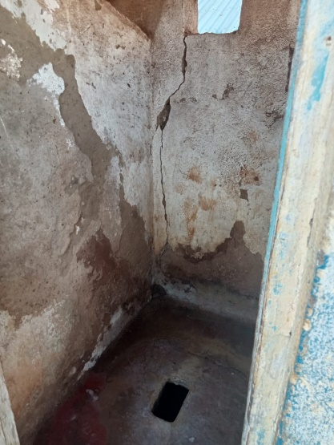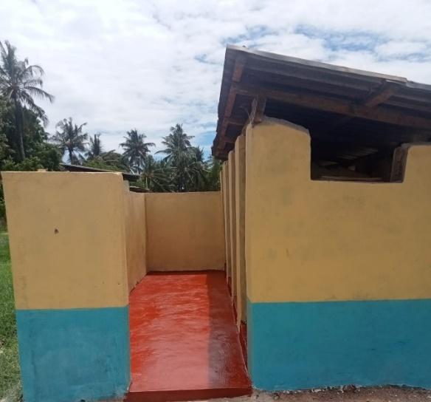
Before After

University Students

Jumaa at MV who is in his last year doing a degree in engineering and Hatson at JHM who is in his third year doing a BA degree in Education at St. Paul’s University Niarobi.
Thomas (JHM ) started his course in January 2025. James started university this year for engineering in Mombasa.

Helping individuals
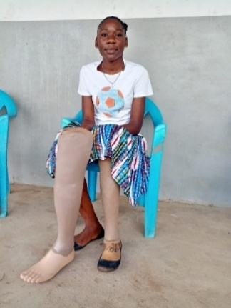
BBK continues to support Mercy by buying her a new prosthetic leg as she grows. She helps Mary at the Gates of Joy to provide school uniforms for the children at the school, on her new sewing machine.

George was electricuted in Feburary and BBK has paid for all his hospital treatment which has been very extensive.

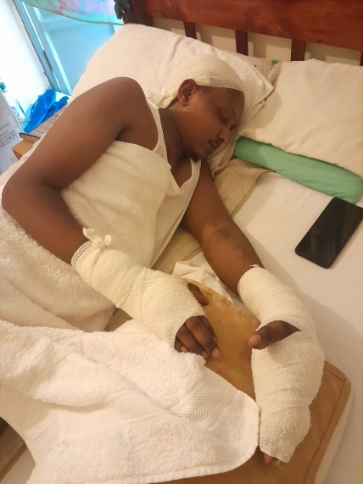
George continues to improve, his head and back are now fine. His badly burnt hands are still receiveing treatment and we pray he make a full recovery,so he can return to work and support his family.

Many individual children are supported when needed, BBK has now started to help families in the communities. Approximately 6 famililies are now receiveing help with clothing,food and school fees.

With God’s help BBK has achieved so much this year and we thank our wonderful God for his faithfulness. BBK is committed to promoting the Christian faith by helping as many as we can in Kenya. Thank you for being a part of BBK. May God Bless you and your families.

