Case Study
Project tittle: Poor student
Beneficiary Name: Noor Fatema Age: 9 Gender: Female Family Members: 7

Background Information/ব্যক্তিগত তথ্য:
Noor Fatema is a daughter of Abul Hashem and Chanuara Begum. She reads in class three. Her father is a day labor and mother is a housewife. She has three brothers and one sister. She lives in Napiter char under Kacchapia union of Ramu upazilla,Cox’s bazar district.
Situation Faced/কি সমস্যা ছিল:
Noor Fatema`s family condition is very poor. Her father is a daily laborer. He earns his living by working as a day laborer. As a result, there is a lack of family . She was not sent to school regularly due to lack of family.
Support Received/কি সেবা পেয়েছে:
Nur fatema`s parents convinced her to come to school regularly. She got the benefits of books, note books, pens, clothes etc. from the Dakbhanga education project. Apart from this, they received rice, dal, oil, salt, onion etc. from the Dakbhanga education project.
How has the Program me/service helped them/কি পরিবর্তন হয়েছে:
She now attends school regularly and studies in class three. Her family is a little better off by receiving food items from the Dakbhanga education project .Her family is very satisfied with the support.
Message from beneficiar/উপকার ভোগীর বার্তা বা স্টেটমেন্ট:
I am Chanuara, mother of Fatema.I will not forget donation of (rice, oil, salt, dal, etc. and elements of various kinds) Dakbhanga Education project. Dakbhanga Education project increased helping hand by foods and educational materials for my daughter. So I thanks to Dakbhanga Bangladesh education project and teachers of Dakbhanga primary school.

Prepared by
Arefa Akter Rifa
Head teacher (Acting)
Dakbhanga Primary School
Pictures of Case Study
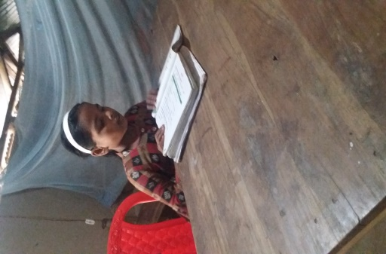 | 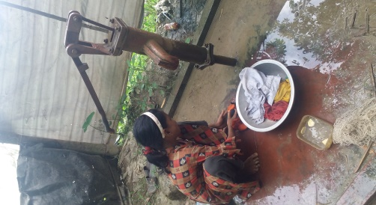
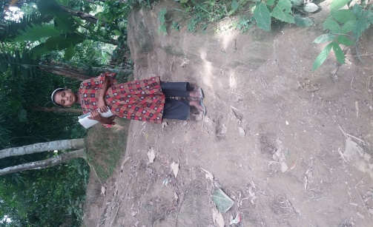 | 