REPORT 1: Food for children affected by South African Riots

As a result of violent riots in the South African provinces of KwaZulu-Natal and Gauteng, businesses, homes, and city infrastructure were destroyed, leaving thousands of young children without access to essential items, especially food. With the generous support of Global Giving and our generous donors, we were able to provide emergency aid to young children and their families in these areas in partnership with disaster relief organizations, food suppliers, and volunteers.
In the document, you will find a brief summary of how the money was used to help vulnerable children.

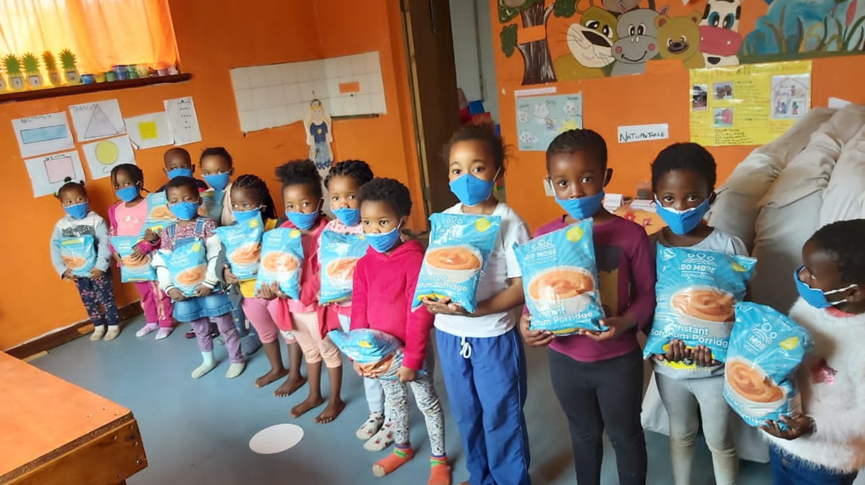

INTRODUCTION

The South African provinces of KwaZulu Natal and Gauteng were severely affected by large-scale violent riots and looting for 9 days in July 2021. The unrest now stands as the worst in decades, with more than 332 deaths reported.

The violence, destruction, and looting disrupted major logistics networks and transportation routes for essential goods such as food, medicine, fuel and has left young children isolated and without access to these essential goods. While there are various concerns around the impact this has on our economy, food security is our primary concern, and we need to ensure food accessibility, affordability, nutrition, and stability over time to avoid placing the most vulnerable (especially young children in vulnerable communities) at any further risk since poverty has been exacerbated by severe social and economic restrictions.

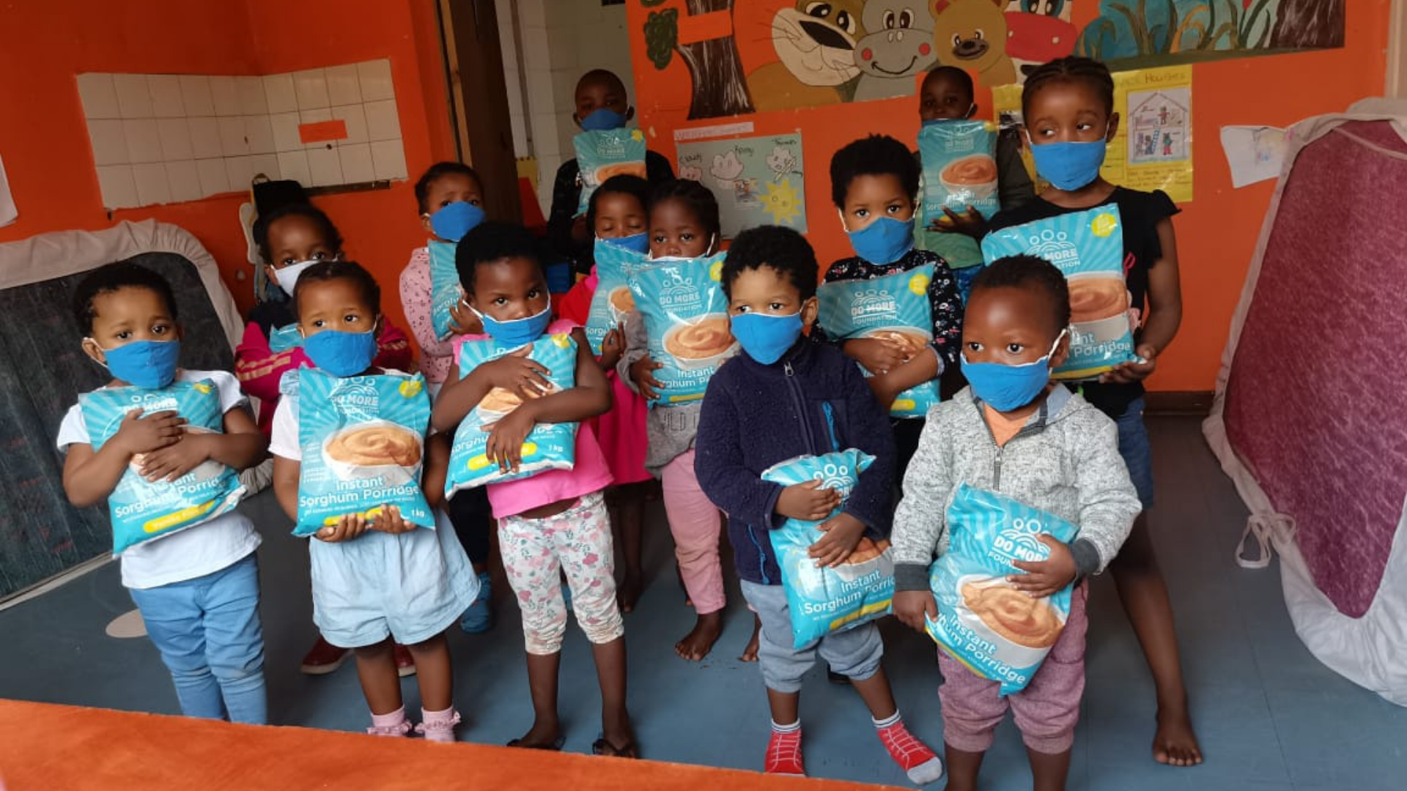

Since the start of the Covid-19 lockdown (almost 18 months ago), the DO MORE FOUNDATION has been working tirelessly to ensure the vulnerable children of South Africa are not left behind. With over 147 partners from the private, public and NGO sectors, we have provided over 10 million meals to vulnerable children and their families across all 9 provinces. Whilst the lockdown regulations have eased, the hunger pandemic in South Africa continues to grow due to increased job losses and rising cases of malnutrition among our country’s most vulnerable group – young children. Working together to find a longer-term solution to South Africa’s growing hunger pandemic.
The kind and generous donation we recoeved from supporters on Gloabal Giving has enabled the Foundation to get food to those that need it most.The DO MORE FOUNDATION's food relief effort depends on collaborative support from individuals and organisations like yourself and partnerships on the ground within the communities we serve.

AREAS OF DISTRIBUTION

We have focused our efforts on reaching young children in five provinces because of the increased need for early childhood development centres and playgroups across the country. The table below shows how meals have been distributed to young children .

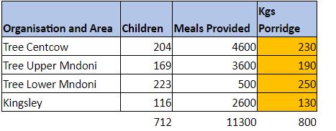
Thanks to your combined efforts, we have secured nutritious food for young children to receive while they attend their ECD Centres. We have worked with top-class partners to ensure the porridge meets young children's needs at home when we are unable to deliver it to ECD Centres due to lockdown restrictions (and the closure of ECD Centres).
On the next page, you will see pictures of the DMF porridge being delivered at the ECD centers, where your donation will benefit young children.

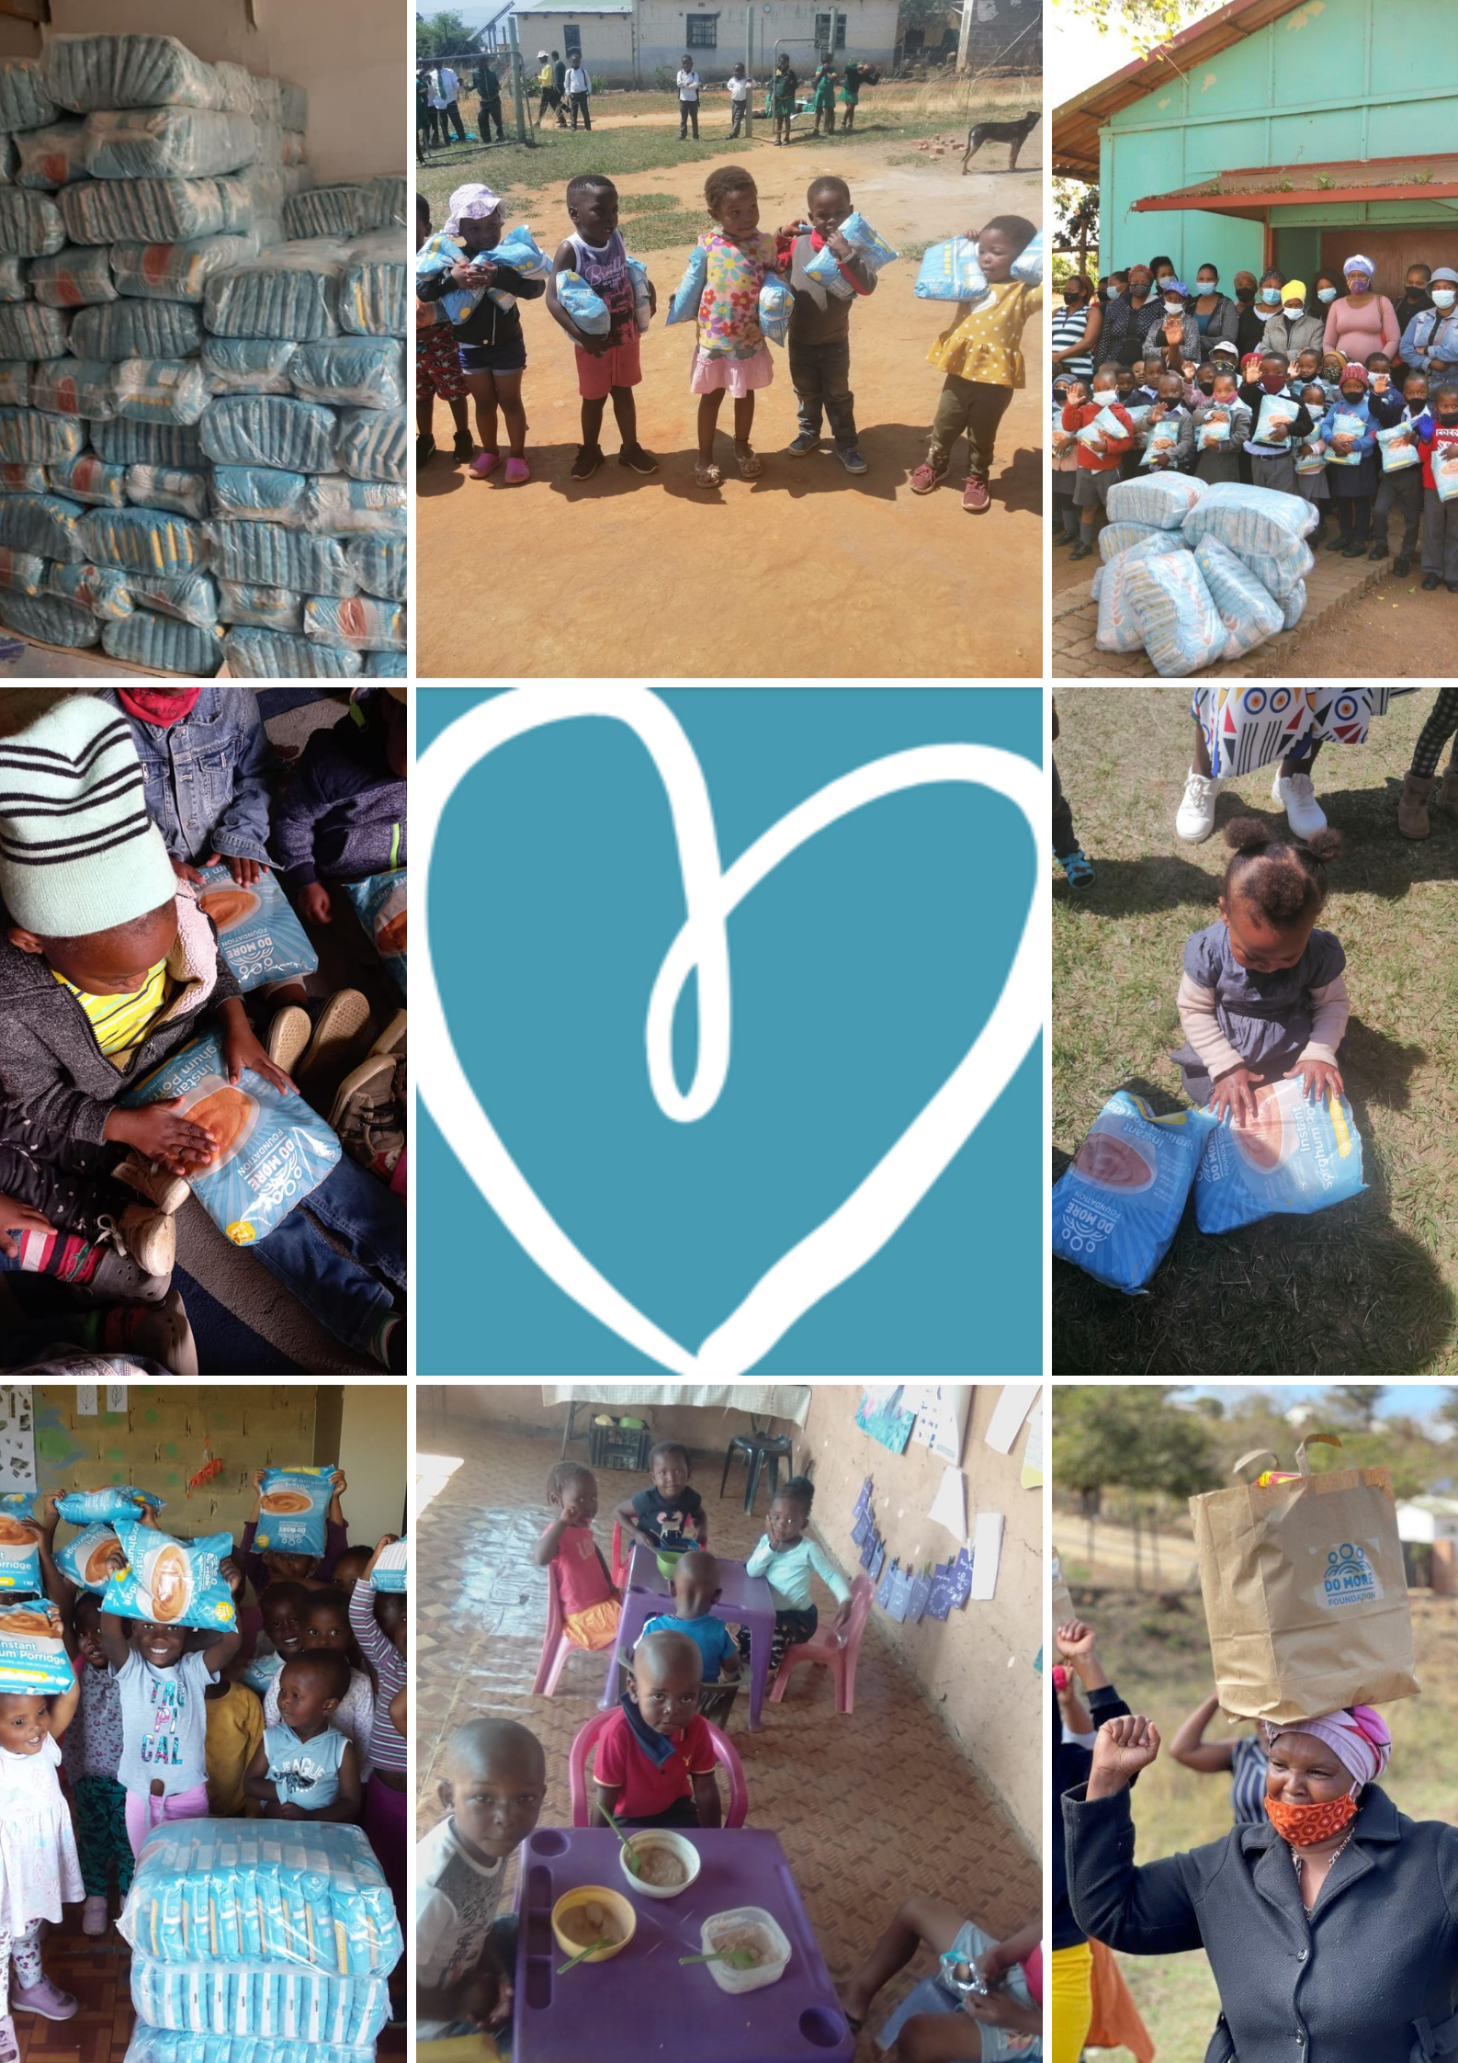

END NOTE

To break the cycle of inter-generational poverty, we need to give young children a healthy and equitable start in life. Providing nutrition and an incentive for early learning for 20,000 of our countries most vulnerable young children will strengthen their development during the most fundamental years of human development (90% of brain growth occurs before the age of five); build their future health and economic prospects; and unlock the potential of future generations. Thank you for helping contribute towards this vision.
Please feel free to review our website and social media platforms to view our ongoing work during this pandemic and beyond.

Website: https://domore.org.za/
Facebook page: https://www.facebook.com/domore.org.za/
Instagram Feed: https://www.instagram.com/domorefoundation/
Linkedin page: https://www.linkedin.com/company/the-do-more-foundation/?viewAsMember=true

Thank you for #DoingMore!

Kind regards,
The DO MORE FOUNDATION team
