Support Toilet for School Children in Nigeria (53006)

Compassion, Love and Service … these are at the heart of serving the disabled, vulnerable and poor of our society. Thanks to partners, our supporters and all our staff who are at the very close relationship with these children supporting them in their learning to give them hope, care and support for their future lives.

There are more than 200 children at Immaculate heart Primary School Adani Enugu state of Nigeria. These children have no good toilet facility to use when in school and as such goes to toilet inside the bush or even in the school premises. These children are at the risk of infection, disease and insect or animal bite as they are not safe with lack of toilet facility in their school. This project will affect more than 200 children who study in that school.

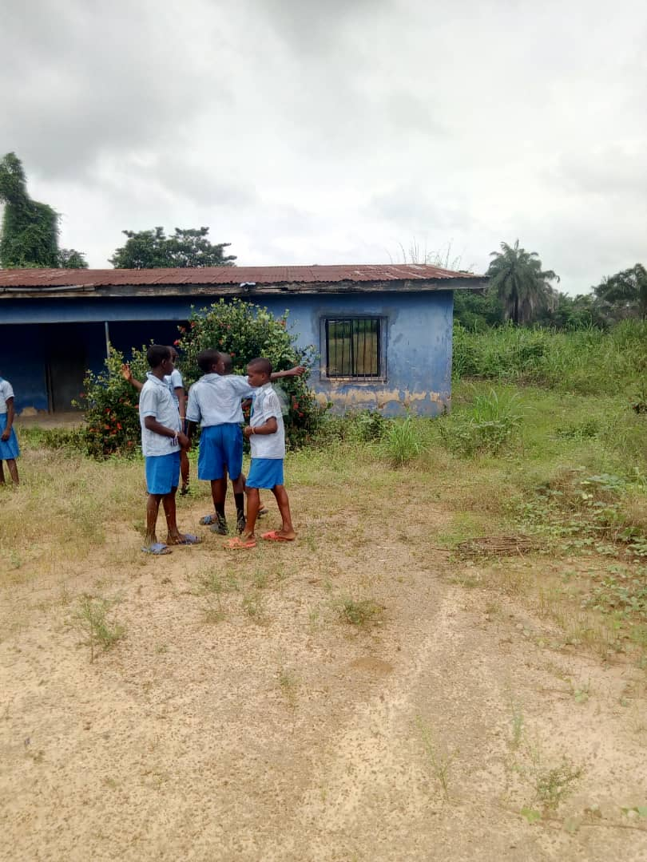 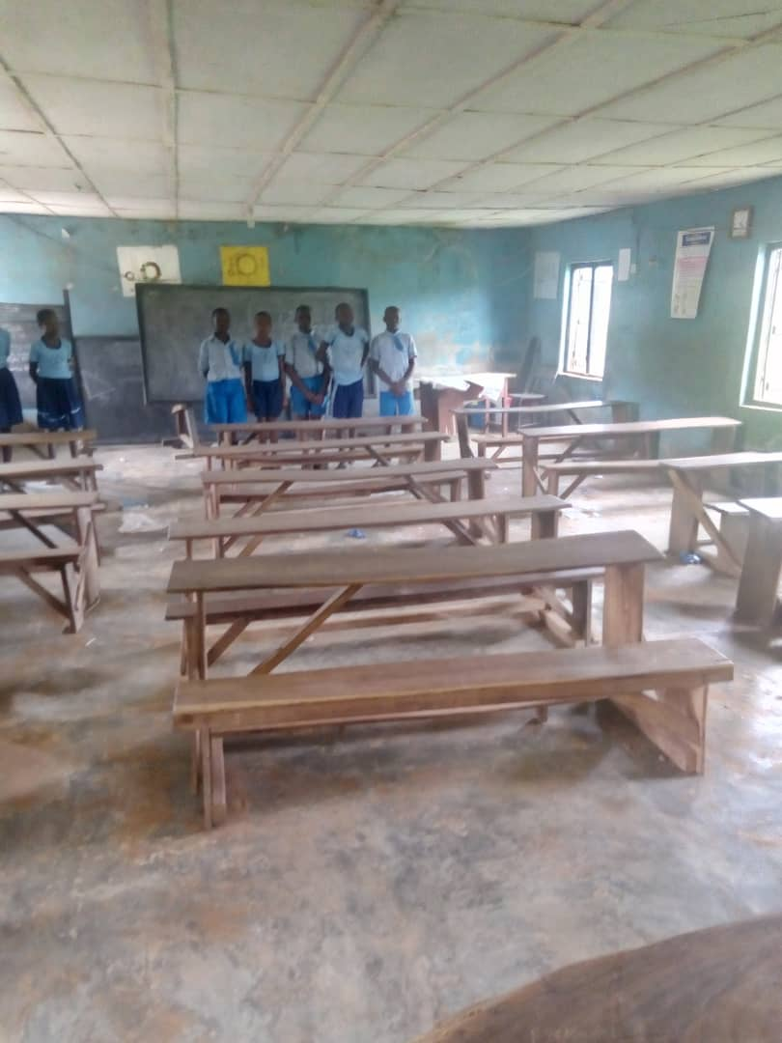

Through this project we hope to provide 12 modern toilets for the school children six for boys and six for girls. We also hope to septic water tank for them for flushing when used. The children will be protected from infection, disease and exposure to danger. They will have good sanitary learning environment. The sisters provide nutrition, hygiene and health care support to the children. Their parents are also trained in nutrition, infection prevention and children care on using appropriate hygiene for their children.

They participated in different exercise to keep their mental health and wellbeing. One of the resident commented, “To see a modern toilets constructed for our use in the school makes me feel good and safe from danger of going to the bush’’ and another said, What I liked most is been able to go to toilet comfortably without fear of getting bitten by snake or dangerous animals in the bush’’ One of the teacher expressed her joy ‘ At least we are sure of neat and tidy classrooms, the3 children can go to the toilet and not use classrooms as toilets’ The joy of having modern toilets in the school gives us more sense of responsibility of keeping our children in the safe environment in our studies, “said one of the parents”.

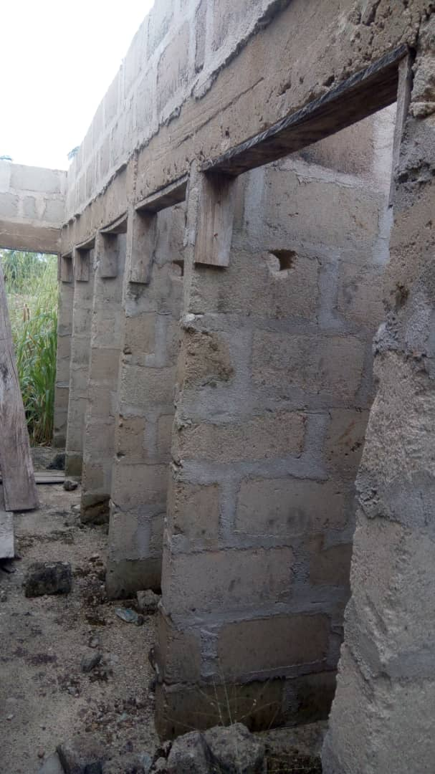 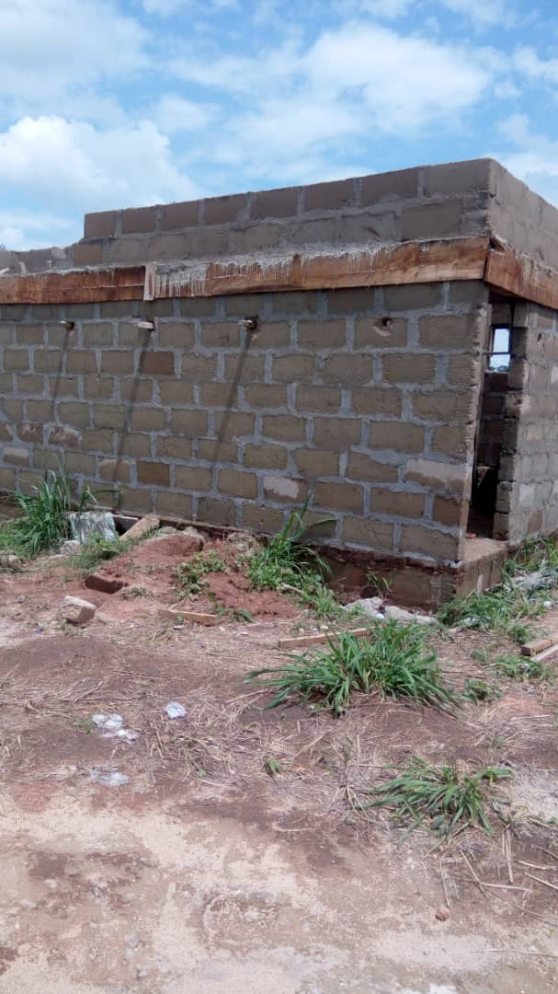 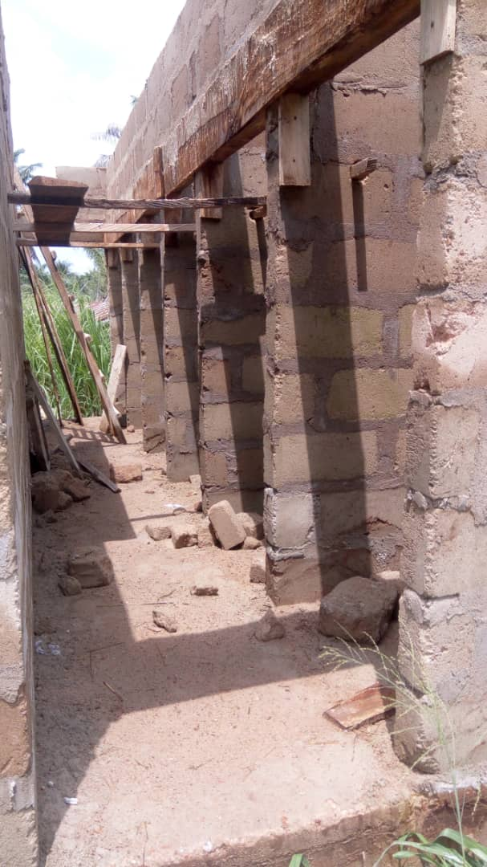

Bringing the joy and hope to our school children is as result of donors like you who are providing the financial support that helps us to construct the modern toilet for them and offer these dynamic support and care to them. All members of our staff have embraced these programs and are enthusiastically working with residents to provide them with all the care and assistance they need and hands-on creative learning. We are grateful to you for making the “Support Toilet for School Children” an opportunity to support and care for pupils. Your donation to Sisters of the Immaculate Heart of Mary is helping us to build these toilets through our enrichment programs and activities. Donations help us to educate 200 families and their children on sanitary and hygiene, which will provide for their families' health and well-being etc. As you see the toilets are still under construction waiting to be completed, your donations would help us to meet the target by December 2021. We couldn't do it without you.