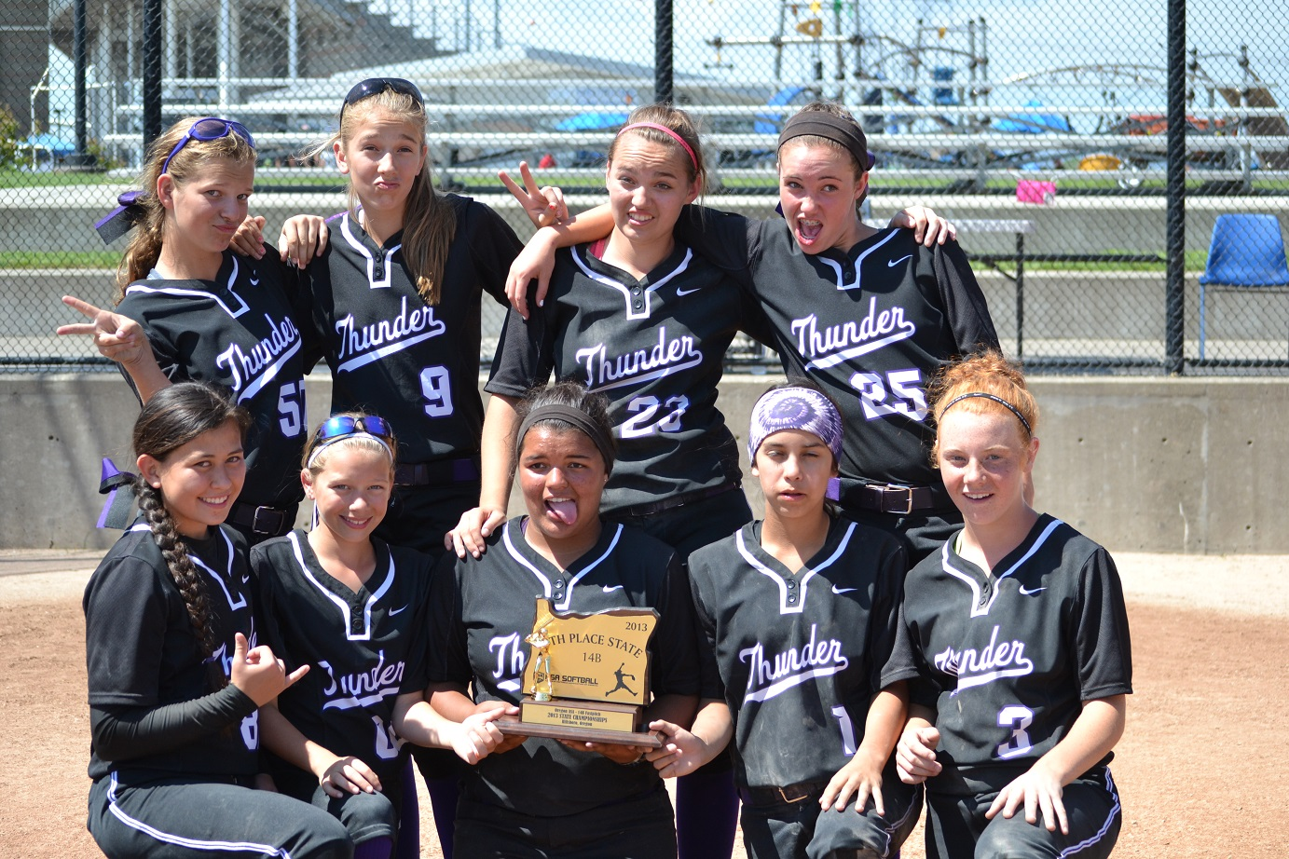
Oregon

Thunder

Fastpitch

Thunder fastpitch (tuck) 14U
Team bonding
These girls have built strong bonds and friendships over the last 3 years of playing together. They celebrate the good times, get through the tough times and laugh each other out of a mental slump. Softball has taught them the importance of being strong physically and mentally. These girls walk through teenage life with confidence.
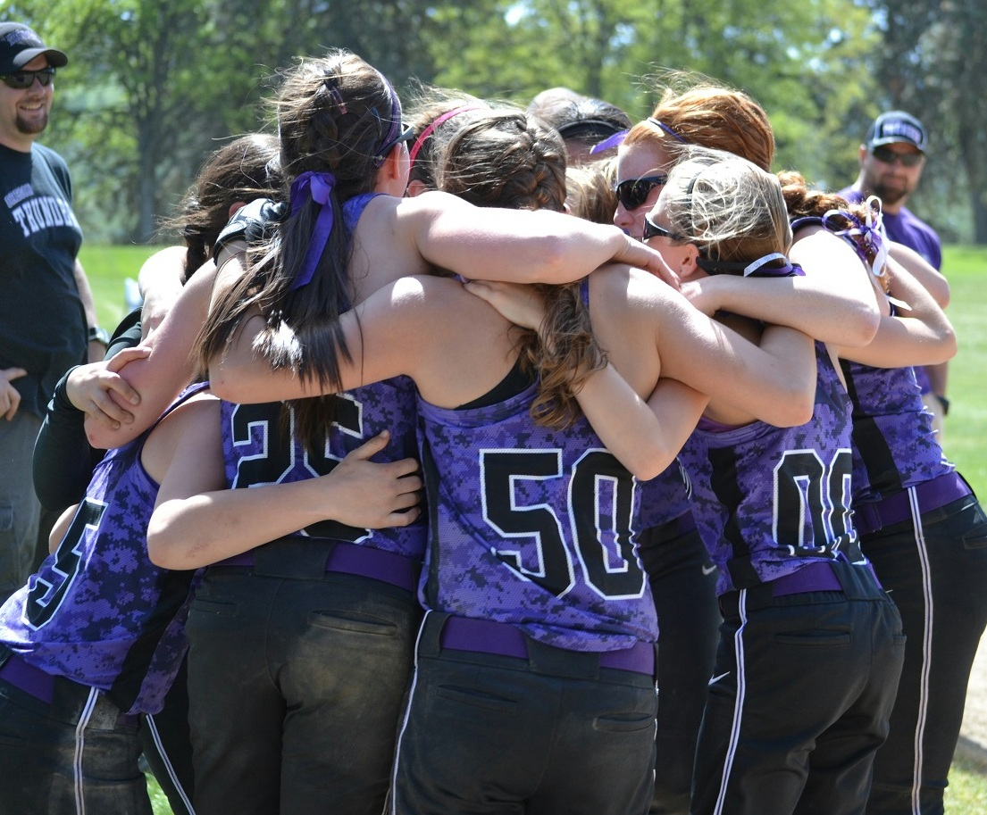
Team pre-game cheer
The 2013 season was a time of development and fine tuning the girls’ fielding and batting techniques. These growing teenage girls were grateful for the upgraded Nike uniforms and equipment. The success of an athlete are made up of components like: skill, coaching, equipment, and athletic ability

“Play like I know you can play, give it all your heart while on that field.” ~Coach

competing in state with 9 strong girls
Head coach Tuck likes to keep the team small to give the girls more playing time and less time on the bench. The coaching staff genuinely care about these girls as an extended family having been together for so long. Our small close knit team proved to be a bit of a challenge as we had our fair share of injuries and growth through those injuries. Each girl on this team knows that they are critical to the success of the team. They would often hear “Play like I know you can play, give it all your heart while on that field” from their coaches. Along with other sayings, like: “Mash” and “Wheel” meaning to hit hard like I’ve seen you hit & run like the wind.
The 14U State tournament was July 5-7th in Hillsboro, our home field, so the girls were feeling great about State. The girls played great Friday and then Saturday on Game 4 met with their first defeat by 1 run. This put us in the loser bracket meaning we played all games back to back until we lost or won the final game. Girls were on the field at 6:30am for the 8:00am game, we won our first game and played 4 games back to back many going into extra innings. In the end we placed 5th in State, with the girls playing hard for three days. They learned to work hard and persevere even when they were tired and sore.
This 2013 season was a success in terms of the outcome of games played locally while developing the girls’ skills and confidence both at the plate and in the field. Half of the team started high school and much of their confidence at school is a direct result of their confidence on the field.

