|  |  |  |
| --- | --- | --- |
| Monthly  Newsletter | |  |
| Volume2 | Issue 3 | Mother Earth March 2021 | | |
| Announcement May 1, 2021 Rolling out New Programs  Diploma in Primary Teacher Education (DPTE)  Diploma in Special Needs Education (DSNE)  February 9, 2021 Inauguration of the Bishop Elect Rt. Rev. Michael Odiwa Catholic Diocese of Homa Bay  February 8, 2021 Micro-teaching Begins Certificate Class  February 11,2021 Mid -semester Assessments Certificate & Diploma Class  February 15, 2021 Academic Break Begins No class and All Offices Closed |  | Inside This Issue  PG. 2  The National Social Security Fund donates tree seedlings to the FTCN Community  PG. 3  Water scarcity at FTCN  PG. 4  Co-curricular and Brain Development |

**School Environment and Cognition**

Madam Hilda Nyangweso in an outdoor class session. Our classrooms get overly hot, and that’s an incentive to plant many trees to generate fresh air, and to cool down our learning environment.

|  |  |  |
| --- | --- | --- |
| OUR MISSION, VISION & VALUES **Mission**  St. Francis Training College Nyamonge (FTCN is dedicated to continuous professional development, productive use of technology, and partnerships with parents and community.  FTCN embraces teacher education as a mode to empower and to prepare individuals to excel in the pursuit of knowledge and truth, and to live it well.  **Vision**  St. Francis Nyamonge is committed to offering transformational education to all people, to educate the “whole person” and to empower students to realize their potentials, and to seek new knowledge in making the world a better place in which to live.  **Core Values**  Catholic Identity; Respect; Teamwork  Service; Empowerment; Excellence    **Launching Tree Planting at St. Francis Training College Nyamonge**  The FTCN Community receives 200 tree seedlings donated from the National Social Security Fund Organization. |  | WELCOME TO  FTCN  OUR HOME  BY  THE LAKE  **“To be the best version of yourself”**  To be the best version of yourself” |
|  | In Figure 4, above, students are rushing for the KIWASCO Water, after trekking for water from Kibos River for over a week. When the Well is dry and there is no any other water source, we are often left with the polluted Kibos River as our last hope. With the COVID-19 pandemic, this put our students in an imminent danger of contracting the virus and further cross-infection. This very water is polluted by the Kibos Sugar and allied industries. We appeal for a borehole; a long-lasting solution. |  |

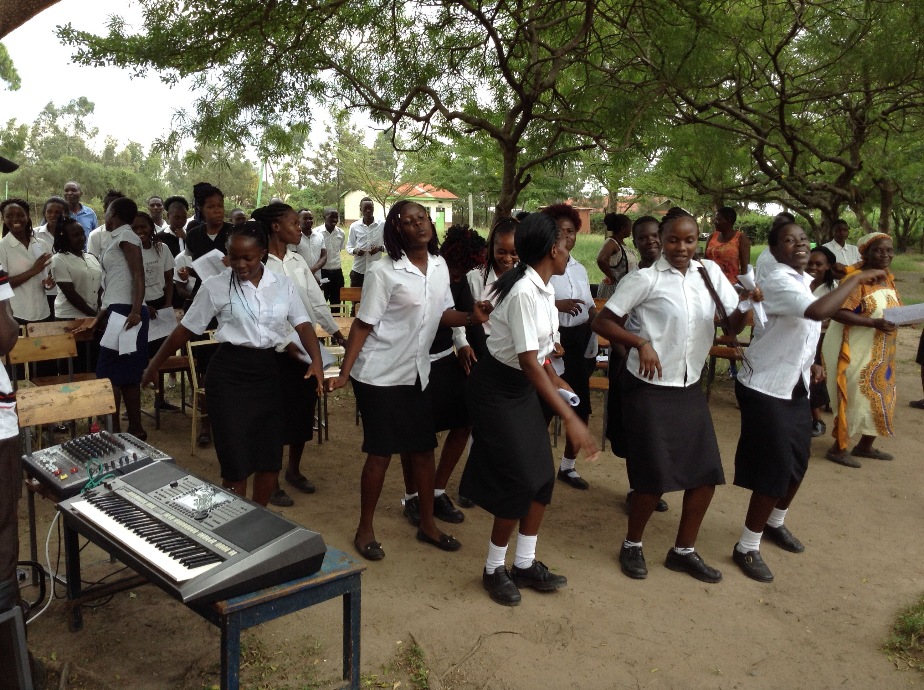

WATER SCARCITY AT ST. FRANCIS TRAINING. C. N

*Conducive Learning Environment*

Creating a conducive and enabling learning environment at St. Francis is at the core of all its activities. It is an invitation to engage in holistic approach, which stems from our belief that a student is an individual who should be viewed as a whole consisting of various aspects that all need to be developed.

Our focus is not only limited to academics, but also to other significant kinds of learning as explained by Lee D. Fink in his book on *Significant Kinds of Learning*. As we strive to shape up our learning environment, we also seek to equip our students with spiritual nourishment, that will help direct their learning to the pursuit of truth, who is God Himself. At the beginning of every semester, students, faculty, and staff, congregate to celebrate the Mass of the Holy Spirit, to seek for divine intervention throughout the semester. As a faith-based institution, this is a practice we have cherished since the founding of FTCN.

An aspect that is key to teacher education is human dimension, the ability to build personal and social competence to provide a seamless connection between teachers and pupils/students. Attributes like self-awareness, self-regulation, motivation, empathy, and social skills.

|  |  |  |
| --- | --- | --- |
|  |  | Co-curricular and Brain Development Teacher training is not complete without physical exercise. At FTCN, we take pride in physical activity as it helps to improve self-confidence, self-esteem, and self-control. Daily quality physical education is an important part of a student’s comprehensive, well-rounded education program and a means of positively affecting life-long health and well-being.  Being a proponent of Brain-based education, we instill in our students the culture and norm of routine program for physical, wellness and fitness. Research on Brain-based education revealed that exercise enhance blood circulation, stimulate the production of nerve growth factor, and promotes the production of new cells in the brain. |
| A FRANCISCAN EDUCATION  |  |  |  |  | | --- | --- | --- | --- | |  |  | Knowledge |  | |  | COMMITTED TO EXCELLENCE – Spirit Warrior Ministry | Excellence |  | |  |  | Truth |  | |  |  |  |  |   We seek the knowledge to excel in our quest for Truth, that is, to know God, to find God, and serve God in all we do. The ultimate Truth is God; therefore, at St. Francis Training College, our education is to lead us back to the Truth. To be in owe at God’s revelation as we progress in our studies. |
|  | Are you ready for a course in Special Needs Education?  Focus:  You will understand the needs of every learner in the digital age.  You will understand that students learn differently, they come to us with many multifaceted learning capacities. Sometimes a disability or challenge in one area may be countered by extraordinary ability in another.  The focus is on best practices, evidence-based practices, in a lesson activity;  You will be able to determine whether to use “adaptations or accommodations to achieve the goal of each lesson and activity.”  You will learn some ideas for best practices like Bloom’s *Taxonomy, the Taxonomy of Significant Kinds of Learning.*  You will be able to help learners to make meaning of their learning. |