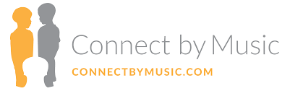

Adapting our new program to a new reality: Covid-19

In March 2020, a global pandemic struck the world. We all had to learn how to navigate this provisional new reality we are living, which has had a tremendous social impact globally. In the humanitarian aid sector, work has become dramatically complicated, leading some organizations to cease operations because of the multiple set-backs, and others, such as Connect by Music, to strive for resilience, in compromise with the community we serve.
Connect by Music adopted a series of safety measures to adapt to the new needs and be able to deliver our program and continue creating a positive impact despite the circumstances:
- Hand sanitizer is available at the beginning and end of the session and any time a student request.
- Heater/air-conditioning is used only in extreme weather conditions and for a short period of time. Instruments and chairs are cleaned with antiseptic wipes by the music teacher or music therapist at the end of every session.
- Only six students are allowed per space.
- 1’5m social distance is required between all attendees.
- Use of masks is mandatory at all times.
- Shorter sessions: before the pandemic, there would be up to 17 students in one class; after decreasing the number to 5, the teams decided to do shorter sessions in order to include all the students registered in the program.
We believe in perseverance. The world is changing and so we will adapt. Flexibility is a non-negotiable in the humanitarian field, where everything is subjected to ever changing environments. With common sense and best practices, we continue to provide the best we do to the ones who need it the most.

