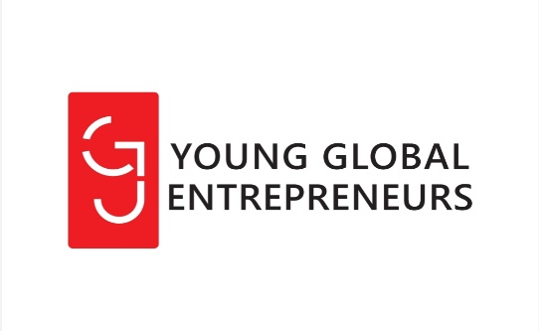
Dr Bukirwa Irene Kamara
| 45 OLIVE, MIDRAND, JOHANNESBURG , South Africa
Young Global Entrepreneurs (YGE)
2020/2021 Annual Report

Contents
Organizational information 1
Implementation strategy: 1
Project information 2
Project objectives 2
Achievements and impact 2
Financials 5
Organizational plan for 2021 5

Organizational information

Who we are: Young Global Entrepreneurs (YGE) is a South African-based non-profit organization based in Gauteng Province established in August 2018.

Our mission: YGE eempowers the youth, women and their communities with knowledge and skills through a collaborative and evidence-based approach that will enhance their education, health, and nutrition to improve their socio-economic status and wellbeing in South Africa.

Our purpose: YGE improve livelihoods and economic independence of unemployed women and the youth who are not in education, employment or training (NEETS).

Organisational structure: YGE has a highly skilled staff and strong management structure led by a six-member board. The program team is led by the Founder and Chief Executive Officer, the Project Director, two Community Coordinators, one Finance Manager and five volunteers.

Implementation strategy

Tackle hunger: Teach our beneficiaries economic and sustainable ways of helping themselves to produce food through small scale agriculture, begin to break the poverty cycle and help the community develop.

Build relationships: Collaborate with community leaders, local youth and women’s groups, various government agencies, community-based organisation to identify the most pressing needs that the youth and women face and provide solutions through effective, scalable, and community empowerment at the household level.
Improve the quality of life and promote social change: Gardens will contribute to improved attitudes toward healthy food, improved understanding of life science concepts, and improved interpersonal skills, Children will children (and adults) to explore nature in the middle of urban areas.

Generate employment opportunities as entrepreneurial ventures grow: With the growth of their agricultural businesses people can begin to create employment within their communities. Small enterprises are critical in the training of locals and creating jobs.

Project information

Food security in South Africa: New evidence suggests that two of every five adults reported that their household lost its main source of income since the COVID-19 pandemic lockdown restriction in March 2020 in South Africa (Coronavirus Rapid Mobile Survey (Crams), 2020). This has had devastating consequences for food insecurity and household hunger. Hunger will likely continue to grow in South Africa, especially as unemployment may continue to rise from the 2.2 million jobs believed to have been lost in 2020 during the Covid-19 pandemic. The current situation presents a major threat to food security and livelihoods of a large proportion of households receiving grants from the government and those who lost their jobs. The social relief efforts through local governments and non-state institutions are insufficient and non-sustainable.

YGE creates opportunities for its beneficiaries who are less advantaged to be part of the solution to their problems. YGE helps its beneficiaries develop a mindset that enables them to believe in themselves, their abilities and in working for themselves. Young Global Entrepreneurs is on a mission to empower youth and women with agricultural skills that will enable them to grow and improve their livelihoods.

The involvement of households in agricultural activities for subsistence farming can play an important role in reducing the vulnerability to the hunger of urban and informal settlements food-insecure households. So, what works best to improve access to food? There is a dire need to set up sustainable agricultural food systems to address hunger at the household level where communities are empowered to produce nutritious food for themselves. In response to food shortage during the COVID-19 pandemic lockdown in South African, in March 2020, YGE launched the ‘Help a woman, feed her family’ program was launched.
Where we work: We work in informal settlements in the Gauteng province. In 2020, we set up the ‘Help a woman, feed her family’ project in Vusimuzi. Vusimuzi is an underserved informal settlement with no electricity supply, clean running water or a sewer system. The settlement consists of more than 1 000 shacks, with at least five people living in each shack and a high unemployment rate.

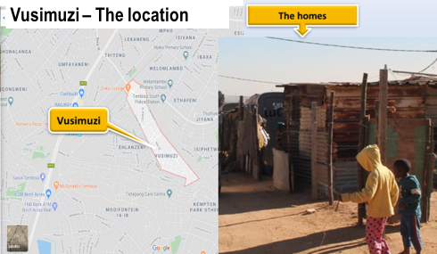

Project objectives
- To educate and equip women and youth with agri-business skills needed to manage family-owned gardens for improved food security in informal settlements, in Gauteng Province.
- To build sustainable small-scale businesses for unemployed women and youth who are not in education, employment or training (NEET) through quality entrepreneurship vocational education and training.

Achievements and impact

Founded in 2018, YGE has a high skilled staff and strong management structure led by a six-member board. The program team is led by the Founder and Chief Executive Officer, the Project Director, two Community Coordinators, one Finance Manager and five volunteers.
YGE believes in beneficiary engagement and we do so through community dialogues and stakeholder engagements to seek buy-in and ownership for the sustainability of the organisation. Building partnerships and relationships with the community and community leaders, through regular meetings, was important for setting up the vegetable gardens.

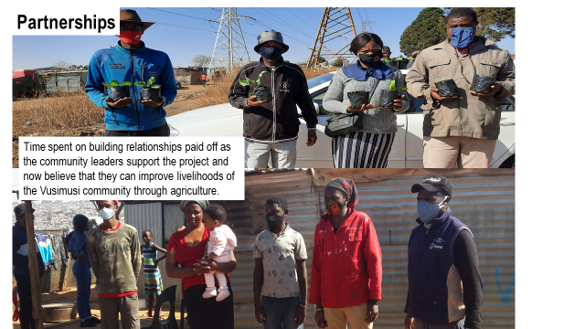

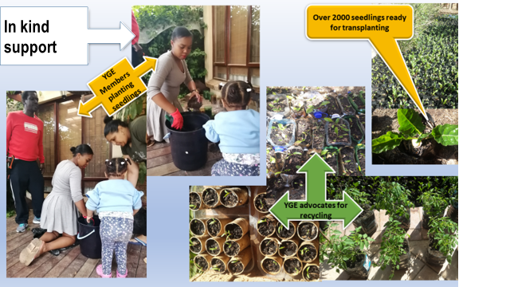
Seedlings were also donated by YGE towards starting a community garden. Participants were trained. YGE continuously monitored the project ensuring that the skills taught were followed.

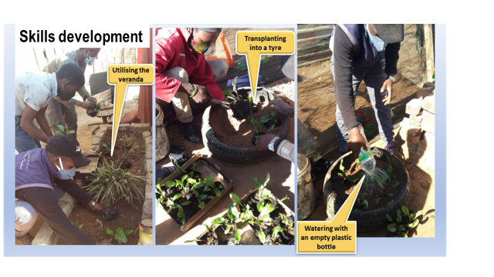

Program Results: In 2020/2021, YGE enrolled 100 women and young people from the Vusimuzi community who planted vegetable gardens in their backyards. We also set up a community garden that was run by women and youth from the community.

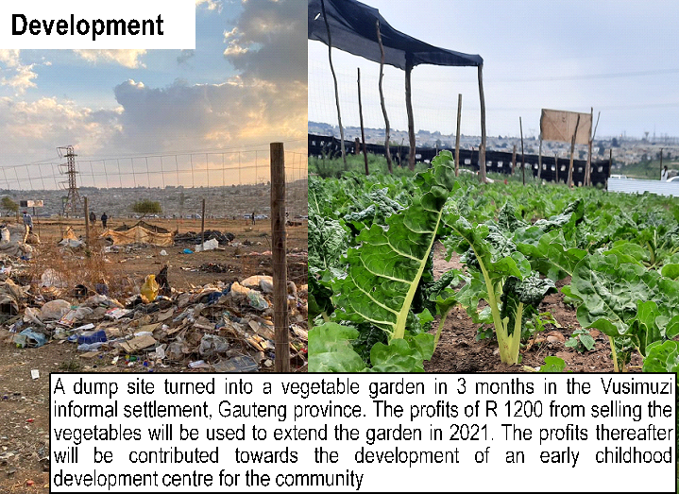
In just under a year our project transformed a dumpsite in Vusimizi Community into a community garden in collaboration. The project has since then sold vegetables sold from the community garden and generated an income that will contribute to the expansion of the community garden project.

To measure our progress, we track outcomes, outputs, and inputs. This allows us to decide on what matters most to families facing hunger. This past year, we were able to involve 100 families in the “Help a woman feed her family project”. We were able to feed 100 families and improve livelihoods. Our beneficiaries gained agribusiness skills. There has been a cultural change as some women and the community members are exploring ways to expand the agribusiness project to substantiate their income in addition to feeding their families.
Testimony: “My name is Noyise Makhalane. I live in Vusimuzi in a shack. I have a husband and 3 children. I started a garden at Vusimuzi Section, Tembisa 1632. I started this garden in a place that was a dump. It was not easy to clean that dump. Because I was so excited to do this garden, it is clean. Now it is a clean a nice garden that has fresh and nice vegetables. And I supply the community with my vegetables at small prices. I was lucky because I have Dr Kamara who is my organiser of this, and we work together on this project. I have applied for Agriculture for sponsorship. They will come to see the garden. I think they will give me money to make the garden bigger.” Noyise Makhalane 28 January 2021

Monitoring: YGE conducted training and project monitoring throughout 2020 -2021 through telephone calls and weekly onsite check-ups. This approach improved our relationship with the community and ensured that the skills taught were followed. YGE has developed strong relationships with the community as we can begin to see evidence of buy-in and ownership through the level of commitment from the beneficiaries, local government representative and community leaders.
Challenges: Building trust was a big challenge as the community had lost hope and motivation to improve their lives during the COVID-19 pandemic lockdown. Material sourcing and labour also turned out to be a challenge due to limited funds. Added expenses were incurred to secure water for irrigation and for sourcing material to protect the garden from pests and rodents.

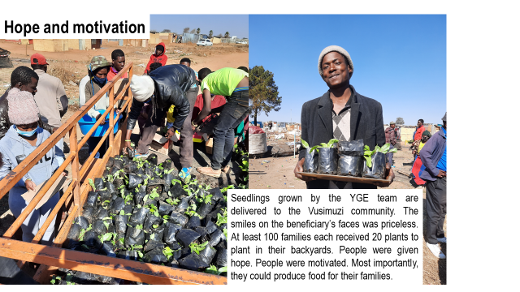

Financials
Summary budget
Income type (Donations) | Budget (Rands) | Comments
Dr Irene Kamara (CEO/Founder) | 115,000.00 | For administrative, non-project staff and programme costs
In-kind donations | 72,000.00 | Donated as labour, transport and expertise costs
Total Budget | 187,000.00

Organisational plan for 2021

- To expand the “Help a woman, feed her family” project in Vusimuzi and additional informal settlements.
- To raise funds for project expansion.
- To develop training materials including interactive videos

