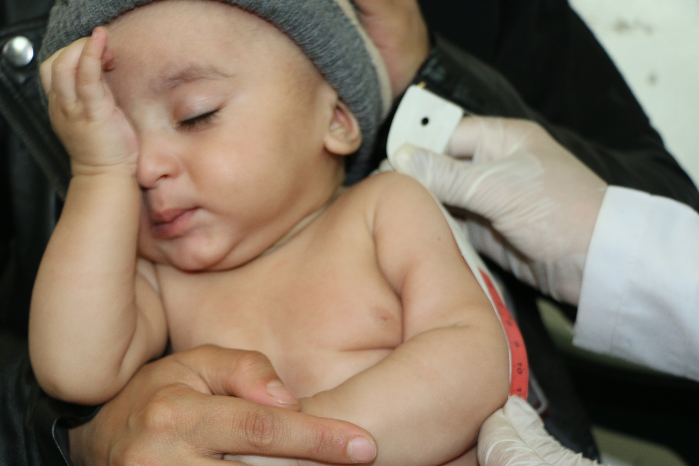

**Report on Children’s Tools in Yemen and women’s Urgent Needs**

**June - - August 2023 AD**

**An Overview of the Tragic Situation in Yemen**

Yemen has been experiencing a civil war since 2015 between the Houthi rebels, supported by Iran, and the internationally recognized government, backed by a Saudi-led coalition. This conflict has resulted in widespread violence, displacement of millions of people, and a severe humanitarian crisis.

|  |  |
| --- | --- |
| **The conditions of children in Yemen**  Nearly 4.2 million children in Yemen suffer from acute malnutrition . Reports also indicate that more than 60,000 children have died from acute malnutrition since the outbreak of the conflict in 2015. More than 3.6 million girl children suffer from gender-based violence, including early and forced marriage. Nearly 2.4 million children are deprived of education due to the conflict |  |

|  |  |
| --- | --- |
| **\*The urgent needs of women in Yemen\***  * More than 6.1 million women in Yemen need protection services. Displaced women are particularly vulnerable to risks, including sexual and gender-based violence. Women are also forced to bear more economic burdens due to the loss of male breadwinners. Women face difficulty accessing basic services, such as health care and education .  Women and children in Yemen are exposed to widespread sexual and gender-based violence. Domestic violence, early marriage and forced labor are among the threats children face Women in Yemen depend heavily on men for economic support. However, the conflict has caused many men to lose their jobs, leaving women responsible for supporting their families . |  |

**Here are some activities that Implemented :**

*Distribution of food and medicines to families affected by the conflict.* 20 families . *Providing vocational training for women, Which helps them find work.* Providing legal support to women and children who have been exposed to violence.* Raising awareness of local communities b The rights of women and children.*

Recommendations: Providing the necessary support for activities to reach and benefit from the Yemeni countryside. Activities must focus on the specific needs of women and children in Yemen. For example, women in rural areas may require access to education and training in agriculture or business. Children in urban areas may need psychosocial support to overcome the trauma they have experienced.

.