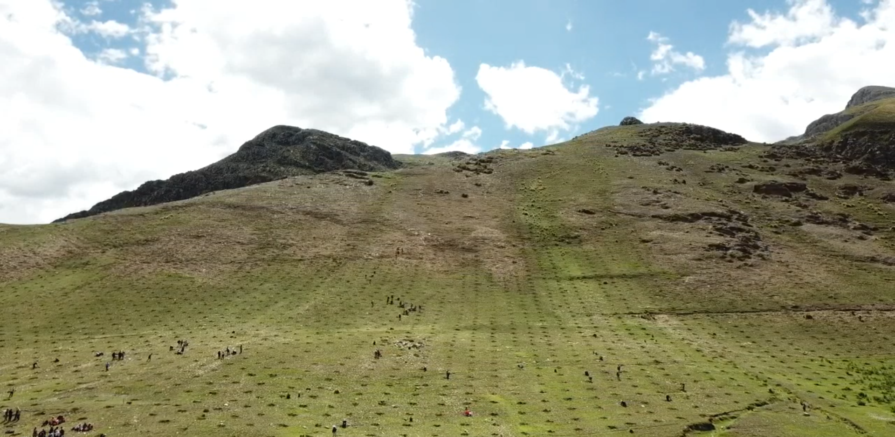
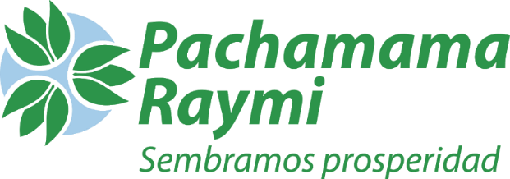
MORE TREES PROJECT.
Dear Donors,
In recent months, we have been working on the restoration of degraded land and the eradication of poverty. The project is designed to benefit more than 4,000 families and to restore approximately 1,900 hectares of degraded soil each year, over a period of about seven consecutive years.
The geographic scope of implementation covers 35 rural communities located in the districts of Huanoquite, Omacha, Accha, Ccapi, and Ccapacmarca, in the Cusco region of Peru.
We are currently in the third year of implementation. We have recently completed our second forestry campaign (2024), successfully planting approximately 2,000 hectares. There is still a long road ahead, with much to learn alongside the participating communities and local governments.
We are currently in the third year of implementation, having successfully completed two forestry campaigns.

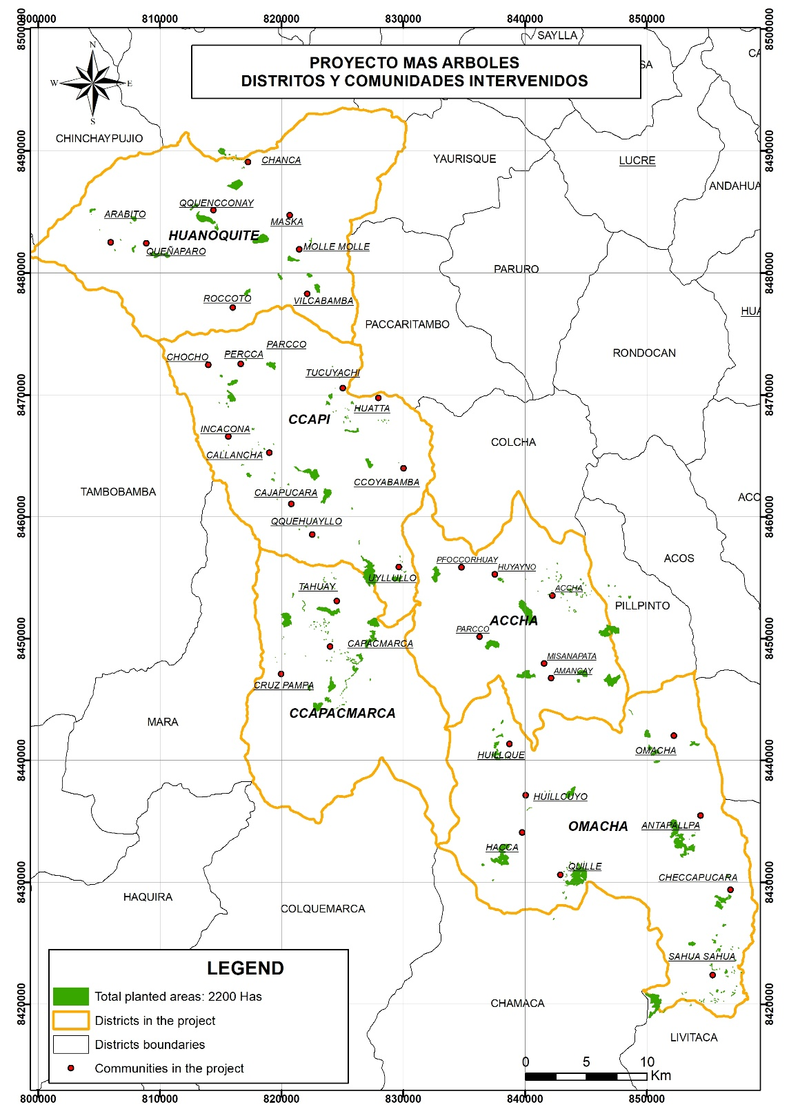
Image 1:
Map of the project area and hectares restored through tree planting

We continue to affirm that the future of the planet is in the hands of family farmers.
Our main Target of the MORE TREES project is to restore 13,300 hectares and establish 1,330 hectares in conservation.

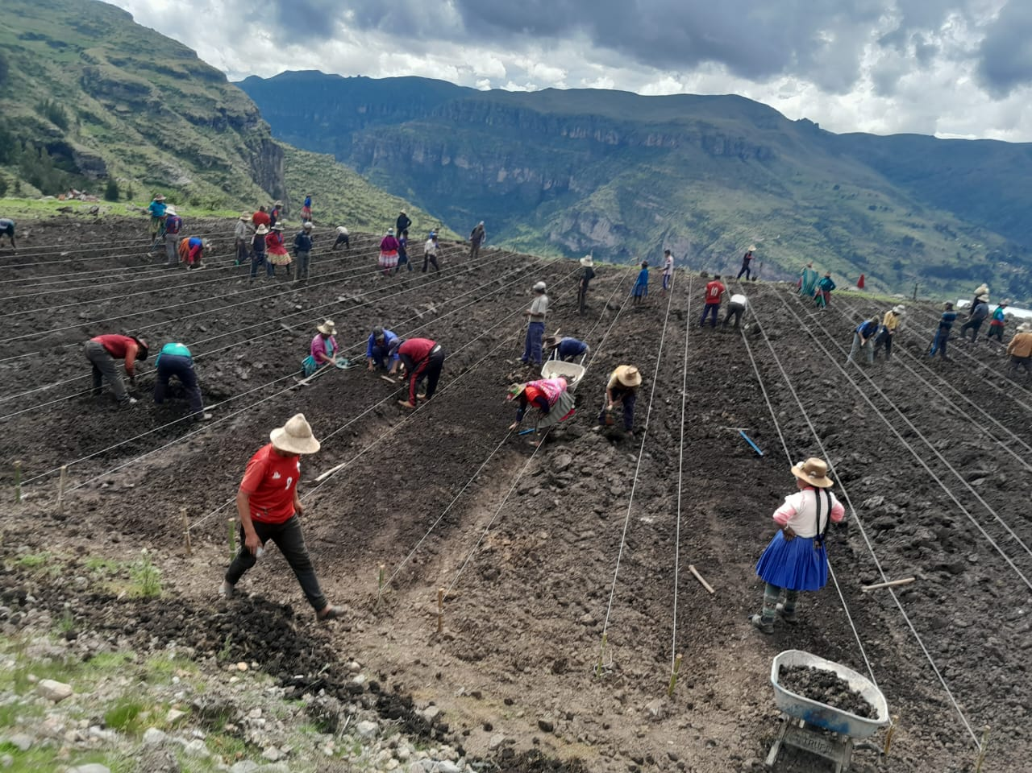
Active community participation is essential to achieving the project's objectives, as their knowledge of the territory, commitment, and ownership of the processes ensure the sustainability and long-term impact of the actions implemented.

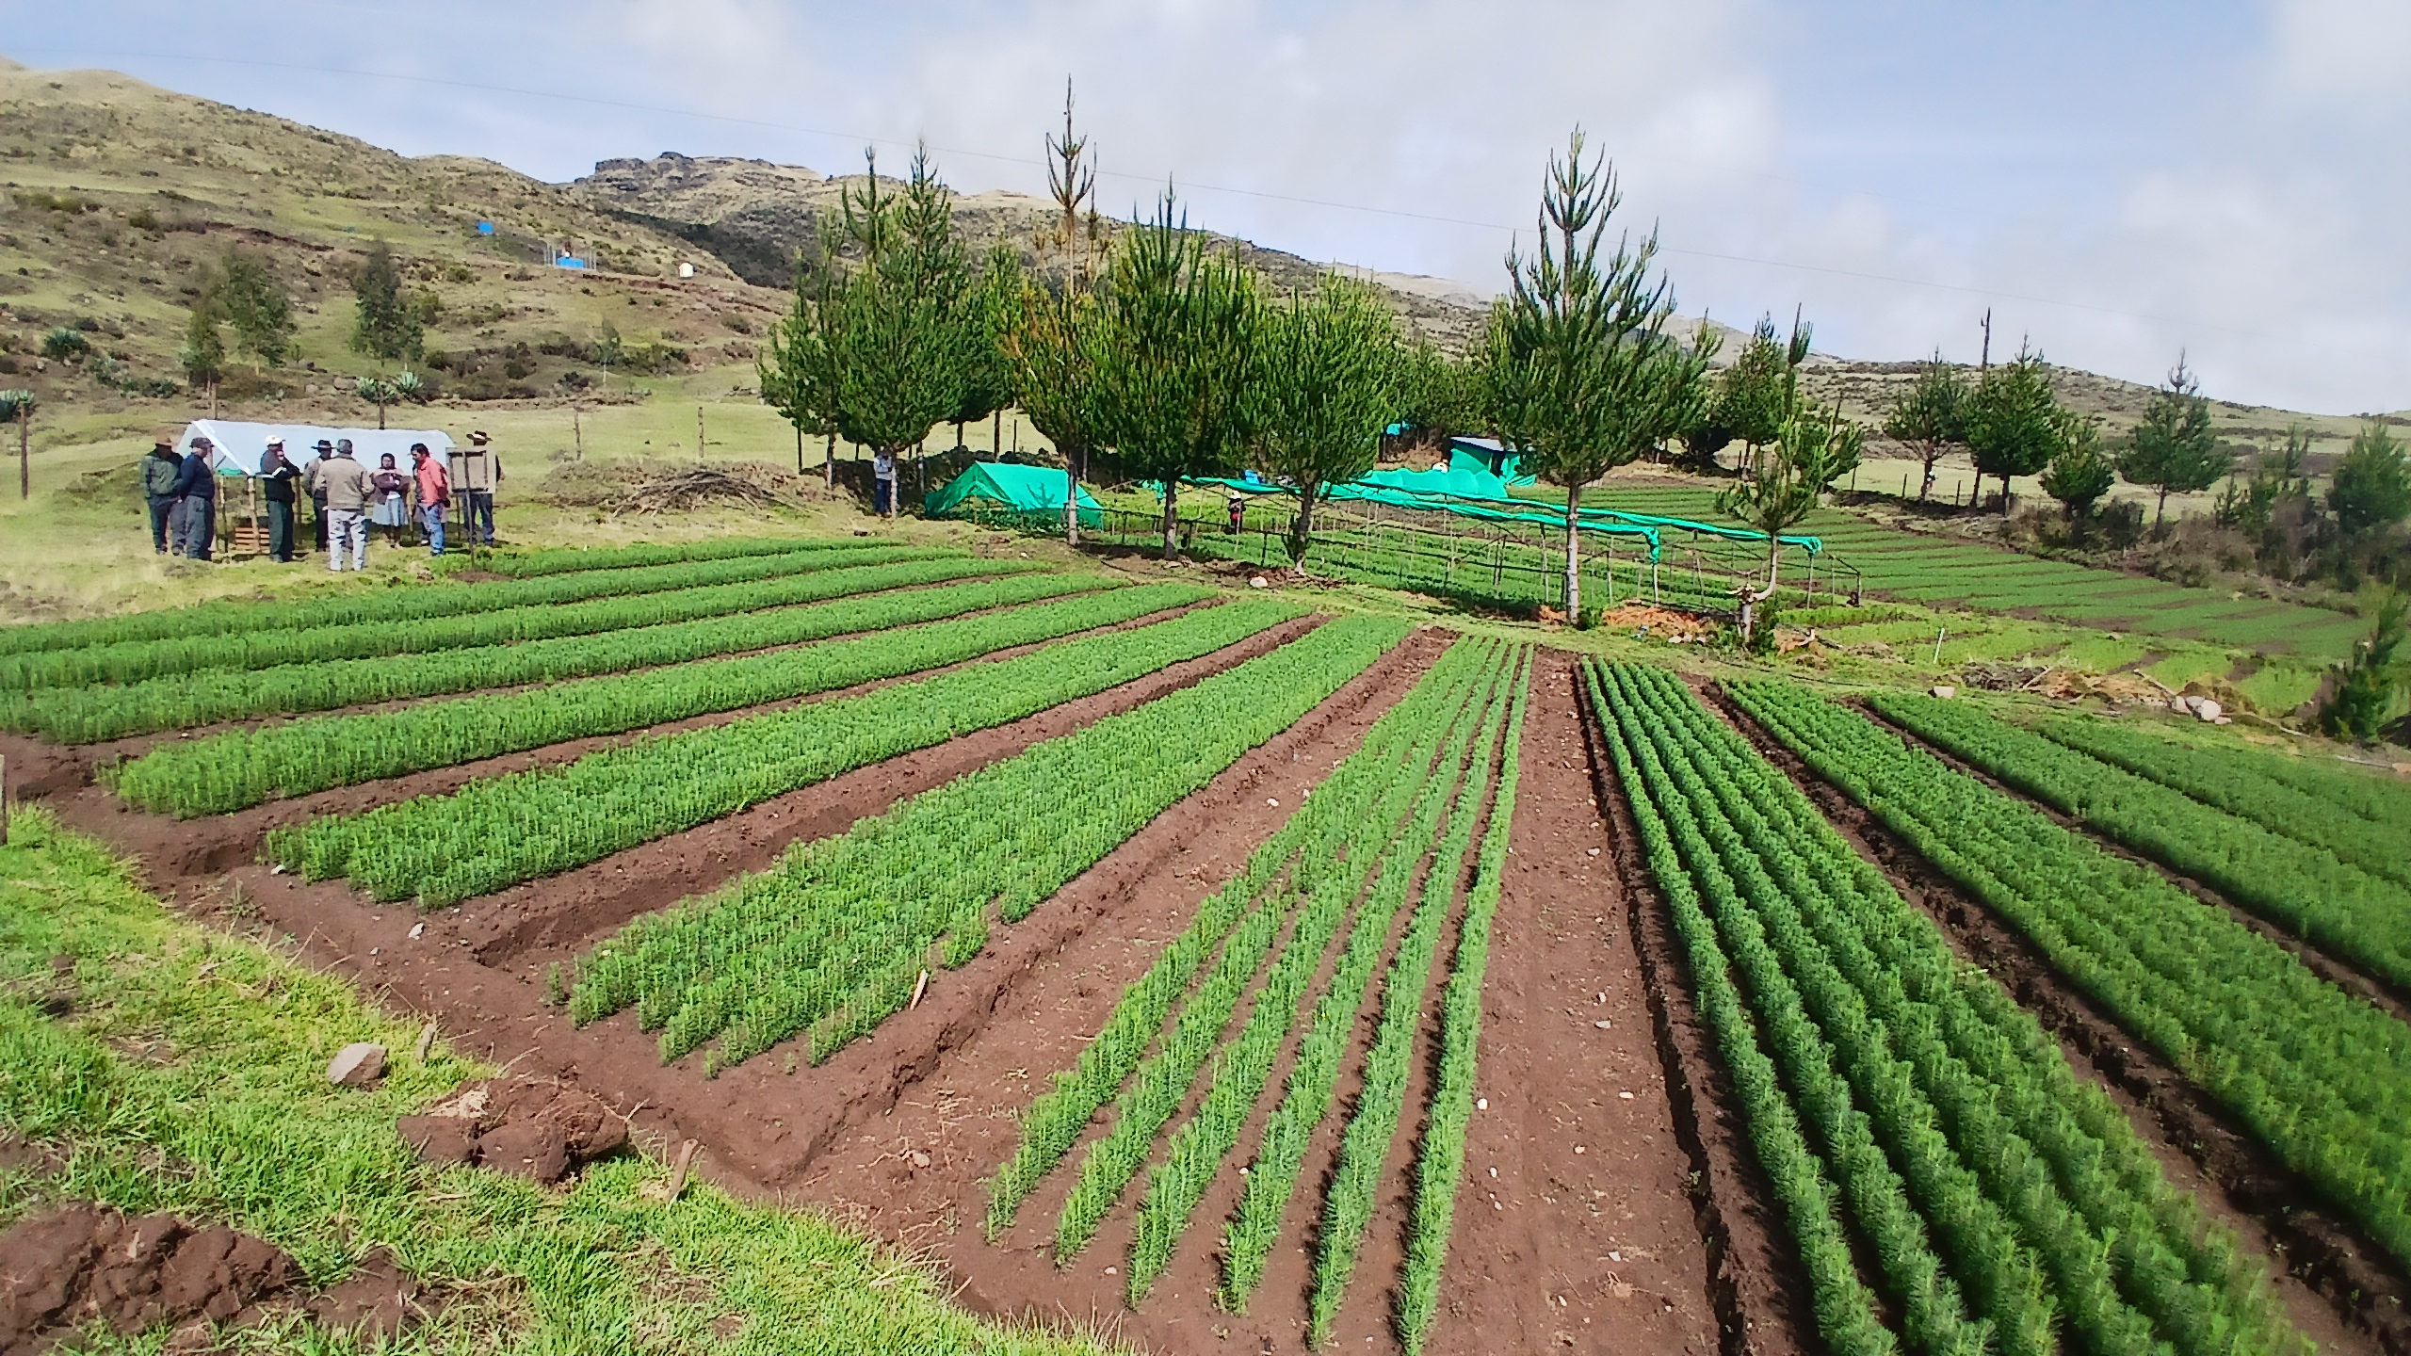

This project offers environmental, economic and social benefits in rural communities.
The analysis of the degraded ecosystem requires a lot of research and action. The assessment strategy we have implemented comprises the following steps:
- Mapping and identification of the degraded area in the communities.
- Diagnosis and selection of the Pachamama Raymi Methodology.
- Identification of the reference ecosystem
- Consultation with local actors

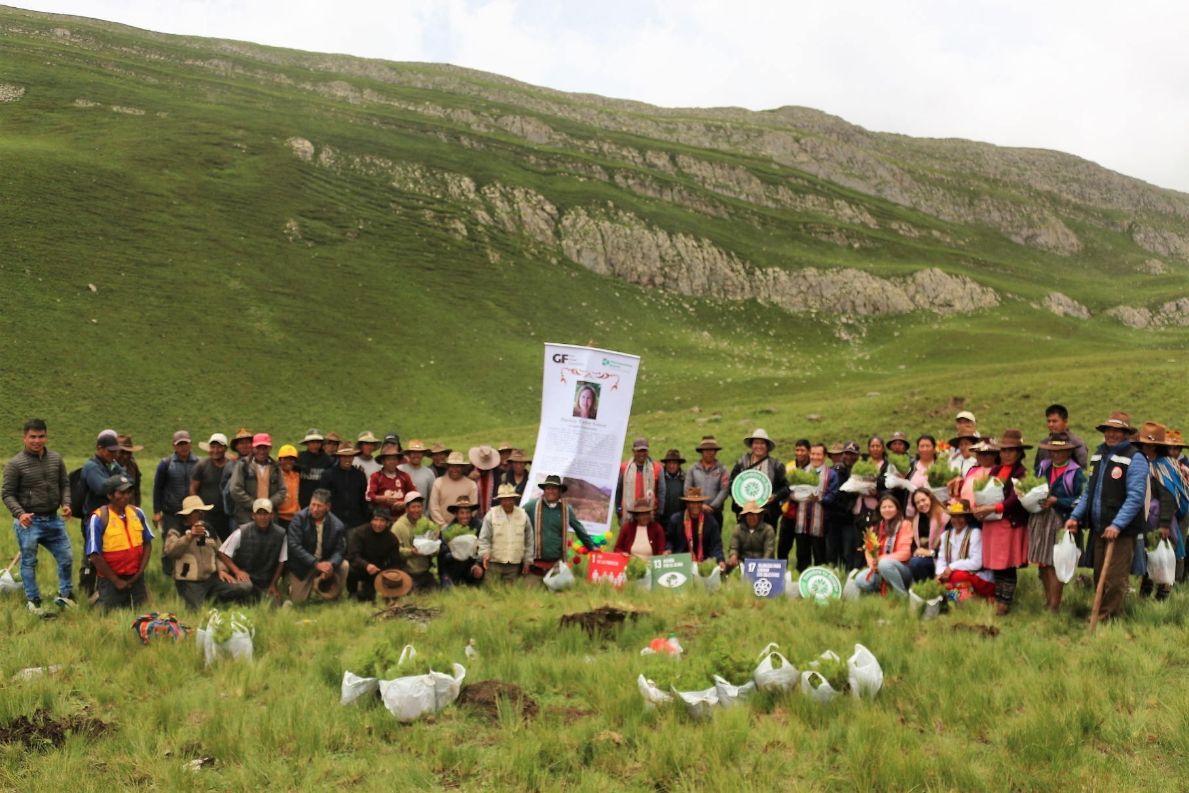

WhatsApp Image 2024-09-30 at 12.45.32 PM.jpeg

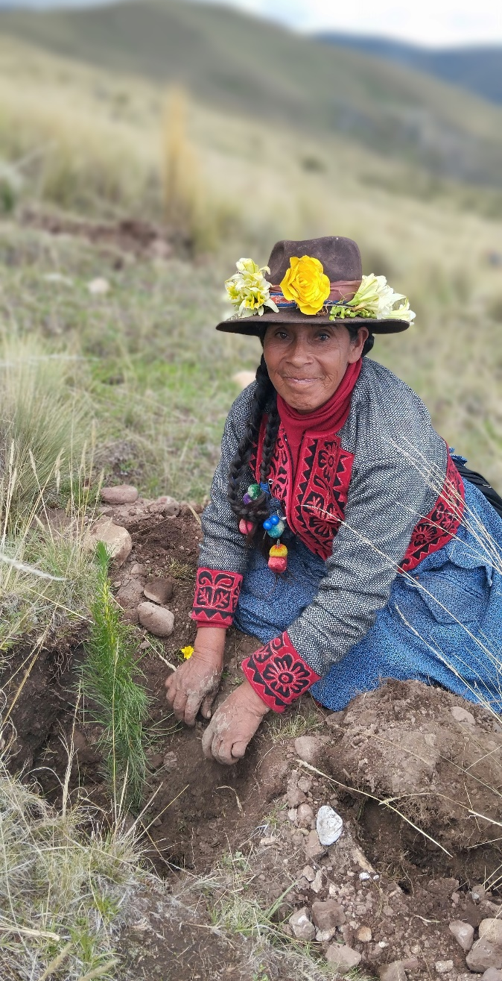
The project is aligned with ten of the sustainable development objectives
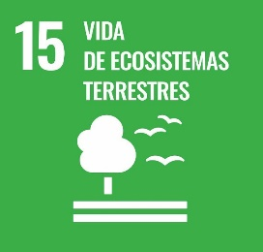
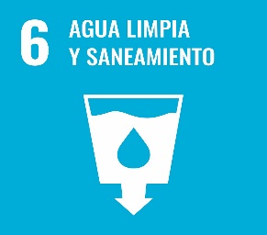
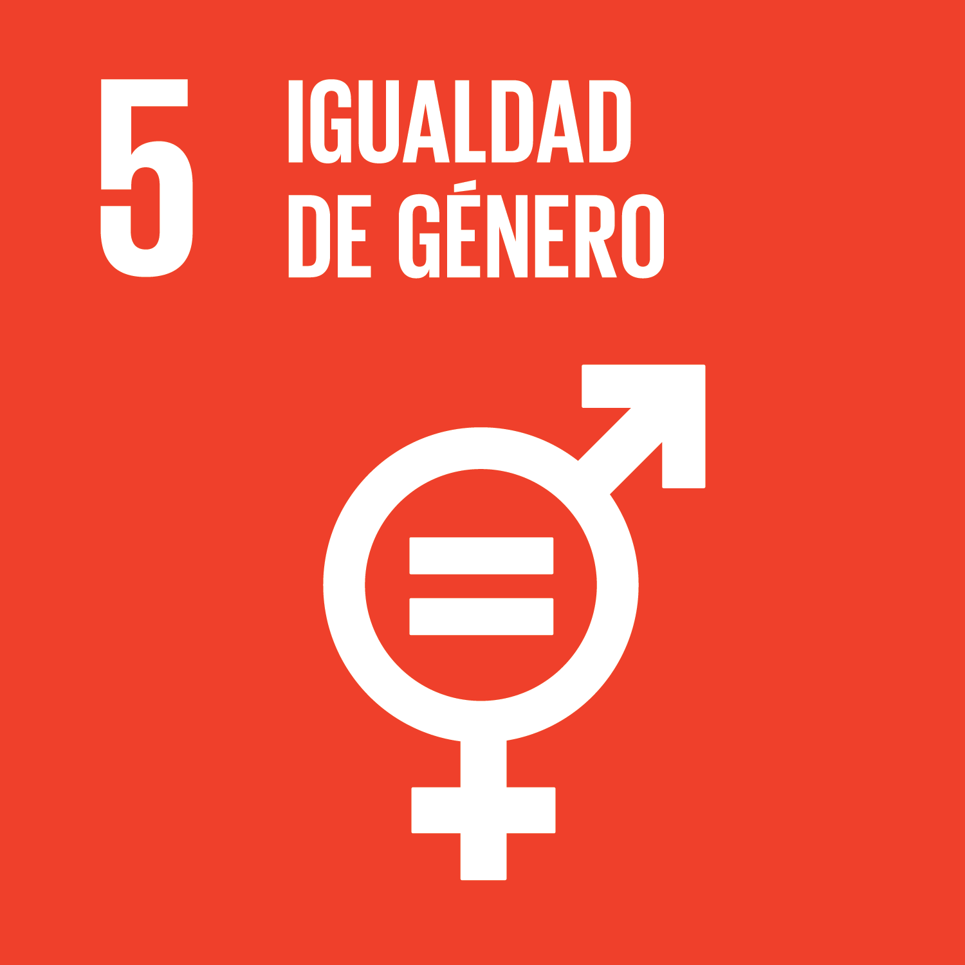
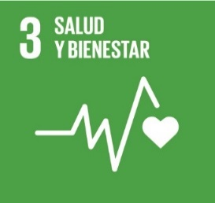
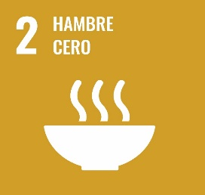
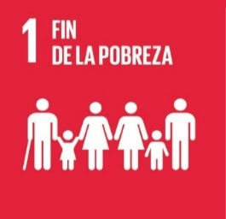
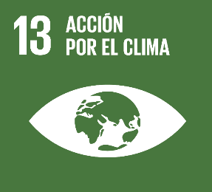
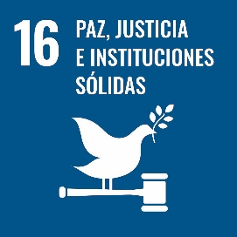
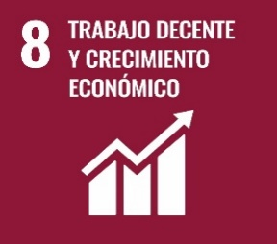
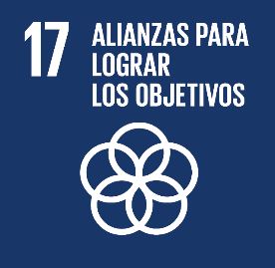
MAIN OBJECTIVE:
Achieve the prosperity of peasant families and the recovery of natural resources, through the establishment of forest plantations, which generate goods and ecosystem services in favor of peasant families and communities.

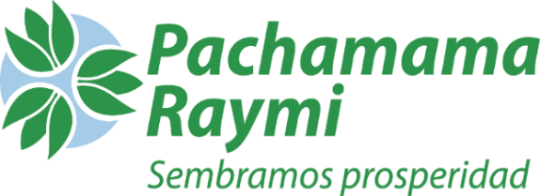
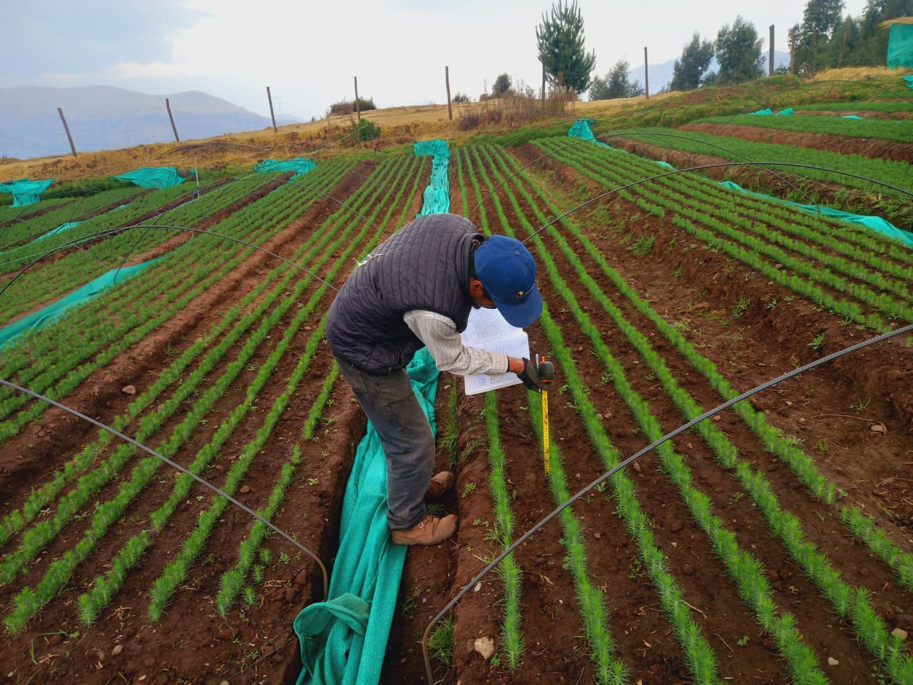
We are currently in full production for the 2025 forestry campaign. We have established 11 nurseries across various districts, with a total production capacity of 2 million trees. This phase is crucial to ensuring the continuity of the project and the achievement of our ecological restoration goals.

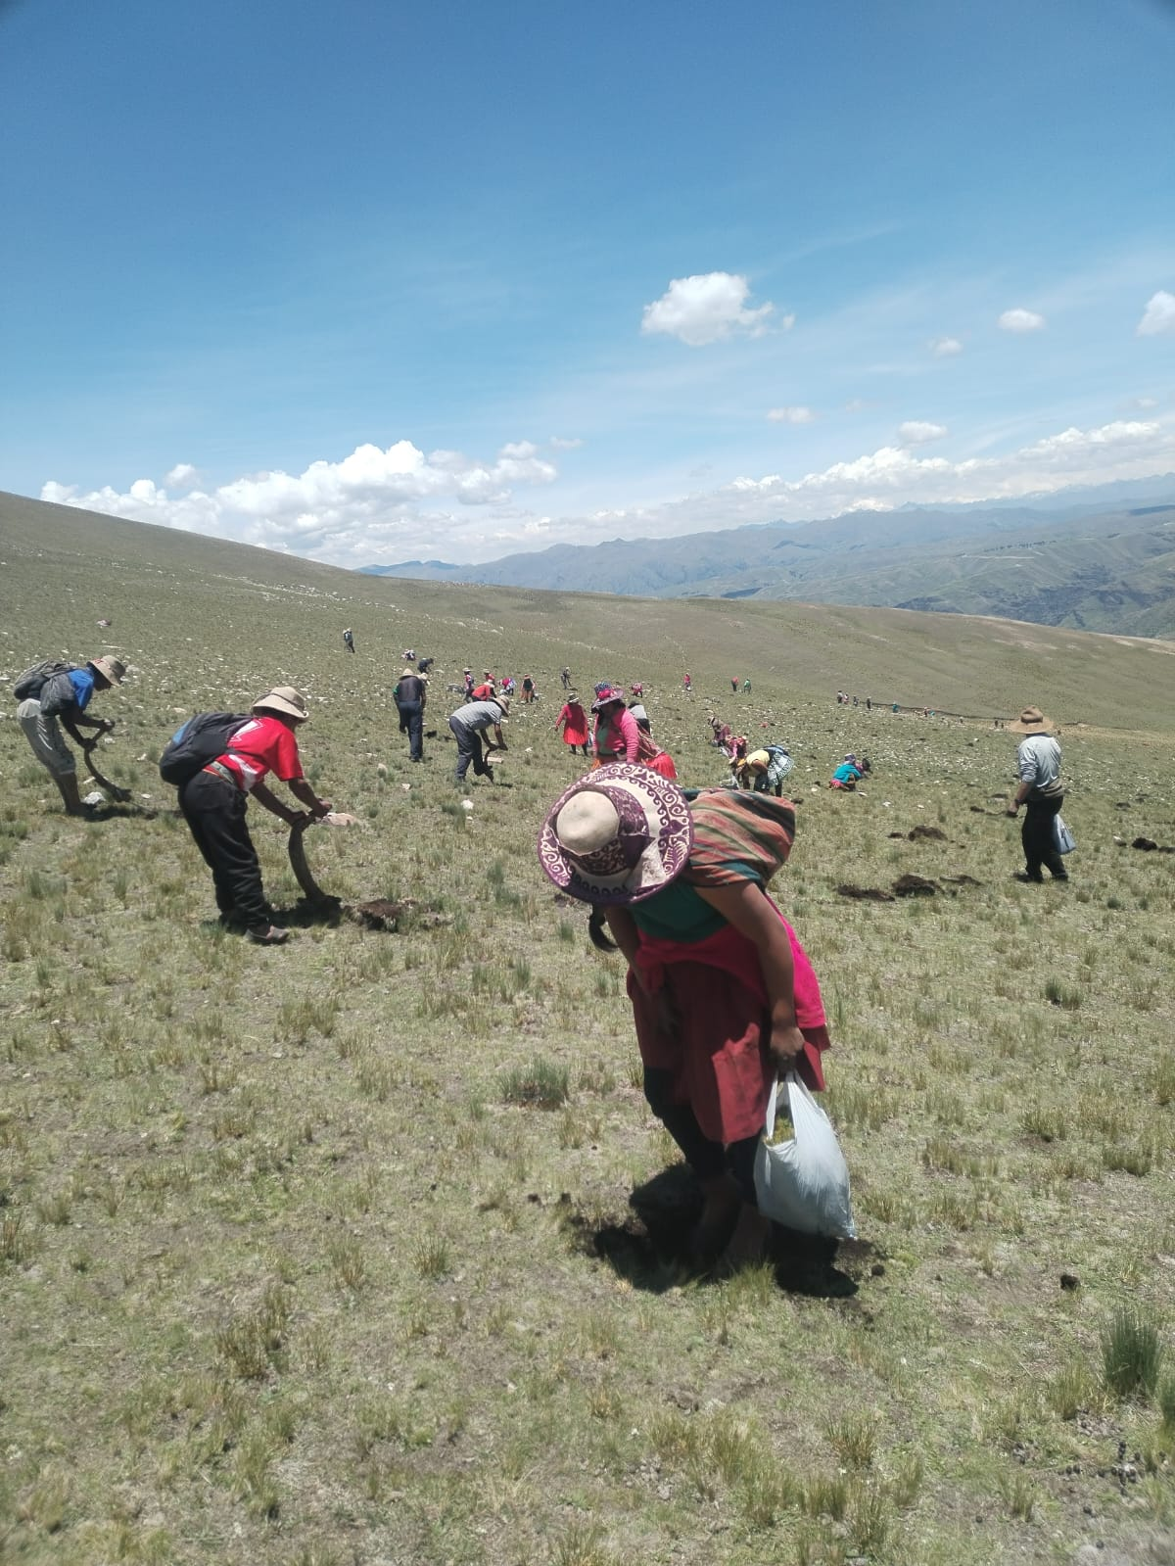
Restoring eroded soils is not only possible, but essential. Although it is more challenging than intervening in earlier stages, the social, environmental, and economic benefits of rehabilitating degraded land make it a smart and necessary investment. By supporting this effort, you’re not just helping to heal the Earth — you're empowering communities, protecting biodiversity, and building a more sustainable future. Every contribution makes a real and lasting impact

Our project also includes the restoration of vulnerable areas, prioritized according to the needs and criteria defined by the communities themselves. To date, we have established 627 hectares of relict forests in two communities. In the coming months, together with the participants, we will evaluate more areas for conservation and restoration, ensuring that the actions are relevant, sustainable, and aligned with the project's objectives.

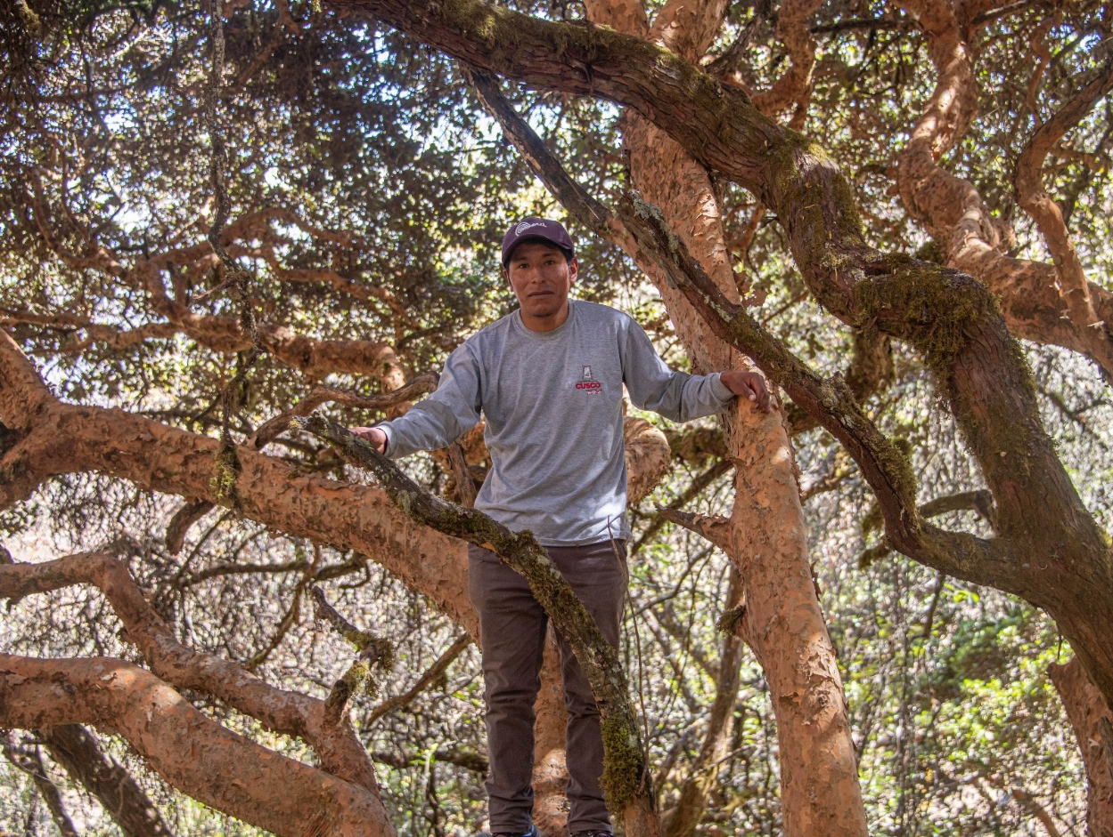
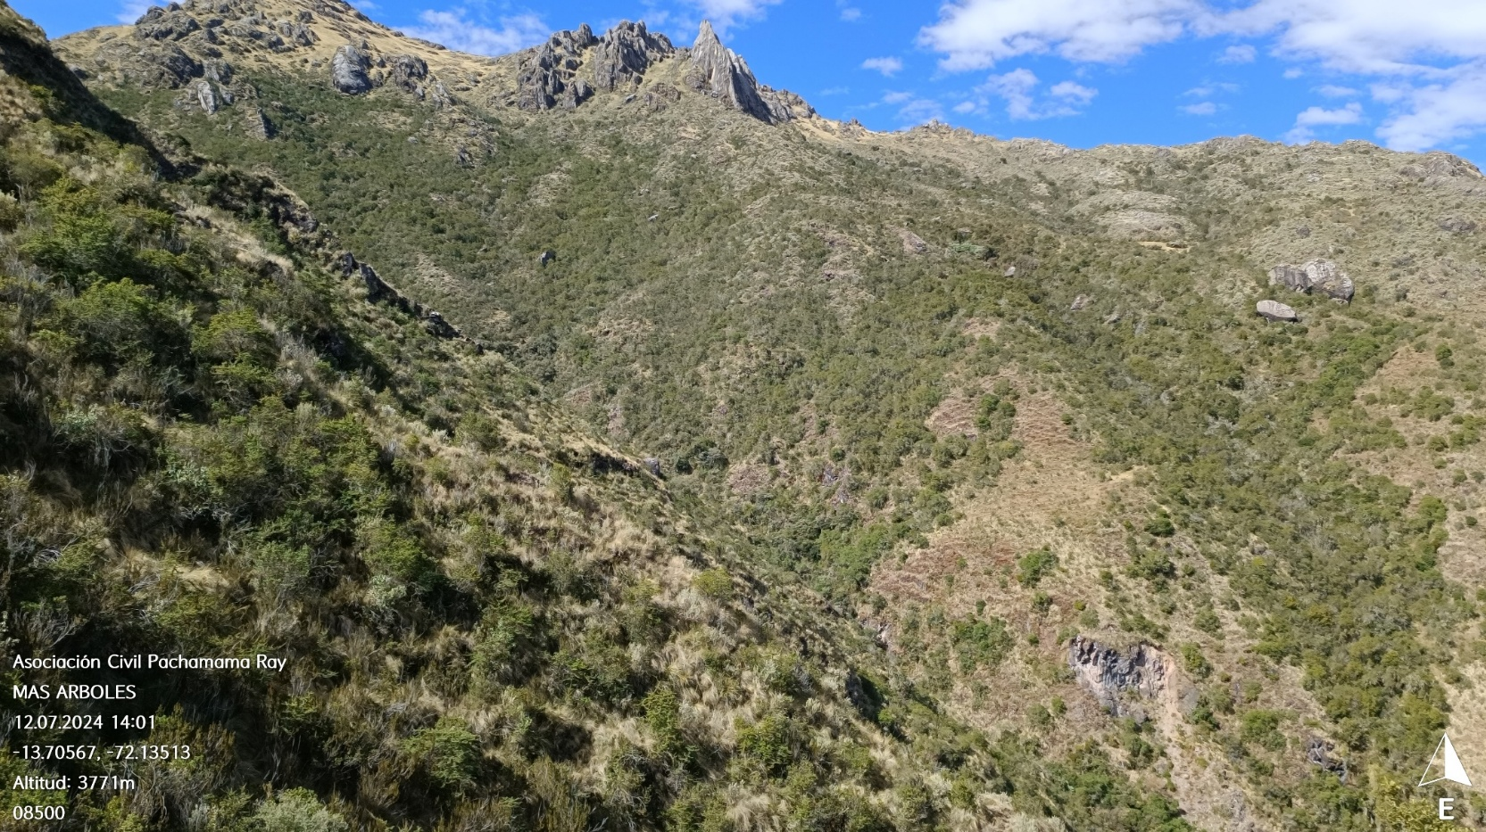

Our next steps:
- Monitor the established plantations: plant survival and growth.
- Certification of forest plantations.
- Generate economic income for communities through the sale of carbon credits.
- Strengthen the communities' capacities in management and organization.

Thank you for your generosity and continued support. Together, we are creating a better future.
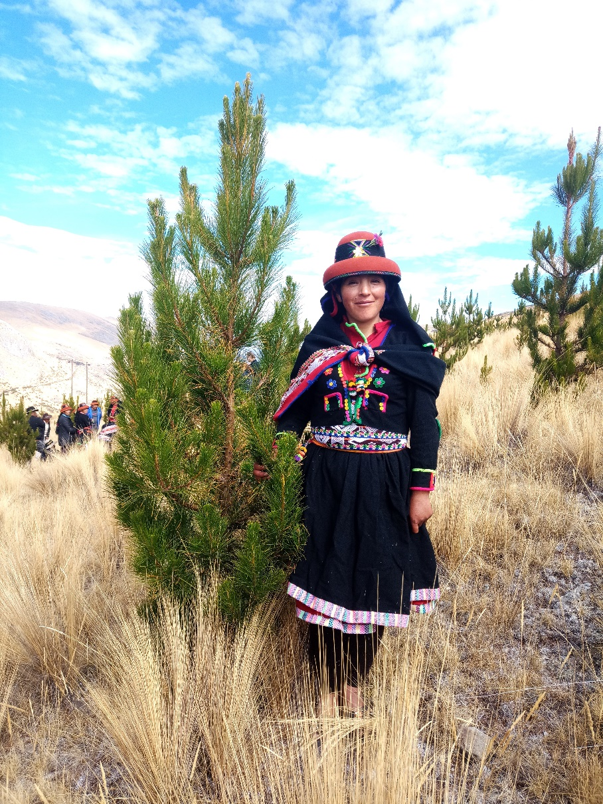
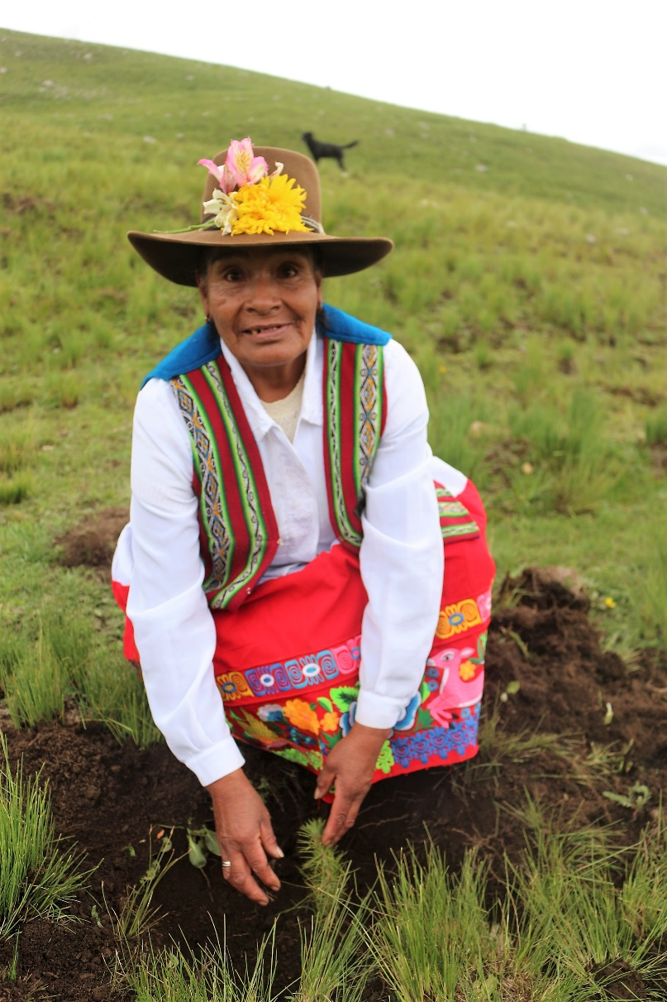
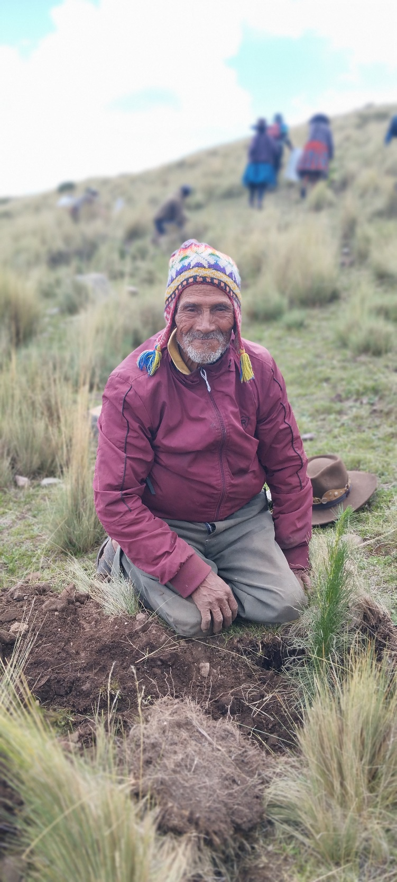
Help us with your donation to Planting Prosperity!

BLESSINGS, TEAM PACHAMAMA RAYMI

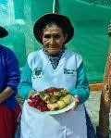
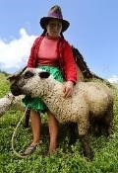
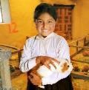
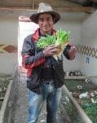
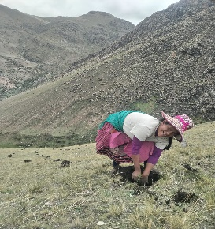

Calle Pavitos 567 Interior, Cusco – Perú.
Telf. +51-84-236540, www.pachamamaraymi.org

