Help 3000 homeless and refugee Iraqi children

Summary
As a result of the ISIS-related conflicts and the increase in the number of refugees, Iraq is facing a displacement crisis, many children left school to work or because they can't afford school. 3000 orphans, homeless, refugee children will be provided with meals, gifts, new clothes, games, and orphan support. Help our support center for the most vulnerable children. We will provide children with mental health support and consoling.
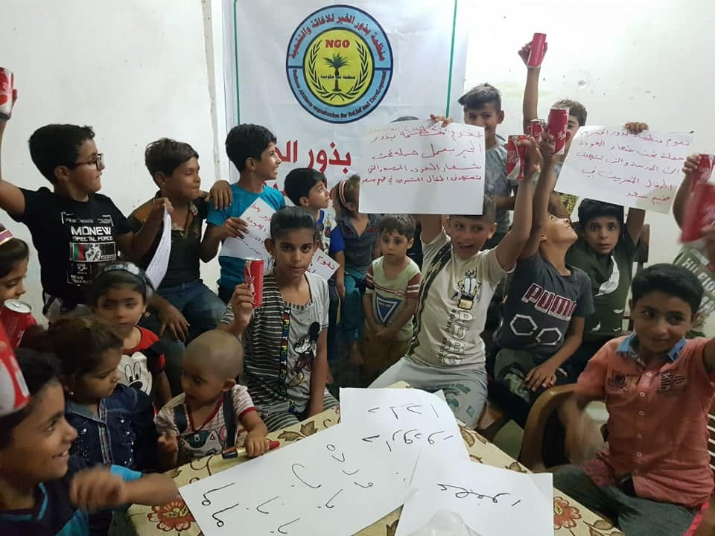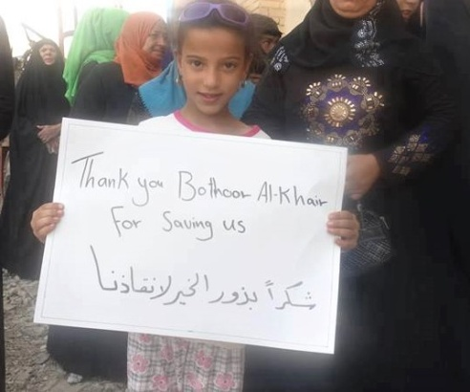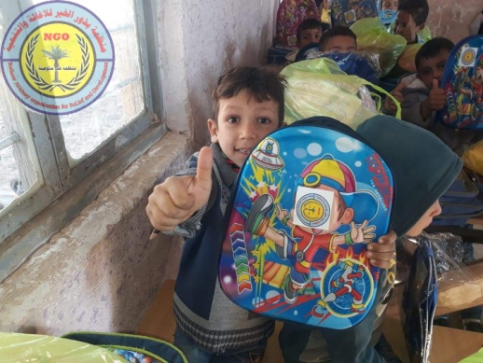

Challenges
Statistics of government agencies and international organizations concerned with children show the extent of the tragedy, which has reached dangerous levels, as a result of the battles and war raging in Iraq, one UNICEF study said "Children make up the majority of up to 4.5 million Iraqis at risk of falling into poverty and deprivation due to the impact of covid-19". making them vulnerable to falling prey to the exploitation at the hands of terrorist groups.

Solution
our organization has a center for orphans and homeless children to help them return to school through classes specially designed by professionals to help drop-out children rejoin their peers in schools. we provide food, clothing, psychological support, games, and gifts, orphan financial support. Creating wonderful memories at the center where children will cut cakes and have face painting, sing, and dance. Children will have delicious and nutritious rice, meat, chicken, ice cream, and juice.
The effect is long term
In 2019: * 1,400 children received food and clothing. * 335 children received missing legal identity documents that are required to attend school and receive basic government benefits; 259 children received social services to stop child labor, end abuse, and meet medical and other needs. * 243 children (full-time and part-time) received private tutoring and nutrition at the center 150 orphaned children received monthly support
Project’ s budget
help 3000 homeless and orphan Iraqi children
details | unit | ammount
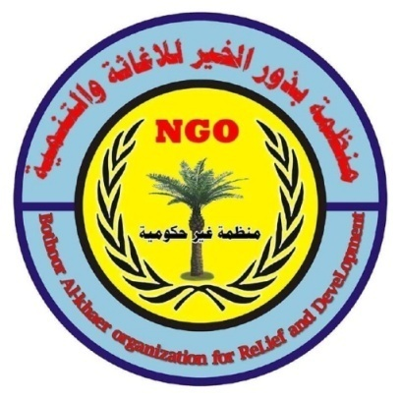  orphan support for 250 child for one year | 1 yeay | 75000
school supplies for 1500 child | 1 year | 7560
meals for homeless children and children in refugee camps | 1 year | 60000
clothes | 2 years | 30500
gifts | 2 years | 6000
recreational activities for children | 2 years | 3500
school transport fee for children in remote areas | 1 year | 16000
Center rental costs | 1 year | 6000
staff salaries | 1 year | 9440
educational classes | 1year | 20000
classroom materials and furniture and educational equipment | 1 year | 47000
mental health consoling |  | 11000
total |  | 292000

Accreditations:-
- Certificate of Appreciation by the FAO
- Certificate of Appreciation by the UNESCO
- Certificate of Appreciation by the UNAMA
- Certificate of Appreciation by the DRC
- Certificate of Appreciation by the Mercy Corps + WFP
- Certificate of Appreciation by the NPA
- Certificate of Appreciation by the Iraqi Government security, environment

We are a charitable humanitarian organization registered in Iraq under the number 1Z5712 all legal approvals
Internet Presence
Website: http://www.baord.live/
Facebook:https://www.facebook.com/BothoorAlkhaerHumanOrganization/?ref=hl
Twitter: https://twitter.com/BothoorO
Instagram: https://www.instagram.com/bothoor_alkhaer_organization/

