**Progress report**

***MHO is women headed a non-governmental, organization established in 2011 with mission Empowering and changing the personal social and economic status of all women and children’s of Ethiopia who live in under poverty by giving the opportunities and supports which leads to development. MHO founded by a role model women, who long been served in Ethiopia Red Cross. She currently considered by many Ethiopian as 'mothers' to Ethiopia's most vulnerable and kid. . Since its establishment, the organization has implemented programs /***projects mainly focusing on addressing the felt needs of targeted women and children.

One Improve Girls' Education in Ethiopia among currently active project implemented by MHO though Global Giving with support of special individuals and foundations like Corteva who provide the funds. We can say that Girls' Education in Ethiopia already born fruit and attained the desired outcomes and impact

**: My disability not prevented me to attend my school**

Marta, pictured here with MHO Director, is an eighteen-year-old disabled girl who has benefitted under the project Improve Girls' Education in Ethiopia Marta is 10 grade girl from konso which 607.2 km from Addis Ababa . For disabled girl like Marta besides double burden because her gender and disability, being from rural areas is another factor limiting her educational opportunities Before MHO presences in the area there is hardly any NGOs in the target area are implementing programs \ projects that address the Girl Education. After MHO presence Marta, among other girl benefiters provided with one year educational material, uniforms. Bags, sanitary and etc . Now am not feel as disabled, I am attending my school without any problem as equal as our peer “Marta explained” to MHO executive directory

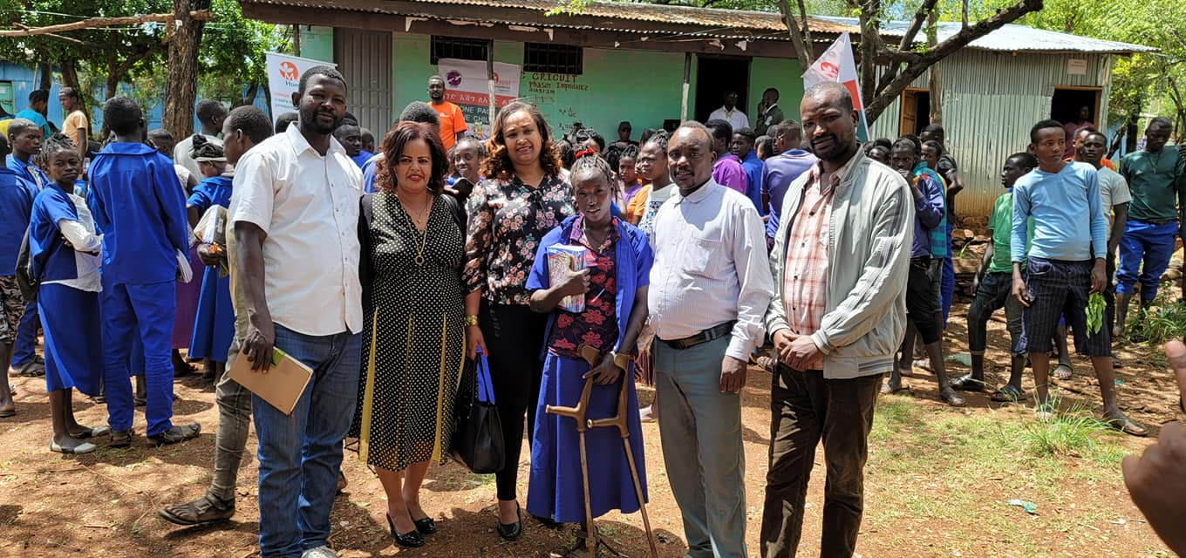

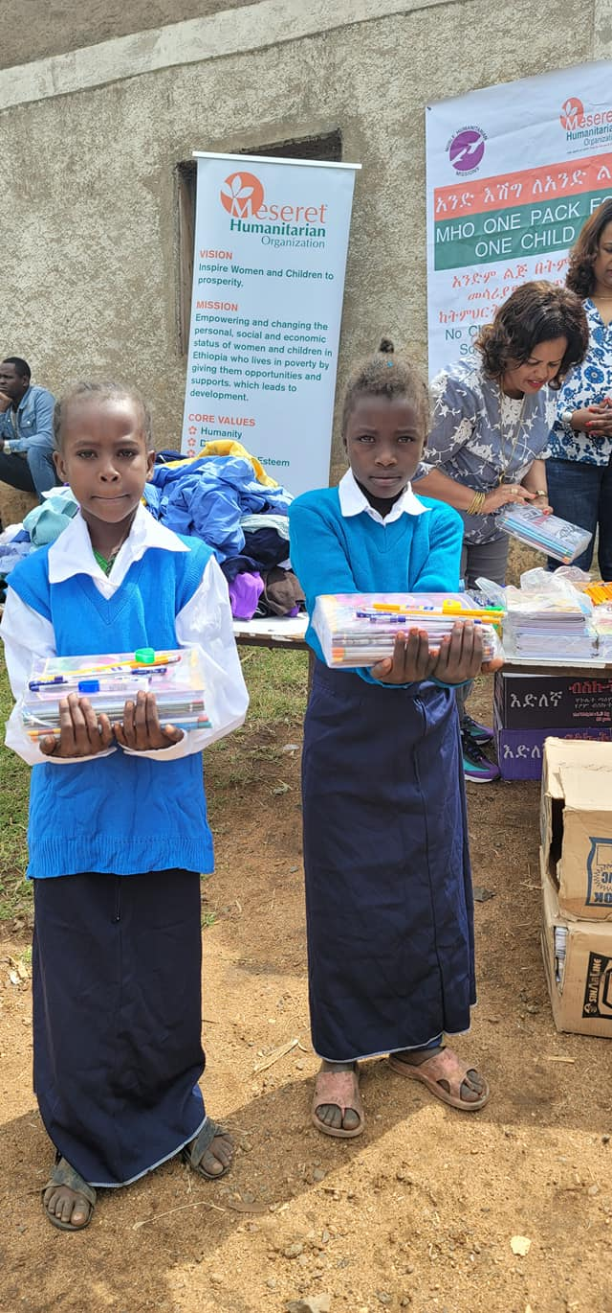

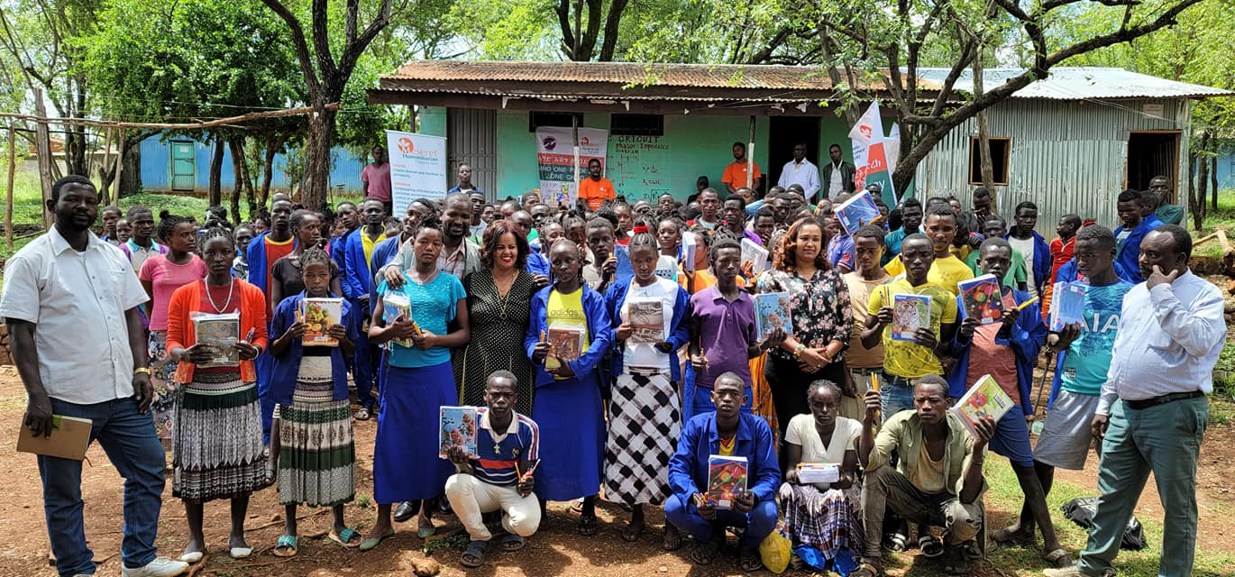

**Note: All the pictures and Name mentioned in the report real and MHO beneficiaries**