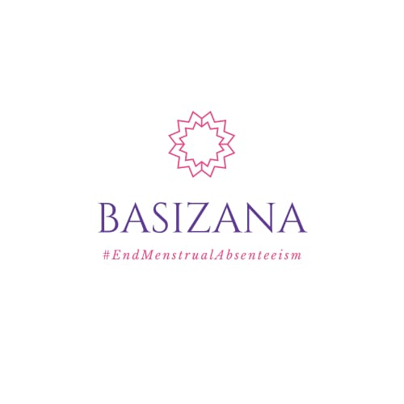
THE BASIZANA PROJECT 4th QUARTER REPORT 2023
PREPARED BY FRIDAH PHIRI

Table of Contents
Executive Summary 3
Highlights…………………………………………………………………………………………………………………………………………..3
Activities……………………………………………………………………………………………………………………………………………4
Conclusion…………………………………………………………………………………………………………………………………………4

Executive Summary
The Basizana project is a non-profit initiative that was established in September 2021 by the Bupilo Foundation to focus on female reproductive health. On average, Zambian rural girls miss about 10% of school days annually due to lack of menstrual supplies, often missing exams or performing poorly as a result of their absenteeism during their period. In response to this, our mission is to provide long-term sustainable solutions to fulfill our goal of bringing an end to period poverty and menstrual absenteeism.
We believe adopting the following principles will help us accomplish this.
- Integrity: Our integrity is an integral part of our campaign to bring an end to menstrual absenteeism and period poverty. As such we commit ourselves to operating in an accountable and transparent manner to comply with the international guidelines for philanthropy.
- Sustainability: Our efforts are driven by the pursuit of sustainable solutions to completely address the challenges surrounding period poverty. These include providing reusable menstrual supplies with high durability that reduce menstrual absenteeism to 0% with little cost to the environment.
- Health and Safety: The health and safety of our stakeholders and beneficiaries is important to us. Hence, we are committed to adhering to the appropriate national and international guidelines for health and safety.

HIGHLIGHTS OF THE YEAR

- Purchased sewing, cutting and overlocking machines
- Processing certification from Zambia Bureau of Standards
- Started producing pads using the Basizana machines at our factory in Lusaka West.

ACTIVITIES
- A total of 204 girls (The same beneficiaries from the previous year) received reusable sanitary pads this year. Each girl received a pack containing four (4) reusable pads with a durability of 2-5 years. These would sustain most of the girls throughout the duration of the secondary education.
- During every visit, the Basizana team conducts a Menstrual Hygiene Management. The purpose of this session is to train and inform girls on how to use the reusable pads sustainably. However, the session did not take place this time around, because the students who received pads for the first time are now being trained and informed by previous beneficiaries. In this sense, sharing of knowledge is being improved as well as raising awareness of menstrual issues within the rural communities.
- The last quarter of the year did not have much activity due to focus on raising funds that are set to be used for 2024 project operations
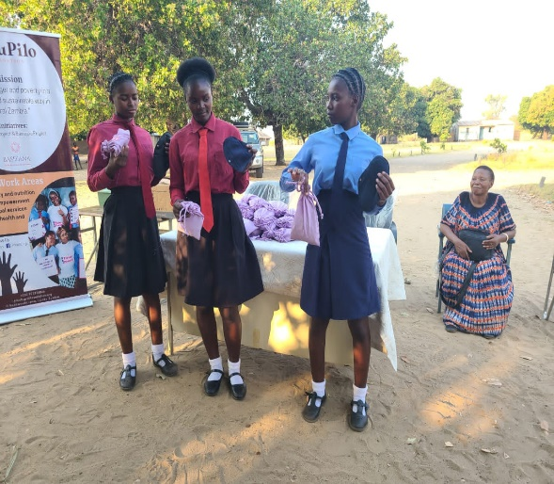
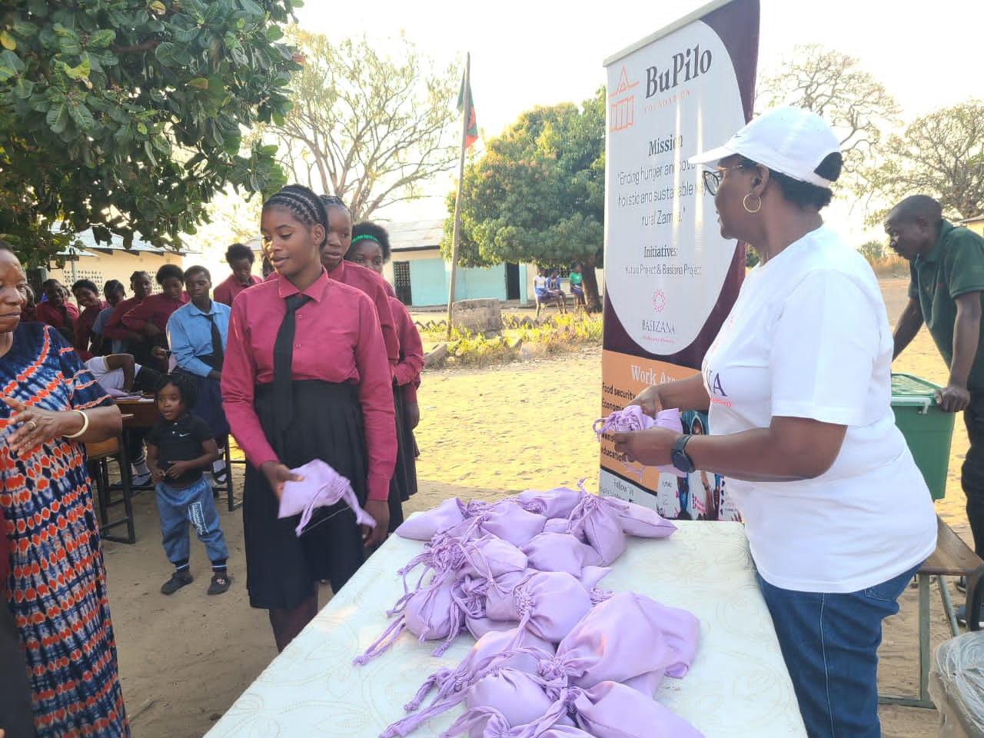

Conclusion
In conclusion, poverty has the face of a woman/girl, this implies that, more females than males in the world live in poverty. Hence, the ultimate goal of the Basizana project is to completely put an end to menstrual absenteeism of girls in school, so as to increase the number of the educated female population, thereby, empowering them with knowledge as a tool which they can use to get out of poverty. As reported, the Basizana project has reduced menstrual absenteeism to zero at Sitoya Secondary. With the introduction of a matron, the girls are confident and free to talk about female reproductive health.

