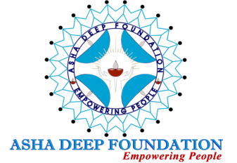

ASHA DEEP FOUNDATION
Registered Office: 175C, J & k Pocket, Dilshad Garden, Delhi-110095, INDIA
Central Office: D-81, Shahid Nagar, Near Shalimar Garden, Delhi, NCR, Ghaziabad (U.P)
Email : jothichetty@adf.org.in
Website: www.adf.org.in

Organization related information:
- Name of the Organization : Asha Deep Foundation
- Head Office Location : Delhi
- Person to Contact : Mrs. Jothi Chetty
- Designation : Secretary & Chief Executive
- Email Id : jothichetty@adf.org.in
- Contact Number : 9810009497
- Website : www.adf.org.in

Introduction:
Since its inception in 1983 by Late Fr. A.R. Rajamoney, the Founder of the organization, the foundation has laid immense emphasis on serving the society at large and impacting as many lives as possible. It has always aimed at holistic development of the community people exerting importance to all demographics equally.
Over its long journey, the foundation has successfully launched its centers in five states of India (Delhi, Mumbai, Chennai, Haryana and Uttar Pradesh). The foundation is running numerous projects placing special focus on Education, Health, Skill, Trainings and Placements.ADF is trying to place focus on the lower section of the society who are unable to access basic level of resources for existence.
ADF has over 18 projects running which span from mother and child care till the end of the life cycle. All people of community including women, children, senior citizen, physically challenged and orphan and destitute are being benefited by the projects

Father initiated and designed a programme for holistic development of street and working children in Delhi. Through this program approximately 30000 vulnerable children have been mainstreamed in the society.. Slowly then he established two beautiful homes for orphan and destitute children and through these homes many children are getting benefit and building their bright future. He set off a well-equipped Vocational and Technical Training Centre for community youth who are not able to go for higher education or training due to some reason or the other and even today lot of boys and girls are availing good training and making their life successful.The seed which he put in 1983 is growing up like a tree and bearing lot of fruits in it by reaching more than 5 lakh underprivileged population of India.

Our Past and Present funding partners : UNICEF, Bank of America, Barclays, Cognizant Foundation,Save the Children, Tech Mahindra Foundation, Aspire System ( P) Ltd. Giving Hands Japan, Asia Child Support – Japan, PVR( Nest), Infogain, G- Cube, Ts- Tech, Holistic Child Development India, HDFC Bank , India Vision Foundation , Smile Foundation, CBN Foundation etc.

Vision:

To help people realize their potentialities and human dignity and create their own destiny

Mission:

To work amongst the deprived and underprivileged community to inspire and motivate them to realize
Their human dignity, develop their own capacity and help them to solve their own problems. The organization strives to work for the social and economic development of the people by providing whatever practical help they need in the form of information, advice, capacity building, training and support.

Goal: Empowering the underprivileged People.

Focus Area: Education, Health , Livelihood , Child Card & Protection, WASH and Environment.

Area of Intervention: Rural and Urban
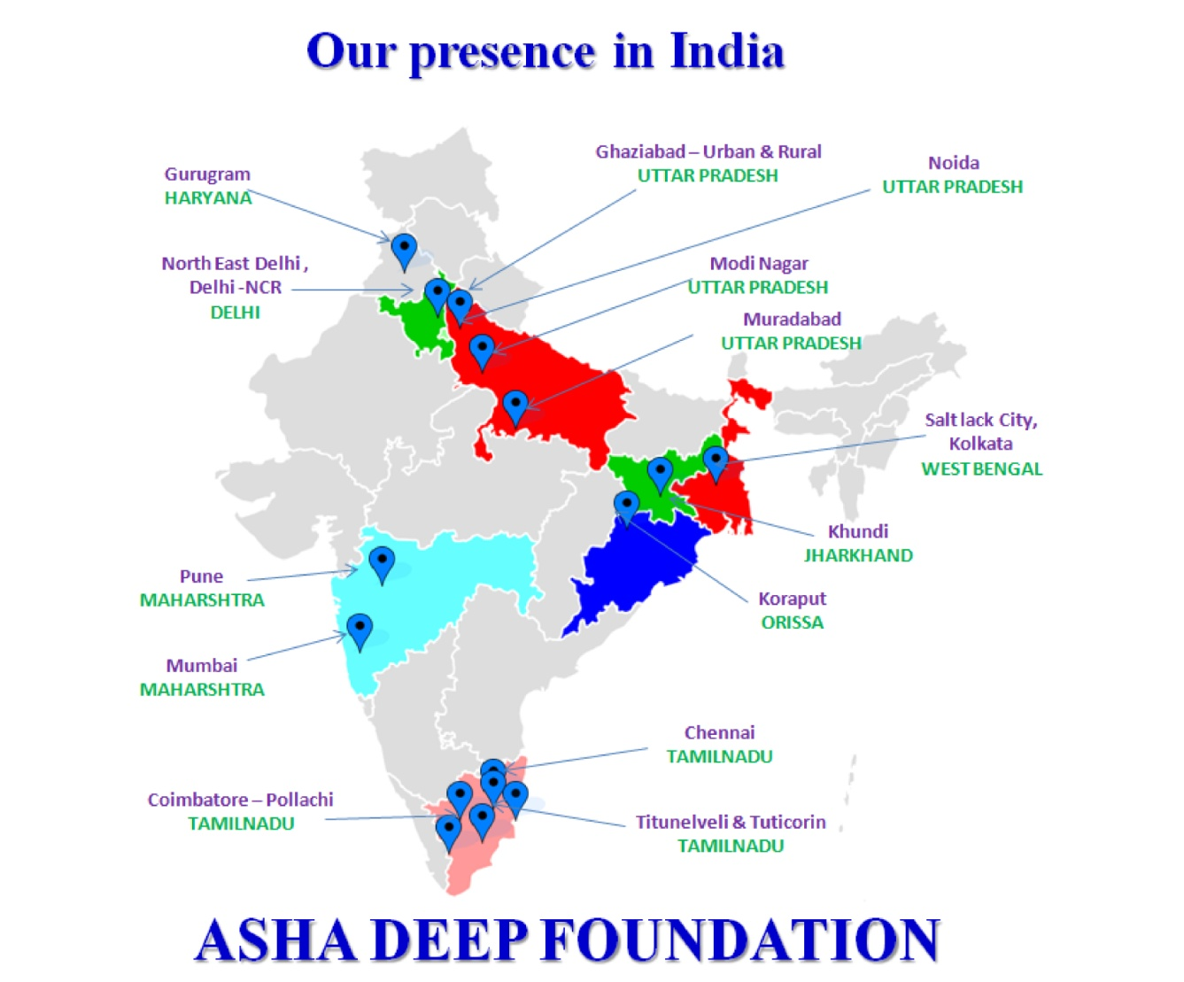

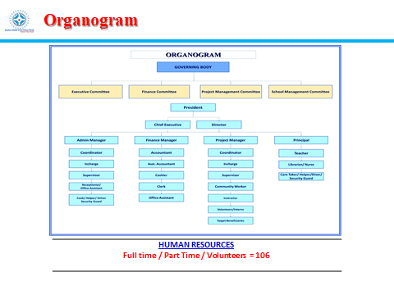

Projects of Asha Deep Foundation:

EDUCATION:

- St.James Convent School for the underprivileged Children (Pre School to Class X) :Presently 600 Children are studying in the School. From Nursery to Class Tenth at Shahid Nagar, Ghaziabad, Uttar Pradesh. Running since 1983. Reached more 35000 children.

- Child Care Centre for the children whose parents are involved in Rag picking: Educational Programme : Presently 53 children benefit from this programme. Through this programme the organisation works towards eradicating rag picking among the children. Running since 2005. Reached more than 5500 children

- Asha Community Centre: Educational Programme for the Rag Picking Community Children :
Children who were out of School were identified from Rag Picking Community Children and admitted in the St. James Convent School as the organisation works towards the aim of all children should go to School. Total 53 Children are admitted in the School. It is a new initiative of the organisation. Initiated in September 2019.

- After School Support for the Rag Picker’s Community Children : The children who are admitted by the organisation in the Government School, it is noted the children are not able to cope up with the studies , so the organisation runs after School support to the children. 50 children. Running since 2005. Reached to 1600 children

- Child Development Centre: The children who are out of School and not attending School are identified and brought to Child Development Centre and they are prepared for Schooling. The Children will be admitted in the Government School after preparation. 100 children from the Rag Picking Communities are benefitted through this project.

- Remedial Classes for the children whose parents are in Prison: 100 children who are in hostel attend the remedial classes from 2.30 pm to 4.30 pm daily, the teacher given individual attention to each child and help the child to do better performance in the School. It is a new initiative.

- Early Childhood Educational Programme (Gali Pre School): To eradicate rag picking among the children the organisation run gali schools run by the adolescent girls of the community in their own residence for two hour daily and when the child reaches 5 years the child is admitted in the Government School. Presently 200 children are benefitted through 10 gali schools. Running since 1990. Reached 8000 plus children

- Gerneral Duty Assistant (GDA) Training to Youth for employability : The underprivileged youth will be trained on GDA for three months and will be helped/ facilitated to get placements which will help the family to become economically empowered.

- Sports for Development Programme: Sports is one of the important activities of the organisation, coaches for football come and train the children. Running since 2005. Reached to 5000 plus children

LIVLIHOOD:

- Asha Vocational Technical Training Institute (AVTTI) : Vocational Training Institute for women and Girls helps them to become self-reliant. Presently 50 women/ girls are benefitted. Running since 1985. Reached 8500 plus youth/ women

- Asha Computer Institute for Girls: Skill Training Institute exclusively for women and Girls towards job placement and sustainability. Basic Computer, Spoken English and Personality Development trainings are provided to the girls from underprivileged community. Presently 50 girls / women are benefitted. Running since 2015. Reached to more than 450 girls .

- Youth Employability Programme: Skill Training and Placements of Underprivileged Youth and bringing economic empowerment among the families and community as a whole. Presently 100 youths are benefitted. Running since 2010. Reached more than 8000 youth with 80% Placements.

- Smile Twin e- Learning Programme : STeP : Skill Training and Placement of underprivileged youth between 18-28 years . The youth are trained for four months on Basic Computer, Spoken English, Retail, Financial Skill , Job Readiness etc. The youth will be provided placements after completion of the training . Presently 90 youth are benefitted through this project.

- Asha Fashion Designing Centre for adolescent girls: The women who want to become self-entrepreneur joins this course; Presently 35 women are attending the centre. Running since 2016. Reached to more than 350 Girls/ Women.

CHILD CARE & PROTECTION:

- Childline Project- 24 hours helpline for the destitute children at Ghaziabad and Modi Nagar- Uttar Pradesh. Running since 2008. Reached more than 11000 calls.
- Psycho Social Care Centre: Regular counselling and support to all target groups of the community, residential home children, slow learners etc. Running since 2005.

HUMAN RESOURCE DEVELOPMENT & TRAINING CENTER:
- Conducting and organizing training, workshop, Seminar and conference with different groups at various levels.

- Designated Trainer to sensitize Delhi Police of North East District on Juvenile Justice (Care and Protection of children) Act, 2000/2006/2015 from 2010 to 2015

- POCSO Act-2012/2016
- Police Personnel on Child Rights/ Care and Protection of C
- Children Parliament Child Labour ( Regulation and Prohibition Act-1986)
- Child Rights ( UNCRC)
- Youth Empowerment
- Women Empowerment
- HIV/ AIDS
- Counseling and Career Guidance
- CBO formation, SHG, IGP, Federation and Cooperative Society formation

- Rehabilitation and mainstreaming the Street & destitute children to have a decent life into the Society as equal with other children:

- Productively dealing for behaviors modification, counseling and helping to develop positive attitude of
- Children involved in Rag Picking
- Children and youth using Drugs
- Children and Youth whose parents are in Prison
- Street and Working Children
- Orphan/ Semi Orphan Children
- Children and Youth with physical and mental Disabilities

Community Based developmental and Training Programmes:

- Community Development Programme : To work among the 5000 Rag Picking Families in bringing development in all sectors like Child Development, Youth Development , Women Development and bring Economic Empowerment among the rag picking community.

- The victimized target migrant community strives to access their occupational and civic rights overcoming the devastation of pandemic, COVID-19 : The projects ultimately aims at the victimized community unsafely migrated gain their human and occupational dignity along with leading a sustainable life in the place of destination with acceptable socio-economic standard. Accessing occupational and civic rights are the key to this. After the calamity of pandemic Covid-19, the community has lost the basic minimum life support they need to pull on in the place destination. Hence the precondition is that they overcome the devastation of pandemic first and forward along with it to achieve the ultimate goal.

- Community Health Programme: Community Health Care Programmes with a special focus on curing tuberculosis, Mother & Child Care Programme, Support to malnourished children with a special focus on Rag Picking Community Children etc. Running since1985.

- TB Control Programme (DOTS) : The organisation reaching to the Shahid Nagar community people who are suffering from TB and help them to get medicine from the Government and also requested them to come to DOT centre regularly to consume medicine in front of the Health Worker. It is a success that no defaulters are recorded as the health worker visits the houses of the patients if they do not visit the DOT Centre to consume medicine.Running since 1990. Reached more than 3000 TB Patients and cured from TB.

- Day Care Centre for Senior Citizens: A love and care home for the senior citizens who are neglected by their own family members, 25 senior citizens attend the day care centre. Running since 1990. Reached more than 500 Senior Citizens.

- Rehabilitation Centre for the people who are differently able: A centre to provide the love, care and therapy to the children/ youth who are differently able mostly those who are affected by Polio. The children come to the centre, recreational activities are organised like indoor games , play way teaching etc. As per the need therapy was provided.

- Human Resource Development and Training Centre: The organisation organises regular staff training and capacity building programme for staff, workshop and training for target groups etc. Running since 1999.

WASH :
- Safe Drinking Water ( WASH ) : The organisation works in the rag picking community and work on awareness building , training and workshop on Personal Hygiene for the adolescent girls, safe drinking water, safe environment etc. Running since 2015.

ENVIORMENT:

- Campaign for Swachh Bharat Abhiyan : It is the regular activity of the organisation , regular campaign is organised in the community . Running since 2015.

- TREE PLANTATION DRIVE : The organisation in networking with Corporates organises in Schools the Tree Planation Drive and different awareness campaigns on Safe Environment.

_____________________________________________________________________________

