PROJECT PROPOSAL FOR
POLONNARUWA GIRLS FOOTBALL ACADEMY


PRESENTED BY

SYLVIA LANKA FOUNDATION
79 PINNER ROAD NORTHWOOD HA6 1QN

OVERVIEW
The Polonnaruwa Girl’s Football Academy aims to provide an established pathway to succeed in football and contribute towards creating an environment for female players to showcase their talent. PGFA founded in 2017 is the first female football academy in Sri Lanka and started with 20 players. We have now tripled the number of girls playing in our academy for the Under 12/14 and U16 (becomes U18 once the girls age).
We began this to connect the best female players of the Polonnaruwa district with our academy and offer them with the necessary training to develop their talents and help direct them towards the local and national selection pools.
Many of our players are from rural areas with low socio-economic backgrounds and are hidden gems full of talent and ability. Our aim is to progress our players towards harnessing their talents and becoming successful and cultivated role models for Sri Lanka.
Words cannot explain the talent and hunger these girls show towards football, the girls have just let their feet speak. Please watch this short video PGFA Video - YouTube
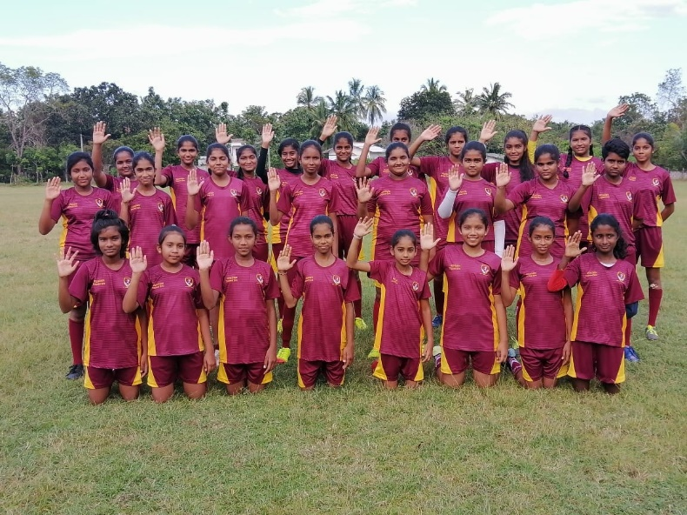

PGFA AIMS
- Provide an accurate technical football training programme.
- Guide players to balance education and sports
- Facilitate the involvement of underprivileged children in sports
- A professional approach to empowering Women in society
- Help players secure a future in the game of football.
- Provide a viable pathway to the National Squads

FOOTBALL DEVELOPMENT STRATEGY
- Organise three training sessions a week
- Facilitate tournament competitions for each age group
- Create a Talent Development process for all age groups
- Regular Talent Evaluations to monitor player progress
- Recording and analysing player performance data to support development
- Facilitate tournament competitions for each age group
- Provide free online sports education for coaches and players to accelerate development
- Working closely with parents to support player’s sports/education balance
- Award the Sylvia Lanka Foundation ‘Inspire Our Future’ Sports and Education Scholarship programme to support high achieving player’s sporting and academic futures
- Weekly meetings with coaches to monitor progress and maintain accountability

EXPECTED OUTCOMES
- Empower young girls to explore football as a sport and allow talented players to develop in Polonnaruwa and for the National Team.
- Allow young females to develop into successful women’s prospects who can improve the economic situation of themselves, and their family.
- As more and more players succeed, this will help improve the local area in terms of popularity, possible sponsorship opportunity, and local business development.
- By helping football gaining popularity in Polonnaruwa, this journey may help bring a football stadium where locals can dream of watching their local players compete for national and international glory.

UNIQUE GIRLS FOOTBALL ACADEMY
- The first female football academy in Sri Lanka
- The academy with the greatest number of female players.
- Providing Football training free of charge, free from any discrimination
- Supported by a network of volunteers and voluntary coaches
- Supporting children with economic difficulties

PLAYERS ACHIVEMENT
- Nimesha Sadaruwani - U16 Sri Lanka National Vice Captain
- Dualni Sandeepani - U12 Sri Lanka Best Player 2018 ; Participated in tour of Barcelona FCB
- Sasidi Nimsara - U12 Sri Lanka Best Player 2019; Participated in tour of Barcelona FCB
- Senulmi Himarsha - U14 Sri Lanka Best Player 2018
- Erandika Harshani - U14 Sri Lanka Best Goalkeeper 2018
- Karini Rasangika - Selected for Sports Science and Management Degree, Sri Jayawardanapura Campus, 2020
- Minoli Ahinsa and Pawani Nethmi - U14 Sri Lanka National Team players
WHAT WE NEED
- Football Training Equipment
  - Academy Players
    - Football Boots
    - Shin pads
    - Boot bag
    - Goalkeeper Gloves
    - Junior + Women's Jersey + Shorts
    - Socks
  - Academy Coaches

- Mini Balls (Option A B+ Size 5 balls
- Pop-Up goals
- Agility Ladders + Hurdles
- Coaching tactical notebook + folder
- Goal Nets

- Nutrition for sessions/between sessions/matchday (Female FA Nutrition Guide
Sports Recover Gels)
- Technical and Tactical knowledge for football training
For Academy Players
For Academy Coaches
See PGFA Team Pool Costs here

PLAYER NEEDS
- How to train and techniques/technology
- Match day - what do they need to do, mentally preparation
- How to plan your future in sports
- Women football - how it has become popular internationally

COACH NEEDS
- Training methods for specific age groups
- Physical fitness for football
- New technology + methods
- Training drills

SQUAD

PGFA U12 Team
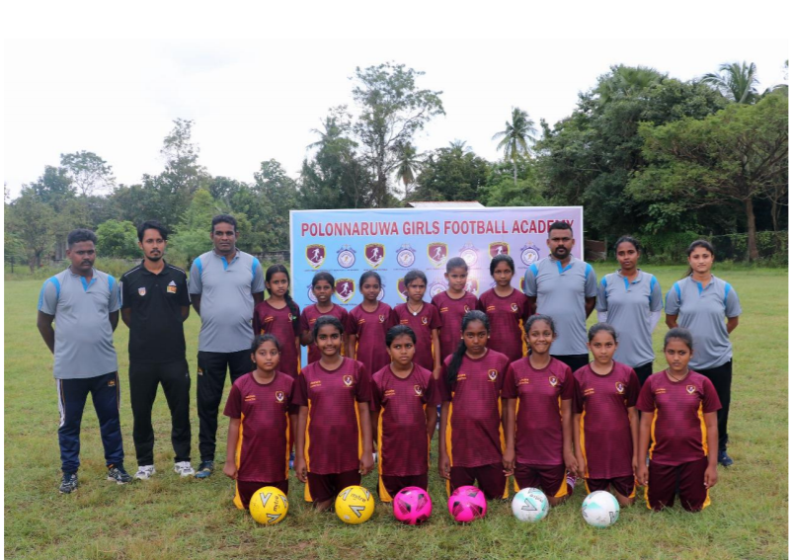
PGFA U14 TEAM
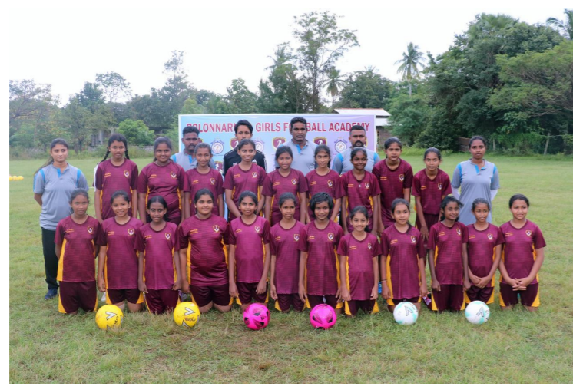
PGFA U16 TEAM
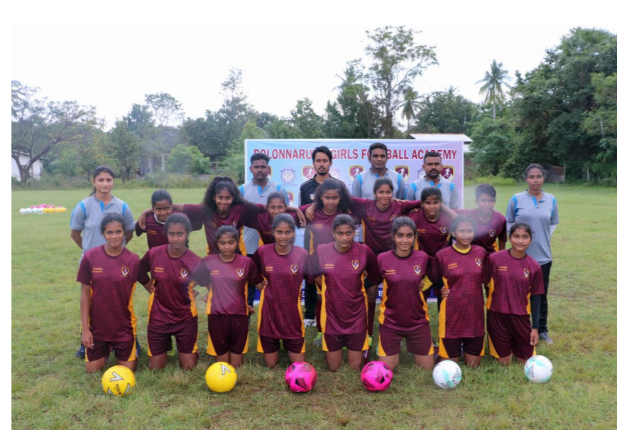

STAR PLAYERS
Senulmi Himarsha - U14 Sri Lanka Best Player 2018
Nimesha Sadaruwani - U16 Sri Lanka National Vice Captain
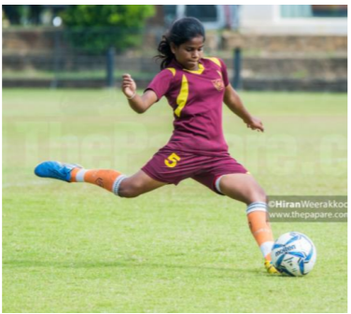
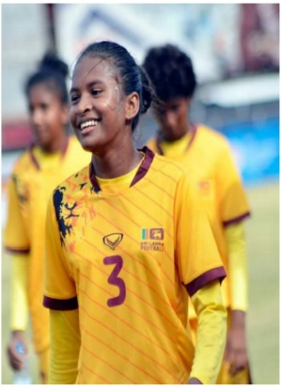

Dualni Sandeepani - U12 Sri Lanka Best Player 2018 ; Participated in tour of Barcelona FCB
Sasidi Nimsara - U12 Sri Lanka Best Player 2019; Participated in tour of Barcelona FCB

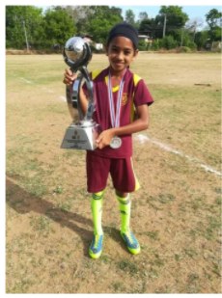
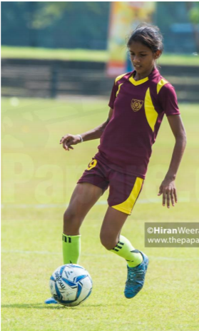

U12 All Island Runner Up PGFA - 2019

