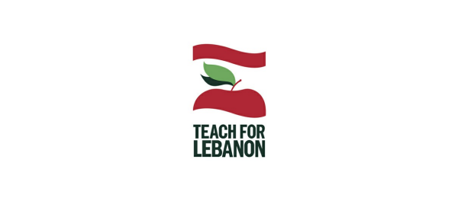
Dear friends,
The situation in Lebanon is extremely difficult. We are in the midst of devastating economic and political crises, as a result of which the education sector is badly suffering. We must ensure that all students in Lebanon have access to quality education. This is more critical now than ever, because we must count on them to build a more sustainable and more equitable Lebanon.
Please support us as we’re currently running three fundraising campaigns on Global Giving: Your help matters.
>> Click here to support the Lebanese Educators Helping Vulnerable Students campaign and support our Fellowship program.
>> Click here to support the Books For Lebanon campaign and provide at-need Lebanese and refugee children with textbooks and literacy resources.
>> Click here to support the Digital Skills For Underprivileged Kids In Lebanon campaign to provide at-need schools and students in Lebanon with laptop computers.
We would also like to take this opportunity to thank from the bottom of our hearts those of you who have already donated to these campaigns.
After Two Years, Teachers and Students Finally Return to the Classroom
Despite a challenging context – massive inflation, price hikes of goods including stationery and textbooks, and an ongoing pandemic – schools have reopened. Our Fellows and their students are finally back in the classroom after two years of online teaching and learning – and everyone is so happy to be back in person!
This year we have 15 Fellows from Cohort 12 and 27 Fellows from Cohort 13 (42 total) placed in 31 schools throughout Lebanon.
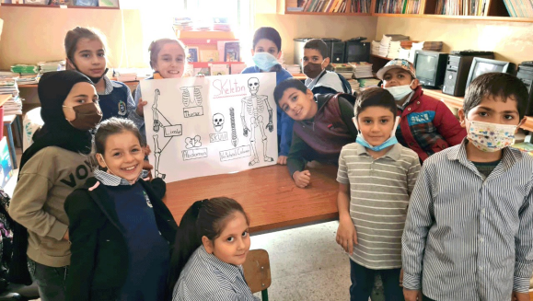
Projects Updates
Access
The English Microscholarship Program (Access), a two-year global scholarship program supported by the U.S. Department of State
Although the current situation in Lebanon is difficult, TFL’s implementation of the Access program is progressing well. In order to compensate for electricity and internet connectivity cuts, we distributed 3G bundles and made our session scheduling flexible. Access teachers and students have made great efforts to attend these online sessions. Student participation and engagement levels have been impressive, and students have shown measurable improvement in English language, communication, and technology skills.
Teacher Training
In September and October, as part of the teacher training component of the Access Program, Teach For Lebanon (TFL) hosted three online workshop series for a total of 22 Access and 77 non-TFL teachers working with underprivileged Lebanese schoolchildren. Click here to read more about one of these workshop series.
Student Presentations
During the month of September, 500 Access students across Lebanon gave 3–5 minute presentations on a topic of their choice inspired by international days they learned about. Click here to read more.
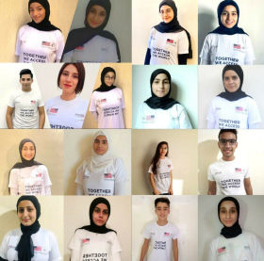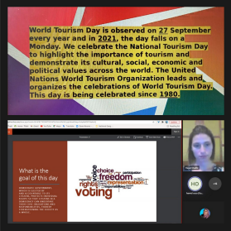
Access 15 students looking beautiful and proud. Credits: Access Teacher Ms. Hayat Khalifeh
1001 Nights
Students' presentation on a topic of their choice inspired by the international days they were introduced to.
We’re proud to announce that the 1001 Nights project has officially launched full-scale this week! We’d like to thank everyone who has worked relentlessly to organize and conduct the 1001 Nights teacher training program and events, as well as the participating teachers who by attending have demonstrated their commitment to improving the education students in Lebanon receive and to instilling the right values in them.
Read more about the hard work and dedication that has made this possible. Watch a clip from one of the program’s sessions in the Saida Generation School classroom.
TFL x Storyvoice
After a break over the Summer our weekly Storyvoice sessions resumed in September: every Thursday at 6 PM a TFL Fellow and a co-host lead a story-reading and activity session on our private Storyvoice channel. Each month is themed: September was “TFL staff and families,” October was “a trip across the world,” and this month is “professions and careers.” Our Storyvoice audiences keep growing – last week we had over 200 people tuned in!
Reminder: a prize is awarded to the most active student every month. Four of our student participants have already received stationery kits over the months of September and October.
Tune in!
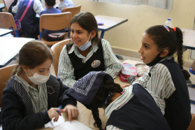
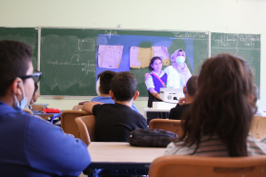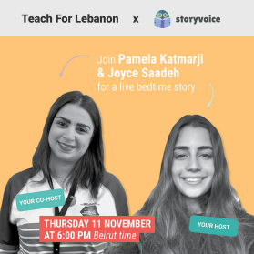
Students at the Saida Generation School in the
classroom enjoying a 1001 Nights session (Left)
Announcing a Storyvoice session co-hosted by
Pamela Katmarji from DHL Express Lebanon (Right)
TFL x CLES
This September, as part of our collaboration with the Lebanese Center For Special Education (CLES) on the Care by CLES program, we distributed a fourth round of rations to underprivileged Lebanese families. As with the previous rounds, members of our executive team generously devoted their own time to distribute the rations. Additionally, a fifth round of distribution took place where a hundred families identified by TFL collected rations from CLES centers.
We are proud of our team and of our continued collaboration with CLES, which provides crucial support to at-need families in these difficult times.
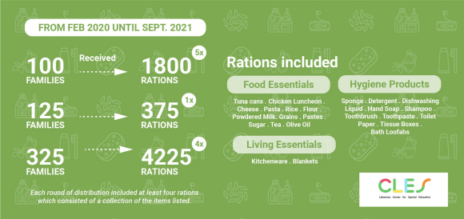
News & Events
Teach For Lebanon at the Teach For All
Global Conference 2021
TFL took on a bigger role than ever at the Teach For All (TFAll) Global Conference 2021. Cohort 12 Fellow’s Chaimaa El Masri students at Maifouq Monastery school appeared in an original song put together by TFAll for the conference. TFL students also had their work featured in the conference’s virtual art gallery.
Our CEO Salyne Samarani contributed a speech to the conference’s opening session in which she argued that, despite the hardships and setbacks we face, we must move from a mode of passive resilience to one of transformative leadership. Our head of HR Mohsen El Husseini hosted the conference’s Daily Assembly sessions. Two of our Fellowship alumni, Fahd Jamaleddine and Josianne Attalah, spoke on panel discussions.
Last but not least, our Build Back Better (BBB) initiative was selected as one of this year’s “Network Breakthroughs”. TFL COO Mouhammad Houssari gave a presentation covering the initiative and hosted a live Q and A along with our partners at Nafsaniyoun to continue the discussion that was ignited by the presentation. The emphasis of Mouhammad’s talk was on mental health and how important it is to assess and nurture it in everyone we work with. In his words: “You don’t need to wait for a giant explosion to start paying attention to mental health and working on how to nurture it and include it in your interventions in a holistic way.” Feedback for both the presentation and the Q and A was overwhelmingly positive. Here are some tidbits:
“Inspiring to see a holistic approach to supporting students ♥” – Amal Muna “Congratulations Teach for Lebanon. Mental health is such an important issue!” – Ana Florez
“Mouhammad, Salyne, Farah, Mohsen, and everyone at Teach For Lebanon – we love you and are so inspired by you.” – Reem Marto
If you’d like to check out these and other sessions and learn about the inspiring work that is being done by our Teach For All Network partners throughout the world, you can find the conference’s video archive here.
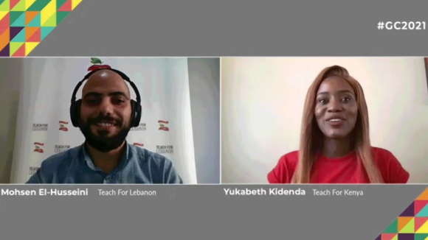
A TFL Wedding
We’re delighted to announce that our head of HR, Mohsen El Husseini, was married to Nadine El Ahmar on Sunday, September 26. Congratulations and blessings to the both of them!
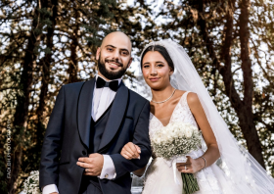
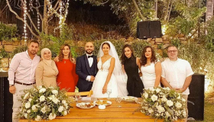
The TFL team celebrating Mohsen's big day.
Support From a TFL Alumnus at Google
Nothing makes us happier than when Fellowship alumni continue to support our vision and mission after graduating, so we are as delighted as we are thankful that Cohort 1 Alumnus Joseph Rahme, who now works at Google, has nominated TFL to benefit from Google fundraising campaigns and mobilized his community to support us. Whatever Joe and the rest of the staff at Google MENA raise for TFL, Google will match. Thank you so much again, Joe – we’ll be using this opportunity to raise funds to provide educational resources to at need Lebanese and refugee students.
Click here to see a short video featuring Joe as a Fellow in 2009 as well as a testimonial from one of Joe’s former students.
A Reflection on The Role of
Educators by TFL Alumna
Ghadir Al Saghir
Ghadir Al Saghir is an alumna of TFL’s 9th cohort of fellows
(2017–19). She is also Teach For Lebanon’s newest Access
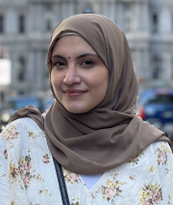
teacher. In a blog article she recently wrote, Ghadir gives
us an update on what she’s been up to since graduating.
Here are her words of wisdom and advice to TFL Fellows:
“To all TFL Fellows, I encourage you to look at the staff at
the schools in which you’re placed as assets – to rely on
their experience and collaborate with them. I also
encourage you to consider your needs and those of your
students, the conditions in which you’re working, and the
teaching resources at your disposal. Then ask yourself the
important questions: ‘What can I learn?’ and ‘How can I
contribute?’ Why? Because these reflections are your
starting point, and you will take them with you wherever
you go.”
Read the full article here.
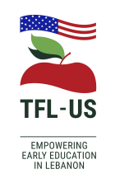
TFL-US page on Facebook
Our page on Facebook is dedicated to keep
our friends and followers in the US
updated with Teach For Lebanon's
fundraising projects and activities.
If you’re in the US or one of the
countries listed here, you can now
donate through our TFL-US Facebook
page with a simple click on the
Donate button!
www.teachforlebanon.org
CONTACT US:
LEBANON
salyne.elsamarani@teachforlebanon.org
USA
ctagher@stifirestop.com
TFL-US, Inc. is a tax-exempt 501(c)3 public charity
and all donations are tax deductible

