The Village Microclinic
Web site : www.thevillagemicroclinic.org

- Mission and objectives of TVM
The Village Microclinic (TVM) is a community-based organization in Burundi aiming at empowering people from peri-urban settings of Burundi to advance their own health and wellbeing. TVM envisions a world where everyone lives his life to the fullest.
TVM uses an integrated approach based on a referral medical polyclinic and medical hubs in the community to reduce child and maternal mortality and increase health service delivery outcomes.
A medical hub is a community center equipped with easy-to-use technologies for screening common illnesses, promote health literacy, provide primary care and ensure referral to the Medical Polyclinic. The hub is run by a qualified nurse and ensures 24-hour maternity services. The nurse is the liaison agent between the medical polyclinic and medical hubs. The hub is equipped with a motorbike to ensure emergency transport. An ambulance is also available at the medical polyclinic and is requested on need by medical hubs.
- Social problem TVM addresses and need of a maternity unit
In Burundi, the traditional health system is equipped to provide short-term interventions and do not allow access to universal health care. An unacceptable number of people, mostly women, infants and children, continue to suffer or die untreated from conditions that are preventable and treatable such as malaria, diarrhea, respiratory infections, malnutrition and non communicable diseases. The situation is worse in peri-urban areas where over 60 per cent of women deliver at home without the assistance of a qualified professional. 41 babies out of every 1,000 live births die in the first four weeks of birth – about 16,000 child deaths per year. An estimated 88 per cent of deaths from diarrhea are attributed to poor hygiene practices, unsafe drinking-water supplies and inadequate access to sanitation.
Some of the few clinics and health centers available in peri-urban areas have limited diagnostic capabilities due to lack of appropriate devices and tools, lack of trained health professionals, lack of health literacy, lack of prevention programs within communities, lack of tools to help clinicians follow standard protocols for quality care which lead to mistreatment of patients and referrals for advanced facilities. In peri-urban settings of Burundi, the people are generally poor and live on less a half US Dollar per day and therefore many patients are not able to afford cost of the trip and health services and prefer to stay and die at home. Maternal mortality is high, due to complications during pregnancy and childbirth, as well as too early and too frequent pregnancies. Most families in our catchment area travel many kilometers to reach the nearest health facility and the youngest and most vulnerable young mothers-who might be just 14 or 15 years old still encounter discrimination, intimidation and social stigma. The Village Microclinic wants to build a maternity pavilion to provide an effective educational program for expectant mothers. TVM will offer mothers critical lifesaving information and instill in them the importance of seeking health care before, during, and after child birth. The knowledge gained by expecting mothers will not only save lives but will also empower mothers to make sustainable change in their families and communities.
By preparing mothers for pregnancy and child birth, we are building a prepared and informed community for the future. In this way, we are developing better maternal and family health not just for today, but for years to come.
- The solution TVM provides
Our model
Our interventions are focused on patient needs beyond medical care through holistic approach to health. We want to create a world where access to prevention and health services is not a privilege but an unalienable right. We want to treat everyone as a complete individual with physical, emotional, social and spiritual needs. The main focus of The Village Microclinic is the improvement of child and maternal health in Burundi to achieve sustainable development for communities of Burundi. Our main location is the underserved and neglected communities of peri-urban areas of Burundi.

Clinical care
Community Medical hubs
Economic Development

Why we do it?
Financial Education

Clinical care
Our clinical care model is based on treatment at our Rukundo Medical PolyClinic and public outreaches in the communities via our medical hubs. The health services delivery is based on 4 pillars:
- Child and maternal health: we make a special effort to eliminate under-five mortality in Burundi which is among the worst in Sub-Saharan Africa. Apart medical services provided at our medical polyclinic, we recruit, train, equip and pay Community Health Workers who are actively involved in: pregnancy tracking and referral for antenatal care and delivery in health facilities, screening of and referral for danger symptoms in pregnancy or in neonates, home visits, counseling communities on the importance of immunization, good nutrition and hygiene. Community Health Workers also diagnose and ensure emergency treatment of acute respiratory infections, diarrhea and malaria.

- Reproductive health: We circumvent traditional barriers which prevent women and girls to access reproductive health services and information when they need them. The Village Microclinic offers education and tools to girls; women and couples to allow them avoid unwanted pregnancies. Community health workers sensitize and offer counseling services in the community on family planning and distribute condoms and oral contraceptive pills.

- Non Communicable Diseases Prevention and Management: The Village Microclinic focuses on prevention and management of Diabetes, High Blood Pressure, malnutrition and neglected tropical diseases in our polyclinic. Our network of community health workers support their communities through community education on prevention of Diabetes, High Blood Pressure, malnutrition and neglected tropical diseases; home visits to support persons living with diabetes, high blood pressure and neglected tropical diseases; provision of basic first aid; community mobilization to reduce stigma and discrimination of persons living with chronic illnesses.
- HIV community care and support: The Village Microclinic offers a broad category of HIV/AIDS services that are required to comprehensively and holistically support HIV/AIDS-related needs. Our approach is community-centered and responds to non-clinical needs of persons living with HIV and their families that impact clinical care and retention. We go beyond medical management of HIV (antiretroviral treatment and biomedical follow up) and comprehensively respond to material, cultural, psychological and legal needs of persons living with HIV. Our network of community health workers and our community health nursing program offer home-based treatment and ongoing support on antiretroviral therapy adherence, positive prevention, tuberculosis screening and referral for treatment and other common co-infections.

Photo of the maternity unit
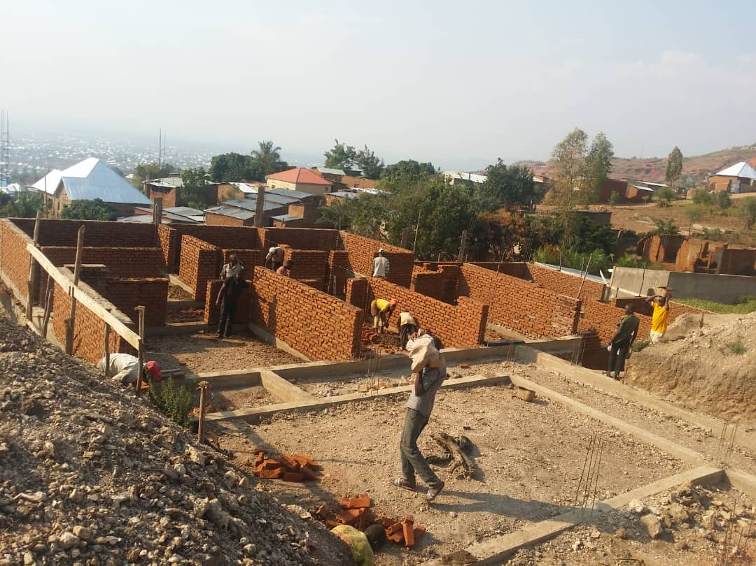
Budget for the maternity unit of TVM
Nr | Item | Unit | Quantity | Unit cost in USD | Total cost in USD
1 | grit | m³ | 35 | 38 | 1 330
2 | moelon foundation | m³ | 56 | 50 | 2 800
3 | Moelon hedgehog | m³ | 67 | 23 | 1 541
4 | Reinforced concrete | m³ | 47 | 110 | 5 170
5 | Mansonery | m² | 258 | 2 | 516
6 | Baked bricks | m² | 432 | 14 | 6 048
7 | Plaster on wall | m² | 530 | 4 | 2 120
8 | Flooring | m² | 341 | 3 | 1 023
9 | Earthenware tiles | m² | 730 | 3 | 2 190
10 | Metal frame | Unit | 180 | 15 | 2 700
11 | Iron sheets BG 28 | unit | 150 | 25 | 3 750
12 | Ceiling | unit | 140 | 19 | 2 660
13 | Doors | unit | 8 | 40 | 320
14 | Windows | unit | 14 | 30 | 420
15 | Painting on walls | m² | 138 | 12 | 1 656
16 | Sanitary and plumbing | unit | 23 | 28 | 644
17 | Electricity | unit | 34 | 18 | 612
 | Total cost |  |  |  | 35 500

