Success Story 2

Hidaya, 17, is a teenage mother who dropped out of school when she got pregnant. With no support to go back to school after giving birth, she stayed home taking care of her child. It was not until she met LifeAgain which changed her life. LifeAgain supported Hidaya to enroll back in Junior High School 2 and supported her till she completed Junior High School and got admission into the Senior High School. Now Hidaya is in her second year in Senior High School reading Home Economics, Clothing and Textile option.
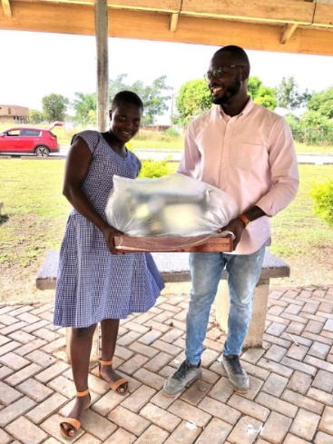
LifeAgain reached out to her when she had no hope of furthering her education and had given up on her dreams but now she is optimistic of achieving the dream she has always had; becoming a fashion designer. In the picture, LifeAgain gave her a sewing machine to help in course of studies.

