FOOD FOR GOOD FOR CANCER PATIENTS IN KENYA- PROJECT 51672
PROJECT REPORT
INTRODUCTION:
Africa Cancer Foundation (ACF) launched in 2011 in Nairobi, a Charitable Trust that works towards preventing cancer and providing holistic solutions for those affected by cancer in Africa.
ACF participated in GlobalGiving's April 2021 Accelerator campaign for a project dubbed ‘Food for Good for Cancer Patients in Kenya.’ The aim of the project is to address the nutritional needs of 300 cancer patients and their families by setting up vegetable cone gardens for them to enhance food security and better nutrition as they undergo treatment of various cancers. The 6 tier cone garden has a variety of vegetables that the patient can harvest and eat or sell the surplus to make money for other necessities.
To date, ACF has managed to raise over $21,436 from 275 donors out of a target of $ 50,000. ACF earned a permanent place on the GlobalGiving platform and a social media badge.

ACHIEVEMENTS
ACF has continued to set up cone gardens for patients and monitoring the patients that we set up for in 2021. Between March 7 2022 and March 16 2022, 17 vegetable cone gardens have been set up in Kisumu.
On March 11 2022, we did a review by visiting patients’ homes in Kisumu County. The report is as follows:
The first home we visited was in Obambo but unfortunately the patient died on November 11 2021. The garden has been used well and a seed bed has been prepared to replace the planted vegetables. This is being done by the wife who said the garden has really helped them.
The 2nd patient is from Kayakwar. Set up was done in August 2021. The garden was neglected. We advised that the place is fenced off using an old mosquito net. There is a seed bed nearby and his wife has committed to take care of it because they have benefited from it a lot.
The 3rd visit was in Nyahera. The set up was done in August 2021. Garden is well maintained and has very healthy vegetables and is fenced off well. The beetroot did not do well.
Another patient in Nyahera, the garden was fenced very well and the vegetables are in good health. However, the patient wasn’t at home.
In Kajulu, the garden was completely neglected as we could not get any explanation because we did not find him or his wife. Another patient also from the same area completely neglected their cone garden. We could not get the reason because we didn’t find him or his wife.
In Kaloleni, the gate was locked.
In Lumumba, the patient neglected the garden and she wasn’t at home.
In Nyalenda, the patient’s garden was very vibrant and well fenced. Seedlings are already prepared for replanting.

On 15th March 2022, one cone garden was installed in Nyakach. We also reviewed for other patients we set up for as follows:
A cone garden was installed in Buoye, Kisumu East in July 2021 but the patient said that she had it removed when the vegetables were finished. We reinstalled and asked her to replace her veggies regularly.

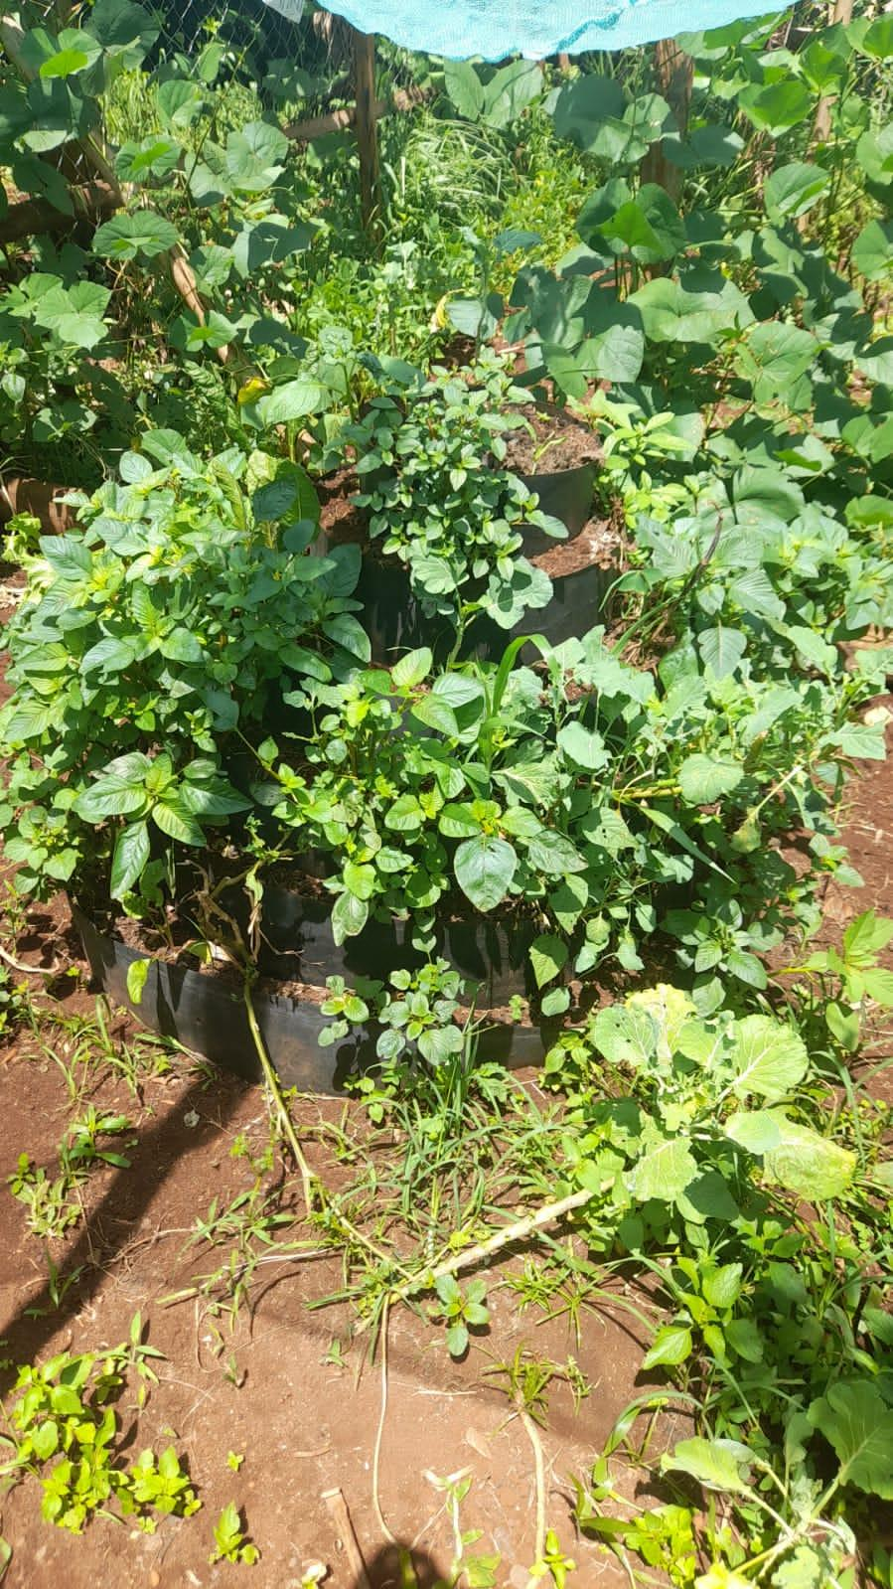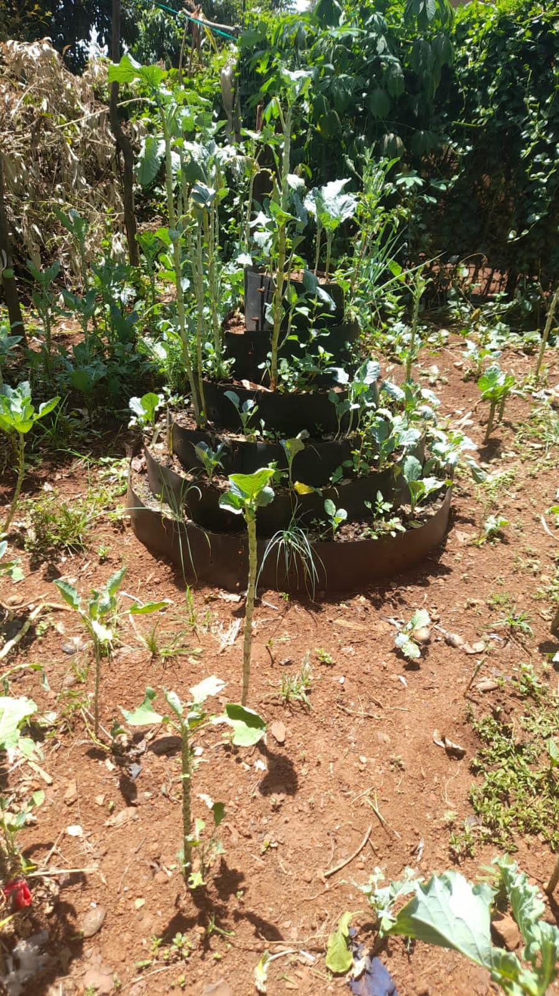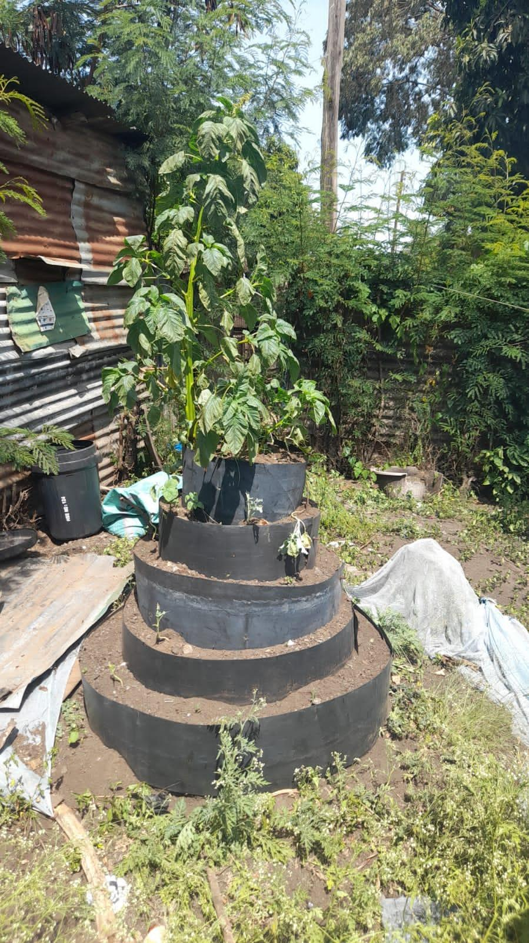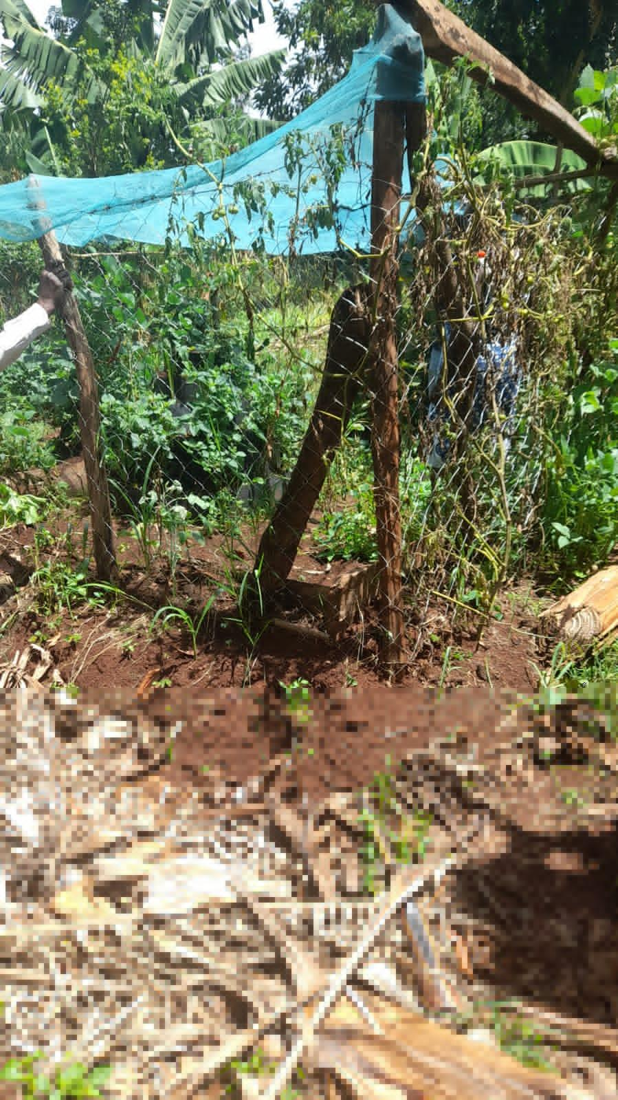

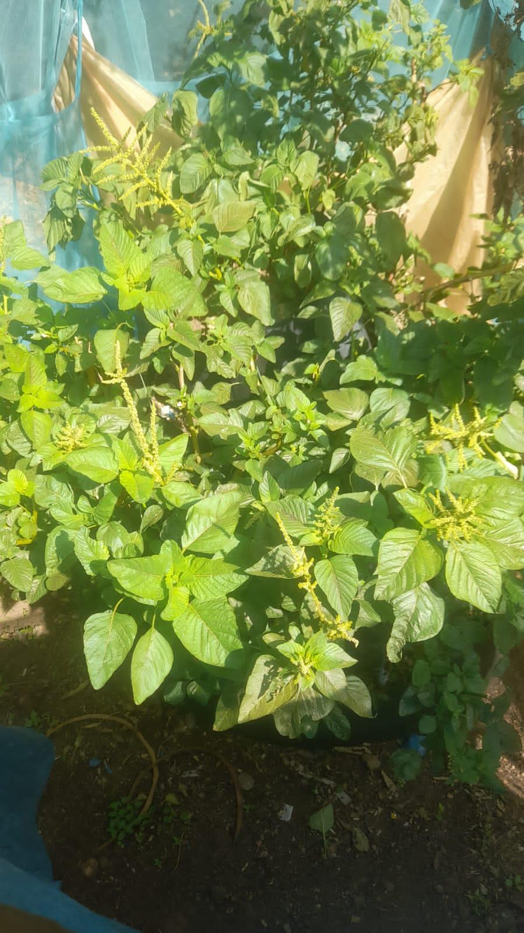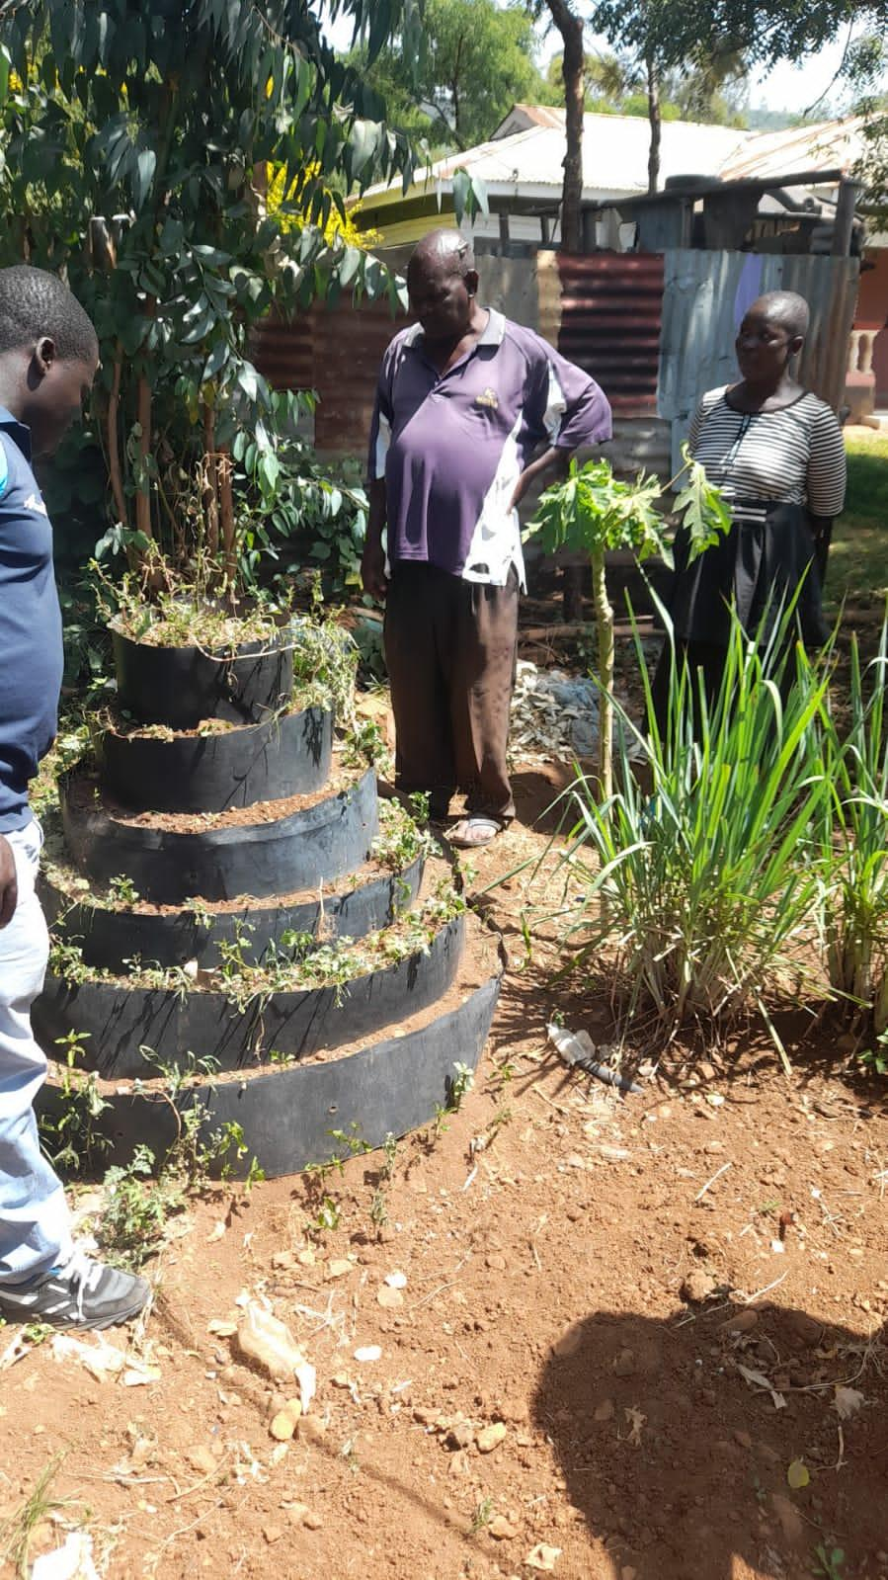
The cone garden set up at Jaramogi Oginga Odinga Teaching and Referral Hospital was repaired. They committed to ensure that the garden is maintained by the ground keepers. This team will also regularly check on it.
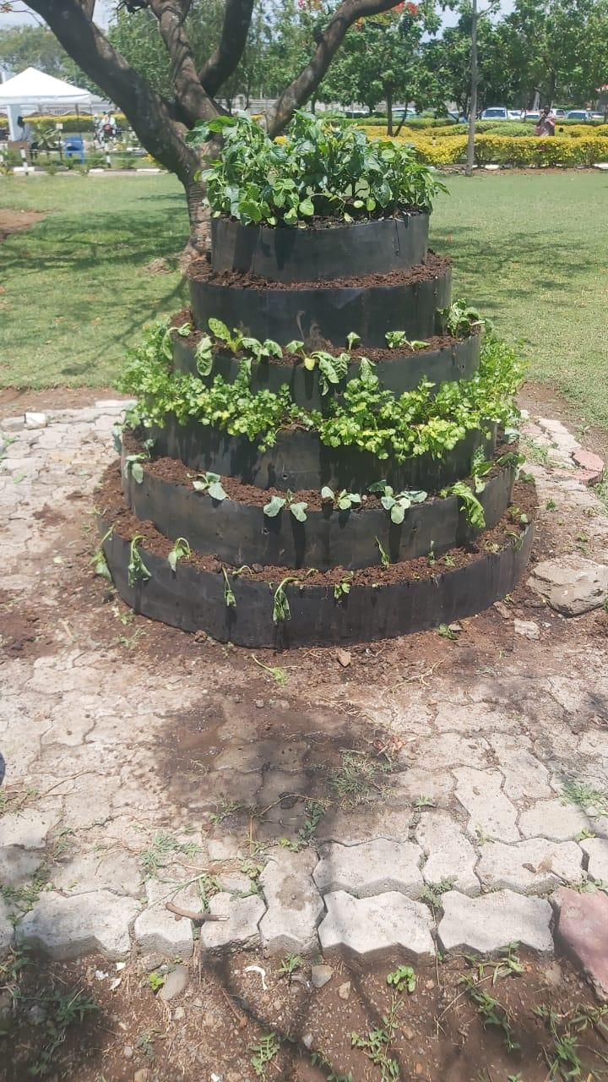

On September 6, 2021 we set up a cone garden for a patient in Nairobi. We visited the patient on December 5, 2021 to review her garden. The garden was full of weeds after harvesting several times. We advised her to do weeding.
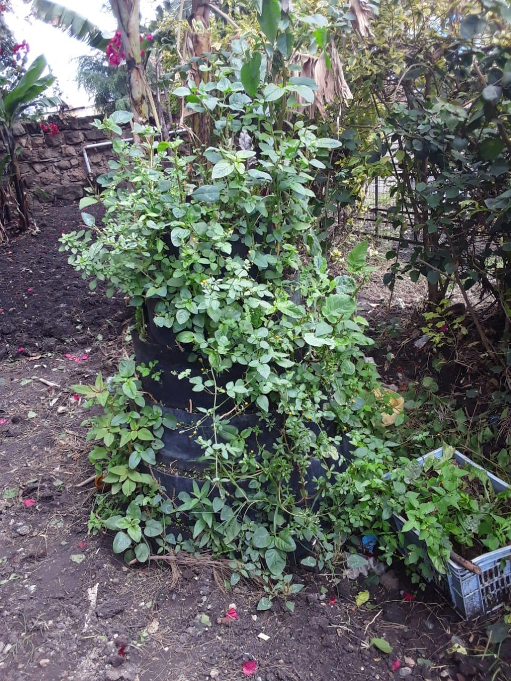
On October 21, 2021 one of the cone tiers of the patient in Nairobi disconnected at the joint due to soil erosion. This was one month after setting up the garden. The patient was away for a week during the heavy downpour. We asked them to fix the screws. The vegetables were doing well though and they mentioned that they will remove the weeds soon.
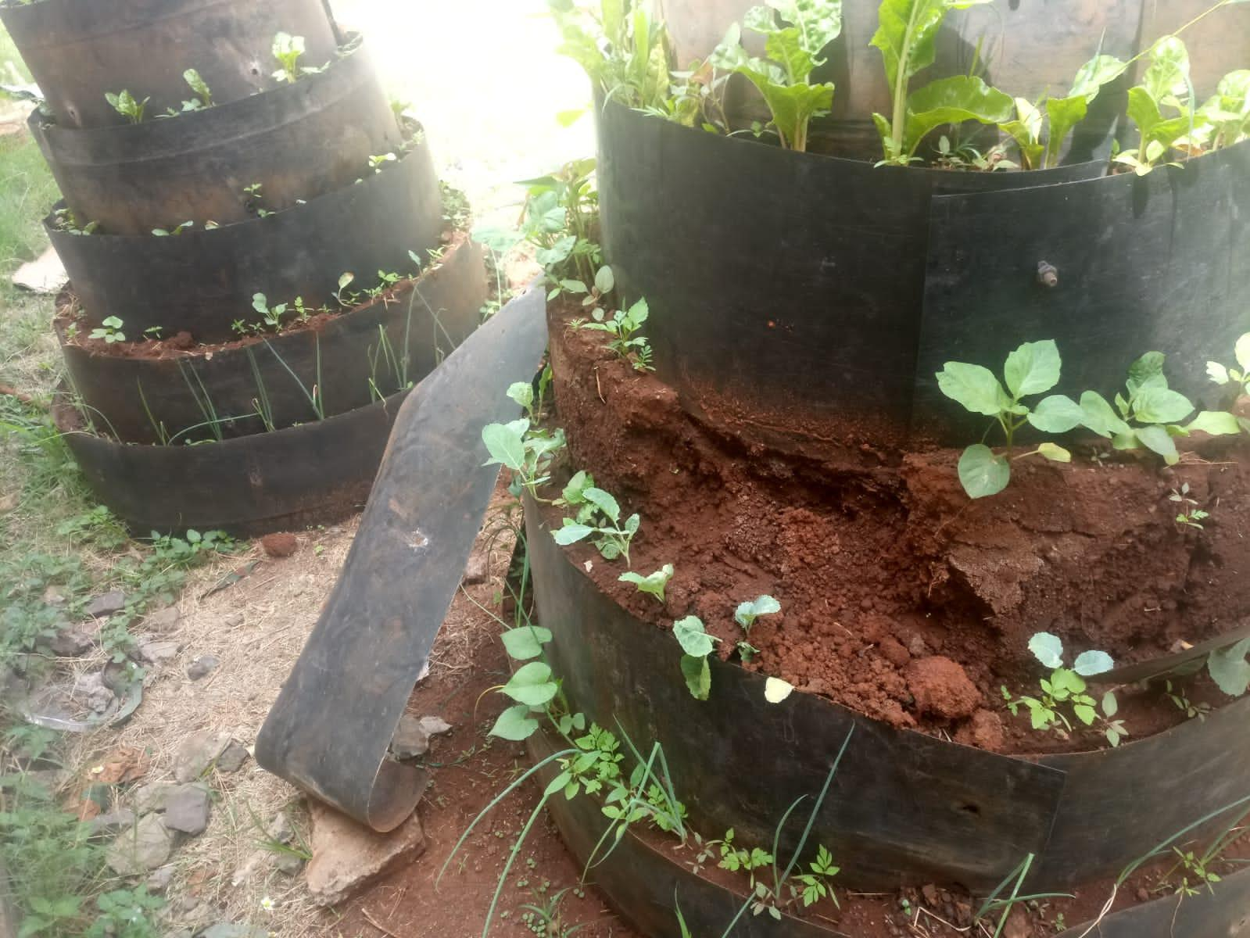

Phoebe from Tumaini La Maisha harvesting the vegetables on 14th January 2022. We set up the cone garden at Joannna’s House, Nairobi on July 7, 2021.
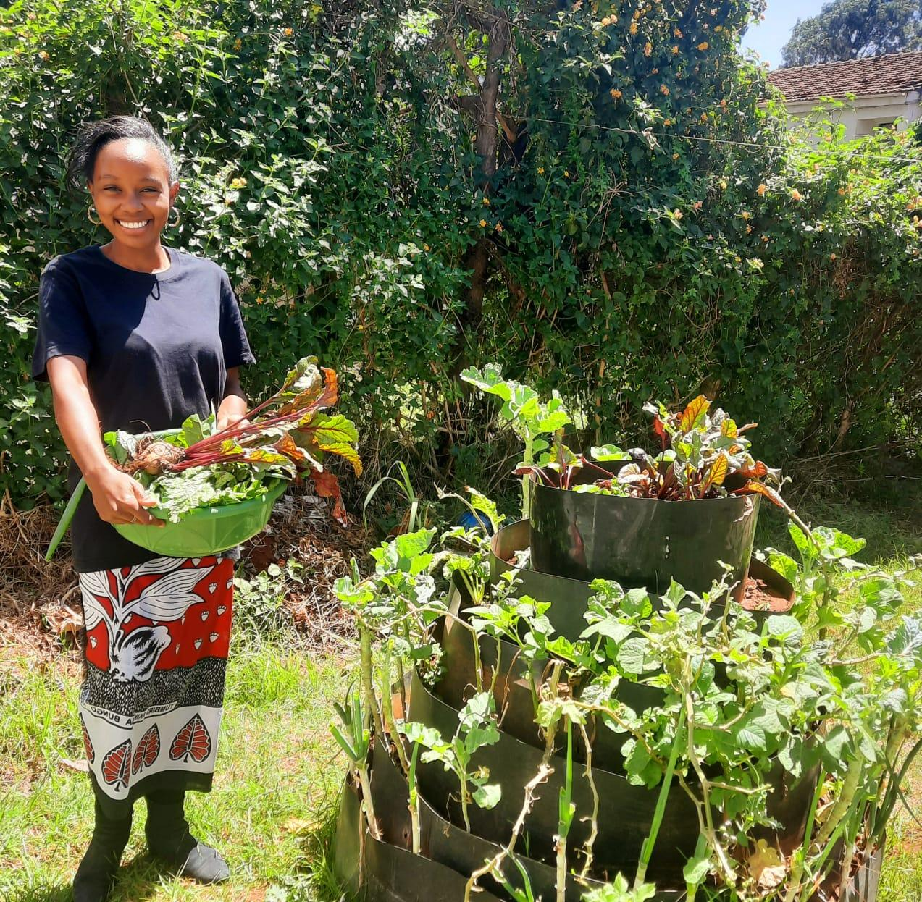

We installed a cone garden for a colon cancer patient in Kiambu County on 14th October 2021 and a month later the vegetables were doing well.
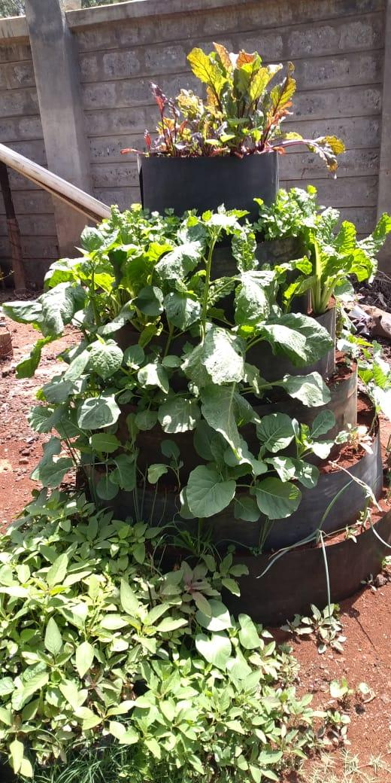
We set up a cone garden for a breast/spine cancer survivor on September 15, 2021 in Kiambu. On October 17, 2021 she was harvesting for the second time.
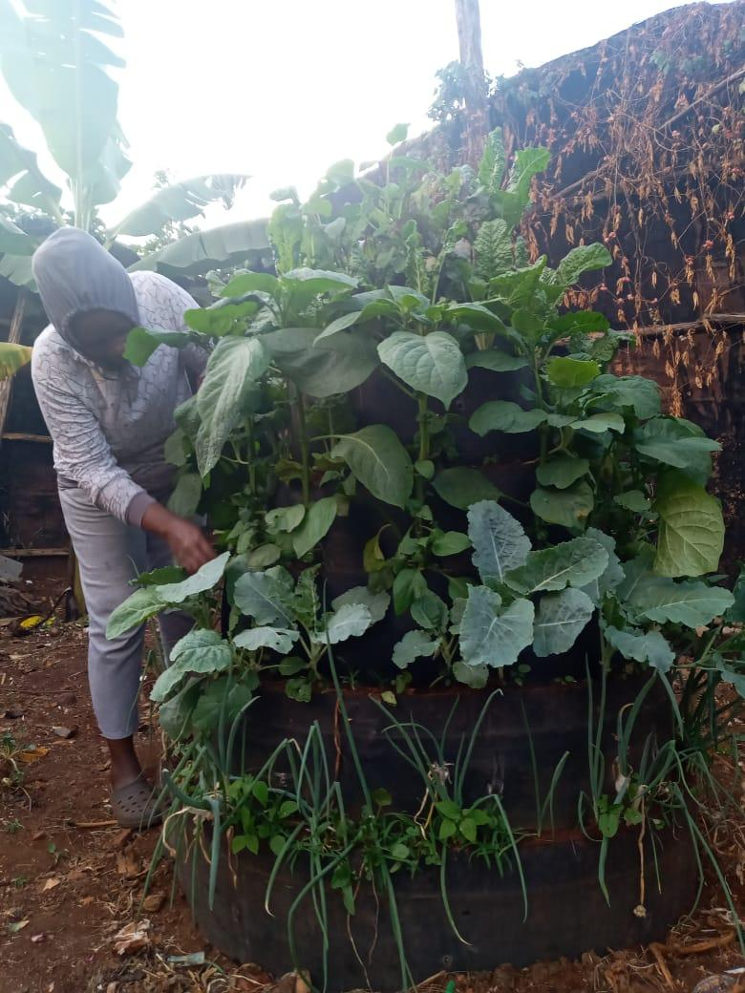

DECEASED
2 patients in Nairobi, 1 patient in Kiambu and 1 patient in Kisumu are deceased. We set up cone gardens for them in 2021.

