BECAUSE WE KNOW THEM,
WE HAVE BEEN CHANGED FOR GOOD

When beginning to write a data-driven report on the status of Computers for Pathway Students in Africa, rather than the stunning numbers demonstrating the continued phenomenal success of the project, such as the 139 COMPUTERS AWARDED IN THE WINTER 2022 CAMPAIGN, or the 191 COMPUTERS AWARDED IN 2021, MAKING A TOTAL OF 330 LIVES CHANGED BY RECEIVING COMPUTERS FROM THE LORD’S HANDS, I kept thinking of the lyrics from Stephen Schwartz’s musical, Wicked.

“I’ve heard it said, that people come into our lives for a reason,
bringing something we must learn.
“And we are led to those who help us most to grow if we let them. And we help them in return.”
Like most of you generous donors, I feel that I have been led to these hard-working students in Central Africa, who are challenged by poverty, corrupt governments, and limited technology. I have learned much from their determination and sacrifices to acquire an education.

“Well, I don’t know if I believe that’s true, but I know I’m who I am today because I knew you.
Who can say if I’ve been changed for the better?”

While reading essays from 348 WINTER CAMPAIGN APPLICANTS, I know that I have been changed. Let me share from one essay that may change your outlook.

“In the refugee camp, education was very limited. Things got hard, and I got low marks, making me feel bad. But through Pathway, I started viewing failures as opportunities to learn more and improve. This really opened my mind, and as soon as I started applying this concept in my life, I actually got better, not only with school work but in most areas of my life.”

“It well may be that we will never meet again in this lifetime.
So, let me say before we part:
So much of me is made of what I learned from you.
You’ll be with me like a handprint on my heart.
Who can say if I’ve been changed for the better,
but because I knew you, I have been changed for good.”

We may never meet these amazing students, but we can learn perseverance from the examples of the 1369 WHO HAVE APPLIED FOR COMPUTERS since the inception of The Lord’s Hands project. They TRIED! THEY GAVE THEIR BEST!

Yes, we are changing lives of Pathway students in Africa through donations for computers, but I also know that AS WE GIVE, WE WILL BE CHANGED FOR GOOD!

Following are some photos and short stories of students whose lives have been changed for the better. Not only their lives, but their families’ lives, and in time, the lives of people in their communities will be changed for good.

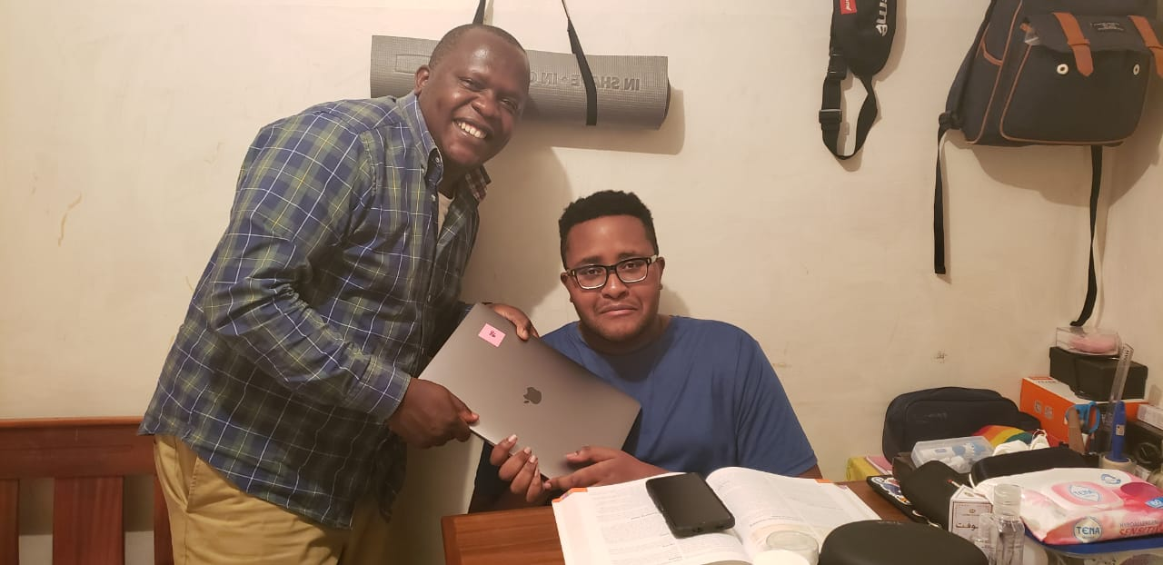

Brother Obito had a stroke, was paralyzed, and could not go to an internet cafe or to the church to do his homework! His future was changed after receiving the computer from The Lord’s Hands.
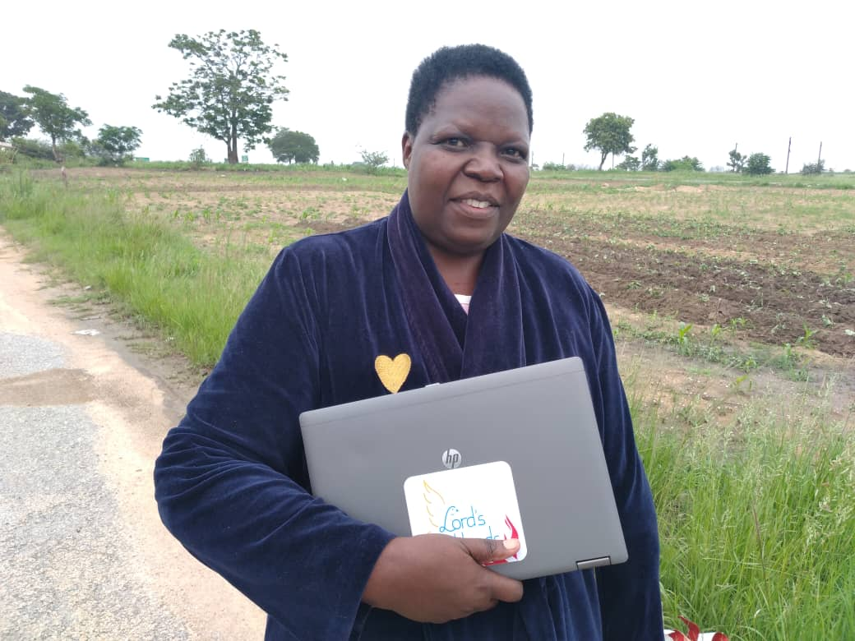

After being a stay-at-home mom for years, Sister Ndlovu, from Zimbabwe, decided to go back to school through BYU PathwayConnect. She struggled a lot in her first semester due to the lack of a computer. She was blessed to earn TLH Computer in her second semester and will matriculate to BYU-I, starting fall 2022. Sister Ndlovu’s and her family ‘s future is changed forever.

