Hope for disabled People (51648)
Compassion, Love and Service … these are at the heart of serving the disabled, vulnerable and poor of our society. Thanks to partners, our supporters and all our staff who are at the very close relationship with these disabled people to give them hope, care and support they need
Our institution as Physically Challenged is not an isolated one but an integrated which is able and physically challenged. We have three different disabled centers in Nigeria and Ghana. The institution was funded by Immaculate Heart of Mary Sisters. The idea of the physically challenged came into reality through two missionaries (Yvonne and Anya ) from Germany who came and had their work experience at IHM School. In the course of their work, they found out that, there were a lot of physically challenged children within the community and then initiated the idea of having an integrated school in collaboration with the IHM sisters to support the community. The school for physically challenged at its initially started with six physically challenged children within the community and now has grown up to 26 children currently and not less than 60 children have passed out since the year 2nd August,2000. The elderly disabled home started with four lay people e and now we have more than 20 people in the home with 24 hours care and support. We also have over 30 sisters in our Mater Christi home for our vulnerable and disabled sisters on 24 hours care and support as well.
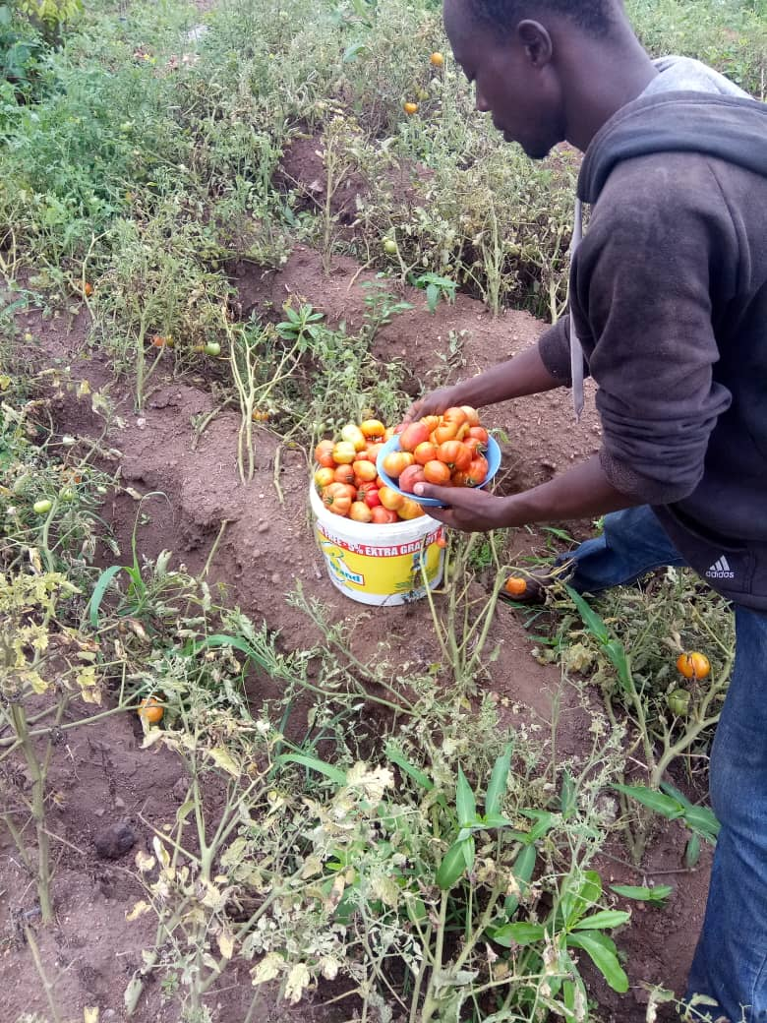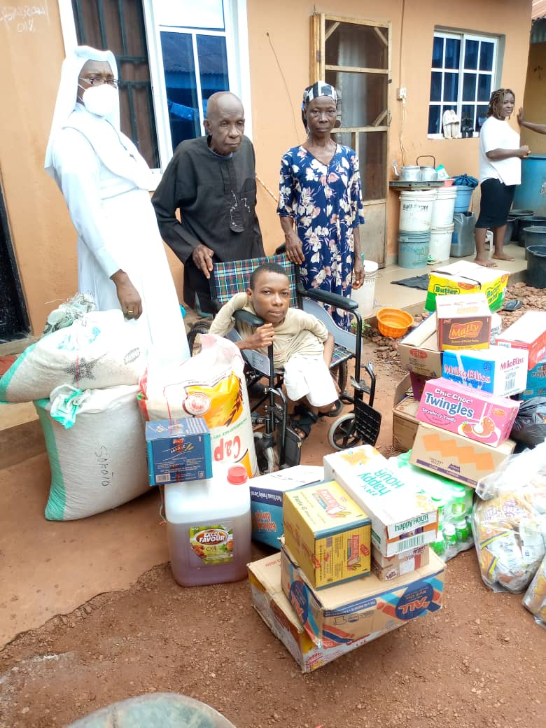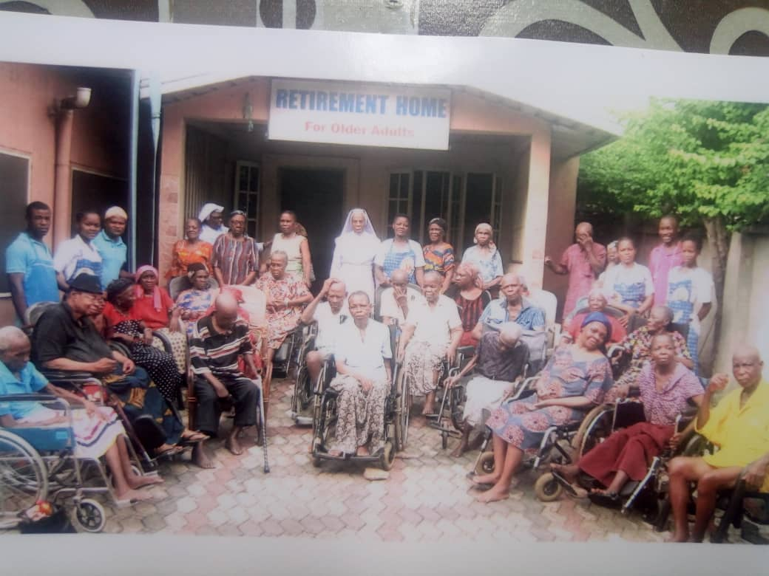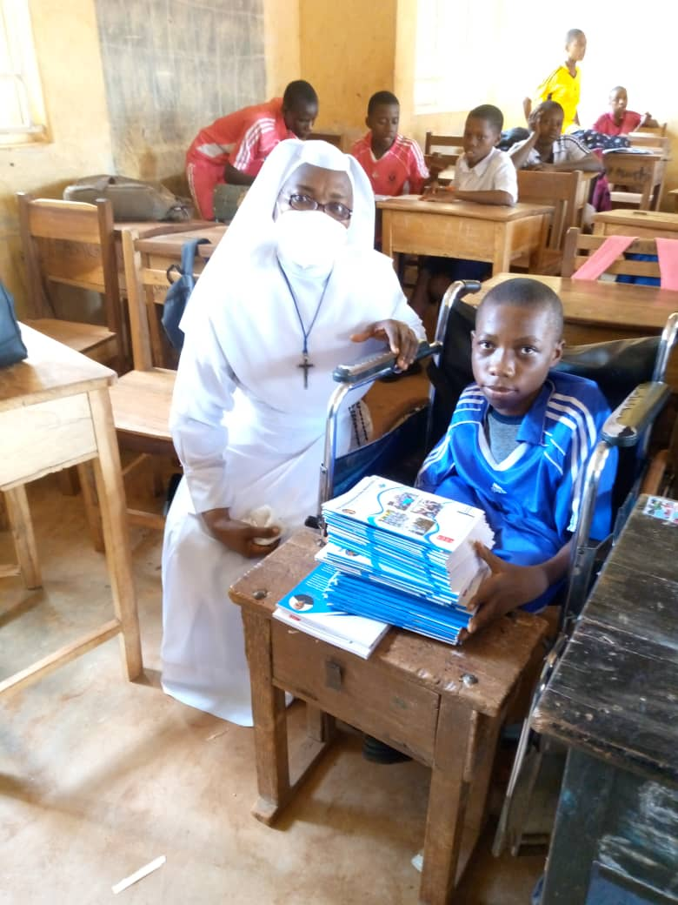
Through project provided monthly feeding and school meals for the 26 disabled residents. We are celebrating Christmas dinner party with gifts to make it a happy day for them. We also provided farming equipment for their use to encourage them and get them involved in things they can do. In Nigeria, we provided Christmas dinner party and gift for them, food bank to those who leave alone, sanitary equipment etc. to enjoy your lives. We support two disabled brothers Emmanuel and Chinaza back to school and start off a small business. We cannot have done it without your support. “ Emmanuel said, “ You have changed my life, I promise to do my best”
Our disabled residents in Nigeria have been doing Exercise. They participated in different exercise to keep their mental health and wellbeing. One of the resident commented, “ I have greatly improved in my walking with regular exercise I do” What I liked most is been able to walk around with my walk support motor. Also in Ghana our disabled residents have been involved in farming, growing tomatoes, cassava, okra and other vegetables to support with their feeding. The joy of doing things in our capacity keeps us going and makes us well loved and cherished “said one of the residents”.

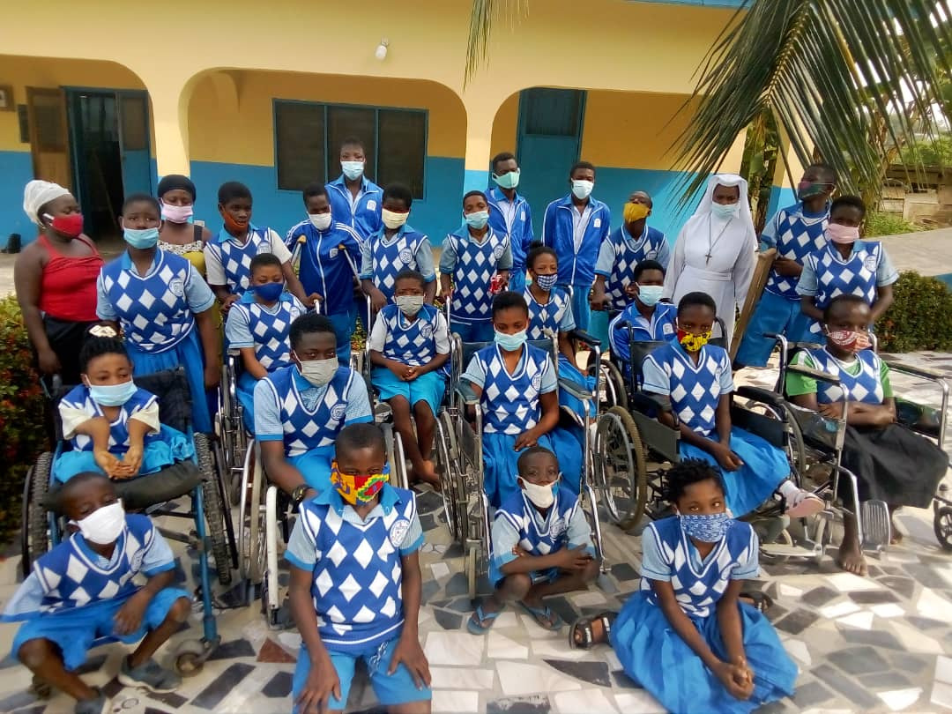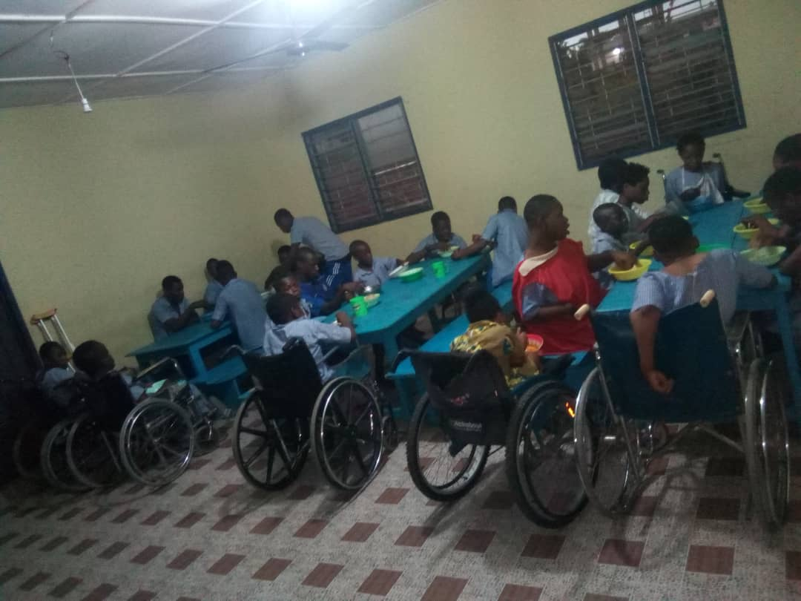

Bringing the joy and hope to our disabled residence is as result of donors like you who are providing the financial support that helps us offer these dynamic support and care to them. All members of our staff have embraced these programs and are enthusiastically working with residents to provide them with all the care and assistance they need and hands-on creative learning. We are grateful to you for making the “Hope for the Disabled People” an opportunity to support and care for disabled people. Your donation to Sisters of the Immaculate Heart of Mary is helping us to give hope for disabled people through our enrichment programs and activities. Donations help us to provide food, medical care, education, mobile support and creative resources for regular exercises etc. We couldn't do it without you.

