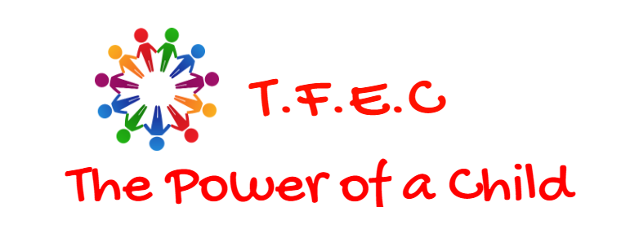

Township Foundation Education Centre
ADDRESS: Gem West-Rangwe Sub-County

Homa Bay County

P.O. Box 128-40303

Rangwe, Kenya

Mobile: +254 728 583 739 or +254 713 181 678

Email: townshipeducationcenter@gmail.com
Website: www.townshipedufoundation.org

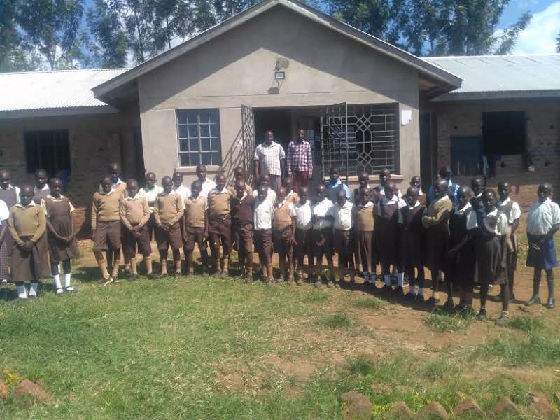

TOWNSHIP FOUNDATION EDUCATION CENTRE

MAIN AIM
Our aim is to meet each child's physical,
educational, spiritual and social need.

ABOUT US
Township Foundation Education Centre (TFEC) is a community based school in Rangwe Sub-County,Homabay County,Western part of Kenya here in Africa.
Started with the rescue of only ten children in 2005 and the center evolved into an education center in 2015 with a current overwhelming population of 475 students.
The founders of TFEC,Charles and I Gonsag,could not ignore the pain we saw the vulnerable and destitute children majorly orphans in our rural home village,in Homa-Bay undergo.They are neglected,abandoned,openly abused and exploited sexually leading to alarming HIV/AIDS infection rate around the lake Victoria region here, thus fail to get the vital basic education. Underage teenage girls are forced into early marriages and pregnancies leading to endless poverty cycle in these areas. We are a small education institution offering humanitarian care for the needy and poverty stricken children.TFEC is where these children learn to know the value of a family in which they are cared for, loved and educated until such a time they will be able to take care of themselves and their own future families.

OUR PROGRAMS

Child Protection
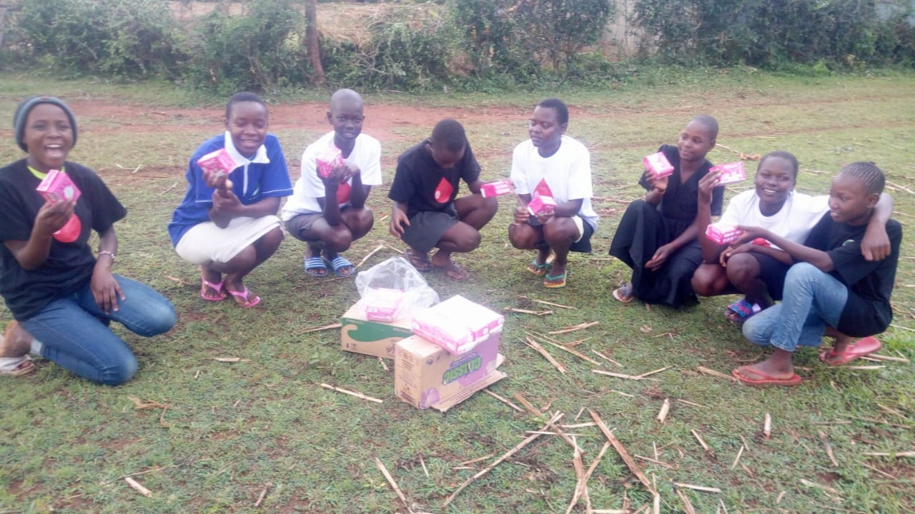
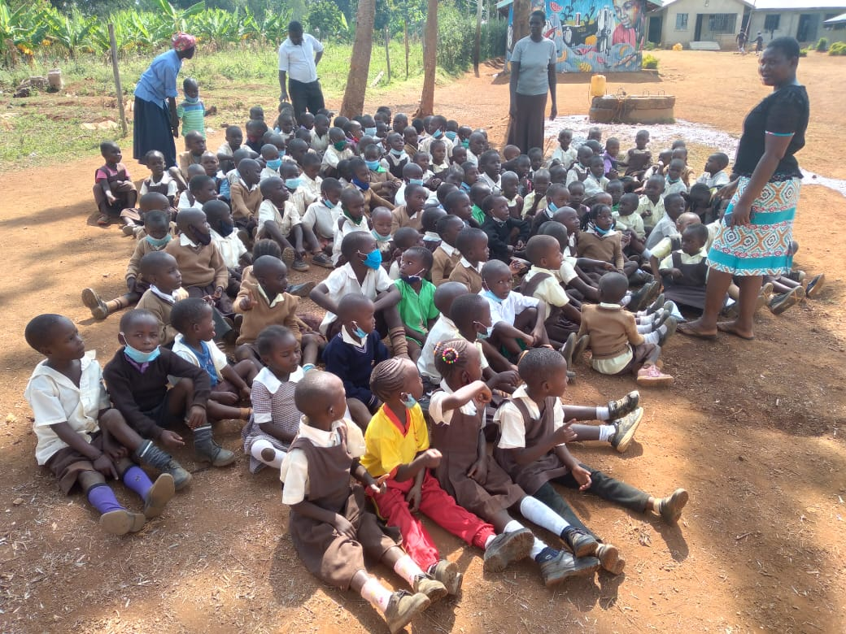
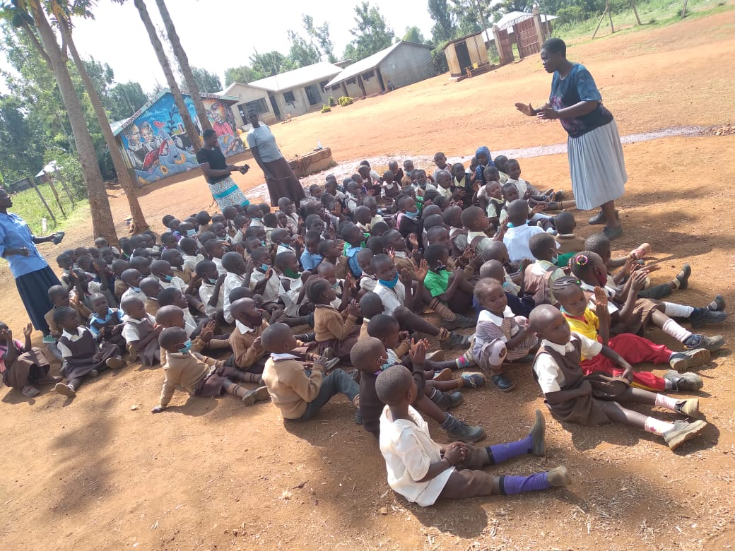
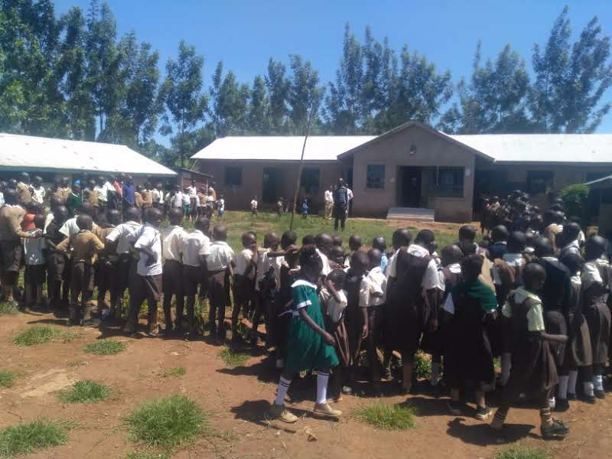
Teachers and mentors counseling the students

We first identify, rescue and protect a needy child by removing them from prone areas, house them in our makeshift boarding section in the school. This also prevents early pregnancies, forced early marriages and stigma that come with early menses on girls who can’t afford pads.

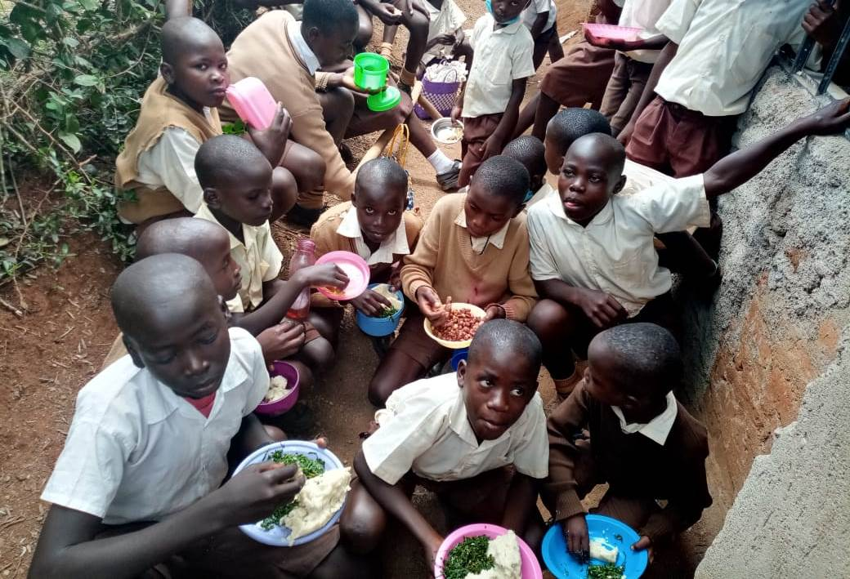
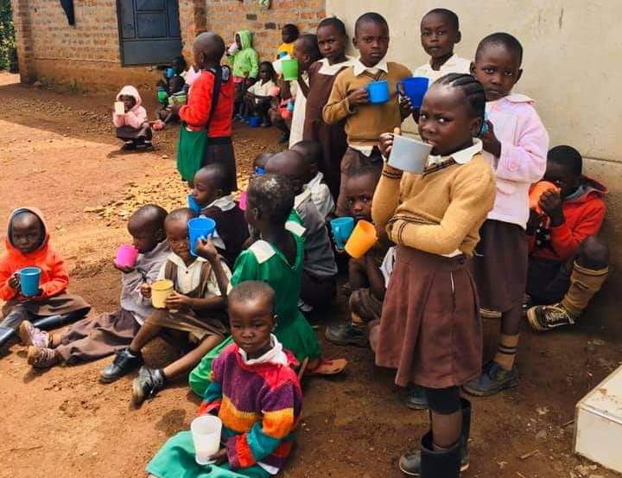
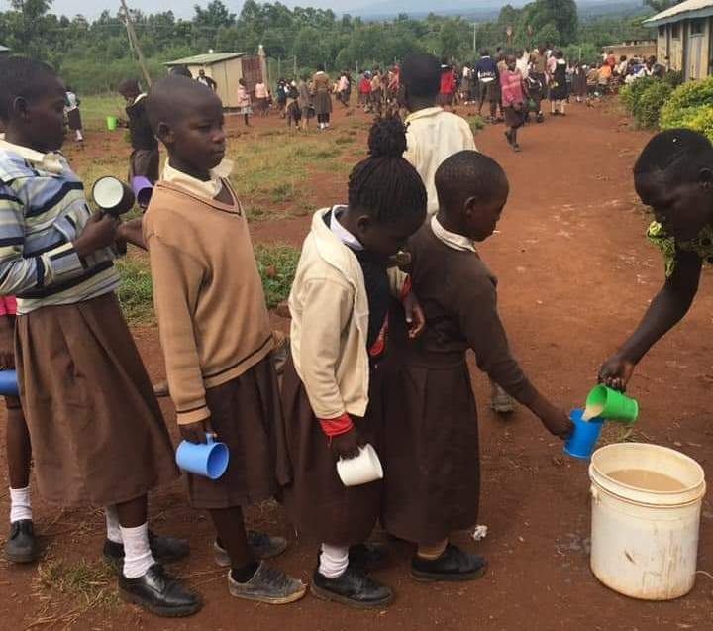
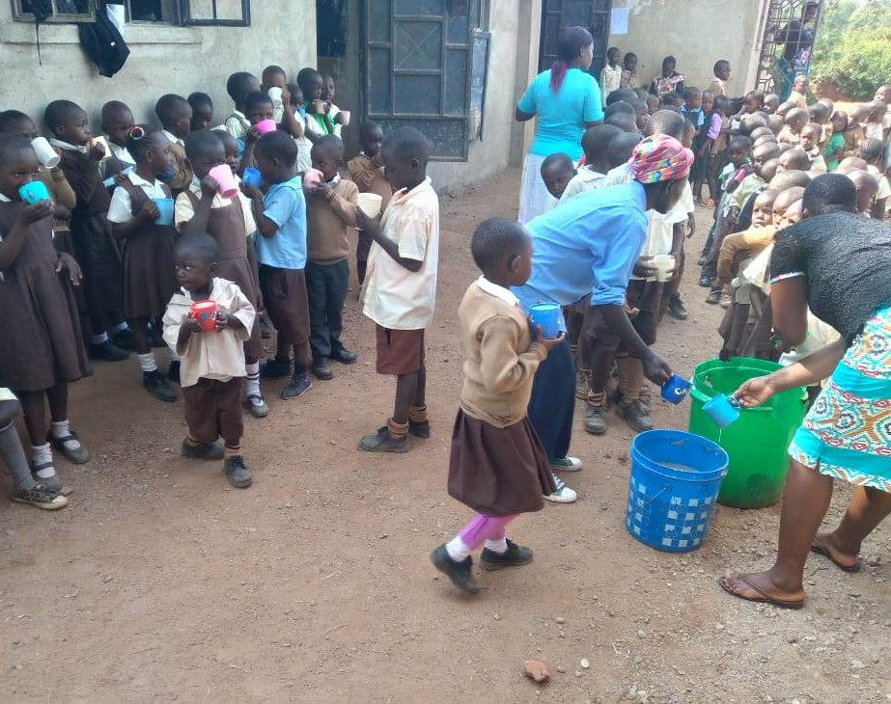
Feeding Program
Students taking their meals

Most of our efforts and resources are allocated to the feeding program which is of top priority. Our reasoning behind this is that nutrition and education play an important role in the development of children. At least while the kids are here at TFEC, we can guarantee they will be fed porridge and lunch for the day. Sometimes this may be the only meal our children eat and may not have this opportunity at home.
​Occasionally this program has to be paused and reduced to a single meal due to lack of funds, which means HUNGRY CHILDREN. It only takes pocket change to feed each child.

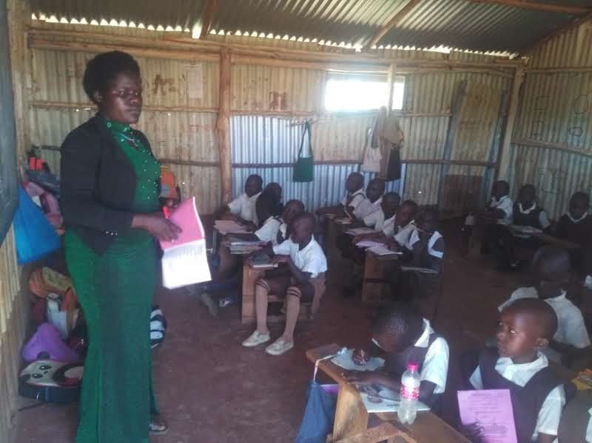
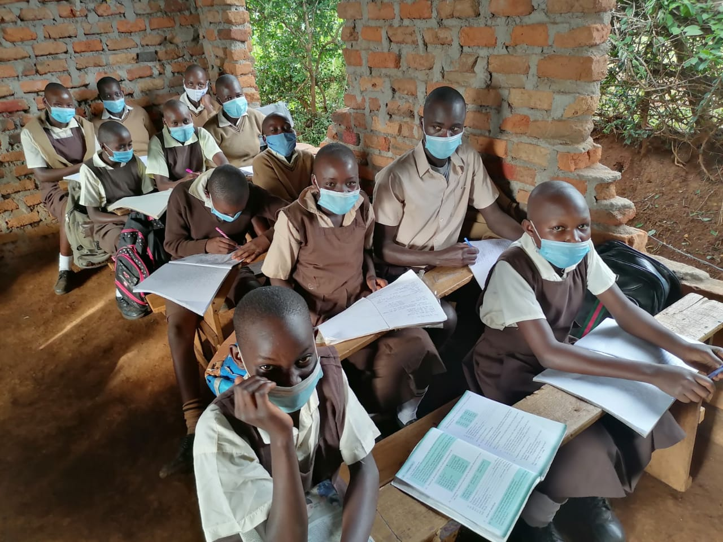
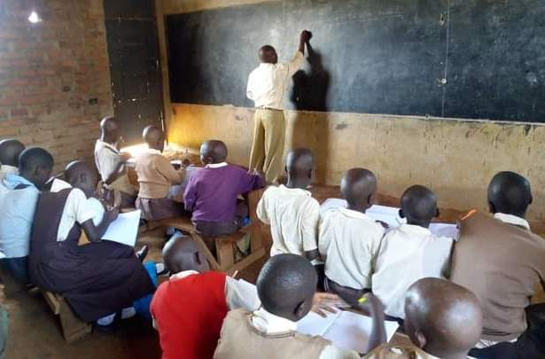
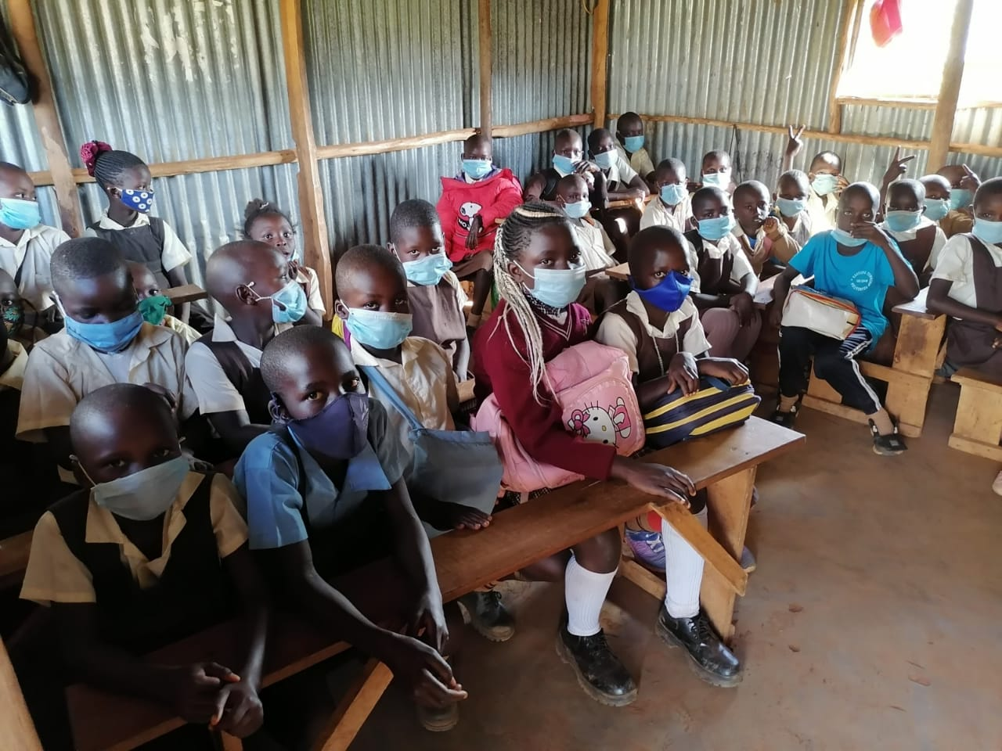
Education Program
Tuition in progress

Giving children an education, provides them with the confidence & tools to get a job. This has such a huge, positive impact on the local community - helping students break free from a life of poverty and crime not only for themselves but also for their parents, guardians and siblings. We try to eradicate poverty by educating as many children as possible.

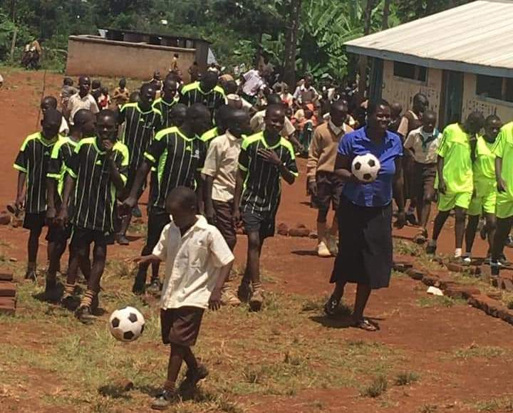
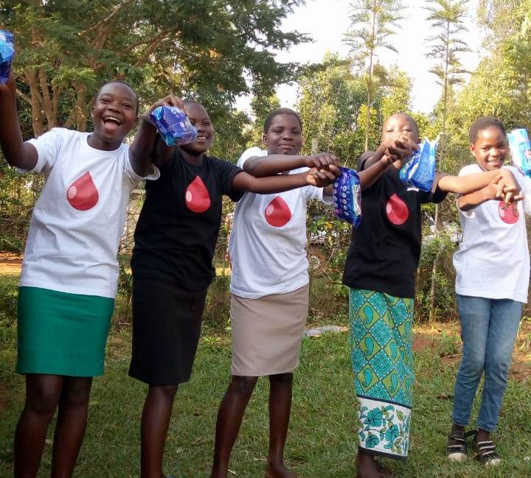
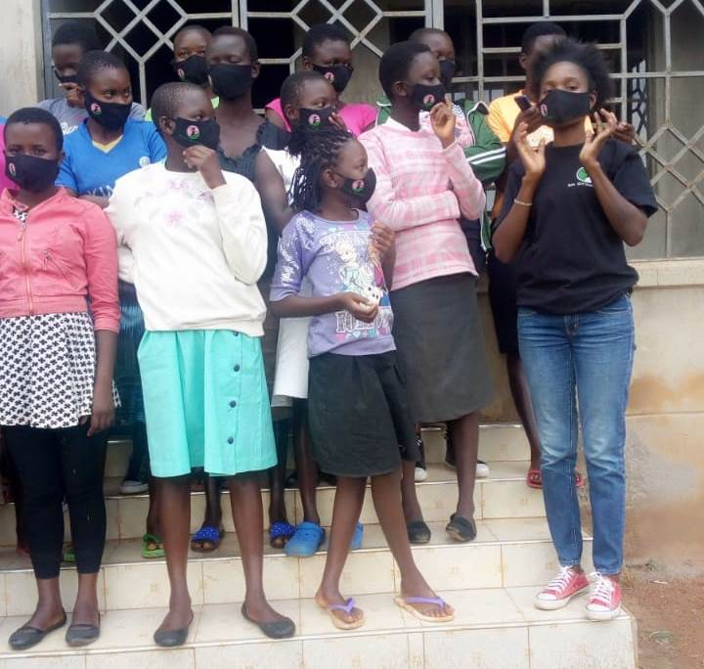
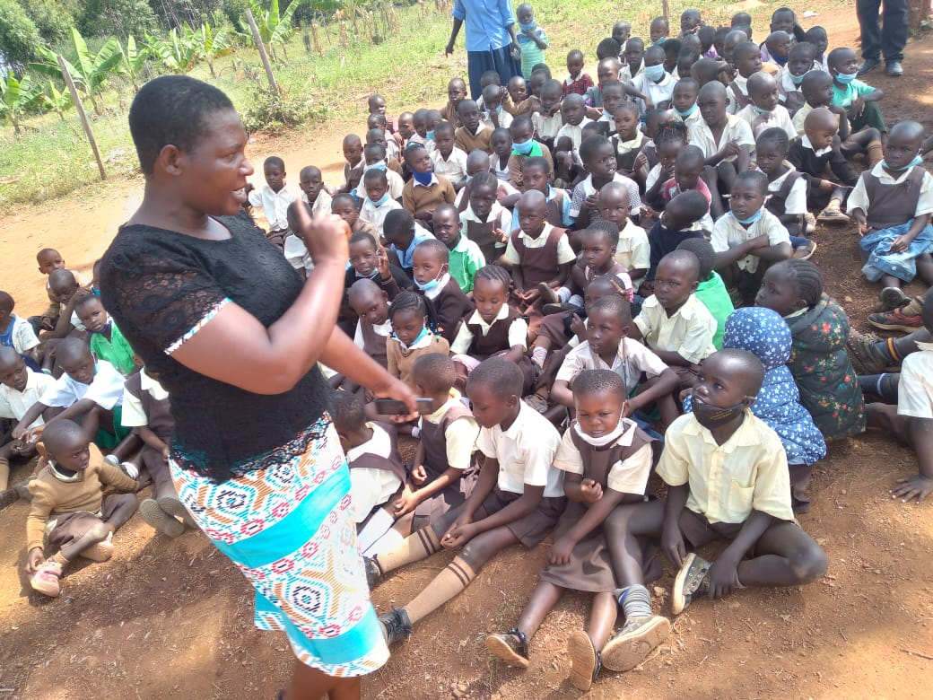
Mentorship and Health Program
Students being guided and empowered on life skills

We have a termly mentorship program where students are given life skills aimed at shaping their personality into responsible and caring people now and in future. We make current and future leaders from them with the hope that they will take over from us and propagate a culture of support to the needy and community. We have children who are either infected or affected by HIV/AIDS whose health both in body and mind has to be taken care of. Our counselors keep an eye on the special cases and handle them with care.

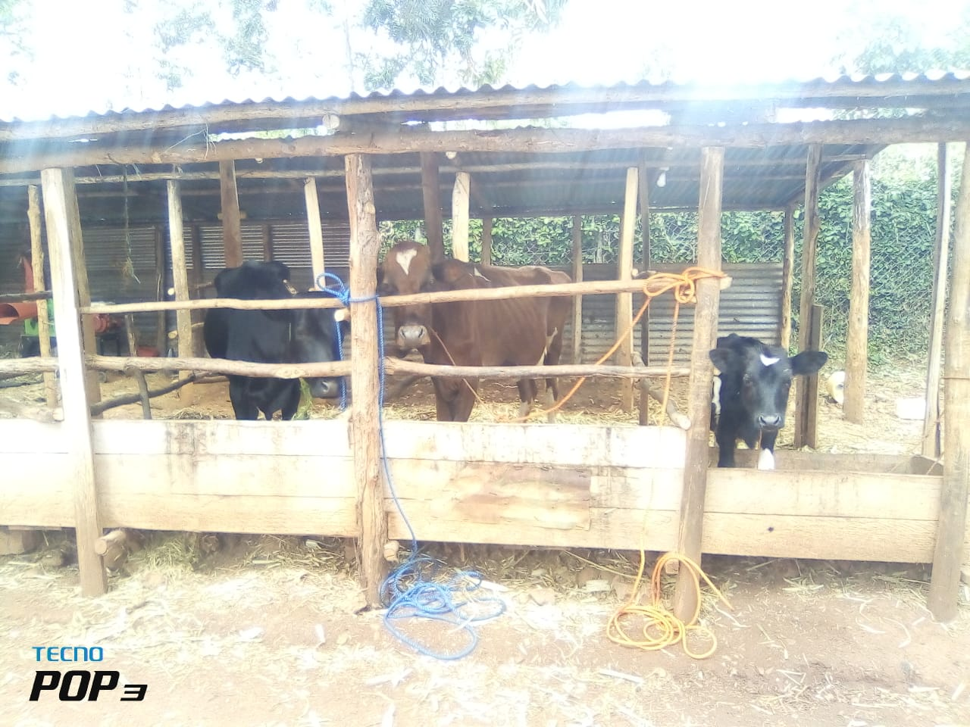
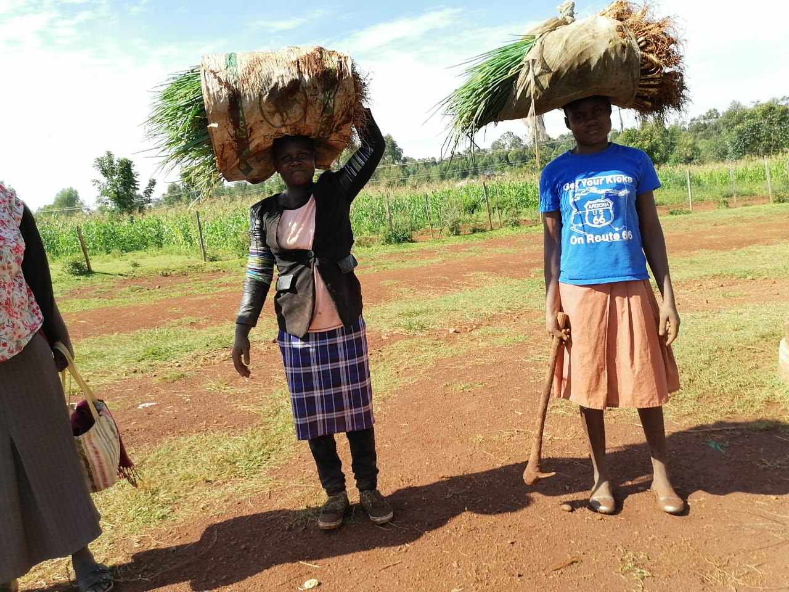
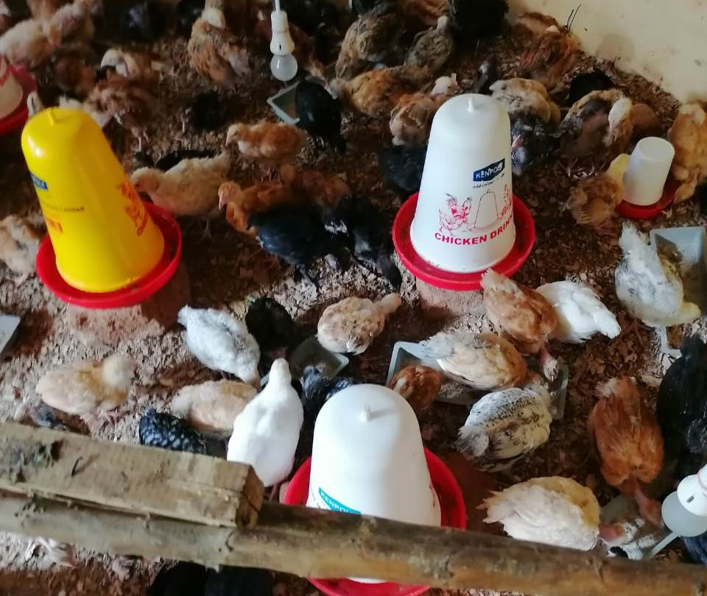
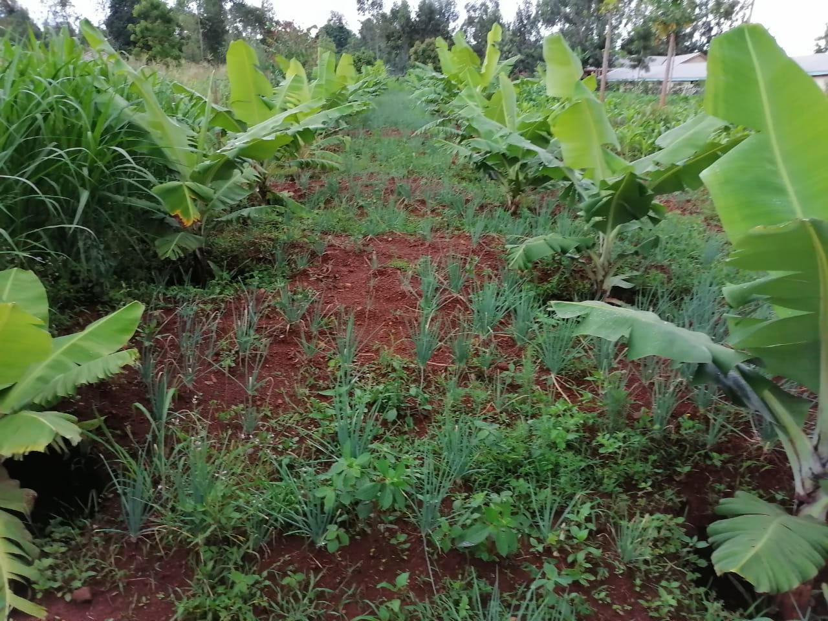
Farming Program
School’s farming activities

We run small poultry and dairy farms in the school. Also do maize, onion and banana production which is our main source of the little food we currently use in the center though too little.

UTILISATIOON OF DONOR FUNDING
If TFEC gets donor funds it be used in the following
Projects:
- We aim to feed all the needy students in the school on three nutritious meals per day that’s breakfast, lunch and dinner. Currently we only struggle to give a meal or two which is not certain.
- We will adequately provide quality tuition and teaching and learning materials like books, pens, chalk and other stationeries to all the needy children and pay electricity bill in the center.
- We shall buy enough sanitary pads for all mature girls to eliminate the shame some our girls go through during their menses.
- We shall buy school uniforms for all the needy students including other items like undergarments.
- The funds will enable us to give our current local volunteering teachers some reasonable stipend of $120 per month. Currently we give them a paltry $20 per monthly which hardly even clothes them. This leads to very high staff turnover as they look for greener pastures somewhere else.
- The funds will finance our health and mentorship programs by running a small sick bay in the school, hire a medical nurse and invite on a termly basis professional motivational speakers, counselors and mentors.
- We intend to support our needy students for secondary education after grade 8 at TFEC to enable them become productive in their future life.
- In the school we currently lack ten classrooms, dining hall, two dormitories and a computer laboratory. If we are lucky to have funding, we intend to initiate the above projects and do them gradually as dictated by the availability of funds so that the students can have where to stay. Currently we use temporal classrooms made of iron sheets, roof and walls which are too squeezed, pupils take meals in the open, they sleep in our family houses and we lack computer lab and computers.
Township Foundation is highly grateful for any support towards this course. We shall ensure a thorough accountability program for every dollar donated to ensure funds are fully used for what they are donated for and the lives of the needy children in this school change for the better. The school will send thank you notes to every donor keep records of every donation, work done or receipt for every item purchased. We shall furnish our donors with every financial report as is required whether monthly, quarterly or annually. The school also encourages our donors to frequently visit the site to assess and advise on the projects. We continue to be grateful to GLOBAL GIVING TEAM for this opportunity to participate.
Thank you very much.
Charles Odero-Co-Director and Founder,
Township Foundation Education Centre-THE POWER OF A CHILD

