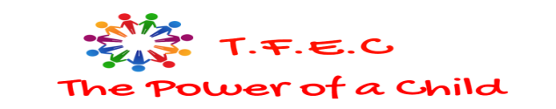
TOWNSHIP FOUNDATION EDUCATION CENTRE P. O. BOX 128-40303 RANGWE-KENYA MOBILE:+254 72858739 Email: townshipeducationcenter@gmail.com
DONATION REPORT FROM MAY 10TH -SEPTEMBER 18TH 2025
ACKNOWLEDGEMENT
Township Foundation Education Centre management acknowledges with great honor the receipt of donations worth $66,800 made on July 2nd 2025 and disbursed as $60,120.00 on July 17th 2025 from The Wilson Family Giving via Fidelity Charitable, driven through GlobalGiving fundraiser platform.
These funds have been channeled to the hospital project majorly and the farming program for TFEC. We sincerely appreciate and thank the Wilson Family and the GLOBALGIVING TEAM
APPRECIATION AND ACHIEVEMENTS
We Township Foundation Education Centre do register our gratitude to The Wilson Family Giving for the support they continually give to our children and to the community. We truly recognize and appreciate the GlobalGiving for giving us the fundraising platform.
ANALYSIS OF FUNDS UTILIZATION
We have invested this money in Feeding program in the school and commencing a community hospital as outlined in the table below.
We bought land and the construction work has begun as indicated in the photos attached below:
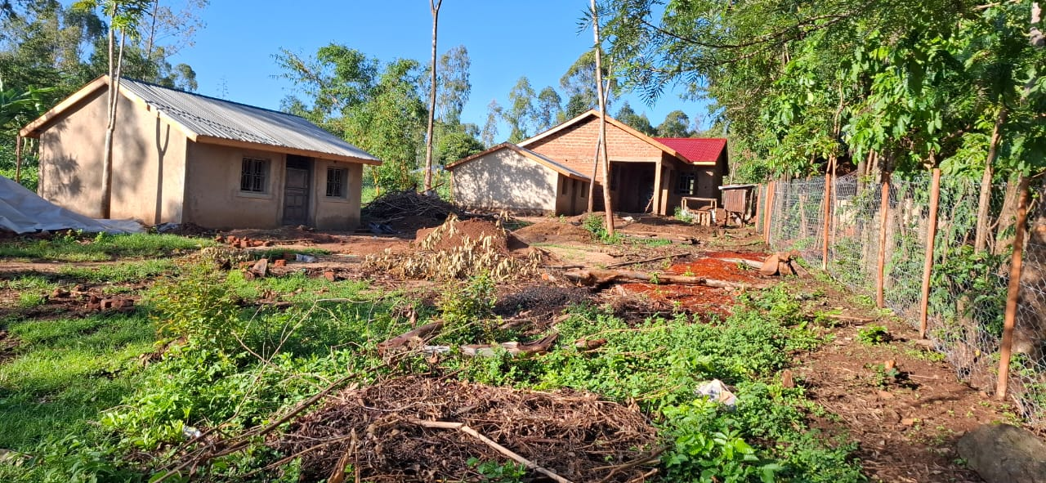
RECEPTION, FRONT OFFICES AND CONSULTAION ROOMS, INJECTION/TREATMENT ROOM
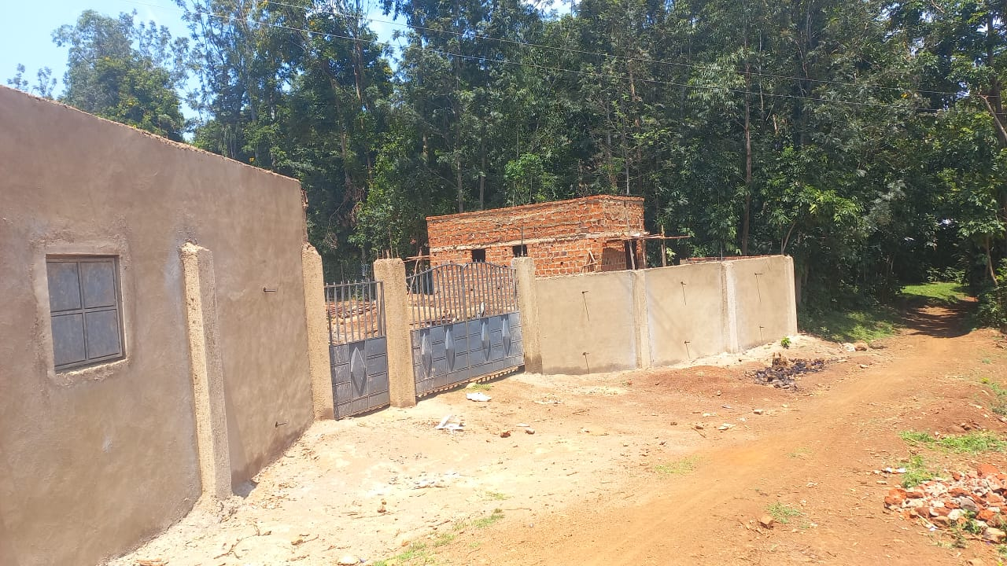THE COMPOUND FENCE AND FRONT GATE UNDER CONSTRUCTION

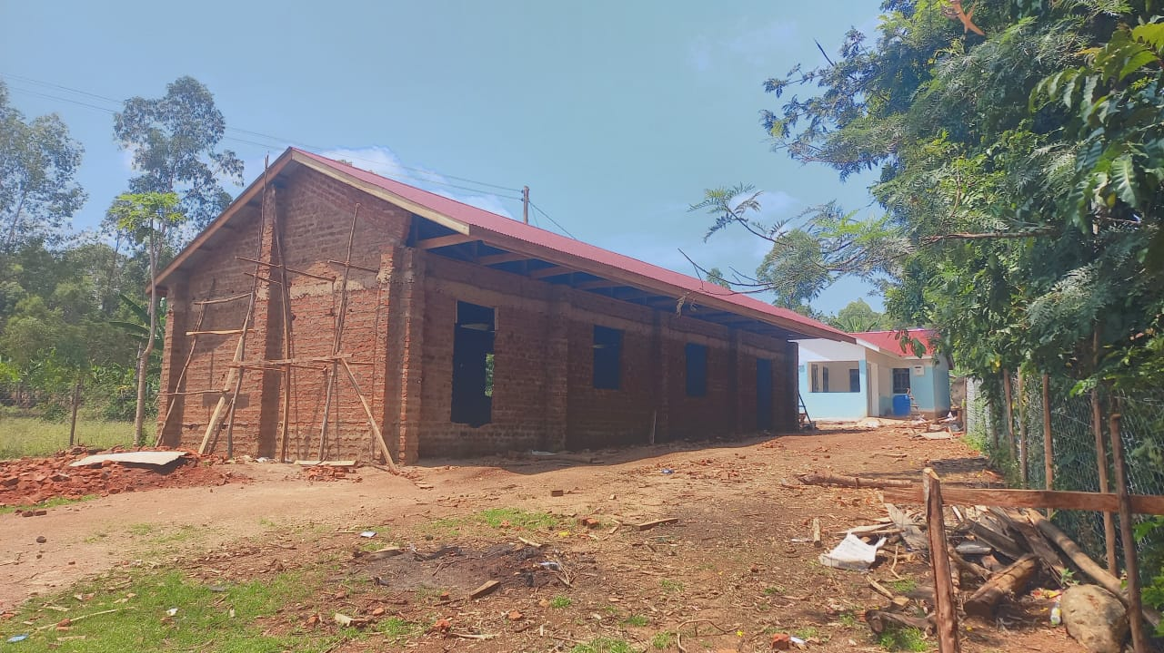
MALE, FEMALE, CHILDREN AND MATERNITY WARDS COMING UP

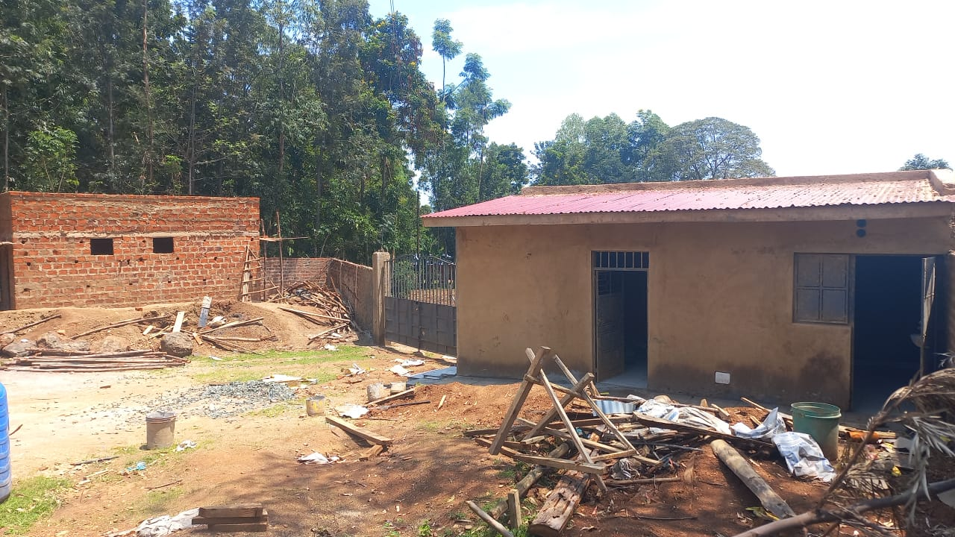LATRINES AND CANTEEN COMING UP

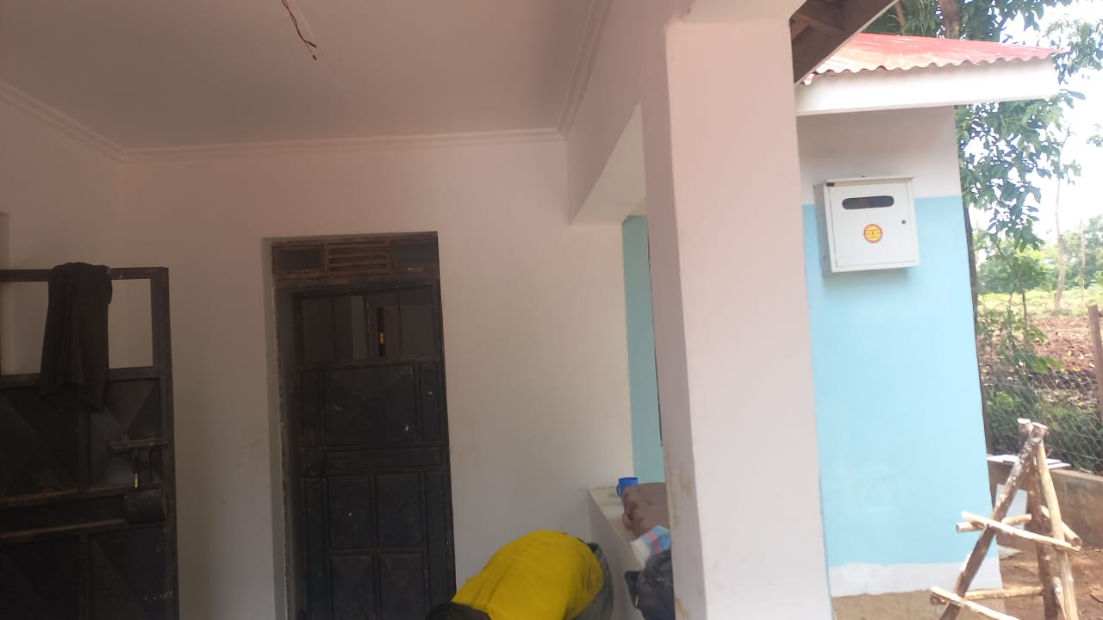
PAINTING ONGOING
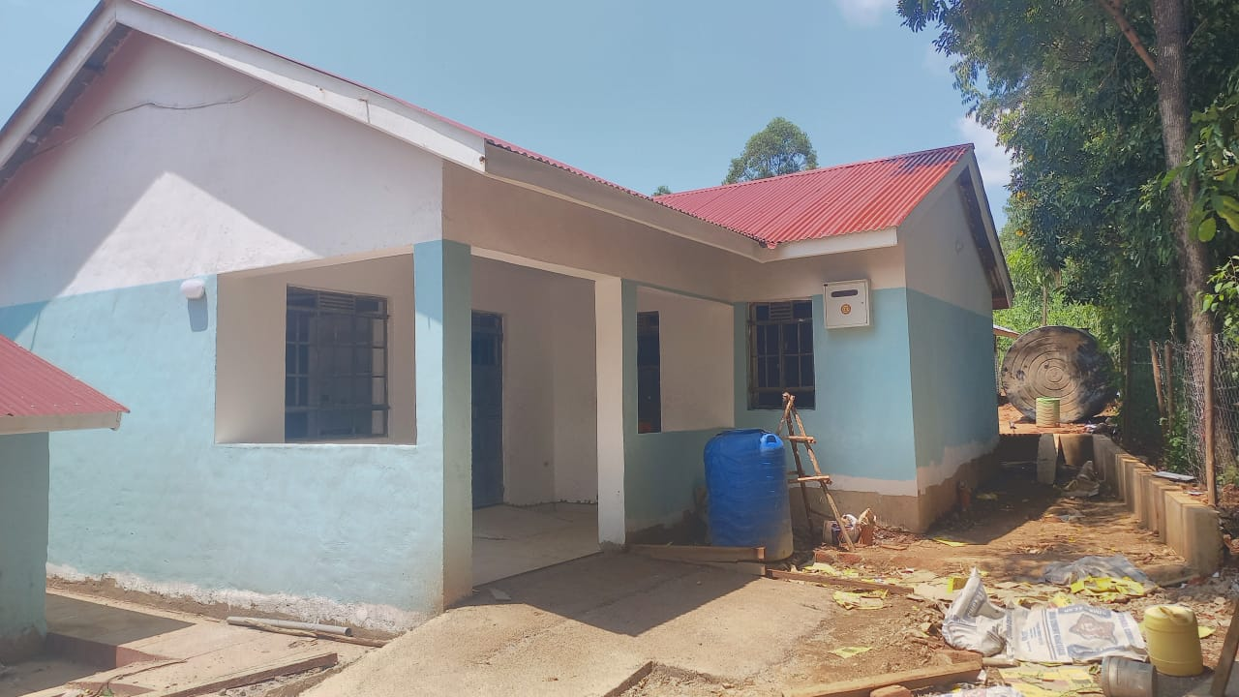
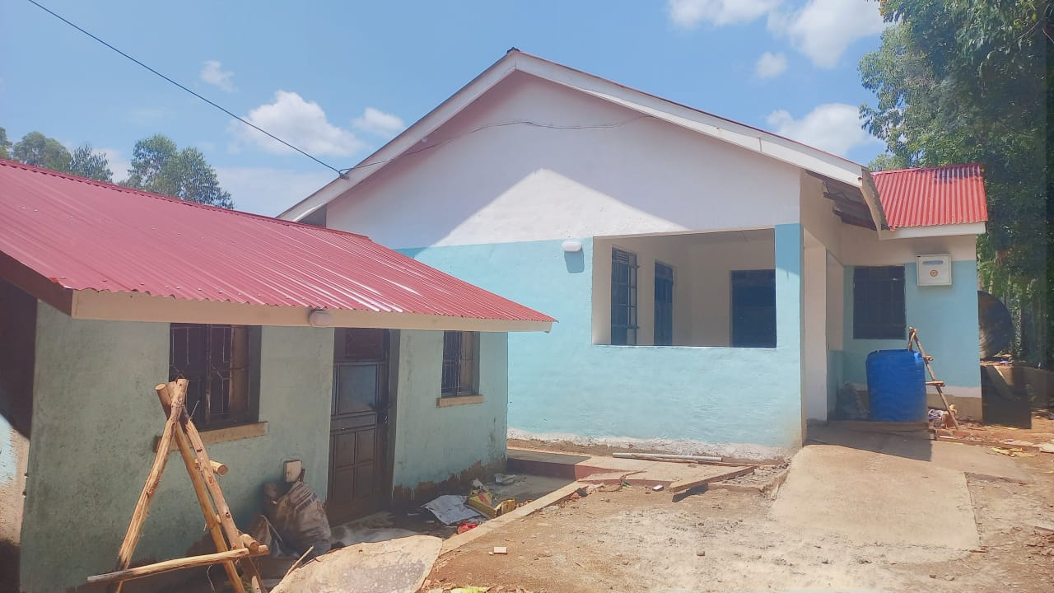
LABORATORY AND THE OUTPATIENT DEPARTMENT COMPLETE

Funds utilization Table
sn | Item description | unit | Quantity | Unit cost($) | Total in USD
1 | Opd Finishes |  |  |  | 25,000
2 | Inpatient hall |  |  |  | 15.000
3 | Laboratory partitioning and fittings |  |  |  | 12,120
4 | Seeds for planting | Kg | 400 | 8 | 3,200
5 | Total |  |  |  | 60,120
We continue to cherish our donors and hold high GlobalGiving for giving us this platform for fundraising. Surely you have given us a chance to put a smile on a numbers of faces which had initially lost hope.
Thank you and be blessed.
Prepared by;
Charles Odero,
Project Leader.

